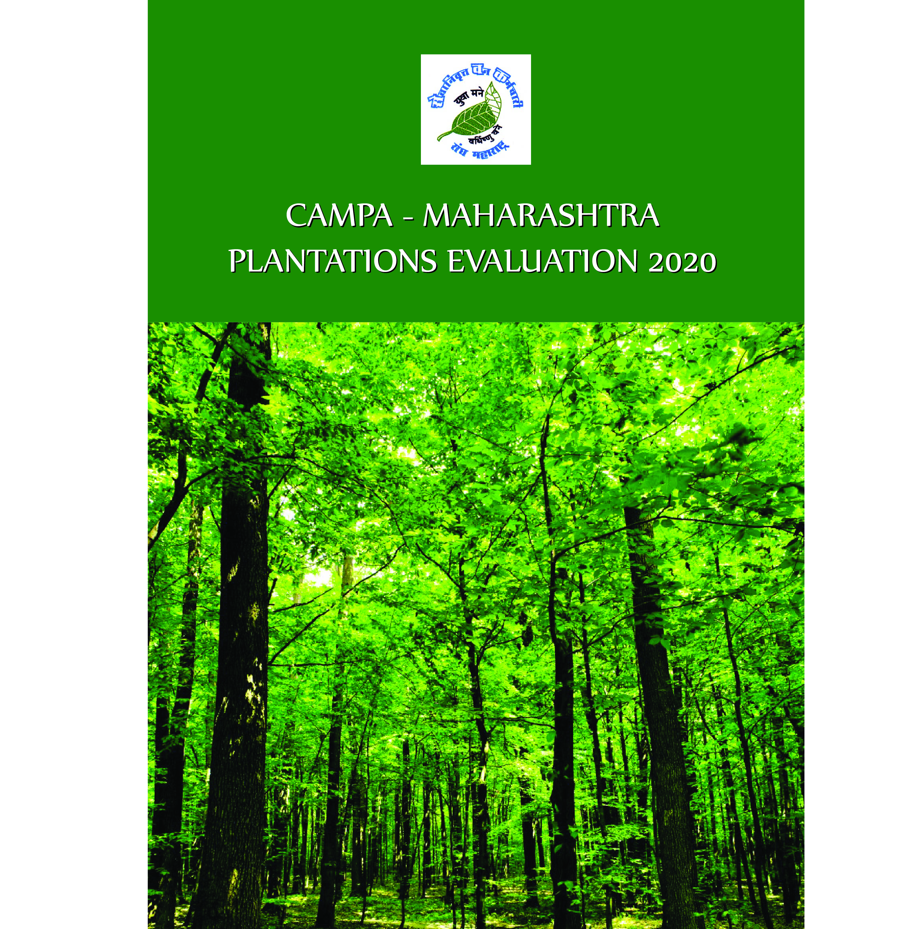

Index
Section Contents Page No.
A. ACKNOWLEDGEMENT (अभिस्वीकृति)
B. ABBREVIATIONS
C. EXECUTIVE SUMMARY OF EVALUATION
D. LIST OF CONTENTS
1. INTRODUCTION
1.1: Forest (Conservation) Act, 1980
1.2: Area for Compensatory Afforestation
1.3: Creation of CAMPA – Maharashtra
1.4: Afforestations / Plantations through CAMPA
1.5: Evaluation
2. EVALUATION METHODOLOGY
2.1: Evaluating Agency
2.2: Constitution of Evaluations Teams
2.3: Selection of Evaluation Sites
2.4: Methodology of Evaluation
3. LEGAL STATUS OF CA LANDS
3.1: Guidelines for Declaring Non Forest Lands into Forests
3.2: Non Forest Lands Declared Forests
4. QUALITATIVE ANALYSIS
4.1: Choice of Species
4.2: Plant Survival
4.3: Plantation Species
4.4: Growth Analysis
4.5: Health of Plants
5. SOCIO-ECONOMIC ANALYSIS
5.1: Expenditure
5.2: Employment
5.3: Maintenance of Financial Records
5.4: Gender Issues
5.5: Difficulties of Field Staff
E. LIST OF TABLES
1.1: Details of Plantation Area selected for evaluation
1.2: Circle wise Abstract of Sites Evaluated
1.3: Forest Circle/District/Forest Division wise
distribution of 103 sites
1.4: Area Abstract of 103 Sites
1.5: CA Treatment Models
2.1: Composition of Evaluation Teams
3.1: Status of Declaring non-forest CA lands as Forests
4.1: Plantation year wise average survival percent
4.2: Local and Botanical Name of Species Planted
4.3: Plantation Year wise Average Height of Plants
4.4: Year wise Health of Plantations
5.1: CAMPA Plantation Evaluation – Expenditure &
Generation of mandays for 101 evaluated sites
5.2: Status of Incomplete MBs
5.3: Status of Audit
F. LIST OF FIGURES
1.1: Plantation Sites Evaluated in Districts of Maharashtra
1.2: Agro Climatic Zones of Maharashtra
4.1: Species Suitability Chart
4.2: Diagram of No. of sites Vs survival %
4.3: Graph Showing Year wise Plant Survival
4.4: Profile of Species planted under CAMPA Project
4.5: Year wise Plantation Height Trend
4.6: Status of Health of Plants
4.7: Gradation of Plantations
5.1: No of Sites Audit not done
G. LIST OF ANNEXURES
I – MoU in Marathi
II – GoM Letter dated 18-02-2020
III – Abstract of 103 Evaluated Sites

अभिस्वीकृति (ACKNOWLEDGMENT)
ही अभिस्वीकृति म्हणजे केवळ शिष्टाचाराची पूर्तता पार पाडण्यासाठी नसून, हृदयाच्या मळ्यातून उमललेल्या भावनांचा गुच्छ अर्पण करण्याची कृति आहे. महाराष्ट्रात आणि भारतवर्षात अनेक नामवंत संस्था हे कार्य पार पाडण्यासाठी ईच्छुक व सबळ असतांना मूल्यांकनाचे कामासाठी सेवक संघटनेची निवड करुन, आमच्यावर जो विश्वास प्रगट केला आहे, त्या करिता आम्ही कॅम्पा -महा. चे ऋणी असून, त्यांचे आभार कसे मानावेत याकरिता शब्द सुमने आमचेकडे नाहीत. सेवक, यासाठी श्री संजीव गौड, भा.व.से.,अपर प्रधान मुख्यवनसंरक्षक,म.रा., नागपूर यांचे विशेष आभार व्यक्त करते. या शिवाय सेवक पुढील व्यक्तींची पण आभारी आहे -
- मा.वनमंत्री, म. रा., मुंबई.
- मा. राज्यमंत्री वने, म. रा., मुंबई
- अपर मुख्य सचिव, वने, मुंबई.
- वन बल प्रमुख, म.रा., नागपूर
- सर्व प्रादेशिक वनव्रुत्तांचे मुख्यवनसंरक्षक
- मूल्यांकन क्षेत्रातील उपवनसंरक्षक / वि. व.अधिकारी
- मूल्यांकन क्षेत्रातील सहाय्यक वनसंरक्षक/वनक्षेत्रपाल/वनरक्षक/वनमजूर/वाहन चालक/कार्यालयीन कर्मचारी.
या महाकाय कामातील, मूल्यांकन प्रपत्रातील विस्तृत माहितीच्या डेटा एंट्रीचे काम श्री. प्रविण पवार यांनी लॉकडाऊनचे काळात वेगाने केल्यामुळे त्यांचे आभार व्यक्त करणे जरूरी आहे.
डेटा क्लिनिंग, संकलन करणे, त्याचे विश्लेषण करून निष्कर्ष काढणे हे काम "एनव्हिजन कॉंप्युटर ट्रेनिंग इन्स्टीट्युट, पुणे ४११०३७" यांनी मेहनतीने व कौशल्याने अल्प कालावधीत पूर्ण केल्याबद्दल सेवक त्यांचे आभार मानते. नाविन्यपूर्ण,तांत्रिक मूल्यांकन अहवालाची मांडणी व संगणीकरण करून हा अहवाल पूर्णत्वास नेण्यासाठी, सर्व व्यवहार ठप्प असतांना, श्री प्राजक्त पत्की यांनी केलेल्या प्रयत्नांमुळे सफलता मिळाली, म्हणून सेवक त्यांचे खास आभार मानते.
श्री. संभाजी गवळी, उपाध्यक्ष, सेवक यांनी मूल्यांकन करणे, अहवाल निर्मित्तीत विश्लेषण करणे, प्रकरणांचे लिखाण करणे या कामी पुढाकार घेऊन कार्यपूर्तता केल्याबद्दल उपकृत आहे. तसेच श्री एस. एम. जगताप यांनी समन्वयकाचे काम उत्साहाने व जबाबदारीने पार पाडल्याबद्दल त्यांचे अभिनंदन करते. सरतेशेवटी सेवक आपल्या मूल्यांकन चमूतील सदस्य आणि कार्यकारणीतील मान्यवरांचे आभार मानते.
या शिवाय अनवधनाने कुणाचे आभार मानण्याचे राहून गेलेअसल्यास सेवक त्यांचे आभार व्यक्त करते.

(वि.त्र्यं.पत्की)
प्राधिकृत सदस्य,सेवक.

ABBREVIATIONS
ACF | Assistant Conservator of Forests
APCCF | Additional Principal Chief Conservator of Forests
APO | Annual Plan of Operations
Av. | Average
CA | Chartered Accountant/Compensatory Afforestation
CAMPA | Compensatory Afforestation Management & Planning Authority
CCF | Chief Conservator of Forests
CCT | Continuous Contour Trench
CEO | Chief Executive Officer
cms | Centimeters
cum | Cubic meter
CW | Conditional Works
DCCT | Deep Continuous Contour Trench
DCF/DyCF | Deputy Conservator of Forests
DFO | Divisional Forest Officer
ET | Evaluation Team
FGd | Forest Guard
Fr | Forester
FYO | First Year Operations
gbh | Girth Breast Height
GoI | Government of India
GoM | Government of Maharashtra
GPS | Global Positioning System
H | Healthy
ha | Hectare
HoFF | Head of Forestry Force
JFM | Joint Forest Management
JFMC | Joint Forest Management Committee
M/m | Meter
MAH/Mah | Maharashtra
MB | Measurement Book
MoEF& CC | Ministry of Environment Forests & Climate Change
MoU | Memorandum of Understanding
PA | Wildlife Protected Area
PCCF | Principal Chief Conservator of Forests
PPO | Pre-Planting Operations
PYO | Preliminary Year Operations
R&FD | Revenue & Forests Department
RFO | Range Forest Officer
Rmt/rmt | Running Meter
SEVAK | Sevanivrutta Van Karmachari Sangh, Maharashtra
SH | Semi-Healthy
SMC | Soil Moisture Conservation
SYO | Second Year Operations
T | Territorial
TCM | Trench cum Mound
TYO | Third Year Operations
UH | Un-Healthy
WAT | Water Absorption Trench
Yr | Year

EXECUTIVE SUMMARY OF EVALUATION
- The CAMPA-MAH identified SEVAK as Third party Evaluating Agency to evaluate 148 sites of plantation under CAMPA and made MoU.
- The summary deals with 103 evaluated sites, excluding PYO-PPO 45 sites, equivalent to about 20% treated area.
The area of 103 evaluated sites is 1453.765 ha., which is classified into Forest Land- 1224.975 ha. (82 sites) and Non-Forest land- 328.790 ha. (21 sites). Evaluation of 45 sites proposed to be treated under PYO/PPO works could not be done due to lockdown of pandemic Covid-19 & non-execution of works on the ground.
- Area of 16 sites out of the 21 Non-forest sites is notified as Forests and process of declaring area of remaining 5 sites as forests is in progress.
- The distribution of plantations is as below -
FYO: 14 sites 186.296 ha.
SYO: 18 sites 295.650 ha.
5th Year: 12 sites 147.690 ha.
8th Year: 34 sites 561.700 ha.
Conditional Works: 25 sites 262.429 ha.
Total: 103 sites 1453.765 ha.
- Following 5 Plantation Models are implemented by & large.
2500 Plants per ha.
1111 Plants per ha.
400 Plants per ha
625 Plants per ha.
400+1100 Plants per ha.
- 66 Plant species were introduced in the plantations. On 80 sites (77%) species selected for planting were suitable. The utility of planted species is as below-
Timber : 11%,Fuel: 02%,Fruit:20%,
Gum:01%,Medicinal Plants:24%,
Multiple use:15%,Ornamental use:27%
- Plant Survival
42 sites-More than 80%
23 sites-60-80%
24 sites- 40-60%
13 sites -less than 40%
01 site- 0% as the site is burnt.
- Average height of plants
2018-19 Plantations 64.32 cms
2017-18 Plantations 73.48 cms
2015-16 Plantations 151.57 cms
2011-12 Plantations 147.92 cms
2011-12 to 2015-16 Plantations 168.31 cms
Average 114.31 cms
- Health of Plants
Healthy 61 sites 69.2%
Semi-Healthy 22 sites 21.4%
Un-Healthy 20 sites 19.4%
Total 103 sites 100.0%
- Grading of Plantations
Average height of plants, general health of plants & survival percentage of plants together were taken into account in grading of plantations.
Excellent (A+) 16 sites
Very Good (A) 32 sites
Good (B+) 28 sites
Average (B) 15 sites
Poor (C) 11 sites
Burnt 01 site
Total 103 sites
- Treatment Map preparation, zonation of the area and it's ground verification need drastic improvement. Role of RFOs & ACFs is not conspicuous.
- Timely monitoring of field operations and expenditure on it need attention.
- Supervision over plantation activities is inadequate. Inspection notes are not recorded in the plantation registers and follow-up is not observed.
- The APO of CAMPA-Mah for 2019-20 received approval of Rs. 498.18 crores from the National Authority in the meeting held on 15-07-2019. The funds were transferred by GoI after the monsoon session of 2019 and hence the supplementary demand could only be placed in the winter session of 2019 for Rs. 389.400 crores and the State Legislature approved amount of Rs. 189.400 cores only. Hence most of the payments from October 2019 onwards could not be made, causing pendency of payments in the field and non execution of PYO/PPO works. (Source - GoM, R&FD, letter, dt. 18-03-2020 addressed to the Dy.CEO, National Authority, MoEF & CC, New Delhi)
- The expenditure on 103 evaluated sites is Rs. 21.9915 crores or say 22 crores.
- The mandays generated through plantation programme are 5,19,610.
section-1
Introduction
1.1 Forest (Conservation) Act, 1980:
The FCA, 1980 deemed to be in force from 25-10-1080, extending to whole of India except the State of Jammu and Kashmir. The President of India granted assent to the Act on 27-12-1980 and the Act came in force as Act No. 69 of 1980. Section 2 of the Act imposes restriction on de-reservation of forest or use of forest land for non-forest purpose.
1.2 Area for Compensatory Afforestation:
Government of India, Department of MOEF vide no. 2-3/86-FC, New Delhi, dated 31-07-1986 communicated guidelines for diversion of forest lands for non-forest purposes under the FCA.
The guideline no. 8.1 specifies norms for land of Compensatory Afforestation.
8.1(i) – Where non-forest lands are available, the CA be raised over equivalent area of non-forest land.
8.1(ii) – Where non-forest lands are not available, the CA be raised over degraded forest lands twice in extent to the area being diverted.
8.1(iii) – Where non-forest lands available is less in extent to the forest land being diverted, in addition to the CA on available non-forest land plantation be raised in the degraded forest twice in extent to the difference between forest land being diverted and available non-forest land.
8.2(c) – In cases of diversion of forest land less than 1 ha. In extent, unless asked for by the Forest Department, the CA shall not be insisted upon.
1.3 Creation of CAMPA – Maharashtra:
There were many loopholes in carrying out CAMPA plantations on forest as well as non-forest lands and no sustainability throughout the country for implementation of the plantation programme for CA. The matter reached to the Supreme Court of India and it was settled by the Supreme Court in 2002 ordering the Central and State Governments to create Compensatory Afforestation Management and Planning Authority (CAMPA). In Maharashtra, the CAMPA was constituted and they are managing plantation of CA from 2010-11 onwards. Monitoring and Evaluation of the CA is one of the important activities of the CAMPA. Generally, the M&E is done by the evaluation wing of the State Forest Department, however, the concept of Third Party Evaluation was introduced according to the SC order.

1.4 Afforestation / Plantations through CAMPA:
In Maharashtra, there are 9 agro-ecological zones. About 50% of the forest land is degraded by biotic interference. The over grazing of cattle and repeated fires on forest lands, the forest area has become unsuitable for Natural Regeneration. The depth of soil in general is shallow. Hence, the concept of Treatment Map was introduced from 1986 onwards under the massive afforestation programme. The CA land to be treated is classified into various zones depending upon the soil depth and plantations are raised on Zone-II lands with smaller plant population and on Zone-III with higher plant population. Under the CAMPA Afforestation, bulk of the plantation programme is carried out in the pits along with SMC works and fencing. So far under the CAMPA, GoM has carried out afforestation programme over 11011.721 ha. of forest as well as non-forest land from 2010-11.
1.5 Evaluation:
The concurrent monitoring and evaluation is done internally by the Forest Department. However, the Department has limitations in carrying out evaluations and hence according to the SC order the third party evaluation concept came in force. The evaluation is needed for understanding sustainability of the plantations, to understand the rate of growth and survival of plants, general health of the plants, to mitigate needs of local beneficiaries and to regenerate the lands for strengthening ecology. The Additional Principal Chief Conservator of Forests (APCCF – MAH) identified the Sevanivrutt Van Karmachari Sangh, Maharashtra for carrying out third party evaluation of the CA programme and signed the Memorandum of Understanding for carrying out the evaluation.
1.6 Target of Evaluation:
MoU was signed by the APCCF and the SEVAK on 03-02-2020, which is enclosed as Annexure-I (in Marathi). Following area were brought under or proposed under CA from 2010-11 onwards in the State of Maharashtra as shown in the Table 1.1 below -
The MoU prescribes about 20% of the treated area for evaluation under various plantation models & year of operations.

Table 1.1: Details of Plantation Area selected for evaluation
Sr. No. | Details of Plantation Operation | Total Area of plantation (In Ha.) | Area selected for evaluation (In Ha.) | No. of Sites | % of selected Area | Remarks | Overall  %
1 | Pre planting  (PPO/PYO) | 4005.344 | 768.500 | 45 | 19.19 | Not evaluated so far
2 | First Year  (FYO) | 767.842 | 186.296 | 14 | 24.26 | Evaluated
3 | Second Year  (SYO) | 1509.730 | 295.650 | 18 | 19.58 | Evaluated
4 | 5th Year  (5th YO) | 673.920 | 147.690 | 12 | 21.91 | Evaluated
5 | 8th YO  (8th YO) | 2811.180 | 561.700 | 34 | 19.98 | Evaluated
6 | Conditional  Plantations | 1243.705 | 262.429 | 25 | 21.10 | Evaluated
 | Total | 11011.721 | 2222.265 | 148 |  |  | 20.18
Table 1.2: Circle wise Abstract of Sites Evaluated
Sr. No. | Circle | FYO | SYO | 5th YO | 8th YO | Conditional | Total
1 | Nagpur | 2 | 2 | 1 | 14 | 5 | 24
2 | Chandrapur | 1 | 0 | 1 | 2 | 1 | 5
3 | Amravati | 1 | 3 | 1 | 2 | 0 | 7
4 | Yavatmal | 1 | 3 | 0 | 1 | 1 | 6
5 | Dhule | 1 | 0 | 1 | 6 | 1 | 9
6 | Nashik | 4 | 0 | 1 | 2 | 1 | 8
7 | Pune | 1 | 1 | 0 | 3 | 1 | 6
8 | Thane | 1 | 8 | 2 | 1 | 10 | 22
9 | Kolhapur | 0 | 0 | 2 | 3 | 4 | 9
10 | Gadchiroli | 2 | 1 | 2 | 0 | 0 | 5
11 | Aurangabad | 0 | 0 | 1 | 0 | 1 | 2
 | Total | 14 | 18 | 12 | 34 | 25 | 103

Table 1.3: Forest Circle/District/Forest Division wise
distribution of 103 sites
Sr. No. | Forest Circle | District | Forest Division | No. of Sites
1 | Thane | Thane | Thane | 4
2 | Thane | Thane | Shahapur | 6
3 | Thane | Palghar | Dahanu | 5
4 | Thane | Palghar | Jawahar | 3
5 | Thane | Raigad | Alibag | 4
Sub Total 1-4 |  |  |  | 22
6 | Nagpur | Nagpur | Nagpur | 7
7 | Nagpur | Bhandara | Bhandara | 2
8 | Nagpur | Gondia | Gondia | 11
9 | Nagpur | Wardha | Wardha | 4
Sub Total 6-9 |  |  |  | 24
10 | Kolhapur | Kolhapur | Kolhapur | 8
11 | Kolhapur | Satara | Satara | 1
Sub Total 10-11 |  |  |  | 9
12 | Pune | Pune | Pune | 1
13 | Pune | Pune | Bhor | 1
14 | Pune | Pune | Junnar | 4
Sub Total 12-14 |  |  |  | 6
15 | Nashik | Ahmednagar | Sangamner | 5
16 | Nashik | Nashik | East Nashik | 1
17 | Nashik | Nashik | Malegaon | 2
Sub Total 15-17 |  |  |  | 8
18 | Dhule | Dhule | Dhule | 6
19 | Dhule | Nandurbar | Nandurbar | 1
20 | Dhule | Nandurbar | Mewasi | 1
21 | Dhule | Jalgaon | Yawal | 1
Sub Total 18-21 |  |  |  | 9
22 | Amravati | Amravati | Amravati | 3
23 | Amravati | Buldhana | Buldhana | 2
24 | Amravati | Akola | Akola | 2
Sub Total 22-27 |  |  |  | 7
25 | Yavatmal | Yavatmal | Pandharkawada | 1
26 | Yavatmal | Yavatmal | Pusad | 2
27 | Yavatmal | Yavatmal | Yavatmal | 2
28 | Yavatmal | Washim | Washim | 1
Sub Total 25-28 |  |  |  | 6
29 | Aurangabad | Aurangabad | Aurangabad | 2
Sub Total 29 |  |  |  | 2
30 | Chandrapur | Chandrapur | Bramhapuri | 2
31 | Chandrapur | Chandrapur | Central Chanda | 1
32 | Chandrapur | Chandrapur | Chandrapur | 2
Sub Total 30-32 |  |  |  | 5
33 | Gadchiroli | Gadchiroli | Wadsa | 5
Sub Total 33 |  |  |  | 5
Total 1-33 |  |  |  | 103

Table 1.4: Area Abstract of 103 Sites
FYO | SYO | 5th Year | 8th Year | Conditional | Total
14 Sites | 18 Sites | 12 Sites | 34 Sites | 25 Sites | 103 Sites
186.296 ha. | 295.650 ha. | 147.690 ha. | 561.700 ha. | 262.429 ha. | 1453.765 ha.

Figure 1.1: Plantation Sites Evaluated in Districts of Maharashtra

Figure 1.2: Agro Climatic Zones of Maharashtra
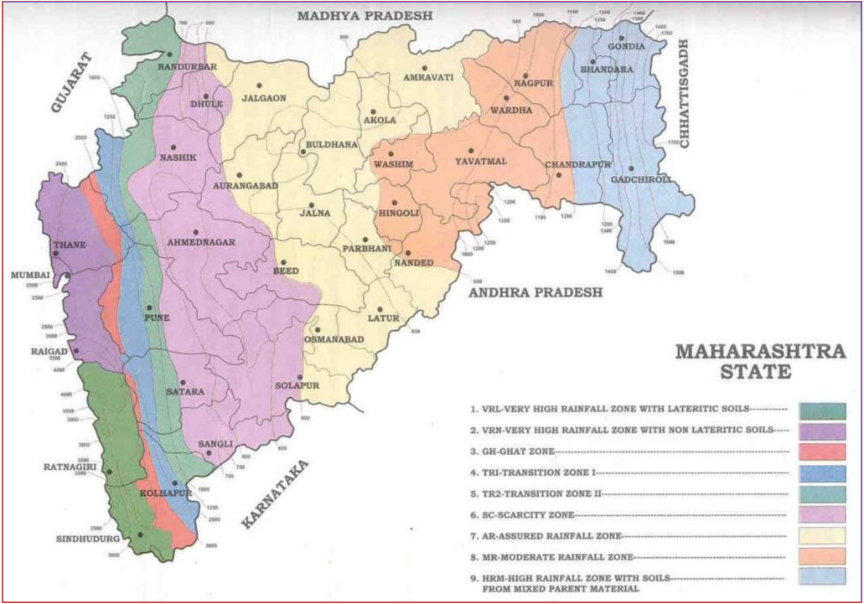
1.7 Treatment Models for CA:
Table 1.5: CA Treatment Models
Sr. No. | No. of plants per ha. | Spacing in meters | Species
1 | 2500 | 2 X 2 | Teak
2 | 625 | 4 X 4 | Bamboo or medicinal trees
3 | 400 | 5 X 5 | Bamboo, Fodder Trees
4 | 400+1100 | 5 X 5 | In FYO, Bamboo
 |  | 3 X 3 | In 5th Year, Tree species
5 | 1100 or 1111 | 3 X 3 | Tree species of community requirement

section-2
EVALUATION METHODOLOGY
2.1 Evaluating Agency:
The Sevanivrutt Vankarmachari Sangh, Maharashtra (SEVAK) is entrusted the work of evaluating the plantation sites under CAMPA. The SEVAK is Retired Forest Employees association of Maharashtra. It is registered under Charity Commissioner, Maharashtra and has registration number F-13312, Dated 28-01-1997. It has a registered office located in Pune. The SEVAK has been carrying out various works related to Forest, Social Forestry and Wild Life Management since beginning. The important component of the activities is –
- Evaluation of Forest Development Agencies in Maharashtra
- Preparation of Flora and Fauna Conservation Plan within radius of 10 kms. around the project site / protected areas.
- Capacity Development and Training of Forest Personnel for strengthening of Forest Management under the JICA Funding Agency.
- Raising of 50,000 tall, rare medicinal plants at Amravati for supplying the seedlings to FD.
- Evaluation of Jalyukt Shiwar Abhiyan Works executed in forest area of Pune District.
- Preparation of Village Forest Management Plans in Dhule District.
- Printing of 1,000 copies of a forest related book authored by Shri. S. M. Jagtap, DFO (Retd.)
- Evaluation of CAMPA plantation activities in Maharashtra. The evaluation work is in progress.
- Publication of quarterly news letter “Nisargawani” upto 2007.
2.2 Constitution of Evaluation Teams:
103 plantation sites were evaluated from 17th February 2020 to 5th March 2020. A team of two members of SEVAK evaluated the CAMPA plantation sites as under –
Table 2.1: Composition of Evaluation Teams
Team Members | No. of Sites | Area
S. S. Dole and V. B. Patil | 9 | Satara and Kolhapur Forest Divisions
A. R. Thakre, N. A. Patil and D. B. Patil | 12 | Thane, Dahanu and Jawahar Forest Divisions
G. P. Garad | 4 | Alibag Forest Division
G. P. Garad and R. K. Adkar | 6 | Pune, Bhor and Junnar Forest Divisions
U. Dhopeshwarkar and R. T. More | 6 | Pandharkawada, Yavatmal, Pusad and Washim Forest Divisions
S. K. Gawali and B. R. Challare | 17 | Dhule, Shahapur, Sangamner Forest Divisions
P. H. Wagh and D. S. Pawar | 8 | Nandurbar, Mewasi, Malegaon, East Nashik, Yawal, Aurangabad Forest Divisions
V. S. Bhonsle and S. B. Dabhade | 7 | Nagpur Forest Division
D. S. Gadpande and A. S. Khune | 9 | Gondia Forest Division
S. A. Gawande and P. K. Lakade | 8 | Gondia, Bhandara and Wardha Forest Divisions
S. M. Jagtap and B. T. Fartode | 10 | Bramhapuri, Wadsa, Chandrapur and Central Chanda Forest Divisions
S. L. Bhagat and V. S. Nimbhorkar | 7 | Amravati, Akola and Buldhana Forest Divisions
Total | 103

The evaluation team along with the local forest staff visited the plantation sites and evaluated the works as agreed to in the MoU. A standard evaluation format was prepared in consultation with the APCCF, CAMPA for compiling the information for evaluation of the sites.
2.3 Selection of Evaluation Sites:
About 20% of the sites were selected for evaluation considering representation to all forest circles, forest divisions, various treatment models and various year of planting. The broad classification is as under –
PYO / PPO – Total area proposed to be treated for PYO/PPO is 4005.344 ha. Out of this area, an area of 768.500 ha. on 45 sites will be selected for evaluation. However, these sites could not be evaluated in the first phase due to endemic of COVID-19 and inadequate fund flow for execution of the work.
FYO / SYO / 5th Year / 8th Year / Conditional Plantations works – Total area treated is 7006.377 ha. The year wise area selected for evaluation are as under –
FYO – 14 sites, 186.296 ha.
SYO – 18 sites, 295.650 ha.
5th Year – 12 sites, 147.690 ha.
8th Year – 34 sites, 561.700 ha.
Conditional Works – 25 sites, 262.429 ha.
The details of site selected for evaluation and its distribution is given in Table No. 1.4 of Chapter – I of the report.
2.4 Methodology of Evaluation:
- Preparation and standardization of evaluation form.
- Collecting advance information from the field officers of the Forest Department.
- Visiting the plantation sites and geo-mapping of the area.
- Verification of plantation journals, nursery registers, treatment maps, measurement books and ground truth verification.
- 3% of the treated area was located in pockets for counting survival of plants, health of the plants, height of plants and girth of plants till the 5th and 8th year plantations.
- Listing names of the plants artificially planted.
- Record change in vegetation due to protection in the plantation area in comparison to the control plot outside the plantation area.
- Verification of the information prepared by the field staff, if required.
- List out inspection of plantations by various forest officers.
- Discuss with the field staff regarding the difficulties faced by them in implementation of the CAMPA programme.
- The contents of the evaluation form are proposed to be analyzed through the customized Application Software.
- First draft of the evaluation will be discussed with the APCCF, CAMPA and finalized after his remarks / suggestions.
- The final draft will be submitted in 5 hard copies.
- Site photographs have been taken for verification.
- The evaluation shall also take into consideration the evaluation code of Maharashtra Forest Department for inferences or conclusion.

section-3
LEGAL STATUS OF CA LANDS
3.1 Guidelines for declaring non-forest lands as Forests:
Guideline No. 8.4(ii) of the GoI, MoEF envisages non-forest lands identified for CA should be declared as Protected Forest (now Reserved Forest) to ensure their safety from biological interference. Out of the 103 CA sites evaluated on 1453.765 ha. forest and non-forest land, 82 sites equivalent to 1124.975 ha. have been treated on forest lands and 21 sites equivalent to 328.790 ha. have been treated on non-forest land transferred by Revenue Department to Forest Department. Hence, legal status of non-forest land treated for CA is being focused.
3.2 Non-forest lands declared Forests:
The CAMPA in Maharashtra State has so far treated 7016.377 ha. forest and non-forest land for CA. It can be inferred from the breakup of 103 sites evaluated so far that CA has been carried out on 77.15 ha. forest land and 22.85 ha. non-forest land.
Table 3.1: Status of Declaring non-forest CA lands as Forests
Sr. No. | Forest Circle | Forest Division | Forest Beat | Area (ha.) | Status of declaring Forest
1. | Amravati | Amravati | Vishroli | 2.530 | No Change
2. | Yavatmal | Washim | Shirputi | 24.420 | Sec. 4 Notification
3. | Thane | Alibag | Choul | 21.260 | No Change
Total FYO |  |  |  | 48.210
4. | Amravati | Buldhana | Deulgaon Sakarsha | 6.490 | Sec. 20 Notification
5. | Amravati | Buldhana | Deulgaon Sakarsha | 27.260 | Sec. 20 Notification
6. | Amravati | Akola | Loni | 9.670 | Sec. 4 Notification
7. | Yavatmal | Pusad | Mudana | 3.000 | Unclassed Forest
8. | Yavatmal | Pusad | Piranji | 25.000 | Sec. 4 Notification
9. | Yavatmal | Yavatmal | Mozar | 40.850 | Sec. 4 Notification
10. | Pune | Junnar | Malthan | 11.470 | Sec. 4 Notification
11. | Thane | Dahanu | Pochade | 7.000 | Protected Forest
Total SYO |  |  |  | 130.740
12. | Amravati | Amravati | Survey | 24.500 | Sec. 20 Notification
13. | Thane | Dahanu | Kardal | 10.000 | No Change
14. | Kolhapur | Kolhapur | Kandalgaon | 25.880 | Sec. 4 Notification
15. | Kolhapur | Kolhapur | Manwad | 14.660 | No Change
Total 5th Year |  |  |  | 75.040
16. | Amravati | Amravati | Pardi | 12.300 | Sec. 20 Notification
17. | Amravati | Akola | Sawarkhed | 8.730 | Sec. 20 Notification
18. | Yavatmal | Yavatmal | Kalamb | 3.000 | Sec. 20 Notification
19. | Kolhapur | Satara | Kaledhon | 4.970 | Sec. 4 Notification
20. | Kolhapur | Kolhapur | Shembawane | 28.500 | Sec. 4 Notification
21. | Kolhapur | Kolhapur | Pendakhale | 17.300 | No Change
Total 8th Year |  |  |  | 74.800
Grand Total 21 Sites |  |  |  | 328.790
All the conditional plantation works have been done on forest land. Out of the 21 sites, process of declaring the non-forest land as forest is completed in 16 sites and there is no change in the status of land in 5 sites.

section-4
QUALITATIVE ANALYSIS
4.1 Choice of species:
The exercise of evaluation data for the 103 sites investigated over the entire state, reveals that 80 sites (77%) the choice of plant species selected for planting were suitable from edaphic, climatic and topographic considerations. Whereas in case of 10 sites (10%) the choice was partly suitable, 11 sites (11%) it was not suitable and 2 sites (2%) the suitability data could not be arrived at or not available.
Figure 4.1: Species Suitability Chart

4.2 Plant survival:
(A) Out of total 103 sites evaluated in phase for FYO to 8th year, 1 site was totally burnt in fire and hence cannot be considered in this analysis.
The range of plant survival percentage varies from minimum of 8% to maximum 100%. In case of 2 plantation sites where Bamboo is major spps. the survival is 60% and 81 % and in 3 cases where plantation survival is noted for two plantation stages separately for I year and IV year, the range of survival percentage is from 37% to 84%.
(B) Now coming to state wide scenario of plantation survival is observed that out of 102 sites 42 sites (40.8%) are having more than 80% survival, 23 sites (22.3%) are having 60-80% survival 24 sites (23.3%) are having 40 to 60% survival and 14 site have less than 40% survival.
(C) The overall picture of the state with classification on 10% survival group/class is shown graphically as under.

Figure 4.2: Diagram of No. of sites Vs survival %

4.2.1 Planting Year wise Survival:
The average trend of plantation survival percentage with respect to year of plantation of the sites investigated and the plantation year groups is shown as under.
It is observed that, as the plantations gets old there is continuous drop in year wise average survival of plantations with exception of year 2011-12.
Table 4.1: Plantation year wise average survival percent
Year of Planting | Avg. Survival %
2018-19 | 87.70
2017-18 | 72.38
2015-16 | 60.33
2011-12 + 2015-16 | 43.67
2011-12 | 56.38
All Years | 66.80

Figure 4.3: Graph Showing Year wise Plant Survival

4.3 Plantation species:
The species planted show good mixture of biodiversity of plants. Barring very few sites, the plantations have multiple species and total 66 species are used, which have multiple uses like timber, fruit, fodder, gum and ornamental purpose in particular.
Figure 4.4: Profile of Species planted under CAMPA Project

Table 4.2: Local and Botanical Name of Species Planted
Local Name | Scientific Name | Use
Adulsa | Adathoda vesica | Medicinal Plant
Ain | Terminalia tomentosa | Timber plant
Amaltas | Cassia fistula, | Medicinal Plant
Anjan | Hardwickia binata | Multiple use
Apta | Bahunia racemosa | Ornamental plant
Arjun, | Teminalia arjuna | Medicinal Plant
Australian Babhul | Acacia auriculiformis | Ornamental plant
Awala | Embelica officinalis | Medicinal Plant
Babhul | Acacia nilotica | Multiple use
Bamboo | Dendrocalamus strictus | Multiple use
Behada | Teminalia belerica | Medicinal Plant
Behda | Terminalia belerica | Medicinal Plant
Bel | Eagle marmelos | Medicinal Plant
Bhindi | Thespecia populnea | Ornamental plant
Bor | Zizyphus jujuba | Fruit plant
Chandan | Santalum album | Multiple use
Chichwa | Albizzia odoretisima | Ornamental plant
Chinch | Tamarindus indica, | Fruit plant
Chinch(bilayati) | Pithocolobium dulche | Fruit plant
Dhavda | Anogeissus latifolia | Gum plant
Fanas | Articarpus hircutus | Fruit plant
Gliricidia | Gliricidia maculata | Medicinal Plant
Hed | Adina cordifolia | Timber plant
Hirda | Terminalia chebula | Medicinal Plant
Jambhul | Syzygium cumini | Fruit plant
Kalam | Mitragyna parvifolia | Timber plant
Kadamb | Anthocephalus kadamba | Ornamental plant
Kahandol | Sterculia urens | Gum plant
Kaju | Anacardium occidentale | Fruit plant
Kanchan | Bauhinia recemosa | Ornamental plant
Kansar | Acacia amara | Fuel wood plant
Karanj | Pongamia pinnata, | Medicinal Plant
Kashid | Cassia saman | Ornamental plant
Kavath | Feronia elephantum | Fruit plant
Khair | Acacia catechu, | Multiple use
Khaya | Khaya senegalensis | Multiple use
Kokam | Garcina indica | Commercial plant
Kumbhi | Careya arborea | Ornamental plant
Kurashi | Terminalia eleptica | Timber
Maharukh | Ailanthus exclsa | Multiple use
Mango | Mangifera indica | Fruit plant
Mehandi | Lawsonia inermis | Medicinal Plant
Moha | Madhuca latifolia, | Multiple use
Narkya | Nothopodytes nimmoniana | Medicinal Plant
Neem | Azadirachta indica, | Timber plant
Pangara | Erythrina indica | Ornamental plant
Papadi | Holoptelia integrifolia | Ornamental plant
Parkinsonia | Parkinsonia acutangula | Ornamental plant
Patharchur | Plectranthus barbatus | Medicinal Plant
Pimpal | Ficus religiosa | Ornamental plant
Raintree | Cassia saman | Ornamental plant
Ritha | Sapindus emarginatus, | Medicinal Plant
Saptparni | Alstonia scholaris, | Medicinal Plant
Sawar | Bombax ceiba | Ornamental plant
Shatawari | Asparagus recemosus | Medicinal Plant
Shiras (Kala) | Albizia lebbek | Ornamental plant
Shisam | Delbergia latifolia | Timber plant
Shivan | Gmelina arborea | Timber plant
Silver Oak | Grevillea robusta | Ornamental plant
Sissoo | Dalbergia sissoo, | Timber plant
Sitafal | Anonna squamosa | Fruit plant
Subabul | Leucaena leucocephala | Fruit plant
Tadiphal | Borassus flabellifer, | Fruit plant
Teak | Tectona grandis | Timber plant
Umber | Ficus glomerata | Fruit plant
Varas | Hetrophragma quadriloculare | Ornamental plant
Wad | Ficus bengalensis | Ornamental plant

4.4 Growth Analysis:
During the field investigation of the selected plantation sites, the average height of the all the seedlings occurring in the sampled grids were recorded and the average of the height of the seedlings in the plantation were recorded. The data of all plantations was tabulated and averaged by grouping the plantations year wise and the same is produced below
Table 4.3: Plantation Year wise Average Height of Plants
Year of Planting | Ave. Height (cms)
2018-19 | 64.32
2017-18 | 73.48
2015-16 | 151.57
2011-12 | 142.92
2011-12 & 2015-16 | 168.40
All Years (I to VIII) | 114.31
Figure 4.5: Year wise Plantation Height Trend

There is slight deep in the plantations where V year stage II planting was not done.
4.5 Health of Plants:
The health status of the plantations for all 103 sites was noted during the investigation. The classification was categorized into 3 classes as Healthy, Semi-healthy and Unhealthy bases on value judgment analysis. The burnt plantation site has been classified as unhealthy. About 60 % site are healthy, 21% are semi-healthy and 19 % are unhealthy.
The detailed analysis of the health status has been tabulated in the following table. The analysis reveals that, except the plantations of 2011-12 that were with plantation model of 400+1100 seedling planting, rest of the plantations are healthy extent of 55% and above with maximum no. of sites seen during
2015-16.
Table 4.4: Year wise Health of Plantations
Plantation year | Healthy |  | Semi-healthy |  | Unhealthy |  | Total Sites
 | No. of sites | %age | No. of sites | %age | No. of sites | %age
2018-19 | 16 | 61.5 | 5 | 19 | 5 | 19.2 | 26
2017-18 | 5 | 55.6 | 2 | 22 | 2 | 22.2 | 9
2015-16 | 15 | 71.4 | 5 | 24 | 1 | 4.8 | 21
2011-12 +2015-16 | 9 | 37.5 | 7 | 29 | 8 | 33.3 | 24
2011-12 | 16 | 69.6 | 3 | 13 | 4 | 17.4 | 23
Total Sites | 61 |  | 22 |  | 20 |  | 103
Health Status % | 59.2 |  | 21.4 |  | 19.4 |  | 100.0

Figure 4.6: Status of Health of Plants

The 103 plantation sites are graded taking into consideration the average height of plants, general health of plants and survival percentage together. The gradations are as under –
Excellent (A+) – 16 Sites
Very Good (A) – 32 Sites
Good (B+) – 29 Sites
Average (B) – 15 Sites
Poor (C) – 11 Sites
Figure 4.7: Gradation of Plantations

section-5
Socio-Economic Anaysis
5.1 Expenditure:
The area of 103 evaluated sites is 1453.765 ha. The ET could get expenditure figures of 101 sites, equivalent to 1423.945 ha., which is reproduced in the Table 5.1. The total expenditure till the evaluation date of 101 sites is Rs. 21,54,04,171/- @ Rs. 1,52,272.81 per ha. The area of 2 sites is 29.820 ha. The expenditure on the 2 sites is estimated to be Rs. 45,10,955/-. Thus the total expenditure on the 103 evaluated sites is estimated to be Rs. 21,99,15,126/- or say Rs. 22 crores. This is without the unpaid wages from October 2019 because of the non-distribution of the grants to the disbursers.
Table 5.1: CAMPA Plantation Evaluation – Expenditure & Generation of mandays for 101 evaluated sites
Year of Planting | Total Expenditure | MS component (40%) | Wage Component (60%) | Daily wage rate | Mandays created (in '000)
2011-12 | 85011514 | 34004606 | 51006908 | 200 | 255.0345
211-12+2015-16 | 10383664 | 4153466 | 6230198 | 285.46 | 21.82512
2015-16 | 43766522 | 17506609 | 26259913 | 285.46 | 91.99157
2017-18 | 44725206 | 17890082 | 26835124 | 327 | 82.0646
2018-19 | 31517265 | 12606906 | 18910359 | 327 | 57.82984
Total | 215404171 | 86161668 | 129242503 |  | 508.7457
5.2 Employment:
Assuming 40% expenditure on Material Cost and 60% expenditure on wages, the break-up of Rs. 22 crores is as follows –
Material Cost – Rs. 8.8 crores
Wages – Rs. 13.2 crores
The plantation programme, it is estimated to create employment of 5,19,610 man days in rural, remote, backward and mostly tribal areas during last 8 years.
5.3 Maintenance of Financial Records:
- The availability of financial record for plantation activity for evaluation purpose had been difficult task for the ET in most of the circles, in-spite of the fact that prior intimation to make the records available was sent well in advance to all the CCFs and ground staff. Such response makes us infer that, a full proof method be devised to monitor this record on the online basis digital form for better monitoring, planning and control.
- Cash book was complete for 74 sites (72 %). In case of 25 sites, it was not available as the record was sent for audit by CA. However, in case of Kolhapur circle, for 3 sites it was reported to be incomplete and in Nagpur circle, it was incomplete for 1 site.
- MB of works is one of the most important record of any forestry works. It was observed that in case of 17 sites, it was incomplete and in case of 7 sites it was not made available to ET. The actual status be verified by the concerned authorities. The circle wise information of the MBs to take cognizance is as below –
Table 5.2: Status of Incomplete MBs
Circle | Incomplete | Not available
Amaravati | 1
Chandrapur | 2
Dhule | 2
Kolhapur | 3 | 1
Nagpur | 6 | 3
Pune |  | 3
Thane | 2 | 1
Yavatmal | 1
Total | 17 | 7

- The data regarding audit of accounts done revealed that, out of 103 site, no audit has been done in respect of 61 sites (59 %), the circle wise break up is as under.
Table 5.3: Status of Audit
Circle | Nos. Sites of Audit not done
Amaravati | 2
Aurangabad | 1
Chandrapur | 5
Dhule | 7
Gadchiroli | 5
Kolhapur | 7
Nagpur | 7
Nashik | 1
Pune | 6
Thane | 14
Yavatmal | 6
Total | 61

Figure 5.1: No. of Sites Audit not done

5.4 Gender Issues:
Maximum works of Nursery, planting, weedings and soil working were carried out by female workers, while the male workers carried out works of digging pits, pit filling, TCM and SMC works. The participation of female workers is about 60% and male workers about 40%. Thus the role of female workers in creating the plantation assets is larger.
5.5 Difficulties of Field Staff:
The frontline staff has not been properly trained in preparation of treatment map, maintenance of measurement books, plantation registers etc. Special training sessions need to be organized at Forest Circle or Forest Division level to train the ground staff. The most important difficulty of the field staff is non-payment of wages from October 2019 onwards in most of the sites. No grants were made available for disbursement. The 45 sites selected for evaluation of PYO/PPO works, evaluation could not be done due to non-execution of the works and lock down period. If the works are executed, evaluation of 45 sites can be carried out at appropriate time.

ANNEXURE – I Memorandum of Understanding in marathi
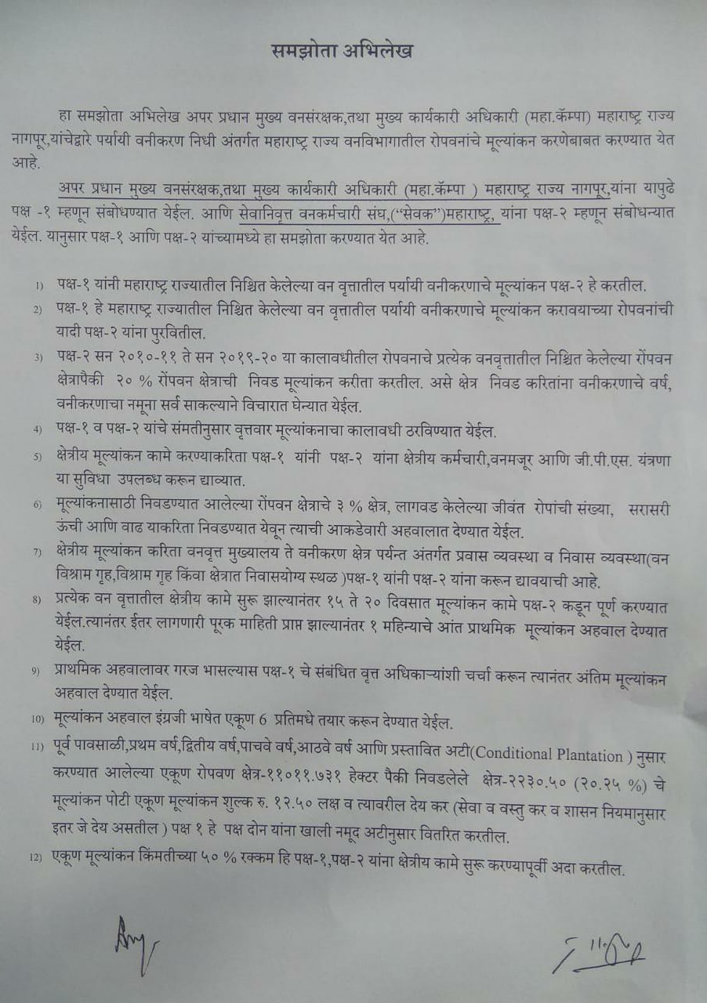
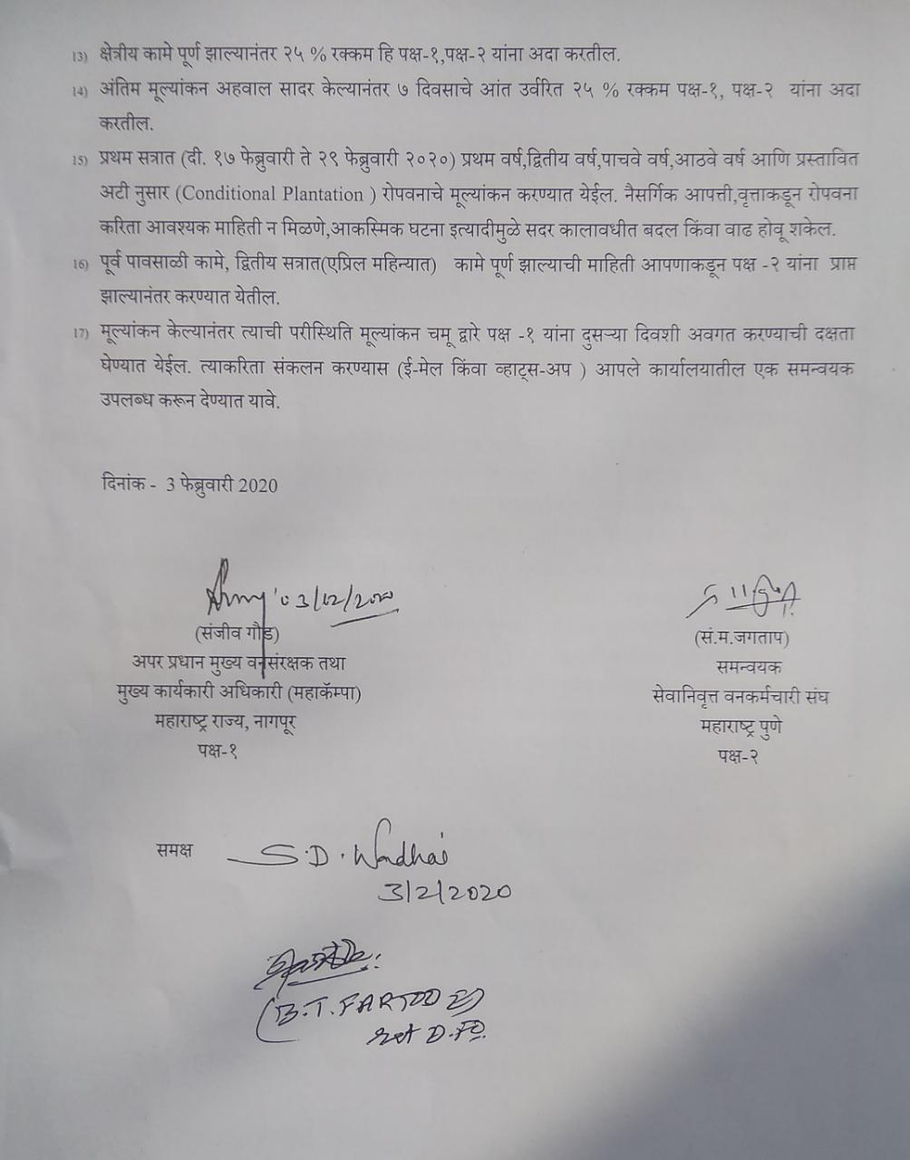

Annexure – II government of maharashtra letter

Annexure-III
Abstract of 103 Evaluated Sites

SITE WISE EVALUATION ABSTRACT
Site Number: 1
1st Year Works: Site No. 1-14

A. Description of site
Name of Site- Vishroli
Place- Survey No.323, 334
Beat- Vishroli Round- Shirajgaon
Range- Paratwada Forest Division- Amravati
Forest Circle- Amravati
Area of Treatment- Plantation: 2.530 Ha. GPS: Polygon: 2.480 Ha.
Difference- Less 0.050 Ha.
Status of Land- Reserved Forest- No Protected Forest- No
Unclassed Forest- No Received as compensatory land- Yes
Zudpi Jungle- No
Site quality- NR Density- NR Slope- Gentle
Available vegetation (Local Names)- Bor, Grasses - Petha, Ganjar Gawat
B. Plantation Details
Model - 1111 plants/ha.
Spacement- 3 × 3
Treatment Map- Yes
Soil Zone- Zone-I, Zone-II, Zone-III
Species selected for planting- Jambhul, Bamboo, Nim, Papda, Awala, Chinch

C. Survival & Status
Site suitability- NR
Suitability of species planted- Yes
Plant survival percentage- 89%
Average Height of plants- 52 cm.
Average girth of plants- < 3 cm.
General Health of Plants- Semi-healthy
Sustainability- As the plantation area is surrounded by agricultural fields, it is well protected from illicit grazing.

D. Protection-
Fencing Status- TCM - 945 Rmt.
Fire- Amount Sanctioned in the estimate- Rs. 1637.11/-
Execution of the work- Work Not Done
Expenditure/Payment of the work- Rs. 0.00/-
Grazing- Not Obseved

E. Monitoring
Inspection of Plantations- APCCF - 0, CCF - 0, DCF - 0, ACF - 0, RFO - 0
Plantation register- Up-to date
Measurement Book- Up-to date
Cash Book- Not Available
Financial audit- Done. Year - 2018-19
Fund pattern- The funds received are utilized timely.
F. Overall Rating A Grade
(Excellent – A+, Very Good – A, Good – B+, Average – B, C-Poor)
Reasons for success/ Failure- Presently successful. But for casualty replacement in the next year tall plants should be used.

G. Date of Evaluation 24 Feb 2020
Name of Evaluators Mr. S. N. Bhagat, Mr. V. B. Nimbhorkar
H. Photographs-

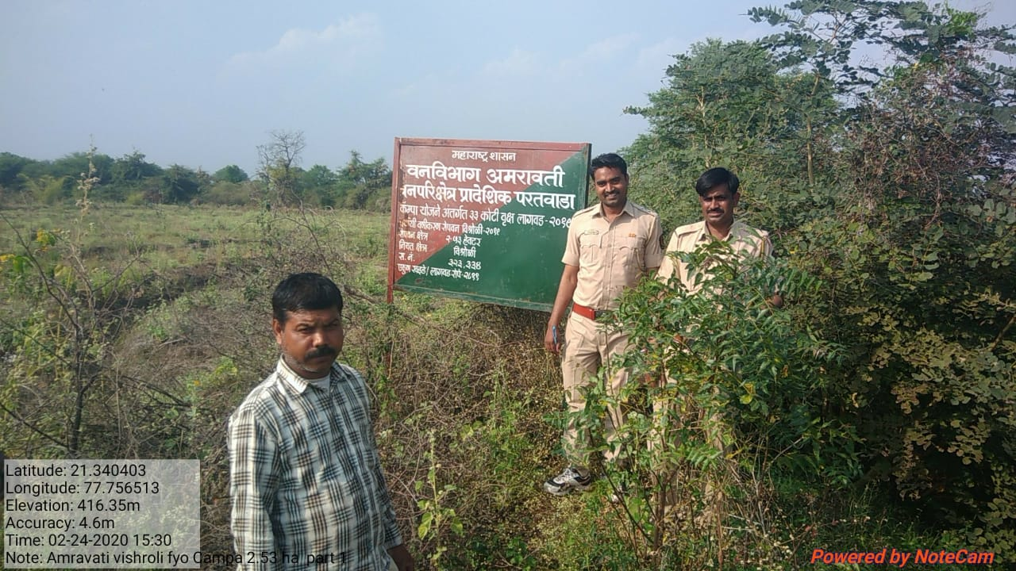

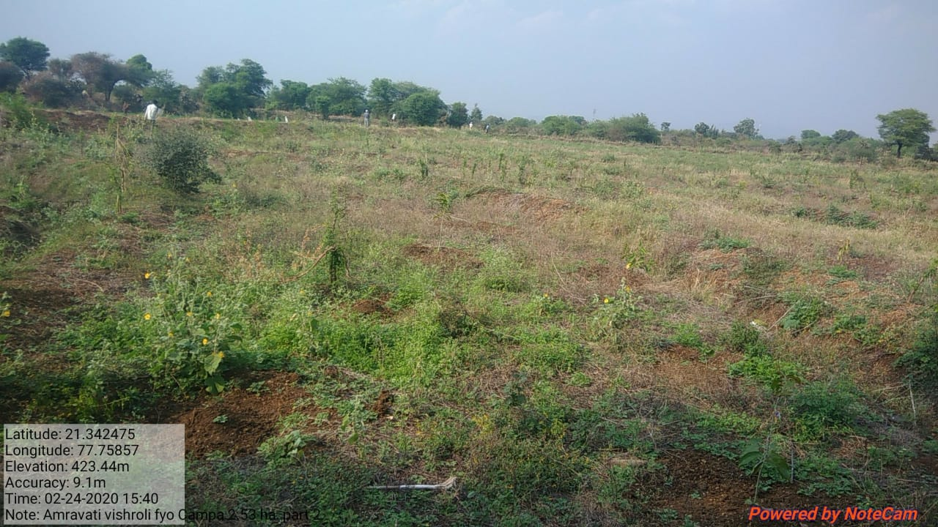
SITE WISE EVALUATION ABSTRACT
Site Number: 2
A. Description of site
Name of Site- Bramhapuri
Place- SR.NO. 139/ 849
Beat- Bramhapuri Round- Bramhapuri
Range- North Bramhapuri Forest Division- Bramhapuri
Forest Circle- Chandrapur
Area of Treatment- Plantation: 2.270 Ha. GPS:Polygon: 2.460 Ha.
Difference- Excess 0.190 Ha.
Status of Land- Reserved Forest- No Protected Forest- Yes
Unclassed Forest- No Received as compensatory land- No
Zudpi Jungle- No
Site quality- NR Density- Less than 0.2 Slope- Gente
Available vegetation (Local Names)- Bor, Kusal
B. Plantation Details
Model - 2500 plants/ha.
Spacement- 2.0 × 2.0
Treatment Map- Not as per giide lines
Soil Zone- Zone-I, Zone-II, Zone-III
Species selected for planting- Aola, Neem, Hirda, Behda, Jambhul, Kawath

C. Survival & Status
Site suitability- Soil is degraded, hard & no moisture retention capacity. Earlier it was encroached land for human habitation. Selection of medicinal plantation model with 2500 plants/Ha. on refractory soil is not justified.
Suitability of species planted- No, Soil strata is hard muroom & hardened due to pasturing of domestic animals & encroachment for houses by villagers. No moisture in soil & Medicinal plantation with 2500 plants / Ha. without watering facilities will not sustain.
Plant survival percentage- 97%
Average Height of plants- 56 cm
Average girth of plants- Less than 5 cm.
General Health of Plants- Semi-healthy
Sustainability- Will not sustain

D. Protection-
Fencing Status- Barbed Wire / Chain Link - 850 Rmt.
Fire- Amount Sanctioned in the estimate- Rs. 1468.87/-
Execution of the work- Work Not Done
Expenditure/Payment of the work- Rs. 0.00/-
Grazing- Prior plantation, area was under encroachment. Still one hut inside plantation could not be removed. ACF informed that the case is pending in court. Very panic situation.
E. Monitoring
Inspection of Plantations- APCCF - 0, CCF - 0, DCF - 0, ACF - 1, RFO - 1
Plantation register- Up-to-date
Measurement Book- Up-to-date
Cash Book- Up-to-date
Financial audit- Not Done
Fund pattern- Funds are allotted to RFO after requisition from them only.
F. Overall Rating A+ Grade
(Excellent – A+, Very Good – A, Good – B+, Average – B, C-Poor)
Reasons for success/ Failure- Target oriented approach must be discarded. Allotment of funds for site specific estimates as per direction from PCCF vide letter Dtd.1.4.2015 is essential.

G. Date of Evaluation 21 Feb 2020
Name of Evaluators Mr. S. M. Jagtap, Mr. B. T. Fartode
H. Photographs-
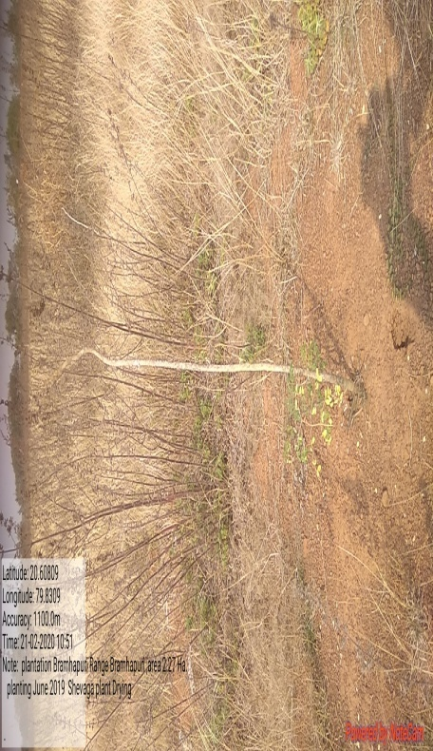

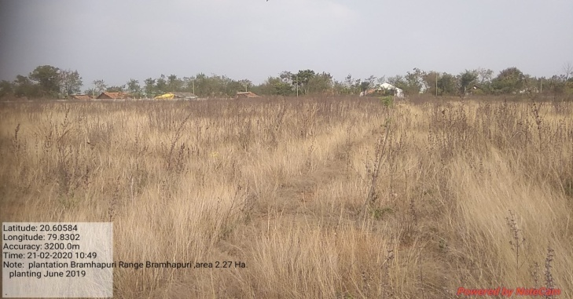
Hard muroom soil,earlier encroached area,selected for Medicinal species plantation
Planted species covered by grass

SITE WISE EVALUATION ABSTRACT
Site Number: 3

A. Description of site1
Name of Site- Hatti BK
Place- Component No- 352-353
Beat- Hatti BK Round- Mhasale
Range- Sakri Forest Division- Dhule
Forest Circle- Dhule
Area of Treatment- Plantation: 6.500 Ha. GPS:polygon: 15.000 Ha.
Difference- Excess 8.500 Ha.
Status of Land- Reserved Forest- Yes Protected Forest- No
Unclassed Forest- No Received as compensatory land- No
Zudpi Jungle- No
Site quality- V1 - Normal Density- 0.3 RF Slope- Moderate (10 to 25 degrees)
Available vegetation (Local Names)- Shruby forest of kansan, Babhul, Bor, Hivar, Prosopis, Ghaneri, Grasses - Kusal
B. Plantation Details
Model - 1600 plants/ha.
Spacement- 2.5 × 2.5
Treatment Map- Yes
Soil Zone- Zone-I, Zone-II
Species selected for planting- Neem, Kawath, Sissoo, Khair, Aawala, Chinch, Bamboo

C. Survival & Status
Site suitability- Suitable
Suitability of species planted- Partly. No Bamboo is not suitable for this location
Plant survival percentage- 90%
Average Height of plants- 45 cm
Average girth of plants- 4 cm
General Health of Plants- Healthy
Sustainability- It will be sustainable provided it is protected from biotic pressures.

D. Protection-
Fencing Status- TCM - 710 Rmt.
Fire- Amount Sanctioned in the estimate- Rs. Sanctioned estimate/-
Execution of the work- Work Not Done
Expenditure/Payment of the work- Rs. 0.00/-
Grazing- No

E. Monitoring
Inspection of Plantations- APCCF - 0, CCF - 0, DCF - 0, ACF - 0, RFO - 0
Plantation register- Incomplete
Measurement Book- Up-to-date
Cash Book- Not available due to audit by CA
Financial audit- Not Done
Fund pattern- Funding to carryout the plantation operations is main the motivating factor to staff in the field
F. Overall Rating A+ Grade
(Excellent – A+, Very Good – A, Good – B+, Average – B, C-Poor)
Reasons for success/ Failure- Chainlink fencing is recommended.

G. Date of Evaluation 17 Feb 2020
Name of Evaluators Mr. S. K. Gawali, Mr. B. R. Challare
H. Photographs-

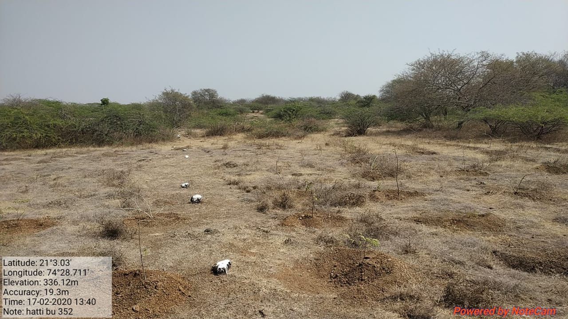
SITE WISE EVALUATION ABSTRACT
Site Number: 4

A. Description of site
Name of Site- Sakhara
Place- Comptt. No.4B
Beat- Sakhara Round- Porla
Range- Porla Forest Forest Division- Wadsa
Forest Circle- Gadchiroli
Area of Treatment- Plantation: 25.000 Ha GPS: polygon: 32.400 Ha.
Difference- Excess 7.400 Ha.
Status of Land- Reserved Forest- Yes Protected Forest- No
Unclassed Forest- No Received as compensatory land- No
Zudpi Jungle- No
Site quality- IVB Density- Less than 0.4, Slope- Gentle
Available vegetation (Local Names)- Khair, Neem, Moha, Garadi, Ain, Bhirra, Bel, Hirda, Arjun, Semal, Tendu, Shindi, Bor, Amaltas, Ritha, Shisam, Sisoo, Salai, Garadi, Rohan, Tendu, Ukshi, Chiman Chara, Kusal
B. Plantation Details
Model - 1111 plants/ha.
Spacement- 3 × 3
Treatment Map- Yes
Soil Zone- Zone-II, Zone-III
Species selected for planting- Khair, Holoptelia integrefolia, Albizia, Embelica oficinalis, Neem,Tamarindus,Sisoo, Pongamia pinnata, T.belerica,Arjun, Bamboo, Cassia fistula, Sapindus, Delbergia latifolia

C. Survival & Status
Site suitability- Suitable
Suitability of species planted- Yes
Plant survival percentage- 92%
Average Height of plants- 83 cm
Average girth of plants- 4.5 cm
General Health of Plants- Healthy
Sustainability- Hardy species & very good protection & physical works. Sustain

D. Protection-
Fencing Status- Barbed Wire / Chain Link - 2 × 295 × 50 Rmt.
Fire- Amount Sanctioned in the estimate- Rs. 18038.50/-
Execution of the work- Work Not Done
Expenditure/Payment of the work- Rs. 0.00/-
Grazing- No

E. Monitoring
Inspection of Plantations- APCCF - 0, CCF - 0, DCF - 0, ACF - 1, RFO - 9
Plantation register- Up-to date
Measurement Book- Up-to-date
Cash Book- Up-to-date
Financial audit- Not Done
Fund pattern- Funds are allotted to RFO after requisition from them only.
F. Overall Rating A+ Grade
(Excellent – A+, Very Good – A, Good – B+, Average – B, C-Poor)
Reasons for success/ Failure- Good quality of physical works. Selection of indegeneous species. 18 months old plants used for planting. Best protection.Timely operations.

G. Date of Evaluation 19 Feb 2020
Name of Evaluators Mr. S. M. Jagtap, Mr. B. T. Fartode
H. Photographs-
Healthy Plants
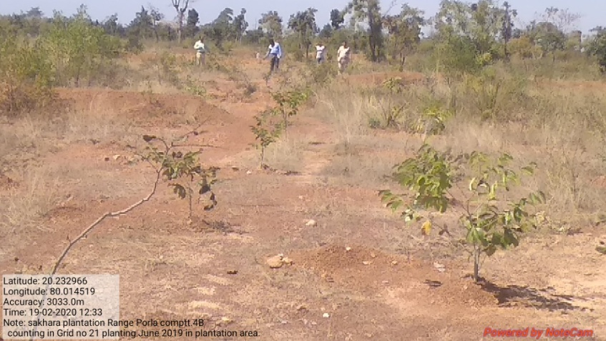

SITE WISE EVALUATION ABSTRACT
Site Number: 5

A. Description of site
Name of Site- Armori (Sukala)
Place- 712
Beat- Sukala Round- Vairagad
Range- Armori Forest Division- Wadsa
Forest Circle- Gadchiroli
Area of Treatment- Plantation: 25.000 Ha. GPS: Polygon: 36.500 Ha.
Difference- Excess 11.50 Ha.
Status of Land- Reserved Forest- Yes Protected Forest- No
Unclassed Forest- No Received as compensatory land- No
Zudpi Jungle- No
Site quality- IV Density- Less than 0.4 Slope- Gentle
Available vegetation (Local Names)- Khair, Neem, Moha, Bija ,Ain , ,Bel, Arjun, Tendu, , Bor, Garadi, , Tenndu, Ukshi, Chiman Chara, Kusal, Amarvel
B. Plantation Details
Model - 1111 plants/ha.
Spacement- 3 × 3
Treatment Map- Yes
Soil Zone- Zone-III
Species selected for planting- Khair, Albizia, Embelica oficinalis, Neem,Tamarindus, Sisoo, Arjun, Maligna arborea, Eagle marmelos, Bija

C. Survival & Status
Site suitability- Suitable
Suitability of species planted- Yes
Plant survival percentage- 94%
Average Height of plants- 100 cm
Average girth of plants- < 5.0 cm
General Health of Plants- Healthy
Sustainability- Hardy species & very good protection & physical works. Sustain

D. Protection-
Fencing Status- Barbed Wire / Chain Link - 2700 Rmt.
Fire- Amount Sanctioned in the estimate- Rs. 18038.50/-
Execution of the work- Work Not Done
Expenditure/Payment of the work- Rs. 0.00/-
Grazing- No

E. Monitoring
Inspection of Plantations- APCCF - 0, CCF - 0, DCF - 1, ACF - 2, RFO - 0
Plantation register- Up-to date
Measurement Book- Up-to date
Cash Book- Up-to date
Financial audit- Not Done
Fund pattern- Funds are allotted to RFO after requisition from them only.
F. Overall Rating A+ Grade
(Excellent – A+, Very Good – A, Good – B+, Average – B, C-Poor)
Reasons for success/ Failure- Good quality of physical works. Selection of indegeneous species. Sturdy plants used for planting. Best protection.Timely operations
G. Date of Evaluation 19 Feb 2020
Name of Evaluators Mr. S. M. Jagtap, Mr. B. T. Fartode
H. Photographs-
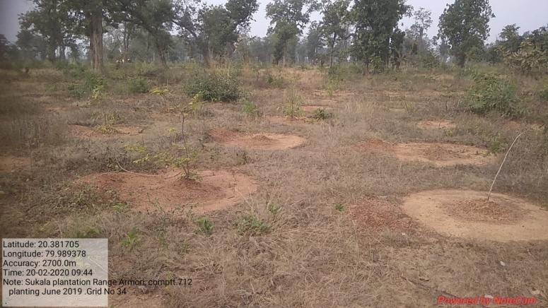
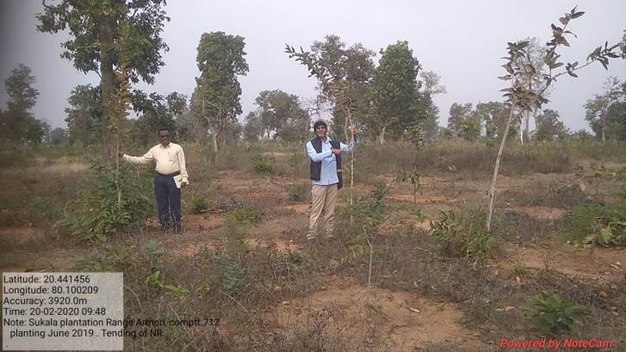
Nice Tending to NR
SITE WISE EVALUATION ABSTRACT
Site Number: 6

A. Description of site
Name of Site- Sasegaon
Place- Sr.No.47 (Comp.382)
Beat- Kolarmet Round- Makardhohada
Range- North Umred Forest Division- Nagpur
Forest Circle- Nagpur
Area of Treatment- Plantation: 3.416 Ha. GPS: Polygon: 4.087 Ha.
Difference- Excess 0.671 Ha.
Status of Land- Reserved Forest- No Protected Forest- Yes
Unclassed Forest- No Received as compensatory land- No
Zudpi Jungle- No
Site quality- Normal Density- 0.1 Slope- Gentle
Available vegetation (Local Names)- Degraded Sites
B. Plantation Details
Model - 1111 plants/ha.
Spacement- 3 × 3
Treatment Map- Yes.(Grid map is available)
Soil Zone- Zonation not done
Species selected for planting- Teak, Aola, Bamboo, Tendu, Khair, Behada, Kavath

C. Survival & Status
Site suitability- Suitable
Suitability of species planted- Species Ritha, Umber, Kawath, Chinch, Arjun are not suitable for this area.
Plant survival percentage- 74%
Average Height of plants- 35 cm
Average girth of plants-
General Health of Plants- Healthy
Sustainability- Unsustainable

D. Protection-
Fencing Status- No
Fire- Amount Sanctioned in the estimate- Rs. 2333.33/-
Execution of the work- Work Not Done
Expenditure/Payment of the work- Rs. 0.00/-
Grazing- Not recorded

E. Monitoring
Inspection of Plantations- APCCF - 0, CCF - 0, DCF - 0, ACF - 4, RFO - 3
Plantation register- Up-to date
Measurement Book- Up-to date
Cash Book- Up-to date
Financial audit- Done. Year 2018-19
Fund pattern- Some times funds are received late.
F. Overall Rating A Grade
(Excellent – A+, Very Good – A, Good – B+, Average – B, C-Poor)
Reasons for success/ Failure- Present success is just due to survival. But 60 % species are not suitable & may not sustain. More wildlife damage.

G. Date of Evaluation 21 Feb 2020
Name of Evaluators Mr. V. S. Bhonsle
H. Photographs-
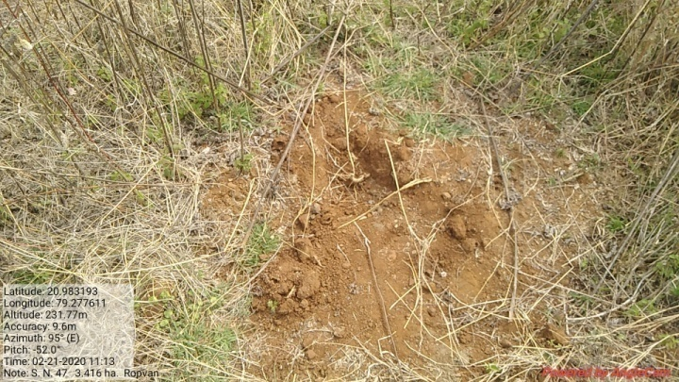
Wild boar damage
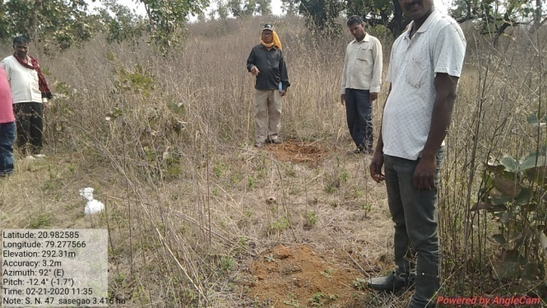
SITE WISE EVALUATION ABSTRACT
Site Number: 7

A. Description of site
Name of Site- Kolarmal (Salai)
Place- Survey No.227 (Mouje Salai)
Beat- Kolarmet Round- Makardhohada
Range- North Umred Forest Division- Nagpur
Forest Circle- Nagpur
Area of Treatment- Plantation: 25.000 Ha. GPS: Polygon: 26.140 Ha.
Difference- Excess 3.400 Ha.
Status of Land- Reserved Forest- No Protected Forest- No
Unclassed Forest- No Received as compensatory land- No
Zudpi Jungle- Yes
Site quality- Normal Density- Open 0 density Slope- Gentle
Available vegetation (Local Names)- Degraded Sites
B. Plantation Details
Model - 1111 plants/ha.
Spacement- 3 × 3
Treatment Map- Yes
Soil Zone- Zonation not done
Species selected for planting- Jambhul, Teak, Chinch, Bamboo, Amaltash, Bel, Moha, Sitafal, Ain, Anjan, Behada, Khair, Neem, Umbar

C. Survival & Status
Site suitability- Suitable
Suitability of species planted- Yes
Plant survival percentage- 86%
Average Height of plants- 46 cm
Average girth of plants-
General Health of Plants- Healthy
Sustainability- It will sustain if monitor properly in future.

D. Protection-
Fencing Status- TCM - 2 × 2 Rmt.
Fire- Amount Sanctioned in the estimate- Rs. 17076.50/-
Execution of the work- Work Not Done
Expenditure/Payment of the work- Rs. 0.00/-
Grazing- Not observed

E. Monitoring
Inspection of Plantations- APCCF - 0, CCF - 0, DCF - 0, ACF - 4, RFO - 3
Plantation register- Up-to date
Measurement Book- MB not produced
Cash Book- Up-to date
Financial audit- Done. Year 2018-19
Fund pattern- Due to some technical problem, funds are not received timely as complained by labours.
F. Overall Rating A Grade
(Excellent – A+, Very Good – A, Good – B+, Average – B, C-Poor)
Reasons for success/ Failure- 1) Watering the plants is recommended. 2) Instead of TCM, chainlink fencing is recommended for better success.

G. Date of Evaluation 20 Feb 2020
Name of Evaluators Mr. V. S. Bhonsle
H. Photographs-

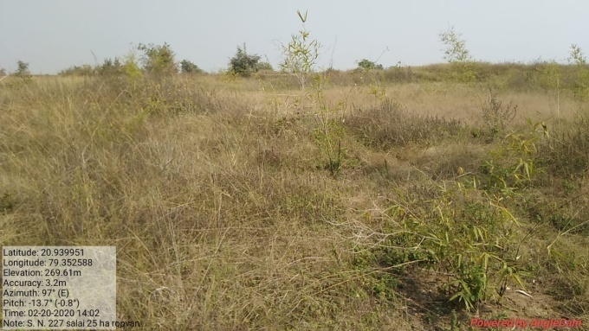
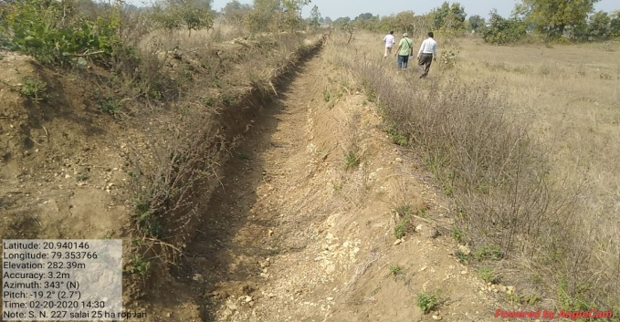
New size of TCM -1Mt.x1Mt.x1Mt.
SITE WISE EVALUATION ABSTRACT
Site Number: 8

A. Description of site
Name of Site- Waghapur
Place- Gat No- 264/1
Beat- Pisewadi Round- Lingdev
Range- Akole(T) Forest Division- Sangamner
Forest Circle- Nashik
Area of Treatment- Plantation: 7.000 Ha. GPS: Polygon: 10.540 Ha.
Difference- Excess 3.540 Ha.
Status of Land- Reserved Forest- No Protected Forest- No
Unclassed Forest- Yes Received as compensatory land- No
Zudpi Jungle- No
Site quality- V Density- less than 0.1 Slope- Moderate (10 to 25 degrees)
Available vegetation (Local Names)- Babhul, Hivar, Grasses-Kusali,Tikandi, Maevel, Lalginda, Pawany
B. Plantation Details
Model - 1111 plants/ha.
Spacement- 3 × 3
Treatment Map- Yes
Soil Zone- Zone-I, Zone-II, Zone-III
Species selected for planting- Wad, Pimpal, Neem, Kanchan, Wavala, Awala, Karanj, Jambhul, Kawath, Chinch, Bhokar

C. Survival & Status
Site suitability- Suitable
Suitability of species planted- Yes
Plant survival percentage- 88%
Average Height of plants- 80 cm
Average girth of plants- 5 cm
General Health of Plants- Healthy
Sustainability- Will be sustainable provided it remains protected.

D. Protection-
Fencing Status- Live Hedge - 378 Rmt.
Fire- Amount Sanctioned in the estimate- Rs. 71723.40/-
Execution of the work- Work Done
Expenditure/Payment of the work- Rs. 73735.00/-
Grazing- No

E. Monitoring
Inspection of Plantations- APCCF - 0, CCF - 0, DCF - 0, ACF - 1, RFO - 3
Plantation register- UP-to-date
Measurement Book- Up-to-date
Cash Book- Incomplete Not made available
Financial audit- Done. Year 2019-20
Fund pattern- The RFO i/c informed that, works like SMC , TCM etc were not carried out for want of funds from superiors.
F. Overall Rating A+ Grade
(Excellent – A+, Very Good – A, Good – B+, Average – B, C-Poor)
Reasons for success/ Failure- 1) Timely realease of funds is recommended.

G. Date of Evaluation 24 Feb 2020
Name of Evaluators Mr. S. K. Gawali, Mr. B. R. Challare
H. Photographs-
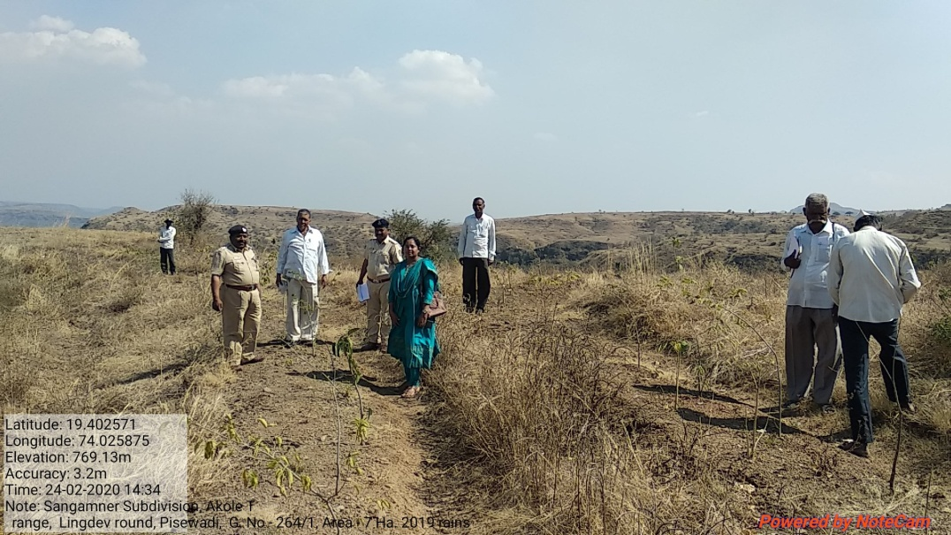
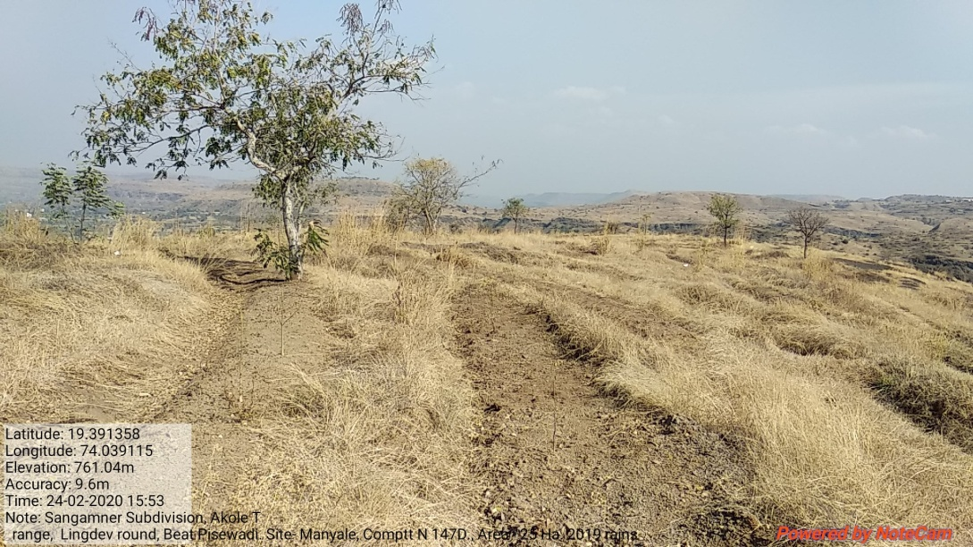
SITE WISE EVALUATION ABSTRACT
Site Number: 9

A. Description of site
Name of Site- Ghargaon
Place- 187
Beat- Ghargaon Round- Ghargaon
Range- Sangamner-1 Forest Division- Sangamner
Forest Circle- Nashik
Area of Treatment- Plantation: 10.000 Ha. GPS: Polygon: 26.000 Ha.
Difference- Excess 17.000 Ha.
Status of Land- Reserved Forest- Yes Protected Forest- No
Unclassed Forest- No Received as compensatory land- No
Zudpi Jungle- No
Site quality- VI Density- 0.1 RF Slope- Moderate (10 to 25 degrees)
Available vegetation (Local Names)- Subabhul, Nilgiri, Neem, Bor, Babhul, Khair, Ajan, Maharukh, Hivar, Grass- Dongari, Kalikusal, Tikand, Herb, Godhadi, Sheda
B. Plantation Details
Model - 1111 plants/ha.
Spacement- 3 × 3
Treatment Map- Yes
Soil Zone- Zone-I, Zone-II, Zone-III
Species selected for planting- Awala, Neem, Sissoo, Chinch, Umbar, Sitafal, Apta, Wavala(Papadi) Pimple, Kanchan, Khair

C. Survival & Status
Site suitability- Suitable
Suitability of species planted- Yes Partly. Umbar and Pimpal are not suitable
Plant survival percentage- 100%
Average Height of plants- 54 cm
Average girth of plants- 4.5 cm
General Health of Plants- Semi-healthy
Sustainability- Sustainable due to good local support and good public relations.

D. Protection-
Fencing Status- Live Hedge - 1020 Rmt.
Fire- Amount Sanctioned in the estimate- Rs. 102462.00/-
Execution of the work- Work Done
Expenditure/Payment of the work- Rs. 102462.00/-
Grazing- No

E. Monitoring
Inspection of Plantations- APCCF - 0, CCF - 1, DCF - 0, ACF - 2, RFO - 2
Plantation register- UP-to-date
Measurement Book- Up-to-date
Cash Book- Sent to pune for audit
Financial audit- Not Done
Fund pattern- Irregular funding pattern , no funds received for last 11 months
F. Overall Rating A+ Grade
(Excellent – A+, Very Good – A, Good – B+, Average – B, C-Poor)
Reasons for success/ Failure- 1)To increase tree cover in this murumy and rocky site Glyrecidia may be planted as coloniser and soil improver. 2) The concept of grass /fodder bank be introduced to strengthen benefits forest ecosystem services.

G. Date of Evaluation 23 Feb 2020
Name of Evaluators Mr. S. K. Gawali, Mr. B. R. Challare
H. Photographs-
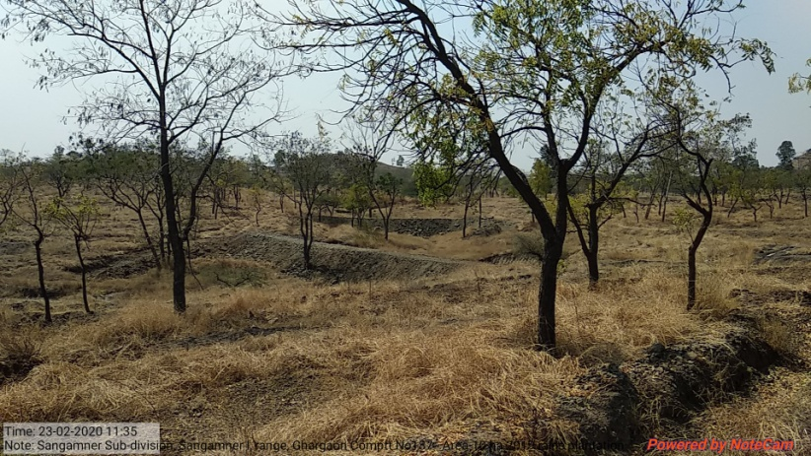
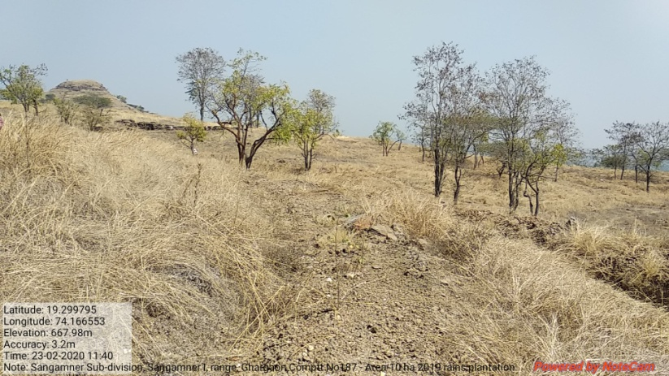

SITE WISE EVALUATION ABSTRACT
Site Number: 10

A. Description of site
Name of Site- Manyale
Place- Compartment No:147-D
Beat- Pisewadi Round- Lingdev
Range- Akole(T) Forest Division- Sangamner
Forest Circle- Nashik
Area of Treatment- Plantation: 25.000 Ha. GPS: Polygon: 38.000 Ha.
Difference- Excess 13.000 Ha.
Status of Land- Reserved Forest- Yes Protected Forest- No
Unclassed Forest- No Received as compensatory land- No
Zudpi Jungle- No
Site quality- V Density- less than 0.1 Slope- Moderate (10 to 25 degrees)
Available vegetation (Local Names)- Neem, Babhul, Nilgiri Teak, Hivar, Kashid, Anjan, Wasansad, Grass- Kusali, Sheda, Pawahy, Surud, Tikand
B. Plantation Details
Model - 1111 plants/ha.
Spacement- 3 × 3
Treatment Map- Yes
Soil Zone- Zone-I, Zone-II, Zone-III
Species selected for planting- Karanj, Wad, Wavala, Kavath, Pimpal, Sissoo, Neem

C. Survival & Status
Site suitability- Suitable
Suitability of species planted- Yes.
Plant survival percentage- 75%
Average Height of plants- 100 cm
Average girth of plants- 6 cm
General Health of Plants- Healthy
Sustainability- Will be sustainable only if provied with chain link fencing is provided.

D. Protection-
Fencing Status- Live Hedge - 1350 Rmt.
Fire- Amount Sanctioned in the estimate- Rs. 256155.00/-
Execution of the work- Work Done
Expenditure/Payment of the work- Rs. 102462.00/-
Grazing- No

E. Monitoring
Inspection of Plantations- APCCF - 0, CCF - 0, DCF - 0, ACF - 3, RFO - 3
Plantation register- UP-to-date
Measurement Book- Up-to-date
Cash Book- Up-to-date
Financial audit- Done. Year 2019-20
Fund pattern- for PPO/PYO there was shortage of funds and for FYO,there are no funds made available
F. Overall Rating A+ Grade
(Excellent – A+, Very Good – A, Good – B+, Average – B, C-Poor)
Reasons for success/ Failure- Chain link fencing is recommended.

G. Date of Evaluation 24 Feb 2020
Name of Evaluators Mr. S. K. Gawali, Mr. B. R. Challare
H. Photographs-
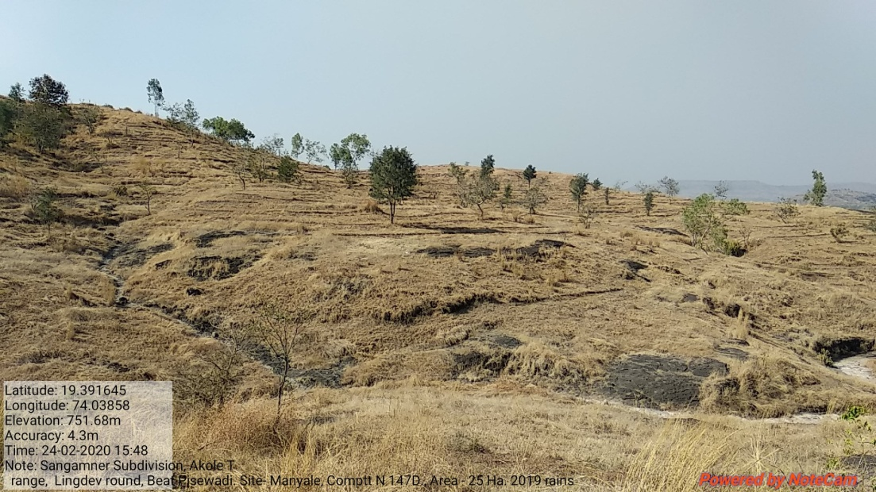
SITE WISE EVALUATION ABSTRACT
Site Number: 11

A. Description of site
Name of Site- Sawarchol
Place- Compartment No:90-B
Beat- Sarwarchol Round- Pemgiri
Range- Sangamner I Forest Division- Sangamner
Forest Circle- Nashik
Area of Treatment- Plantation: 8.000 Ha. GPS: Polygon: 25.000 Ha.
Difference- Excess 17.000 Ha.
Status of Land- Reserved Forest- Yes Protected Forest- No
Unclassed Forest- No Received as compensatory land- No
Zudpi Jungle- No
Site quality- V Density- less than 0.1 Slope- Heavy
Available vegetation (Local Names)- Babhul, Neem, Khair, kashid, Glytecidia, Sitafal, Cantana, Karwad, Gross-Kusali, Pawanya, Suard, Kali Kusal
B. Plantation Details
Model - 1111 plants/ha.
Spacement- 3 × 3
Treatment Map- Yes
Soil Zone- Zone-III
Species selected for planting- Neem, Bor, Kanchan, Chinch, Sitafal, Wad, Umbar, Papadi(Wavala), Sissoo

C. Survival & Status
Site suitability- Suitable
Suitability of species planted- Yes
Plant survival percentage- 96%
Average Height of plants- 58 cm
Average girth of plants- 5 cm
General Health of Plants- Healthy
Sustainability- Sustainable due to good protection.

D. Protection-
Fencing Status- TCM - 834 Rmt.
Fire- Amount Sanctioned in the estimate- Rs. 81970.00/-
Execution of the work- Work Done
Expenditure/Payment of the work- Rs. 81970.00/-
Grazing- No

E. Monitoring
Inspection of Plantations- APCCF - 0, CCF - 0, DCF - 0, ACF - 2, RFO - 1
Plantation register- UP-to-date
Measurement Book- Up-to-date
Cash Book- Up-to-date
Financial audit- Done. Year 2019-20
Fund pattern- No funding so for FYO
F. Overall Rating A+ Grade
(Excellent – A+, Very Good – A, Good – B+, Average – B, C-Poor)
Reasons for success/ Failure- Chainlink fencing is recommended as area is very close to village.

G. Date of Evaluation 23 Feb 2020
Name of Evaluators Mr. S. K. Gawali, Mr. B. R. Challare
H. Photographs-
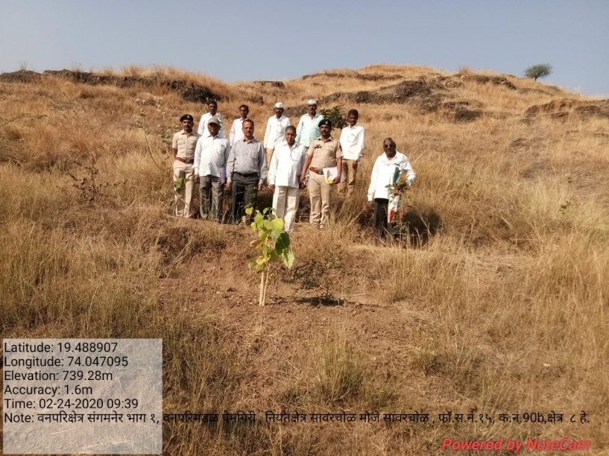
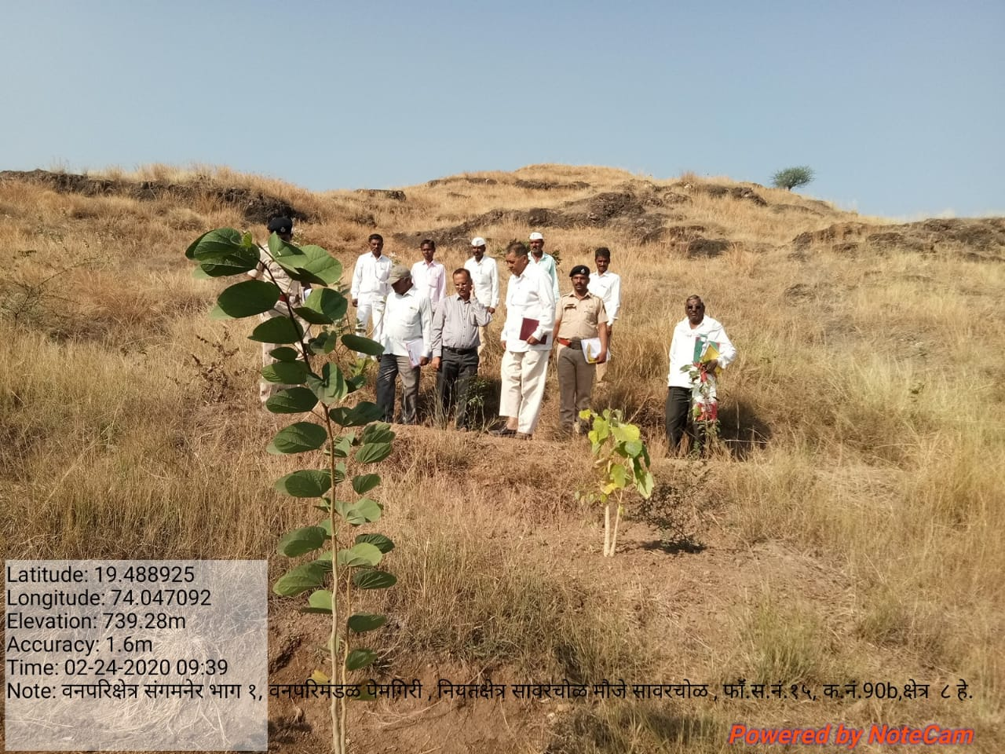
SITE WISE EVALUATION ABSTRACT
Site Number: 12

A. Description of site
Name of Site- Bori Pardhi (Dhaigudewadi)
Place- 464
Beat- Varvand Round- Varvand
Range- Daund Forest Division- Pune
Forest Circle- Pune
Area of Treatment- Plantation: 1.000 Ha. GPS: Polygon: 1.000 Ha
Difference- No change
Status of Land- Reserved Forest- Yes Protected Forest- No
Unclassed Forest- No Received as compensatory land- No
Zudpi Jungle- No
Site quality- Degraded land Density- Less than 0.4 Slope- Gentle
Available vegetation (Local Names)- Tree, Grass
B. Plantation Details
Model - 625 plants/ha.
Spacement- 4 × 4
Treatment Map- No
Soil Zone- Zone-I, Zone-II
Species selected for planting- Wad, Peepal, Sirsoo, Bhindi, Neem, Kanchan etc.

C. Survival & Status
Site suitability- Suitable
Suitability of species planted- Yes
Plant survival percentage- 91%
Average Height of plants- 93 cm
Average girth of plants-
General Health of Plants- Healthy
Sustainability- Too early to predict

D. Protection-
Fencing Status- No
Fire- Amount Sanctioned in the estimate- Rs. Nil/-
Execution of the work- Work Not Done
Expenditure/Payment of the work- Rs. 0.00/-
Grazing- No

E. Monitoring
Inspection of Plantations- APCCF - 0, CCF - 0, DCF - 0, ACF - 0, RFO - 0
Plantation register- Up-to date
Measurement Book- Up-to date
Cash Book- Up-to date
Financial audit- Not Done
Fund pattern- Funds not received for FYO operations.
F. Overall Rating A+ Grade
(Excellent – A+, Very Good – A, Good – B+, Average – B, C-Poor)
Reasons for success/ Failure- Since area is small so no comment

G. Date of Evaluation 17 Feb 2020
Name of Evaluators Mr. G. P. Garad, Mr. R. K. Adkar
H. Photographs-
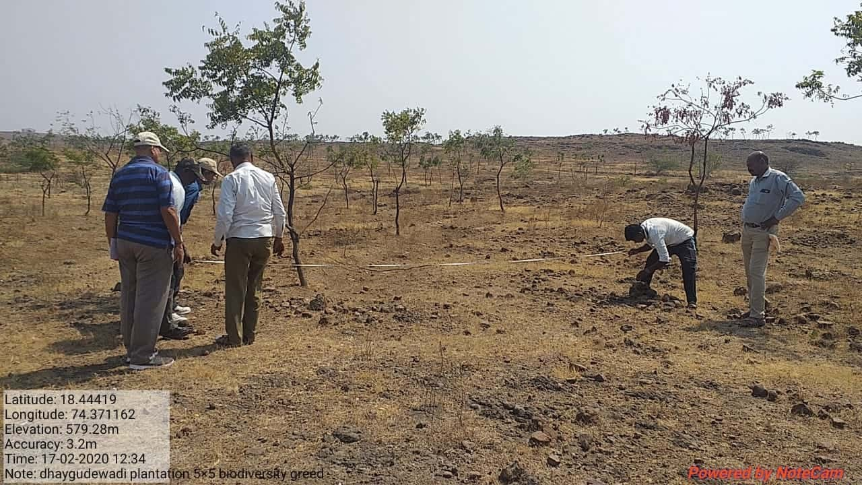
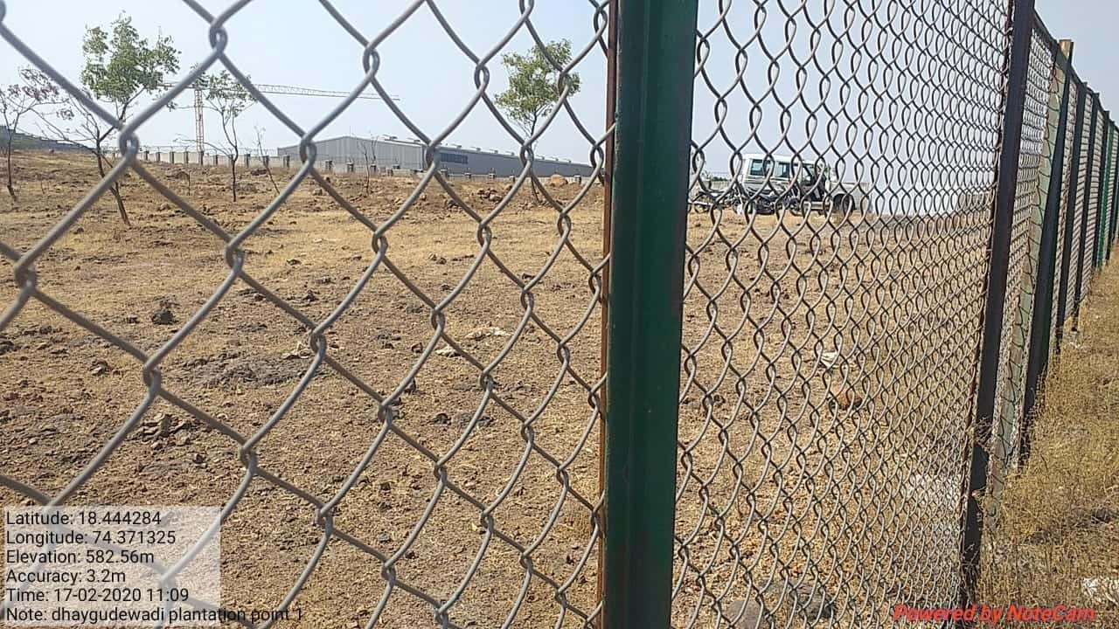

SITE WISE EVALUATION ABSTRACT
Site Number: 13

A. Description of site
Name of Site- Varande
Place- Gat No.155
Beat- Choul Round- Nagaon
Range- Alibaug Forest Division- Alibaug
Forest Circle- Thane
Area of Treatment- Plantation: 21.160 Ha. GPS: Polygon: 21.160 Ha.
Difference- No change
Status of Land- Reserved Forest- No Protected Forest- No
Unclassed Forest- No Received as compensatory land- Yes
Zudpi Jungle- No
Site quality- NA Density- NA Slope- Gentle / Moderate
Available vegetation (Local Names)- Trees, Grass
B. Plantation Details
Model - 625 plants/ha.
Spacement- 4 × 4
Treatment Map- Yes
Soil Zone- Zone-II, Zone-III
Species selected for planting- Aola, Jamun, Khair, Karanj, Chinch, Kaju, Sisoo, Teak, Bohwa, Apta, Hirda, Bor, Bamboo, Umber etc.

C. Survival & Status
Site suitability- Suitable
Suitability of species planted- Yes
Plant survival percentage- 99%
Average Height of plants- 74 cm
Average girth of plants-
General Health of Plants- Healthy
Sustainability- As is gochar land there was rift bet. Dept. & people but now tension is eased out.

D. Protection-
Fencing Status- Barbed Wire / Chain Link - 5 × 500 Rmt.
Fire- Amount Sanctioned in the estimate- Rs. 14456.00/-
Execution of the work- Work Done
Expenditure/Payment of the work- Rs. 14456.00/-
Grazing- Not seen

E. Monitoring
Inspection of Plantations- APCCF - 0, CCF - 0, DCF - 1, ACF - 2, RFO - 0
Plantation register- Up-to date
Measurement Book- Up-to date
Cash Book- Up-to date
Financial audit- Not Done
Fund pattern- Whatever funds received spent in time but fund flow is not regular as Rs.12 × 237/- payment is pending
F. Overall Rating A+ Grade
(Excellent – A+, Very Good – A, Good – B+, Average – B, C-Poor)
Reasons for success/ Failure- It is gochar land needs support of local people. Such lands should not be accepted for CA, programs as there is always rift as people loose their right of grazing

G. Date of Evaluation 25 Feb 2020
Name of Evaluators Mr. G. P. Garad
H. Photographs-
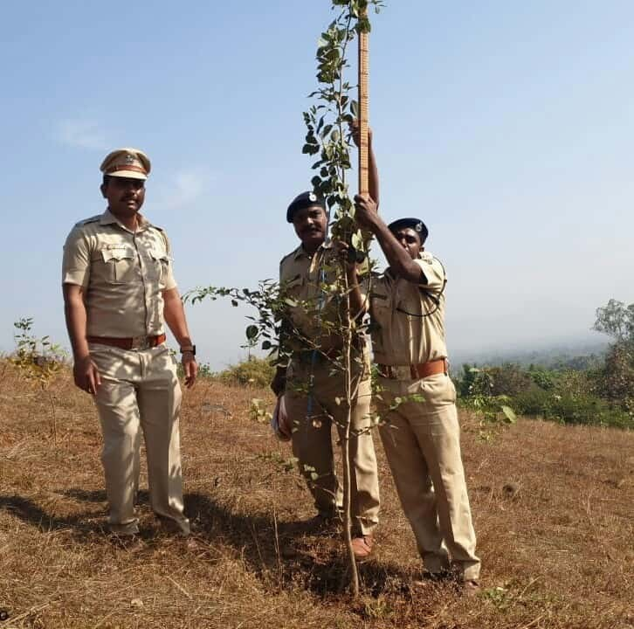
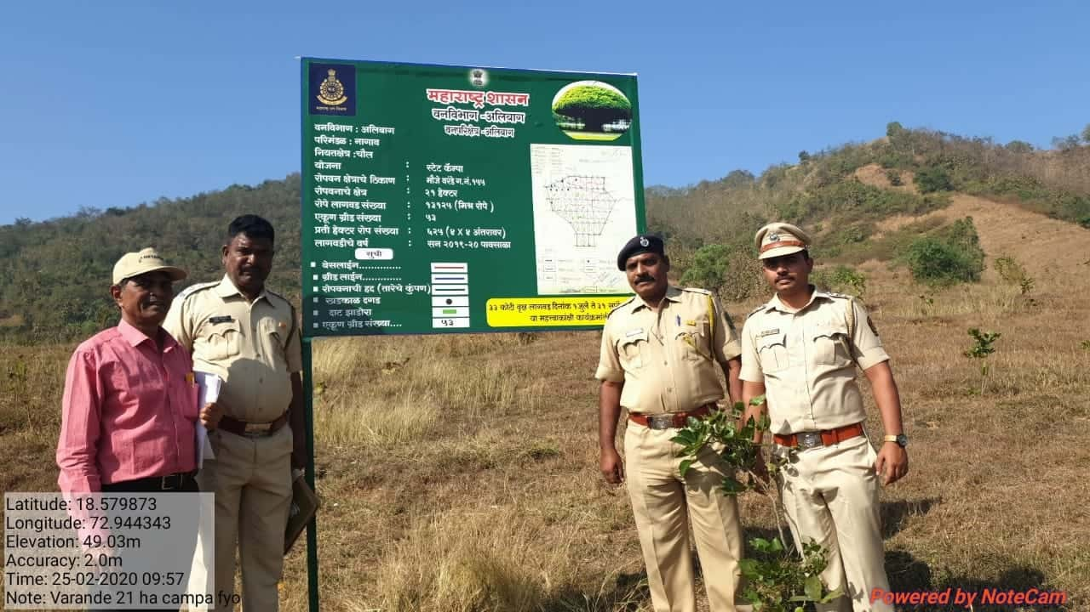

SITE WISE EVALUATION ABSTRACT
Site Number: 14

A. Description of site
Name of Site- Jaipur Dhilli
Place- Gat No. 3
Beat- Shirputi Round- Washim
Range- Washim Forest Division- Washim
Forest Circle- Yawatmal
Area of Treatment- Plantation: 24.420 Ha. GPS: Polygon: 24.420 Ha.
Difference- No change
Status of Land- Reserved Forest- No Protected Forest- No
Unclassed Forest- No Received as compensatory land- Yes
Zudpi Jungle- No
Site quality- Density- Less than 0.1 Slope- Gentle
Available vegetation (Local Names)- Trees Teak, Palas, Pimple, Neem. / Shrubs Chilati, Barhati. / Grass Marvel
B. Plantation Details
Model - 1111 plants/ha.
Spacement- 3 × 3
Treatment Map- Yes
Soil Zone- Zone-III
Species selected for planting- Teak, Karanj, Neem, Awala, Chinch

C. Survival & Status
Site suitability- Suitable
Suitability of species planted- Yes
Plant survival percentage- 94%
Average Height of plants- 38 cm
Average girth of plants-
General Health of Plants- Healthy
Sustainability- Peinganga river is far nearer to plantation, andthere is water provision in estimate- If this fund utilized better way for lift the water directly through river , water problem can be solve permanently which result in improving the growth of the plants

D. Protection-
Fencing Status- No
Fire- Amount Sanctioned in the estimate- Rs. 16680.00/-
Execution of the work- Work Done
Expenditure/Payment of the work- Rs. 16680.00/-
Grazing- No grazing

E. Monitoring
Inspection of Plantations- APCCF - 0, CCF - 0, DCF - 0, ACF - 1, RFO - 1
Plantation register- Up-to date
Measurement Book- Up-to date
Cash Book- Up-to date
Financial audit- Not Done
Fund pattern- In first year funds available in time but this year funds are received yet
F. Overall Rating A Grade
(Excellent – A+, Very Good – A, Good – B+, Average – B, C-Poor)
Reasons for success/ Failure- Painganga river is far nearer to the plantation, and there is water provision in estimate. If this fund could have been utilized better way to lift the water directly through river, water problem can be solved permanently which result in improving the g

G. Date of Evaluation 21 Feb 2020
Name of Evaluators Mr. U. M. Dhopeshwarkar, Mr. R. T. More
H. Photographs-
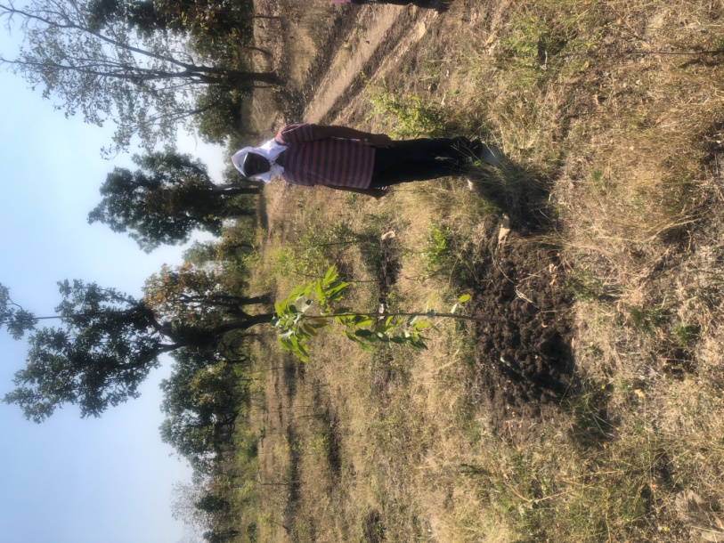
SITE WISE EVALUATION ABSTRACT
2nd Year Works: Site No. 15-32
Site Number: 15

A. Description of site
Name of Site- Mazod
Place- Gat No.304
Beat- Loni Round- Akola
Range- Akola Forest Division- Akola
Forest Circle- Amravati
Area of Treatment- Plantation: 9.670 Ha. GPS: Polygon: 7.659 Ha.
Difference- Less 2.010 Ha.
Status of Land- Reserved Forest- No Protected Forest- No
Unclassed Forest- No Received as compensatory land- Yes
Zudpi Jungle- No
Site quality- NR Density- NR Slope- Gentle
Available vegetation (Local Names)- Pawnya, marvel, kunda pokli, gondali, shrubs- Bor Trees - Neem, Palas, Hiwar, Bor
B. Plantation Details
Model - 1111 plants/ha.
Spacement- 3 × 3
Treatment Map- Yes
Soil Zone- Zone-III
Species selected for planting- Sisoo, Neem, Karanj, Teak, Khair

C. Survival & Status
Site suitability- Suitable
Suitability of species planted- Yes
Plant survival percentage- 88%
Average Height of plants- 75 cm
Average girth of plants- < 5 cm.
General Health of Plants- Healthy
Sustainability- If protected from fire & grazing by wild animal it will be a good plantation

D. Protection-
Fencing Status- Barbed Wire / Chain Link - 1420 Rmt.
Fire- Amount Sanctioned in the estimate- Rs. 5963.00/-
Execution of the work- Work Done
Expenditure/Payment of the work- Rs. 6166.00/-
Grazing- Not Obseved

E. Monitoring
Inspection of Plantations- APCCF - 0, CCF - 0, DCF - 0, ACF - 0, RFO - 1
Plantation register- up-to-date
Measurement Book- Up-to date But Not in prescribe From
Cash Book- Up-to date / In complete Not Available
Financial audit- Not Done
Fund pattern- Fund utilized timely.
F. Overall Rating A Grade
(Excellent – A+, Very Good – A, Good – B+, Average – B, C-Poor)
Reasons for success/ Failure- Protection from grazing is must. Along the barbed wire fencing thorny species seed should be sown to minimize the grazing by wild animals

G. Date of Evaluation 20 Feb 2020
Name of Evaluators Mr. S. N. Bhagat, Mr. V. B. Nimbhorkar
H. Photographs-
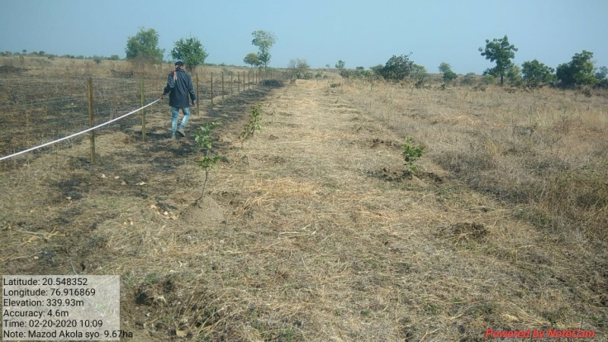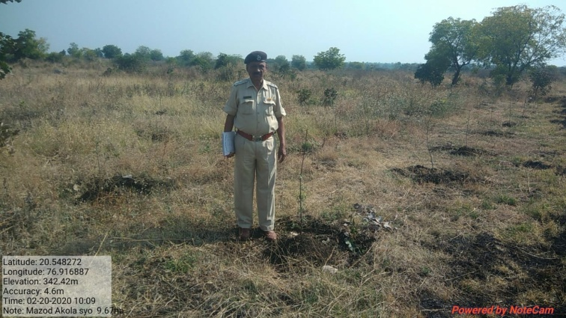
SITE WISE EVALUATION ABSTRACT
Site Number: 16

A. Description of site
Name of Site- Deulgaon Sakarsha
Place- Gat No. 535 to 550
Beat- Deulgaon Sakarsha Round- Mandwa
Range- Ghatbori Forest Division- Buldhana
Forest Circle- Amravati
Area of Treatment- Plantation: 27.260 Ha. GPS: Polygon: 31.546 Ha.
Difference- Excess 4.285 Ha.
Status of Land- Reserved Forest- No Protected Forest- No
Unclassed Forest- No Received as compensatory land- Yes
Zudpi Jungle- No
Site quality- Not Applicable Density- Not Applicable Slope- Heavy
Available vegetation (Local Names)- KuslaIi, Pawanya Tikhadi, H/s Shrubs- Chilhr, Bor Trees - Anjan, Palas
B. Plantation Details
Model - 1111 plants/ha.
Spacement- Planting on trenches
Treatment Map- Yes
Soil Zone- Zone-I,
Species selected for planting- Khair, Karanj, Papda, Sitafal, Awala, Amaltas, Teak, Neem, Sisoo, Bomboo Chinch, Babul, Bor, Kanchan

C. Survival & Status
Site suitability- NR
Suitability of species planted- Yes
Plant survival percentage- 10%
Average Height of plants- 42 cm
Average girth of plants- < 5 cm
General Health of Plants- Semi-healthy
Sustainability- protected from fire & grazing by wild animal it will be a good plantation

D. Protection-
Fencing Status- Barbed Wire / Chain Link - 1350 Rmt.
Fire- Amount Sanctioned in the estimate- Rs. 21234.90/-
Execution of the work- Work Done
Expenditure/Payment of the work- Rs. 17471.00/-
Grazing- Not Observed

E. Monitoring
Inspection of Plantations- APCCF - 0, CCF - 0, DCF - 1, ACF - 0, RFO - 1
Plantation register- Up-to date
Measurement Book- Up-to date
Cash Book- Up-to date / Incomplete Not Available for inspection
Financial audit- Done. Year 2018-19
Fund pattern- Fund received till now are utilized properly & timely. SYO fund not received.
F. Overall Rating C Grade
(Excellent – A+, Very Good – A, Good – B+, Average – B, C-Poor)
Reasons for success/ Failure- Shallow soil, No NR or Grass. Timely operations delayed due to non availability of funds.
G. Date of Evaluation 18 Feb 2020
Name of Evaluators Mr. S. N. Bhagat, Mr. V. B. Nimbhorkar
H. Photographs-

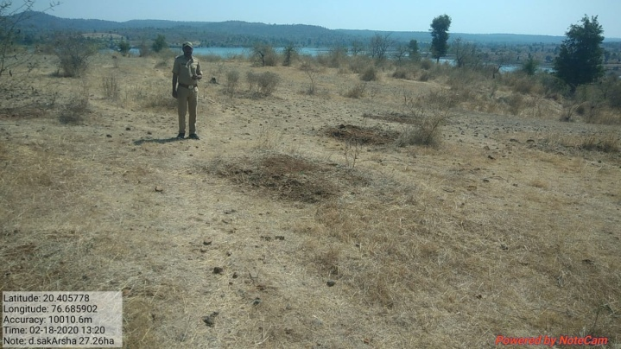

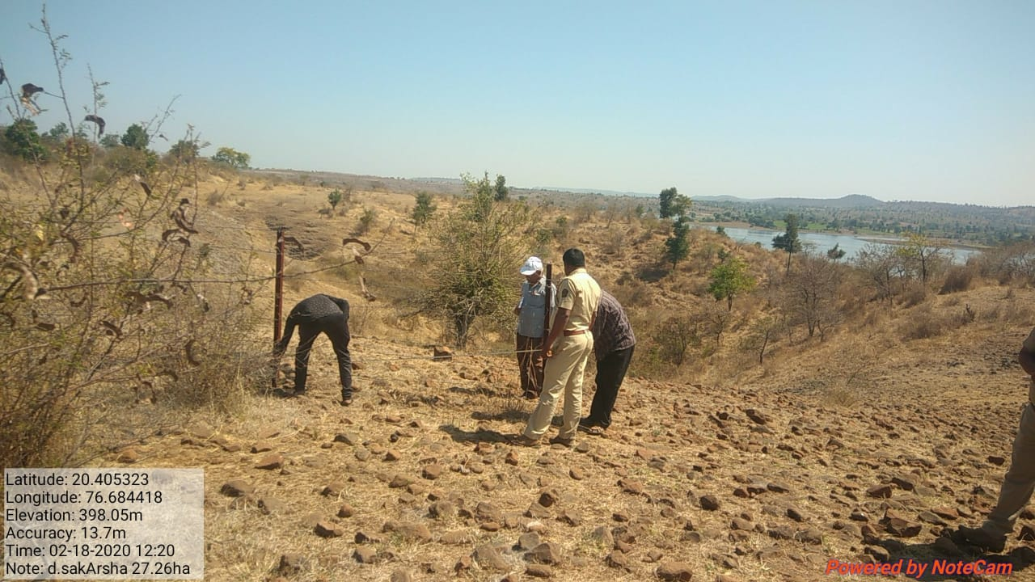
Rocky strata
SITE WISE EVALUATION ABSTRACT
Site Number: 17

A. Description of site
Name of Site- Deulgaon Sakarsha
Place- Gat No 577
Beat- Deulgaon Sakarsha Round- Mandwa
Range- Ghatbori Forest Division- Buldhana
Forest Circle- Amravati
Area of Treatment- Plantation: 6.490 Ha. GPS: Polygon: 7.659 Ha.
Difference- Excess 0.169 Ha.
Status of Land- Reserved Forest- No Protected Forest- No
Unclassed Forest- No Received as compensatory land- Yes
Zudpi Jungle- No
Site quality- Not Applicable Density- Not Applicable Slope- Heavy
Available vegetation (Local Names)- Kusali, Pawanya, Marvel, Trees Chilhar, Bor, Babhul an Palas
B. Plantation Details
Model - 1111 plants/ha.
Spacement- 3 × 3
Treatment Map- No
Soil Zone- Zone II-3 Ha., Zone III-3.49Ha.
Species selected for planting- Chich,Maharukh, Sisoo, Bor, Awala, Siras, Teak, Khair, Papda, Neem, babul, and Kanchan

C. Survival & Status
Site suitability- NR
Suitability of species planted- Yes
Plant survival percentage- 84%
Average Height of plants- 35 cm
Average girth of plants- < 5 cm
General Health of Plants- Unhealthy
Sustainability- protected from fire & grazing by wild animal it will be a good plantation

D. Protection-
Fencing Status- TCM - 5 × 56 Rmt.
Fire- Amount Sanctioned in the estimate- Rs. 4158.53/-
Execution of the work- Work Done
Expenditure/Payment of the work- Rs. 4853.00/-
Grazing- Not Observed

E. Monitoring
Inspection of Plantations- APCCF - 0, CCF - 0, DCF - 0, ACF - 0, RFO - 1
Plantation register- Up-to date
Measurement Book- Up-to date
Cash Book- Up-to date / Incomplete Not Available for inspection
Financial audit- Done. Year 2018-19
Fund pattern- Till FYO Funds received Timely. SYO Funds not Received it may hamper the survival of plantation.
F. Overall Rating B+ Grade
(Excellent – A+, Very Good – A, Good – B+, Average – B, C-Poor)
Reasons for success/ Failure- Good quality of Physiacal operations,Protection from domestic animals,but wildlife damage is more.

G. Date of Evaluation 18 Feb 2020
Name of Evaluators Mr. S. N. Bhagat, Mr. V. B. Nimbhorkar
H. Photographs-

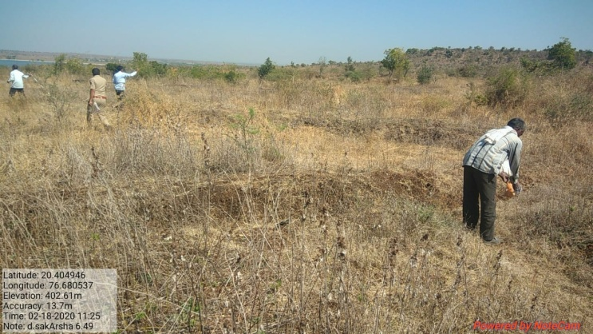
SITE WISE EVALUATION ABSTRACT
Site Number: 18

A. Description of site
Name of Site- Wadegaon
Place- Comptt. No.148
Beat- Wadegaon Round- Kurkheda
Range- Kurkheda Forest Division- Wadsa
Forest Circle- Gadchiroli
Area of Treatment- Plantation: 25.000 Ha. GPS: Polygon: 27.310 Ha.
Difference- Excess 2.310 Ha.
Status of Land- Reserved Forest- Yes Protected Forest- No
Unclassed Forest- No Received as compensatory land- No
Zudpi Jungle- No
Site quality- IV Density- Less than 0.4 Slope- Gentle
Available vegetation (Local Names)- Khair, Neem, Moha, Ain, Bel, Arjun, Tendu, Bor, Garadi, Tenndu, , Chiman Chara, Kusal, Amarvel
B. Plantation Details
Model - 1111 plants/ha.
Spacement- 3 × 3
Treatment Map- Yes
Soil Zone- Zone-III
Species selected for planting- Albizia, Embelica oficinalis, Neem,Tamarindus, Sisoo, Arjun, Maligna arborea, Eagle marmelos, Madhuca latifolia, Syzegium cumini, Bamboo

C. Survival & Status
Site suitability- Suitable
Suitability of species planted- Yes
Plant survival percentage- 92%
Average Height of plants- 90 cm
Average girth of plants- < 5.0 cm
General Health of Plants- Semi-healthy
Sustainability- Hardy species & very good protection & physical works. Sustain

D. Protection-
Fencing Status- Barbed Wire / Chain Link - 2395 × 50 Rmt.
Fire- Amount Sanctioned in the estimate- Rs. 19981.00/-
Execution of the work- Work Done
Expenditure/Payment of the work- Rs. 17139.00/-
Grazing- Yes, villagers tried to break Barbed wire fencing to allow grazing and trespass up to adjoining water body outside plantation. Field staff controlled it.
E. Monitoring
Inspection of Plantations- APCCF - 0, CCF - 0, DCF - 1, ACF - 3, RFO - 1
Plantation register- Up-to date
Measurement Book- Up-to date
Cash Book- Up-to date
Financial audit- Not Done
Fund pattern- Funds are allotted to RFO after requisition from them only.
F. Overall Rating A+ Grade
(Excellent – A+, Very Good – A, Good – B+, Average – B, C-Poor)
Reasons for success/ Failure- Good quality of physical operations,protection.Notorious villagers needs to be convienced to protect the asset for their benefits.

G. Date of Evaluation 19 Feb 2020
Name of Evaluators Mr. S. M. Jagtap, Mr. B. T. Fartode
H. Photographs-
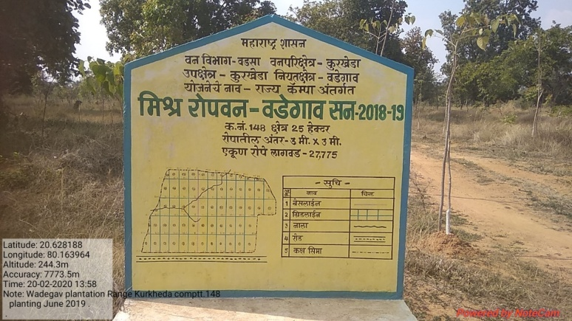
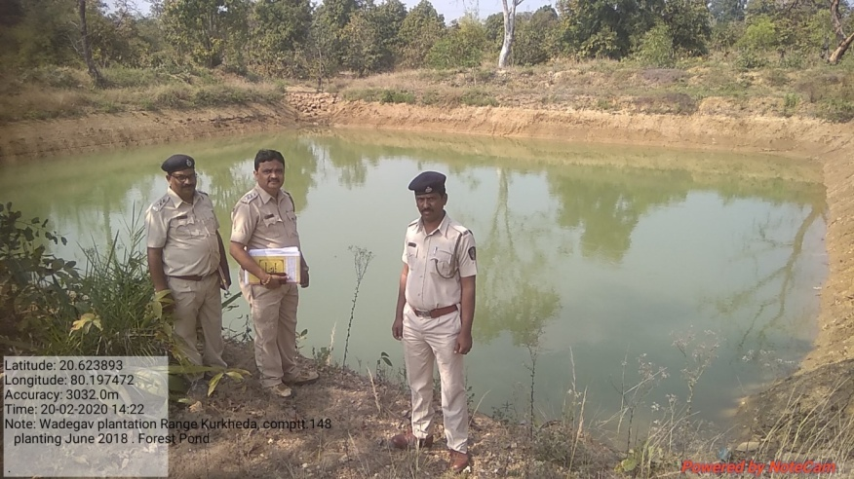
Perfect Forest Pond

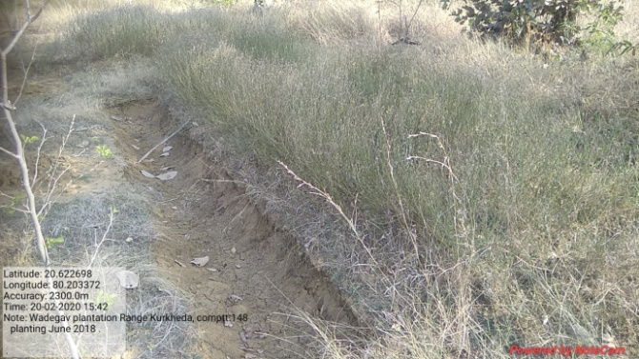
Effective grass seed sowing on DCT
SITE WISE EVALUATION ABSTRACT
Site Number: 19

A. Description of site
Name of Site- Mouze Kanikala
Place- Survey No.7
Beat- Somanada Round- Bhivapur
Range- South Umred Forest Division- Nagpur
Forest Circle- Nagpur
Area of Treatment- Plantation: 3.360 Ha. GPS: Polygon: 4.400 Ha.
Difference- Excess 1.040 Ha.
Status of Land- Reserved Forest- No Protected Forest- No
Unclassed Forest- Yes (Acquired land from irrigation) Received as compensatory land- No
Zudpi Jungle- No
Site quality- NR Density- NR Slope- Heavy
Available vegetation (Local Names)- Babool, Bor, Neem, Hiwar, Palas, Rantalas, Gokharu, Takla, Katumber, Maharukh
B. Plantation Details
Model - 400 plants/ha.
Spacement- 5 × 5
Treatment Map- Yes
Soil Zone- Zone-III
Species selected for planting- Teak, Chinch, Umber, Neem, Bamboo

C. Survival & Status
Site suitability- Site aquired is isolated from forest land with 40% area gets automerged in back water of Indira Sagar Gosewada project and the remaning part under steep slope.
Suitability of species planted- 40% area is damaged in water so only Babul, Bamboo, Bor species is suitable.
Plant survival percentage- 75%
Average Height of plants- 28 cm
Average girth of plants-
General Health of Plants- Unhealthy
Sustainability- Not sustainable as 40% area is under submequence.

D. Protection-
Fencing Status- TCM - 849 Rmt.
Fire- Amount Sanctioned in the estimate- Rs. 2153.00/-
Execution of the work- Work Done
Expenditure/Payment of the work- Rs. 1941.00/-
Grazing- Not recorded

E. Monitoring
Inspection of Plantations- APCCF - 0, CCF - 0, DCF - 0, ACF - 1, RFO - 2
Plantation register- Up-to date
Measurement Book- Up-to date
Cash Book- Yes
Financial audit- Done
Fund pattern- Regular.
F. Overall Rating B+ Grade
(Excellent – A+, Very Good – A, Good – B+, Average – B, C-Poor)
Reasons for success/ Failure- 1) Compensatory area received from the agency is not suitable for planting & development. 2) Due to heavy biomass of unpalatable grass, weeding in strips is recommended.

G. Date of Evaluation 18 Feb 2020
Name of Evaluators Mr. V. S. Bhonsle, Mr. S. B. Dabhade
H. Photographs-
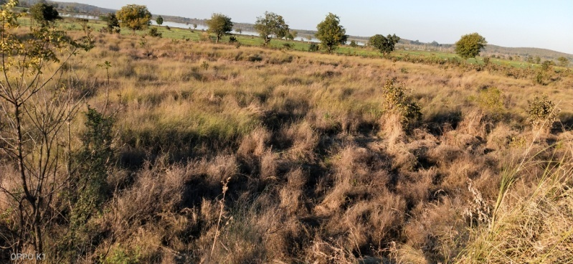
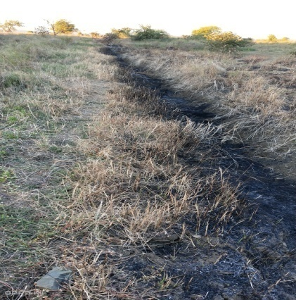
New size of TCM 1Mt.x1Mt.X1Mt.
SITE WISE EVALUATION ABSTRACT
Site Number: 20

A. Description of site
Name of Site- Makardhohada Sasegaon
Place- Survey No.47 (Comp.382)
Beat- Kolarmat Round- Mkardhohada
Range- North Umred Forest Division- Nagpur
Forest Circle- Nagpur
Area of Treatment- Plantation: 24.550 Ha. GPS: Polygon 26.140 Ha.
Difference- Excess 1.590 Ha.
Status of Land- Reserved Forest- No Protected Forest- Yes
Unclassed Forest- No Received as compensatory land- No
Zudpi Jungle- No
Site quality- Normal Density- Below 0.1 Slope- Gentle
Available vegetation (Local Names)- Palas, Neem, Bor, Teak, Aola, Rantulas, Dudhi, Kamal, Pawara
B. Plantation Details
Model - 1111 plants/ha.
Spacement- 3 × 3
Treatment Map- Yes
Soil Zone- Zonation not done
Species selected for planting- Teak, Bor, Chinch, Jambhul, Sitaphal, Kawath, Chinchbilai, Chichwa, Neem, Sisoo, Khair, Raintree, Aola, Karanj, Ain, Arjan, Reetha, Shivar

C. Survival & Status
Site suitability- Cassea, Raintree, Karanj & Anjan are planted but are not suitable for the site selected.
Suitability of species planted- No. Sitaphal, Chinchbilai, Sisoo, Casia, Raintree, Karanj ,Arjun are unsuitable species.
Plant survival percentage- 78%
Average Height of plants- 54 cm
Average girth of plants-
General Health of Plants- Semi-healthy
Sustainability- Unsustainable.

D. Protection-
Fencing Status- No
Fire- Amount Sanctioned in the estimate- Rs. 15139.00/-
Execution of the work- Work Done
Expenditure/Payment of the work- Rs. 8089.00/-
Grazing- No damage by domestic animal

E. Monitoring
Inspection of Plantations- APCCF - 0, CCF - 0, DCF - 0, ACF - 2, RFO - 2
Plantation register- Up-to date
Measurement Book- Up-to date
Cash Book- Up-to date
Financial audit- Done. Year 2018-19
Fund pattern-
F. Overall Rating A Grade
(Excellent – A+, Very Good – A, Good – B+, Average – B, C-Poor)
Reasons for success/ Failure- Only survival, but plants are lanky. Instead of TCM, chainlink fencing is recommended for better protection.

G. Date of Evaluation 23 Feb 2020
Name of Evaluators Mr. V. S. Bhonsle, Mr. S. B. Dabhade
H. Photographs-
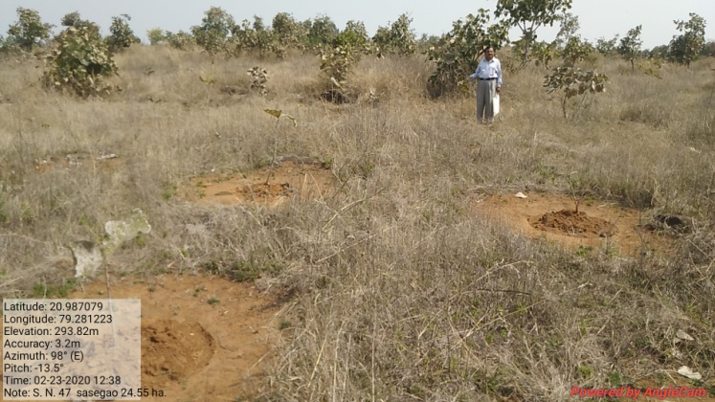

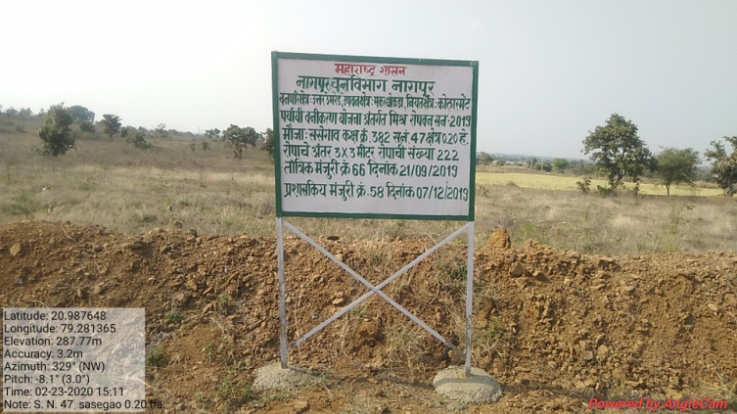
SITE WISE EVALUATION ABSTRACT
Site Number: 21

A. Description of site
Name of Site- Nimgaon Bhogi
Place- 162
Beat- Malthan Round- Shirur
Range- Shirur Forest Division- Junnar
Forest Circle- Pune
Area of Treatment- Plantation: 11.470 Ha. GPS: Polygon: 11.470 Ha.
Difference- No change
Status of Land- Reserved Forest- No Protected Forest- No
Unclassed Forest- No Received as compensatory land- Yes
Zudpi Jungle- No
Site quality- Degraded land Density- Open Slope- Gentle
Available vegetation (Local Names)- Tree, Grass
B. Plantation Details
Model - 1111 plants/ha.
Spacement- 3 × 3
Treatment Map- Yes
Soil Zone- Zone-III
Species selected for planting- Khair, Karanj, Wavla, Kanchan, Chinch, Sisoo, Gulmohar etc.

C. Survival & Status
Site suitability- Suitable
Suitability of species planted- Yes, Gulmohar need not have planted
Plant survival percentage- 66%
Average Height of plants- 90 cm
Average girth of plants-
General Health of Plants- Semi-healthy
Sustainability- Good if protected well

D. Protection-
Fencing Status- No
Fire- Amount Sanctioned in the estimate- Rs. 7349.52/-
Execution of the work- Work Done
Expenditure/Payment of the work- Rs. 7471.00/-
Grazing- NA

E. Monitoring
Inspection of Plantations- APCCF - 0, CCF - 0, DCF - 0, ACF - 0, RFO - 0
Plantation register- NA
Measurement Book- Up-to date
Cash Book- Up-to date
Financial audit- Not Done
Fund pattern- Wages pending for want of funds
F. Overall Rating A Grade
(Excellent – A+, Very Good – A, Good – B+, Average – B, C-Poor)
Reasons for success/ Failure- Planting of Delonix & Cassia Siamea should have been avoided

G. Date of Evaluation 19 Feb 2020
Name of Evaluators Mr. G. P. Garad, Mr. R. K. Adkar
H. Photographs-
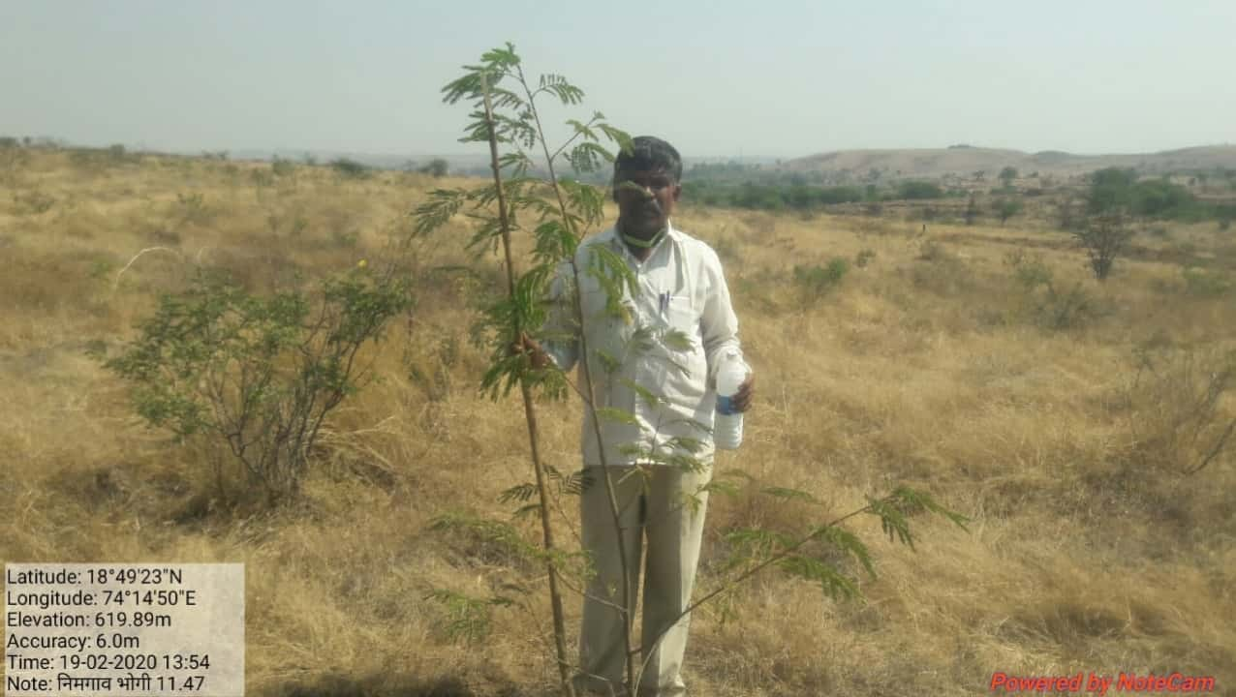

SITE WISE EVALUATION ABSTRACT
Site Number: 22

A. Description of site
Name of Site- Bhonang
Place- Gat No.36
Beat- Ramraj Round- Ramraj
Range- Alibaug Forest Division- Alibaug
Forest Circle- Thane
Area of Treatment- Plantation: 10.000 Ha. GPS: Polygon: 10.000 Ha.
Difference- No change
Status of Land- Reserved Forest- No Protected Forest- No
Unclassed Forest- No Received as compensatory land- Yes
Zudpi Jungle- No
Site quality- NA Density- Open Slope- Gentle
Available vegetation (Local Names)- Shrubs, Grass
B. Plantation Details
Model - 625 plants/ha.
Spacement- 4 × 4
Treatment Map- Yes
Soil Zone- Zone-I, Zone-II, Zone-III
Species selected for planting- Aola, Jamun, Sitaphal, Siwan, Karanj, Wad, Khair, Umber, Bahwa etc.

C. Survival & Status
Site suitability- Suitable
Suitability of species planted- Yes
Plant survival percentage- 93%
Average Height of plants- 74 cm
Average girth of plants-
General Health of Plants- Healthy
Sustainability- Being gochar land there is resistance of people but barbed wire fencing will help a lot.

D. Protection-
Fencing Status- Barbed Wire / Chain Link - 1100 Rmt.
Fire- Amount Sanctioned in the estimate- Rs. 6408.00/-
Execution of the work- Work Done
Expenditure/Payment of the work- Rs. 6408.00/-
Grazing- No

E. Monitoring
Inspection of Plantations- APCCF - 0, CCF - 0, DCF - 1, ACF - 1, RFO - 0
Plantation register- Up-to date
Measurement Book- Up-to date
Cash Book- Up-to date
Financial audit- Not Done
Fund pattern- Second year not yet received
F. Overall Rating A+ Grade
(Excellent – A+, Very Good – A, Good – B+, Average – B, C-Poor)
Reasons for success/ Failure- Improved people's participation is required.

G. Date of Evaluation 25 Feb 2020
Name of Evaluators Mr. G. P. Garad
H. Photographs-
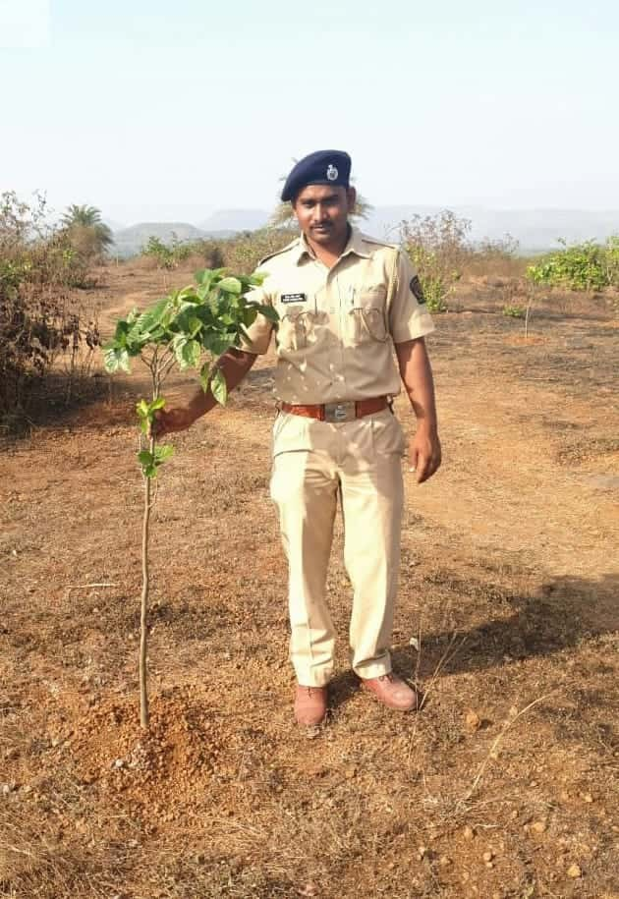
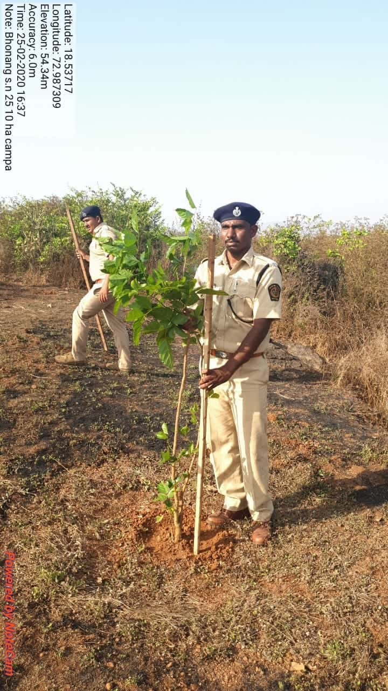

SITE WISE EVALUATION ABSTRACT
Site Number: 23

A. Description of site
Name of Site- Kumbharshet
Place- 24/38
Beat- Chikhalgaon Round- Unhere
Range- Nagothane Forest Division- Alibaug
Forest Circle- Thane
Area of Treatment- Plantation: 24.000 Ha. GPS: Polygon: 24.000 Ha.
Difference- No change
Status of Land- Reserved Forest- No Protected Forest- No
Unclassed Forest- No Received as compensatory land- Yes
Zudpi Jungle- No
Site quality- Density- Slope- Gentle
Available vegetation (Local Names)- Trees, Shrubs, Grass
B. Plantation Details
Model - 400 plants/ha.
Spacement- 5 × 5-in Grid No. 1&2 = 275 plants / 2.5 × 2.5-Rest 9326 plants
Treatment Map- Yes
Soil Zone- Zone-III
Species selected for planting- Aola, Teak, Sisoo, Khair, Karanj, Bheda, Kaju, Bamboo, Apta, Chinch etc.

C. Survival & Status
Site suitability- Suitable
Suitability of species planted- Yes
Plant survival percentage- 74%
Average Height of plants- 78 cm
Average girth of plants-
General Health of Plants- Healthy
Sustainability- Peoples participation required.

D. Protection-
Fencing Status- Barbed Wire
Fire- Amount Sanctioned in the estimate- Rs. Nil/-
Execution of the work- Work Not Done
Expenditure/Payment of the work- Rs. 0.00/-
Grazing- No

E. Monitoring
Inspection of Plantations- APCCF - 0, CCF - 0, DCF - 1, ACF - 1, RFO - 0
Plantation register- Up-to date
Measurement Book- Up-to date
Cash Book- Up-to date
Financial audit- Not Done
Fund pattern- Wages pending
F. Overall Rating A Grade
(Excellent – A+, Very Good – A, Good – B+, Average – B, C-Poor)
Reasons for success/ Failure- Staff is really committed. People support is required. Gochar land should not be taken without taking people into confidence.

G. Date of Evaluation 26 Feb 2020
Name of Evaluators Mr. G. P. Garad
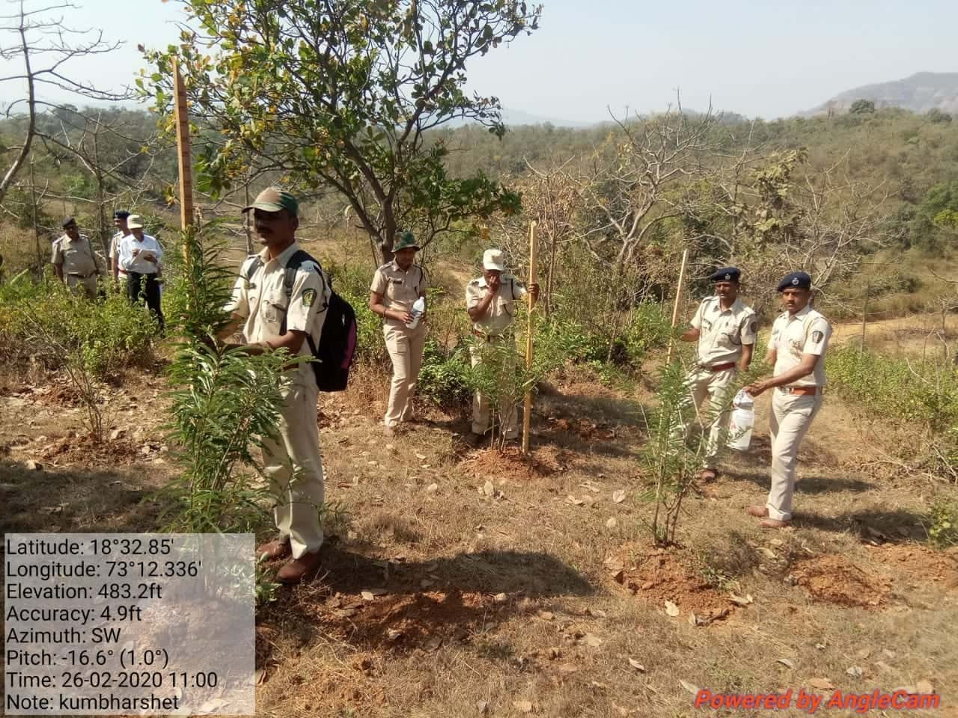
H. Photographs-
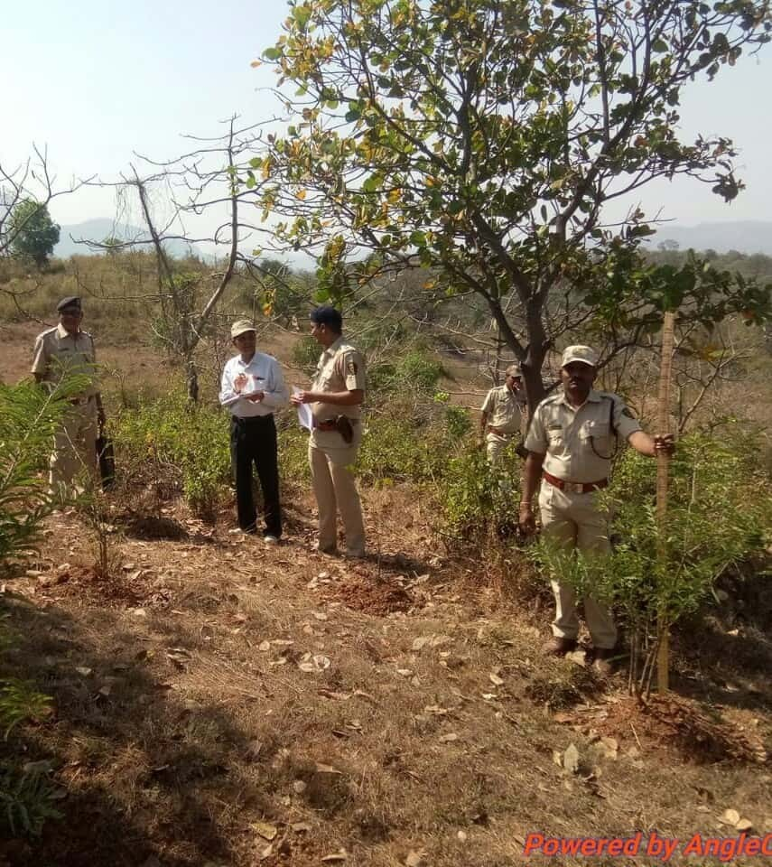

SITE WISE EVALUATION ABSTRACT
Site Number: 24

A. Description of site
Name of Site- Osarvira
Place- 255
Beat- Osarvira Round- Osarvira
Range- Udhawa Forest Division- Dahanu
Forest Circle- Thane
Area of Treatment- Plantation: 20.000 Ha. GPS: Polygon: 31.990 Ha.
Difference- Excess 11.990 Ha.
Status of Land- Reserved Forest- Yes Protected Forest- No
Unclassed Forest- No Received as compensatory land- No
Zudpi Jungle- No
Site quality- III and IV A Density- Varies from 0.2 to 0.5 Slope- Moderate
Available vegetation (Local Names)- Old teak plantation area, hence teak coppice are seen and other species like - Moha, Ain, Palas, Dhavda,, Asana, Savar etc.
B. Plantation Details
Model - 1111 plants/ha.
Spacement- 3 × 3
Treatment Map- No
Soil Zone- Zone-III
Species selected for planting- Cashew, Khair, Shisav, Moha, Bamboo, Chinch, Behda, Ritha, Karanj, Kanchan, Neem etc.

C. Survival & Status
Site suitability- Not suitable. Heavy enchrochment of FRA plots in between 2 degree to 25 degree. Area is suitable for NR model.
Suitability of species planted- Yes
Plant survival percentage- 52%
Average Height of plants- 45 cm
Average girth of plants-
General Health of Plants- Unhealthy
Sustainability- Not satisfactory.

D. Protection-
Fencing Status- TCM - 882.80 Rmt. (Part Fencing)
Fire- Amount Sanctioned in the estimate- Rs. 13585.00/-
Execution of the work- Work Done
Expenditure/Payment of the work- Rs. 13585.00/-
Grazing- Grazzing by strey cattle

E. Monitoring
Inspection of Plantations- APCCF - 0, CCF - 0, DCF - 0, ACF - 0, RFO - 2
Plantation register- Up-to date
Measurement Book- Up-to date
Cash Book- Up-to date
Financial audit- By C.A.
Fund pattern- Funds received in bank (For PYO/PPO works Rs.2 × 24/- on 26/3/18). Should have been in installments.
F. Overall Rating B+ Grade
(Excellent – A+, Very Good – A, Good – B+, Average – B, C-Poor)
Reasons for success/ Failure- 1) Inspections are inadequate 2) Treatment maps are not prepared properly 3) Wrong selection of site for A.R. Model

G. Date of Evaluation 29 Feb 2020
Name of Evaluators Mr. N. A. Patil
H. Photographs-
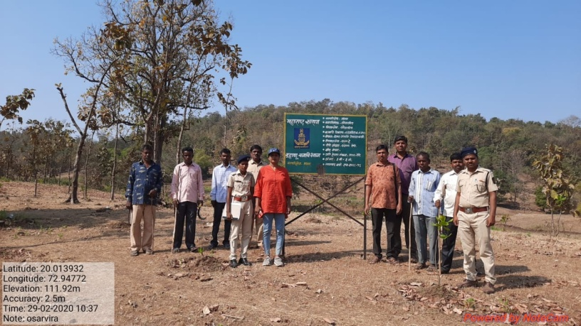
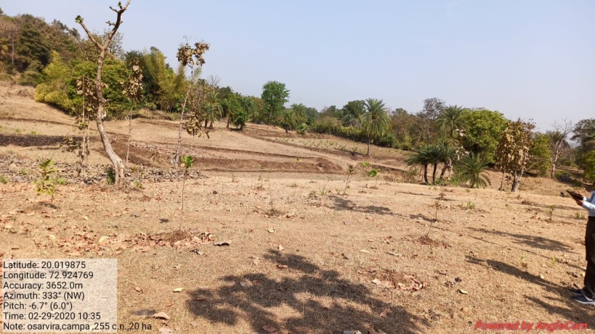
SITE WISE EVALUATION ABSTRACT
Site Number: 25

A. Description of site
Name of Site- Pochade
Place- 12 & 43
Beat- Pochade Round- Manor
Range- Manor Forest Division- Dahanu
Forest Circle- Thane
Area of Treatment- Plantation: 7.000 Ha. GPS: Polygon: 13.731 Ha
Difference- Excess 6.731 Ha.
Status of Land- Reserved Forest- No Protected Forest- Yes
Unclassed Forest- No Received as compensatory land- No
Zudpi Jungle- No
Site quality- III Density- 0.1 Slope- Gentle
Available vegetation (Local Names)- Very sparce growth of Teak, Bor & Palas etc.
B. Plantation Details
Model - 1111 plants/ha.
Spacement- 3 × 3
Treatment Map- Yes
Soil Zone- Zone-III
Species selected for planting- Khair, Kahandol, Behawa, Aaola, Shiwan etc.

C. Survival & Status
Site suitability- Suitable
Suitability of species planted- Yes
Plant survival percentage- 91%
Average Height of plants- 110 cm
Average girth of plants-
General Health of Plants- Healthy
Sustainability- Very good.

D. Protection-
Fencing Status- No
Fire- Amount Sanctioned in the estimate- Rs. 4754.00/-
Execution of the work- Work Done
Expenditure/Payment of the work- Rs. 4755.00/-
Grazing- No

E. Monitoring
Inspection of Plantations- APCCF - 0, CCF - 0, DCF - 0, ACF - 0, RFO - 6
Plantation register- Incomplete
Measurement Book- Up-to date but no entry of SMC works
Cash Book- Up-to date
Financial audit- Done.
Fund pattern- Late funding from Campa or Division office
F. Overall Rating A Grade
(Excellent – A+, Very Good – A, Good – B+, Average – B, C-Poor)
Reasons for success/ Failure- Good plantation works inspite of stony and refractory soil.

G. Date of Evaluation 03 Mar 2020
Name of Evaluators Mr. N. A. Patil
H. Photographs-

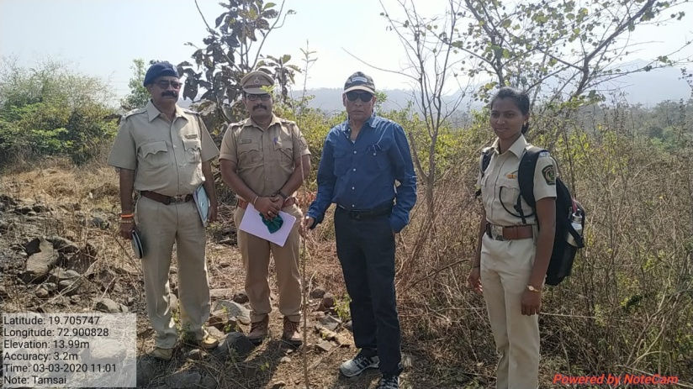
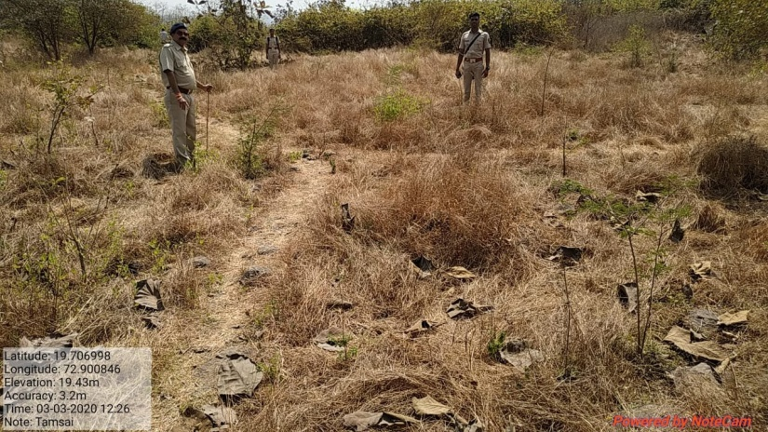
SITE WISE EVALUATION ABSTRACT
Site Number: 26

A. Description of site
Name of Site- Mandava
Place- 153
Beat- Mandava (South) Round- Sonsiv
Range- West Wada Forest Division- Jawahar
Forest Circle- Thane
Area of Treatment- Plantation: 14.000 Ha. GPS: Polygon: 20.500 Ha.
Difference- Excess 6.50 Ha.
Status of Land- Reserved Forest- Yes Protected Forest- No
Unclassed Forest- No Received as compensatory land- No
Zudpi Jungle- No
Site quality- Normal Density- 0.5 RF Slope- Gentle
Available vegetation (Local Names)- -
B. Plantation Details
Model - 400 plants/ha.
Spacement- 5 × 5
Treatment Map- Yes
Soil Zone- Zone-I, Zone-II
Species selected for planting- Bamboo, Jambul, Karanj, Avala, Kanchan, Apta, Khair, Vad, Subabul

C. Survival & Status
Site suitability- Suitable but gravelly with some rocky patches.
Suitability of species planted- Yes
Plant survival percentage- 74%
Average Height of plants- 118 cm
Average girth of plants-
General Health of Plants- Semi-healthy
Sustainability- Very good as the plantation is easily accessible by road

D. Protection-
Fencing Status- TCM - 1596 Rmt.
Fire- Amount Sanctioned in the estimate- Rs. 8300.19/-
Execution of the work- Work Done
Expenditure/Payment of the work- Rs. 8060.00/-
Grazing- No

E. Monitoring
Inspection of Plantations- APCCF - 0, CCF - 2, DCF - 0, ACF - 1, RFO - 1
Plantation register- Up-to date
Measurement Book- Up-to date
Cash Book- Up-to date (Auditted by Mandbk & upto Mar-19)
Financial audit- Done
Fund pattern- Irregular after 1st year
F. Overall Rating B Grade
(Excellent – A+, Very Good – A, Good – B+, Average – B, C-Poor)
Reasons for success/ Failure- The work execution is good. However additional cultural operation will boost up the plant growth.

G. Date of Evaluation 04 Mar 2020
Name of Evaluators Mr. D. B. Patil
H. Photographs-
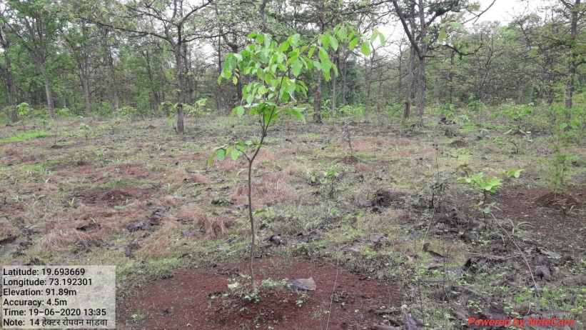
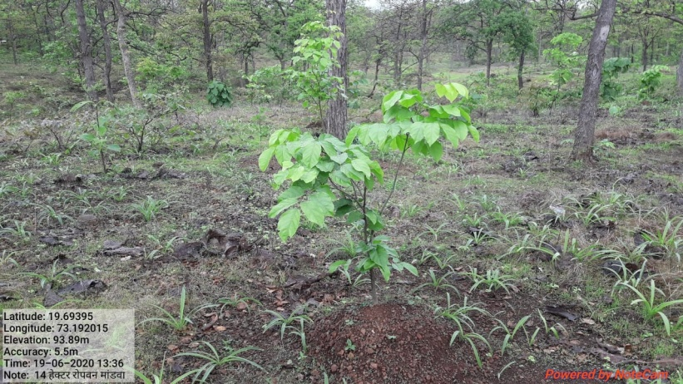

SITE WISE EVALUATION ABSTRACT
Site Number: 27

A. Description of site
Name of Site- Khupri
Place- 988
Beat- Khupri Round- Khupri
Range- West Wada Forest Division- Jawahar
Forest Circle- Thane
Area of Treatment- Plantation: 1.500 Ha. GPS: Polygon:
Difference- Plantation Burnt
Status of Land- Reserved Forest- Yes Protected Forest- No
Unclassed Forest- No Received as compensatory land- No
Zudpi Jungle- No
Site quality- Density- Slope-
Available vegetation (Local Names)- -
B. Plantation Details
Model - 400 plants/ha.
Spacement- 5 × 5
Treatment Map- No
Soil Zone-
Species selected for planting- -

C. Survival & Status
Site suitability-
Suitability of species planted-
Plant survival percentage- 0%
Average Height of plants- -
Average girth of plants- -
General Health of Plants- Burnt
Sustainability-

D. Protection-
Fencing Status- No
Fire- Amount Sanctioned in the estimate- Rs. /-
Execution of the work- Accidently Burnt
Expenditure/Payment of the work- Rs. /-
Grazing-

E. Monitoring
Inspection of Plantations- APCCF - 0, CCF - 0, DCF - 0, ACF - 0, RFO - 0
Plantation register-
Measurement Book-
Cash Book-
Financial audit- Done
Fund pattern-
F. Overall Rating C Grade
(Excellent – A+, Very Good – A, Good – B+, Average – B, C-Poor)
Reasons for success/ Failure-

G. Date of Evaluation 28 Feb 2020
Name of Evaluators Mr. D. B. Patil
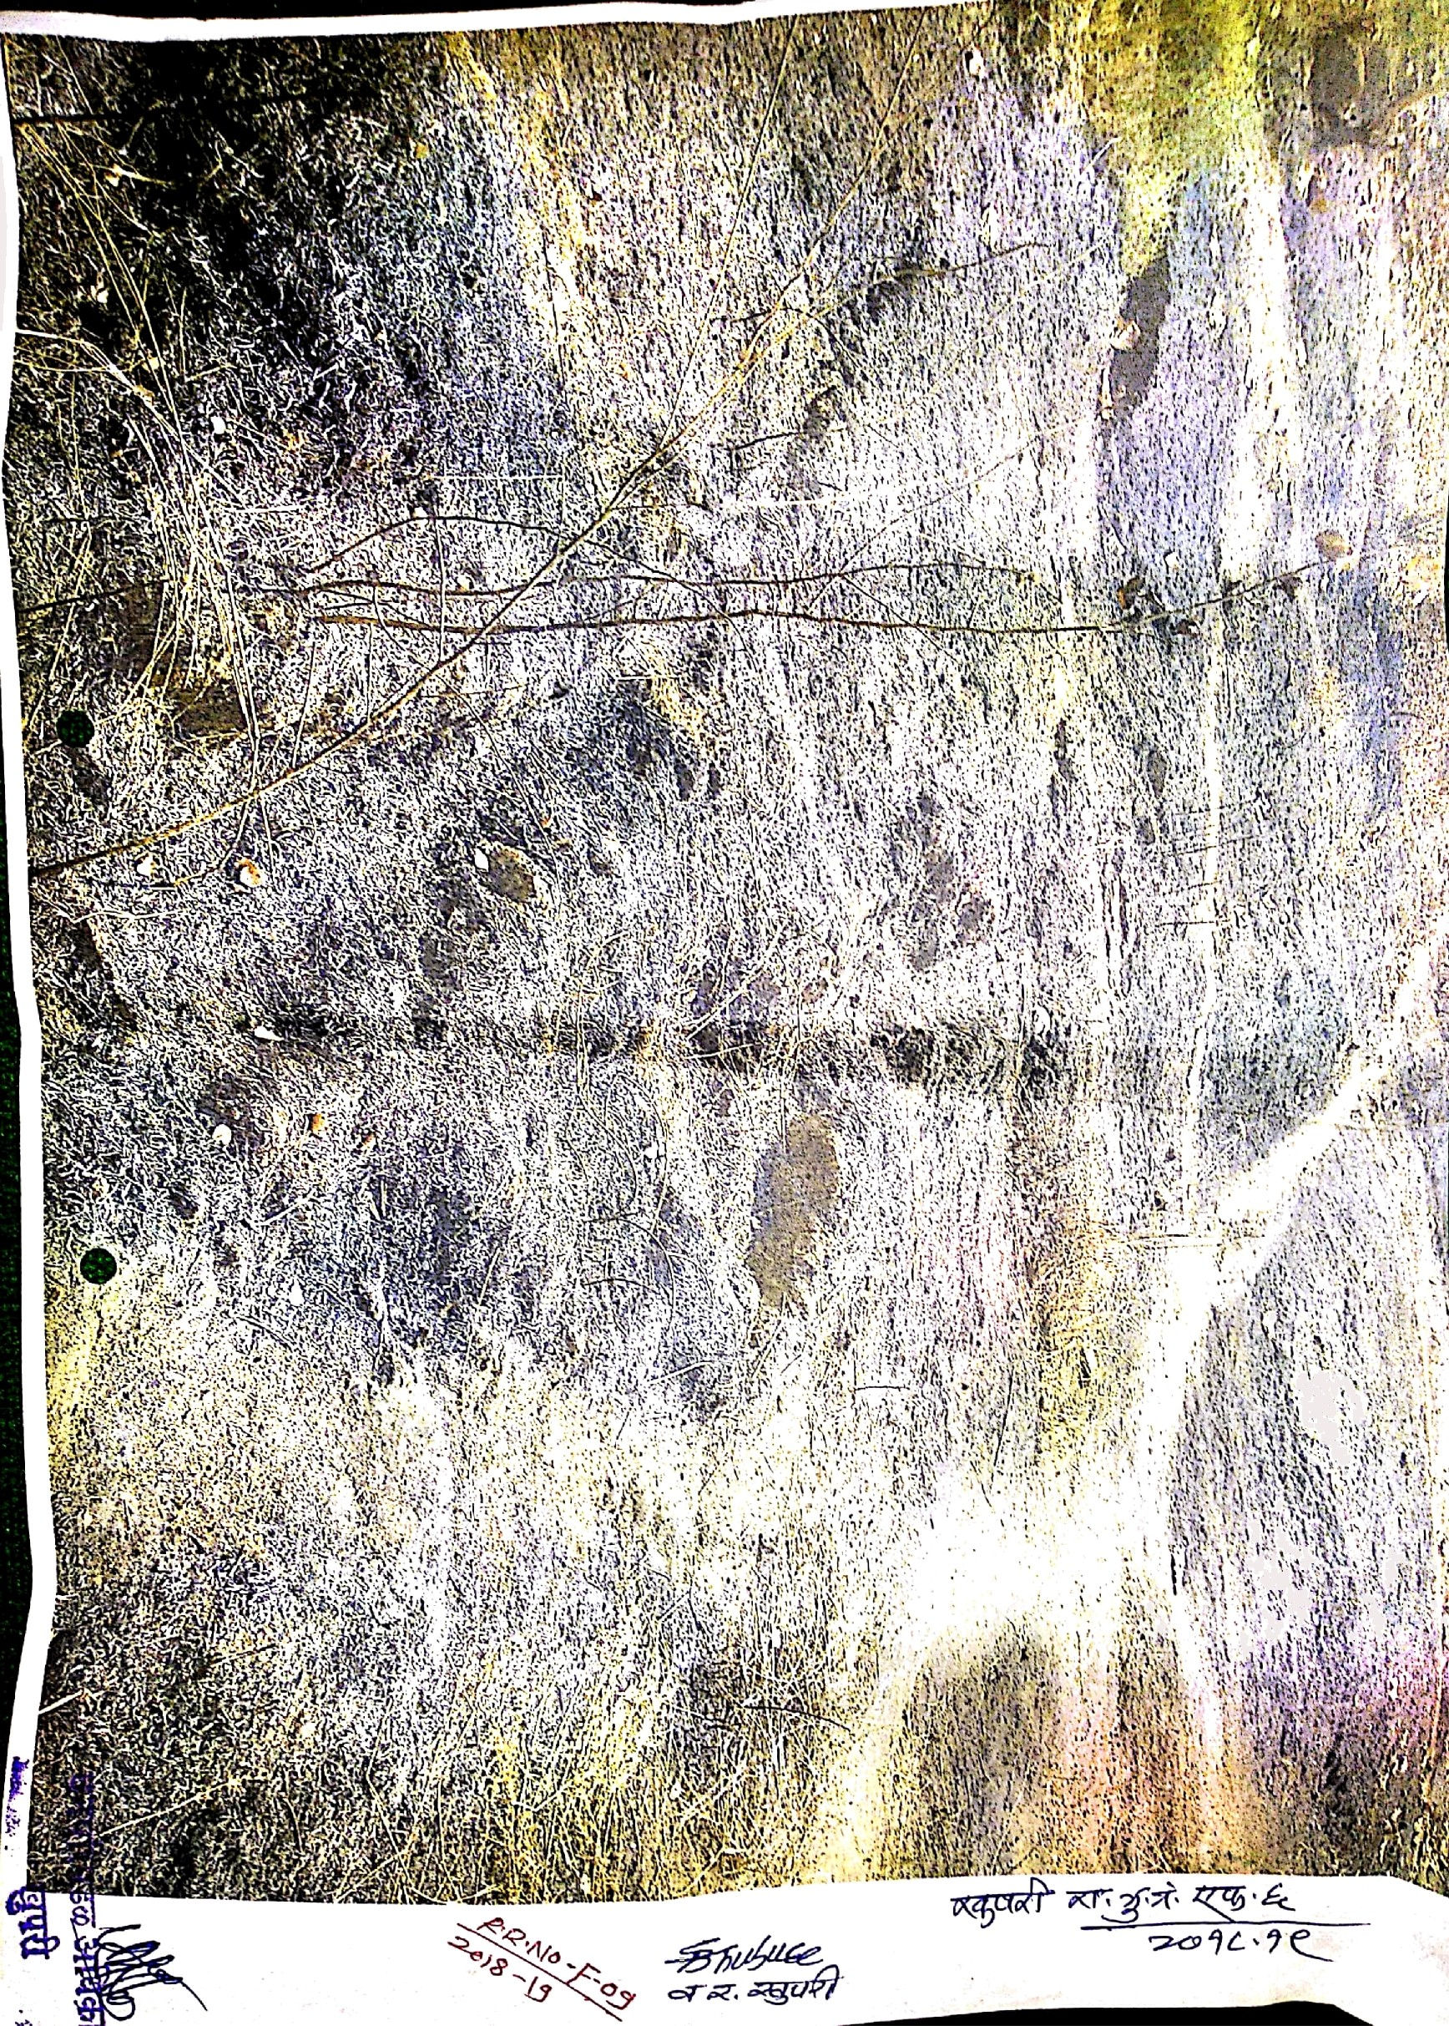
H. Photographs-

SITE WISE EVALUATION ABSTRACT
Site Number: 28

A. Description of site
Name of Site- Divashi
Place- 12
Beat- Divashi Round- Kinhavali
Range- Saiwan Forest Division- Jawahar
Forest Circle- Thane
Area of Treatment- Plantation: 14.000 Ha. GPS: Polygon: 15.000 Ha.
Difference- Excess 1.000 Ha.
Status of Land- Reserved Forest- Yes Protected Forest- No
Unclassed Forest- No Received as compensatory land- No
Zudpi Jungle- No
Site quality- Normal Density- 0.4 Slope- Moderate
Available vegetation (Local Names)- -
B. Plantation Details
Model - 400 plants/ha.
Spacement- 5 × 5
Treatment Map- Yes
Soil Zone- Zone-I, Zone-II, Zone-III
Species selected for planting- Kaju, Bamboo, Bas, Sitafatl, Karanj, ambhul, Moha, Avala, Peru, Kadunimb

C. Survival & Status
Site suitability- Suitable
Suitability of species planted- Yes
Plant survival percentage- 83%
Average Height of plants- 73 cm
Average girth of plants-
General Health of Plants- Healthy
Sustainability- Good.

D. Protection-
Fencing Status- TCM - 1145.762 × 260 Rmt.
Fire- Amount Sanctioned in the estimate- Rs. 9509.08/-
Execution of the work- Work Done
Expenditure/Payment of the work- Rs. 9509.00/-
Grazing- No, inspite of plot borders

E. Monitoring
Inspection of Plantations- APCCF - 0, CCF - 0, DCF - 0, ACF - 0, RFO - 2
Plantation register- Up-to date
Measurement Book- Up-to date
Cash Book- Up-to date
Financial audit- Done
Fund pattern- Till 1st year punctual there after no funds were made available..
F. Overall Rating B+ Grade
(Excellent – A+, Very Good – A, Good – B+, Average – B, C-Poor)
Reasons for success/ Failure- Regular flow of fund is essential.

G. Date of Evaluation 29 Feb 2020
Name of Evaluators Mr. D. B. Patil,
H. Photographs-

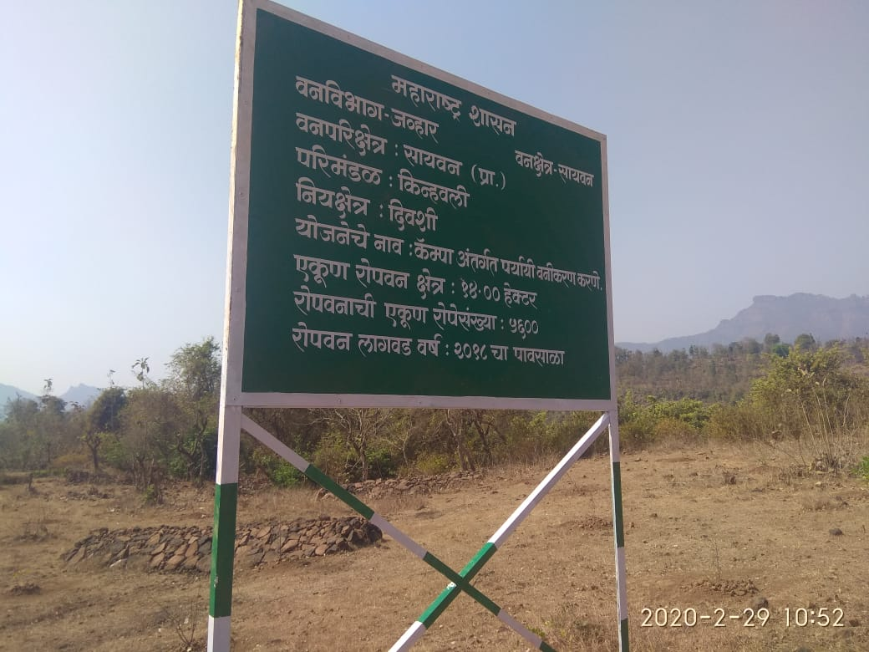
SITE WISE EVALUATION ABSTRACT
Site Number: 29

A. Description of site
Name of Site- Radycha pada
Place- Comptt. No- 590
Beat- Radyacha pada Round- Makhvane
Range- Vihigaon Forest Division- Shahapur
Forest Circle- Thane
Area of Treatment- Plantation: 25.000 Ha. GPS: Polygon 49.000 Ha.
Difference- Excess 24.000 Ha.
Status of Land- Reserved Forest- Yes Protected Forest- No
Unclassed Forest- No Received as compensatory land- No
Zudpi Jungle- No
Site quality- V Density- 0.5 Slope- Moderate (10 to 25 degrees)
Available vegetation (Local Names)- Teak, Ain, Moha, Dhavda, Bondara, Sawar
B. Plantation Details
Model - 1111 plants/ha.
Spacement- 3 × 3
Treatment Map- Yes
Soil Zone- Zone-I, Zone-II, Zone-III
Species selected for planting- Awala, Hirda, Kahandol, Khair, Moha, Behda, Sitafal

C. Survival & Status
Site suitability- Suitable
Suitability of species planted- Yes
Plant survival percentage- 78%
Average Height of plants- 55 cm
Average girth of plants- 4 cm
General Health of Plants- Healthy
Sustainability- Not sustainable as the natural growth is hacked for rab material by the local plot holder.

D. Protection-
Fencing Status- No fencing done
Fire- Amount Sanctioned in the estimate- Rs. 16980.00/-
Execution of the work- Work Not Done
Expenditure/Payment of the work- Rs. 0.00/-
Grazing- Heavy cattle trace pass is seen.

E. Monitoring
Inspection of Plantations- APCCF - 0, CCF - 0, DCF - 0, ACF - 0, RFO - 3
Plantation register- UP-to-date
Measurement Book- Up-to-date
Cash Book- Not produced for varification sent for audit to pune
Financial audit- Not Done
Fund pattern- No
F. Overall Rating A Grade
(Excellent – A+, Very Good – A, Good – B+, Average – B, C-Poor)
Reasons for success/ Failure- 1) Chainlink fencing is recommended. 2) Capacity building of record maintenance of staff.

G. Date of Evaluation 28 Feb 2020
Name of Evaluators Mr. S. K. Gawali, Mr. B. R. Challare
H. Photographs-
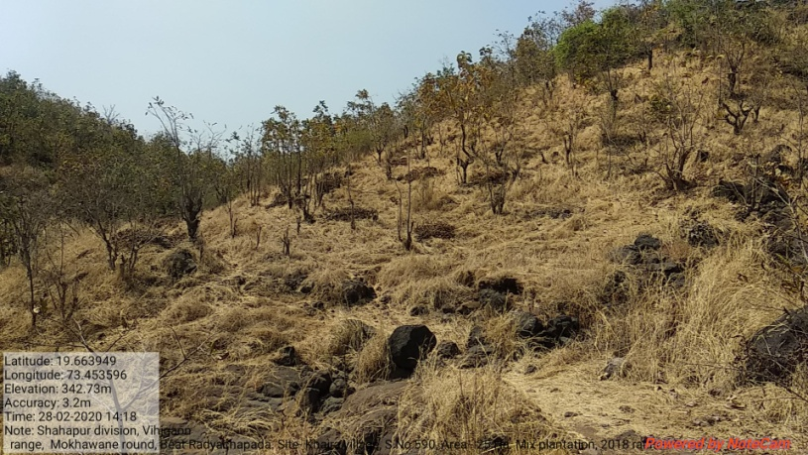

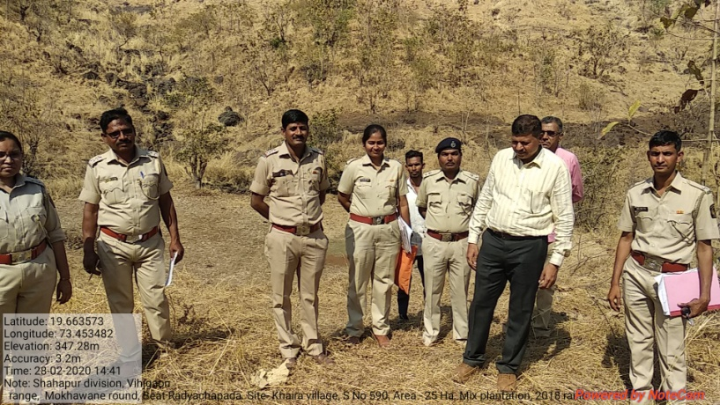
SITE WISE EVALUATION ABSTRACT
Site Number: 30

A. Description of site
Name of Site- Sadhunagar
Place- 16 ( P) Unclassed
Beat- Mudana Round- Mudana
Range- Mahagaon Forest Division- Pusad
Forest Circle- Yawatmal
Area of Treatment- Plantation: 6.500 Ha. GPS: Polygon: 6.500 Ha.
Difference- No change
Status of Land- Reserved Forest- No Protected Forest- No
Unclassed Forest- Yes Received as compensatory land- No
Zudpi Jungle- No
Site quality- IV b Density- Less than 0.2 Slope- Gentle
Available vegetation (Local Names)- Trees: Teak, Palas, Pimple, Neem, / Shrubs: Chilati, Barhati / Grass: Rantulas, Marvel
B. Plantation Details
Model - 625 plants/ha.
Spacement- 4 × 4
Treatment Map- Yes
Soil Zone- Zone-II
Species selected for planting- Teak, Karanj, Neem, Sitaphal, Bamboo

C. Survival & Status
Site suitability- Suitable
Suitability of species planted- No , Karanj is not suitable as is of zone II
Plant survival percentage- 81%
Average Height of plants- 60 cm
Average girth of plants-
General Health of Plants- Unhealthy
Sustainability- Very poor growth of the plantation in second year so sustainability of the plantation is very low

D. Protection-
Fencing Status- TCM - 184.20 Rmt., Stone Wall - 99.50 Rmt., Barbed Wire - 210 Rmt.
Fire- Amount Sanctioned in the estimate- Rs. Nil/-
Execution of the work- Work Not Done
Expenditure/Payment of the work- Rs. 0.00/-
Grazing- Yes

E. Monitoring
Inspection of Plantations- APCCF - 0, CCF - 0, DCF - 0, ACF - 0, RFO - 3
Plantation register- Incomplete
Measurement Book- Up-to date
Cash Book- Up-to date
Financial audit- Not Done
Fund pattern- last year funds receipt were regular and regularly utilization.
F. Overall Rating A Grade
(Excellent – A+, Very Good – A, Good – B+, Average – B, C-Poor)
Reasons for success/ Failure- Nil

G. Date of Evaluation 20 Feb 2020
Name of Evaluators Mr. U. M. Dhopeshwarkar, Mr. R. T. More
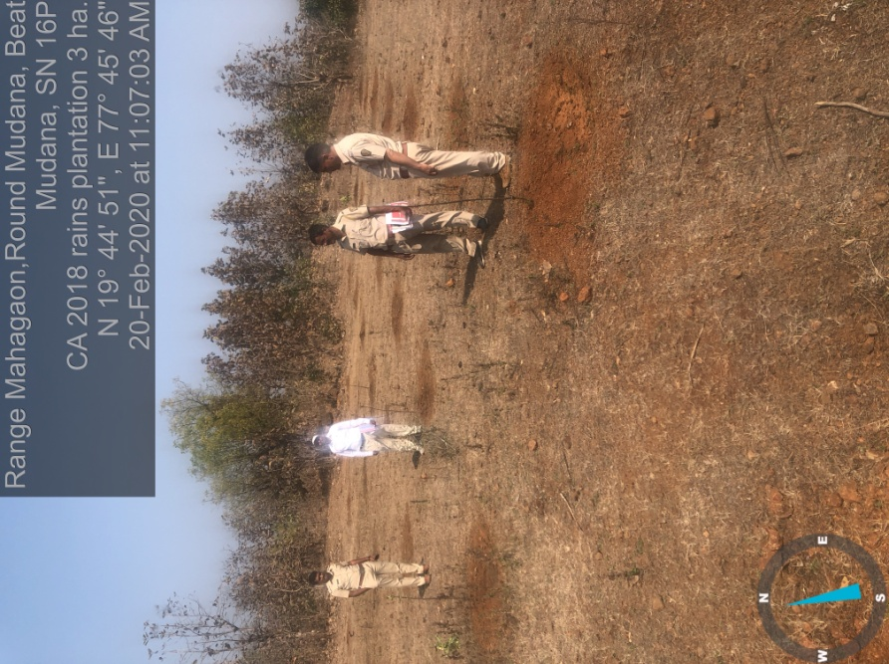
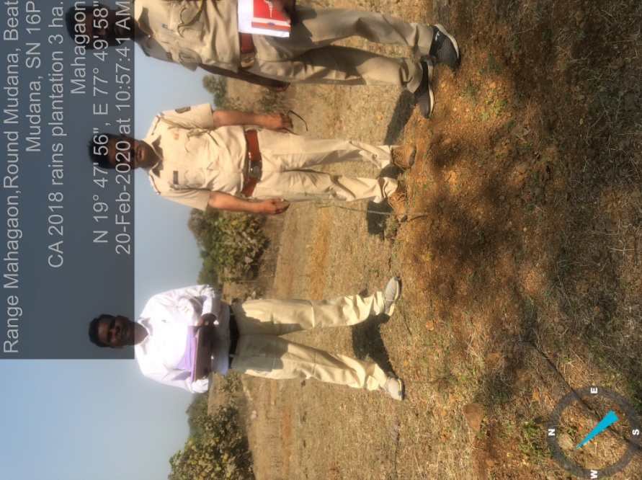
H. Photographs-

SITE WISE EVALUATION ABSTRACT
Site Number: 31

A. Description of site
Name of Site- Piranji
Place- Survey No. 31
Beat- Pirangi Round- Krishnapur
Range- Umerkhed Forest Division- Pusad
Forest Circle- Yawatmal
Area of Treatment- Plantation: 25.000 Ha. GPS: Polygon: 25.000 Ha.
Difference- No change
Status of Land- Reserved Forest- Yes Protected Forest- No
Unclassed Forest- No Received as compensatory land- No
Zudpi Jungle- No
Site quality- IV b Density- less than 0.4 Slope- Moderate
Available vegetation (Local Names)- Trees Teak, Palas, Haldu, Tendu / Fruit tress Biba, Bamboo and Char / Fruit tress BIba and Char / Grass Rantulas, Kusali, Marvel.
B. Plantation Details
Model - 400 plants/ha.
Spacement- 5 × 5
Treatment Map- Yes
Soil Zone- Zone-II, Zone-III
Species selected for planting- Bamboo

C. Survival & Status
Site suitability- Suitable
Suitability of species planted- Yes
Plant survival percentage- 68%
Average Height of plants- 64 cm
Average girth of plants-
General Health of Plants- Unhealthy
Sustainability- Planting Stock inferior quality , though plantation is in second year plants remain lanky and unhealthy. So sustainability is low

D. Protection-
Fencing Status- TCM - 1966.00 Rmt.
Fire- Amount Sanctioned in the estimate- Rs. 17300.52/-
Execution of the work- Work Done
Expenditure/Payment of the work- Rs. 11534.00/-
Grazing- Yes

E. Monitoring
Inspection of Plantations- APCCF - 0, CCF - 0, DCF - 0, ACF - 3, RFO - 2
Plantation register- Incomplete
Measurement Book- Up-to date
Cash Book- Up-to-date
Financial audit- Not Done
Fund pattern- Only this year Funds not available timely
F. Overall Rating A Grade
(Excellent – A+, Very Good – A, Good – B+, Average – B, C-Poor)
Reasons for success/ Failure- Provision of causality should be made as 70 to 75 % of plants are lanky and unhealthy. Protection of plantation from grazing( by both domestic as well as wild ) should be done.

G. Date of Evaluation 20 Feb 2020
Name of Evaluators Mr. U. M. Dhopeshwarkar, Mr. R. T. More
H. Photographs-
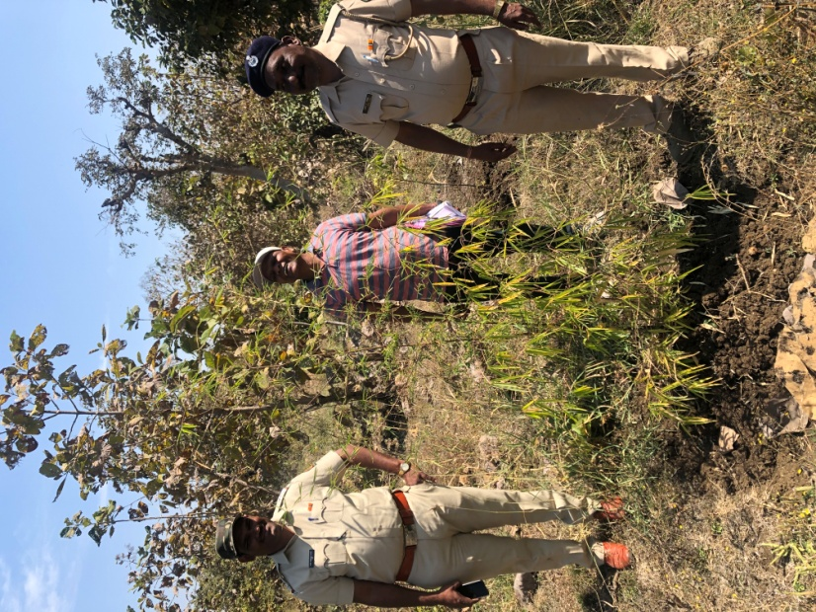
SITE WISE EVALUATION ABSTRACT
Site Number: 32

A. Description of site
Name of Site- Mozar
Place- Gat No. 81
Beat- Mozar Round- Mozar
Range- Ner Forest Division- Yawatmal
Forest Circle- Yawatmal
Area of Treatment- Plantation: 40.850 Ha. GPS: Polygon: 40.850 Ha.
Difference- No change
Status of Land- Reserved Forest- No Protected Forest- No
Unclassed Forest- No Received as compensatory land- Yes
Zudpi Jungle- No
Site quality- Density- Less than 0.1 Slope- Moderate
Available vegetation (Local Names)- Trees Teak, Palas, Hiwar, / Shrubs Chilati, Barhati / Grass Marvel , Kalela, Gondela
B. Plantation Details
Model - 1111 plants/ha.
Spacement- 3 × 3
Treatment Map- Yes
Soil Zone- Zone-II
Species selected for planting- Teak(7094 × 462 × 25 × 5), Bel(2 × 230)

C. Survival & Status
Site suitability- Suitable
Suitability of species planted- No , Sisso and Karanj need black cotton soil or having good soil deepth . But this is eroded ,murami soil depth not more than 30 cms
Plant survival percentage- 89%
Average Height of plants- 90 cm
Average girth of plants-
General Health of Plants- Unhealthy
Sustainability- Though watering is provided to plants and barbed wire fencing, due to fire and poor quality of tending operation plants remain unhealthy and lanky, so sustainability is low

D. Protection-
Fencing Status- Barbed Wire / Chain Link - 1550 Rmt.
Fire- Amount Sanctioned in the estimate- Rs. 19908.00/-
Execution of the work- Work Done
Expenditure/Payment of the work- Rs. 16324.00/-
Grazing- No grazing

E. Monitoring
Inspection of Plantations- APCCF - 0, CCF - 0, DCF - 0, ACF - 3, RFO - 8
Plantation register- Up-to date
Measurement Book- Up-to date
Cash Book- Up-to-date
Financial audit- Not Done
Fund pattern- Last year Funds not available timely
F. Overall Rating A Grade
(Excellent – A+, Very Good – A, Good – B+, Average – B, C-Poor)
Reasons for success/ Failure- Though barbed wired fencing and watering to plants provided in first year, growth of the plants shunted due to low quality of post plantation cultural operation and damage by fire in first year itself

G. Date of Evaluation 18 Feb 2020
Name of Evaluators Mr. U. M. Dhopeshwarkar, Mr. R. T. More
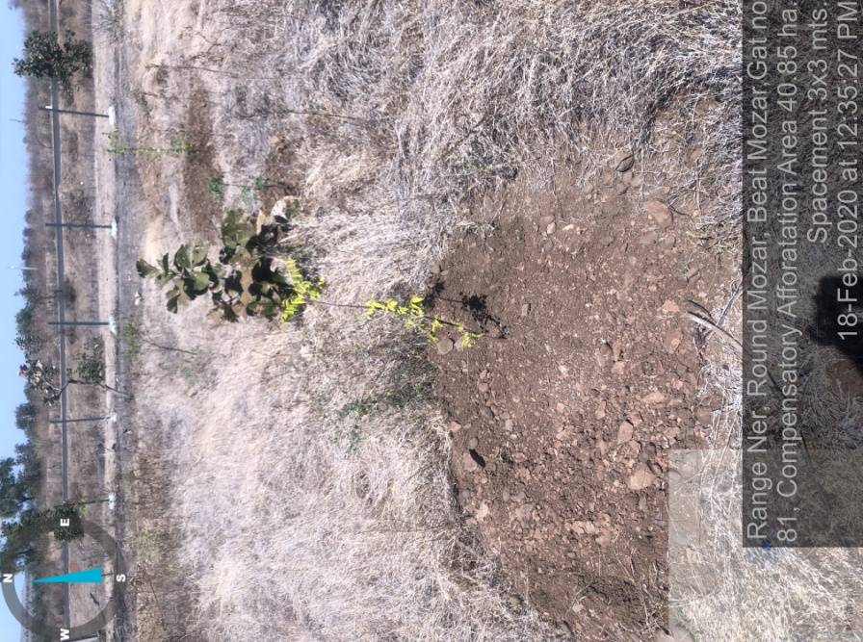
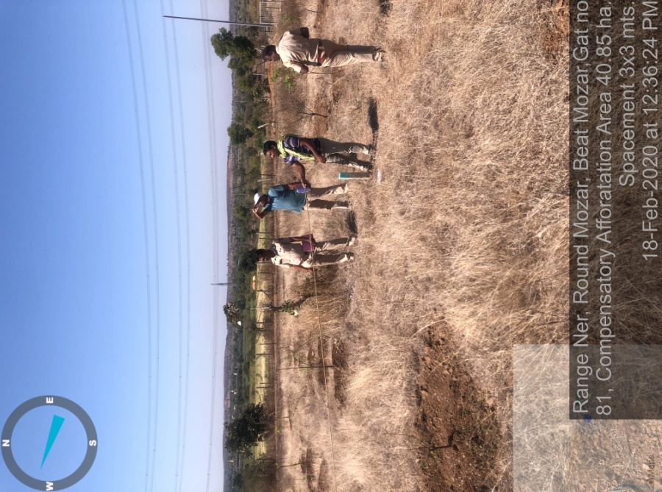
H. Photographs-

SITE WISE EVALUATION ABSTRACT
5th Year Works: Site No. 33-44
Site Number: 33

A. Description of site
Name of Site- Vishroli
Place- Survey 262 to 268, 311, 313 to 315, 324
Beat- Vishroli Round- Shirajgaon
Range- Paratwada Forest Division- Amravati
Forest Circle- Amravati
Area of Treatment- Plantation: 24.500 Ha. GPS: Polygon: 23.593 Ha.
Difference- Less 0.907 Ha.
Status of Land- Reserved Forest- No Protected Forest- No
Unclassed Forest- No Received as compensatory land- Yes
Zudpi Jungle- No
Site quality- NR Density- NR Slope- Gentle
Available vegetation (Local Names)- Palas, Babhul, Bor, Nim, Grasses- Marvel, Tikadi, Kunda, Pavnya
B. Plantation Details
Model - 1111 plants/ha.
Spacement- 3 × 3
Treatment Map- Yes
Soil Zone- Zone-III
Species selected for planting- Teak, Karanj, Awala, Sitafal, Papla, Bamboo, Jambhul

C. Survival & Status
Site suitability- NR
Suitability of species planted- Yes
Plant survival percentage- 16%
Average Height of plants- 192 cm
Average girth of plants- 8 cm
General Health of Plants- Healthy
Sustainability- The plantation is divided in three parts and surrounded by agriculture field therefor it is well protected from illicit grazing

D. Protection-
Fencing Status- TCM - 2175 Rmt.
Fire- Amount Sanctioned in the estimate- Rs. 13107.50/-
Execution of the work- Work Done
Expenditure/Payment of the work- Rs. 13926.00/-
Grazing- Not ofserved

E. Monitoring
Inspection of Plantations- APCCF - 1, CCF - 0, DCF - 1, ACF - 4, RFO - 3
Plantation register- Up-to date
Measurement Book- Up-to date
Cash Book- Not Available
Financial audit- Done. Year - 2018-19
Fund pattern- The funds received are utilized timely.
F. Overall Rating B Grade
(Excellent – A+, Very Good – A, Good – B+, Average – B, C-Poor)
Reasons for success/ Failure- Watering facility must be added in plantation plan so that survival of plantation can be more. Fencing/ Chainlink shouled be provided for the plantation area surrounded by agriculture fields.

G. Date of Evaluation 24 Feb 2020
Name of Evaluators Mr. S. N. Bhagat, Mr. V. B. Nimbhorkar
H. Photographs-
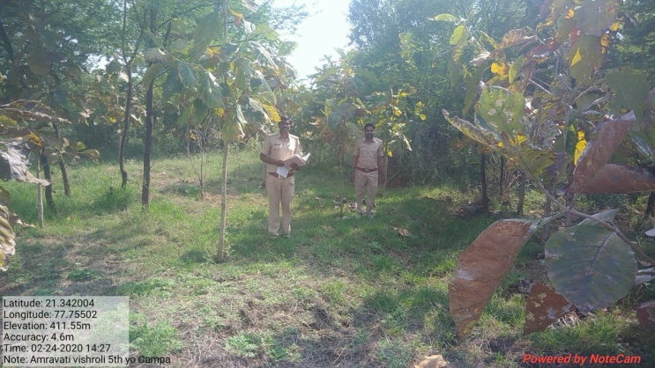
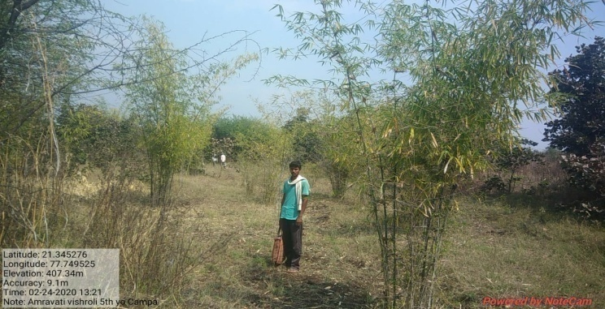
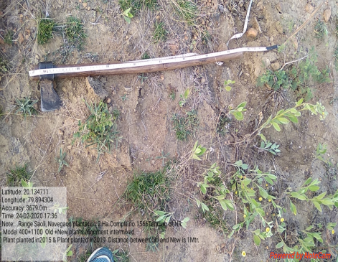

SITE WISE EVALUATION ABSTRACT
Site Number: 34

A. Description of site
Name of Site- Ganori (East)
Place- 171/ G.N.23, 24A
Beat- Ganori (East) Round- Ganori
Range- Khultabad Forest Division- Aurangabad
Forest Circle- Aurangabad
Area of Treatment- Plantation: 8.190 Ha. GPS: Polygon: 13.600 Ha.
Difference- Excess 5.410 Ha.
Status of Land- Reserved Forest- Yes Protected Forest- No
Unclassed Forest- No Received as compensatory land- No
Zudpi Jungle- No
Site quality- Degraded Density- 0.1 to 0.2 Slope- Gentle
Available vegetation (Local Names)- Shrubs
B. Plantation Details
Model - 1111 plants/ha.
Spacement- 3 × 3
Treatment Map- Yes
Soil Zone- Zone-II
Species selected for planting- Neem, Sisoo, Awala, Bamboo, Sitafal, Jambhul, Bhedi, Khair

C. Survival & Status
Site suitability- Suitable
Suitability of species planted- Yes
Plant survival percentage- 42%
Average Height of plants- 150 cm
Average girth of plants-
General Health of Plants- Healthy
Sustainability- Good

D. Protection-
Fencing Status- TCM - 818 Rmt.
Fire- Amount Sanctioned in the estimate- Rs. 4754.95/-
Execution of the work- Work Done
Expenditure/Payment of the work- Rs. 4744.00/-
Grazing- Grazing by Chinkara

E. Monitoring
Inspection of Plantations- APCCF - 0, CCF - 0, DCF - 1, ACF - 1, RFO - 0
Plantation register- Up-to date
Measurement Book- Up-to date
Cash Book- Up-to date
Financial audit- Done. Year2 018-19
Fund pattern- Flow of funds is irregular
F. Overall Rating B+ Grade
(Excellent – A+, Very Good – A, Good – B+, Average – B, C-Poor)
Reasons for success/ Failure- Protective irrigation is recommended.

G. Date of Evaluation 28 Feb 2020
Name of Evaluators Mr. D. S. Pawar, Mr. P. H. Wagh
H. Photographs-
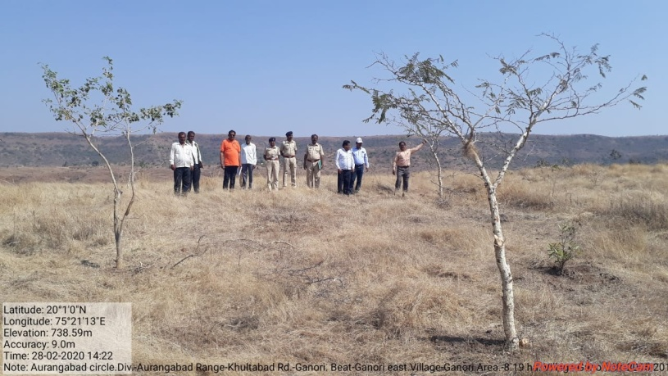
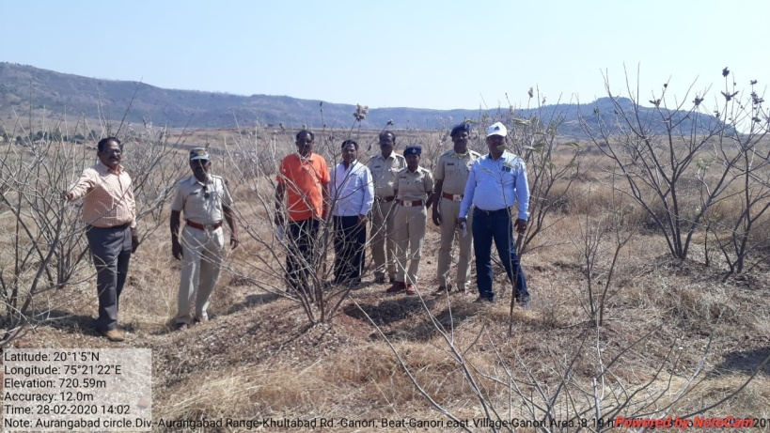

SITE WISE EVALUATION ABSTRACT
Site Number: 35

A. Description of site
Name of Site- Navegaon
Place- Comptt.No.1566
Beat- Navegaon Round- Vyahad
Range- Sawali Forest Division- Chandrapur
Forest Circle- Chandrapur
Area of Treatment- Plantation: 2.000 Ha. GPS: Polygon: 2.870 Ha.
Difference- Excess 0.870 Ha.
Status of Land- Reserved Forest- No Protected Forest- Yes
Unclassed Forest- No Received as compensatory land- No
Zudpi Jungle- No
Site quality- IV B Density- Less than 0.2 Slope- Gente
Available vegetation (Local Names)- Moha, Behada, Aawala,Tendu, Aajan, Kukutranzi, Bhutganja, Sindi, Ain
B. Plantation Details
Model - 400 + 1100 plants/ha.
Spacement- 5 × 5, 3 × 3
Treatment Map- No
Soil Zone- Zone-III
Species selected for planting- (2015) Shiras, Shisam, Karanj, Papada, Khair, Bel, Aajan, Aola, Kawath, Sisoo

C. Survival & Status
Site suitability- Suitable
Suitability of species planted- Yes, NR
Plant survival percentage- 2015- 8%,2019-84.22 %
Average Height of plants- 2015-60 cm, 2019-50 cm
Average girth of plants- < 5 cm.
General Health of Plants- Semi-healthy
Sustainability- Sustain if protected from grazing

D. Protection-
Fencing Status- TCM - 223 Rmt., Barbed Wire / Chain Link - 1085 Rmt.
Fire- Amount Sanctioned in the estimate- Rs. 597.00/-
Execution of the work- Work Done
Expenditure/Payment of the work- Rs. 597.00/-
Grazing- No

E. Monitoring
Inspection of Plantations- APCCF - 0, CCF - 0, DCF - 0, ACF - 0, RFO - 2
Plantation register- Incomplete
Measurement Book- Up-to-date
Cash Book- Up-to-date
Financial audit- Not Done
Fund pattern- Funds are allotted to RFO after requisition from them only.
F. Overall Rating B+ Grade
(Excellent – A+, Very Good – A, Good – B+, Average – B, C-Poor)
Reasons for success/ Failure- `1st Year – Fail, 5th year may survive if protected from grazing.

G. Date of Evaluation 24 Feb 2020
Name of Evaluators Mr. S. M. Jagtap, Mr. B. T. Fartode
H. Photographs-

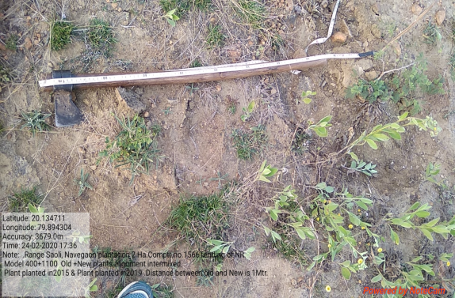
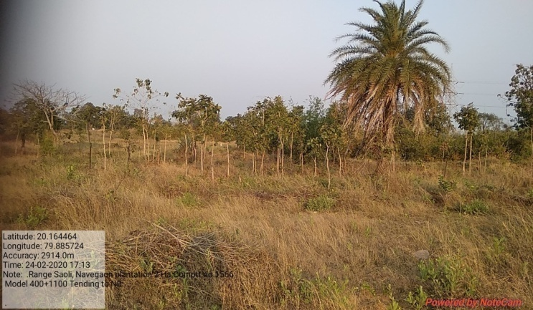
Nice Tending to NR
Difference between spacement FYO & 5th YO Planting

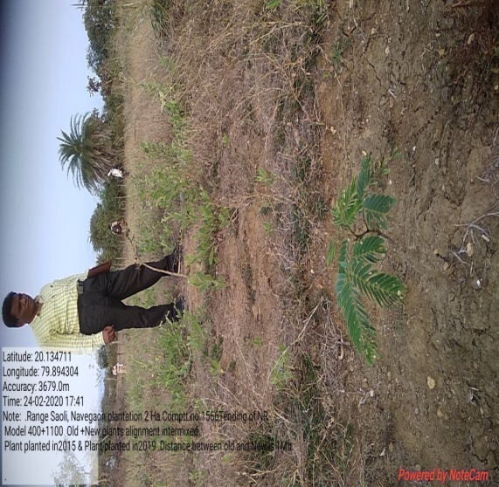
SITE WISE EVALUATION ABSTRACT
Site Number: 36

A. Description of site
Name of Site- Sukapur
Place- Compartment No:215
Beat- Dangshirwade Round- Dangshirwade
Range- Pimpalner Forest Division- Dhule
Forest Circle- Dhule
Area of Treatment- Plantation: 16.000 Ha. GPS: Polygon: 19.000 Ha.
Difference- Excess 3.000 Ha.
Status of Land- Reserved Forest- Yes Protected Forest- No
Unclassed Forest- No Received as compensatory land- No
Zudpi Jungle- No
Site quality- Normal Density- 0.5 Slope- Moderate (10 to 25 degrees)
Available vegetation (Local Names)- Teak, Anjan, Dhavda, Beheda, Moha, Tendu, Kanchan, Babhul, Khair, Subabhul, Shrubs, Henkal, Arroni, Agave, Ghaneri, Gokhanu, Apata, Grass, Kusal, Shedya, Kolha, Bondars, Tokanya
B. Plantation Details
Model - 400 + 1100 plants/ha.
Spacement- 5 × 5, 3 × 3
Treatment Map- Yes
Soil Zone- N.A
Species selected for planting- Karanj, Chinch, Bamboo, Sissoo, Jambhul, Amaltas, Beheda, Neem, Shiras, Umban, Chinch, Pimpal, Khair, Kanchan, Moha

C. Survival & Status
Site suitability- Suitable
Suitability of species planted- Yes
Plant survival percentage- 87%
Average Height of plants- 110 cm
Average girth of plants-
General Health of Plants- Healthy
Sustainability- Definitely sustainable

D. Protection-
Fencing Status- No
Fire- Amount Sanctioned in the estimate- Rs. Sanctioned estimate/-
Execution of the work- Work Not Done
Expenditure/Payment of the work- Rs. 0.00/-
Grazing- Susceptible to grazing but well protected

E. Monitoring
Inspection of Plantations- APCCF - 0, CCF - 0, DCF - 0, ACF - 0, RFO - 0
Plantation register-
Measurement Book-
Cash Book-
Financial audit- Not Done
Fund pattern- No funds were received during current FY.
F. Overall Rating A Grade
(Excellent – A+, Very Good – A, Good – B+, Average – B, C-Poor)
Reasons for success/ Failure- Good work by the filed staff, but TCM should be provided.

G. Date of Evaluation 18 Feb 2020
Name of Evaluators Mr. S. K. Gawali, Mr. B. R. Challare
H. Photographs-
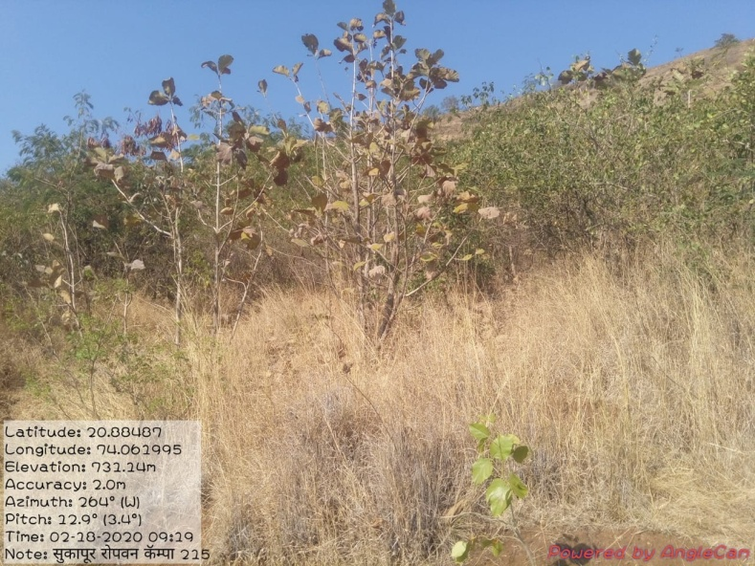

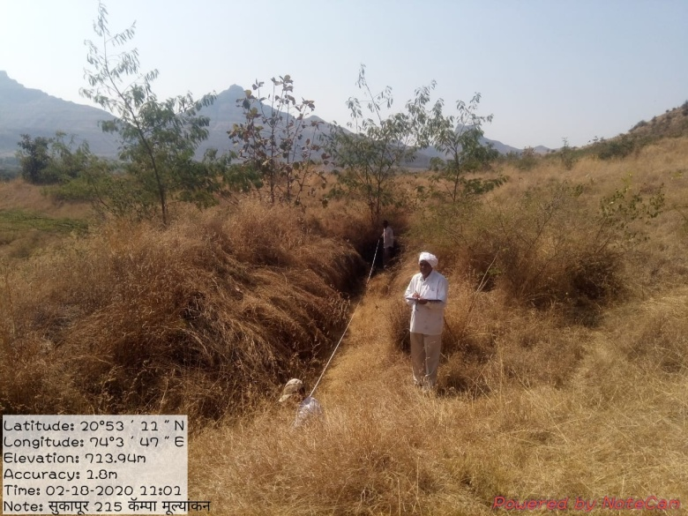
SITE WISE EVALUATION ABSTRACT
Site Number: 37

A. Description of site
Name of Site- Shirsi (Ganeshpur)
Place- Comptt. No.62
Beat- Bori Round- Porla
Range- Porla Forest Division- Wadsa
Forest Circle- Gadchiroli
Area of Treatment- Plantation: 25.000 Ha. GPS: Polygon: 29.690 Ha.
Difference- Excess 4.690 Ha.
Status of Land- Reserved Forest- Yes Protected Forest- No
Unclassed Forest- No Received as compensatory land- No
Zudpi Jungle- No
Site quality- IV/III Density- Less than 0.4 Slope- Gentle
Available vegetation (Local Names)- Khair, Neem, Moha, Bija, Ain , Bel, Arjun, Tendu, Bor, Rohan, Garadi, Tenndu, Ukshi, Chiman Chara, Kusal, Amarvel
B. Plantation Details
Model - 1111 plants/ha.
Spacement- 3 × 3
Treatment Map- Yes
Soil Zone- Zone-II, Zone-III
Species selected for planting- Khair, Holoptelia integrefolia, Albizia, Embelica oficinalis, Neem,Tamarindus,Sisoo, Pongamia pinnata, Arjun, Maligna arborea, Eagle marmelos, Mellotus, Pongammia pinnata

C. Survival & Status
Site suitability- Suitable
Suitability of species planted- Yes
Plant survival percentage- 67%
Average Height of plants- 100 cm
Average girth of plants- 6.0 cm
General Health of Plants- Healthy
Sustainability- Part of area is water logged. Sustenance is partly.

D. Protection-
Fencing Status- TCM - 2650 Rmt.
Fire- Amount Sanctioned in the estimate- Rs. 14918.00/-
Execution of the work- Work Done
Expenditure/Payment of the work- Rs. 14918.00/-
Grazing- No

E. Monitoring
Inspection of Plantations- APCCF - 0, CCF - 0, DCF - 2, ACF - 0, RFO - 3
Plantation register- Up-to date
Measurement Book- Up-to date
Cash Book- Up-to date
Financial audit- Not Done
Fund pattern- Funds are allotted to RFO after requisition from them only.
F. Overall Rating B+ Grade
(Excellent – A+, Very Good – A, Good – B+, Average – B, C-Poor)
Reasons for success/ Failure- Plants in water logged area in rainy season will not survive.Rest part is sucessful and plants are healthy.Quality of operations is good.
G. Date of Evaluation 19 Feb 2020
Name of Evaluators Mr. S. M. Jagtap, Mr. B. T. Fartode
H. Photographs-

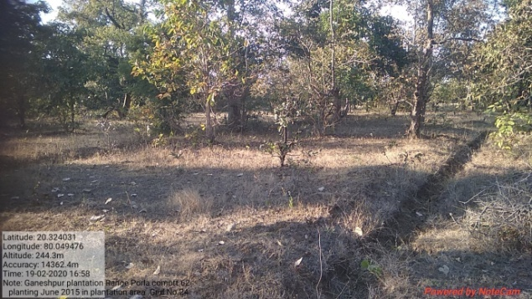
Water logged area
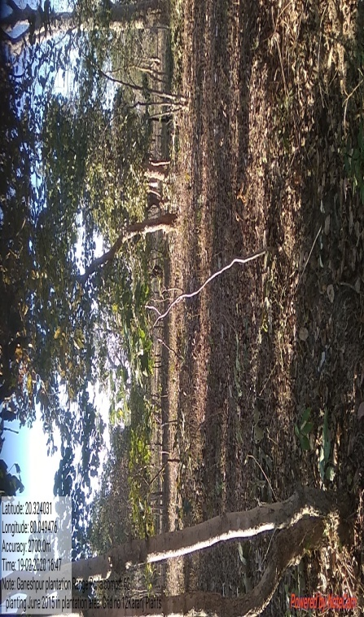
Healthy Karanj Plants
SITE WISE EVALUATION ABSTRACT
Site Number: 38

A. Description of site
Name of Site- Shivrajpur (Kondhala)
Place- 812
Beat- Kondhala Round- Wadsa
Range- Wadsa Forest Forest Division- Wadsa
Forest Circle- Gadchiroli
Area of Treatment- Plantation: 4.000 Ha. GPS: Polygon: 4.500 Ha.
Difference- Excess 0.500 Ha.
Status of Land- Reserved Forest- No Protected Forest- Yes
Unclassed Forest- No Received as compensatory land- No
Zudpi Jungle- No
Site quality- IVB Density- Less than 0.4 Slope- Gentle
Available vegetation (Local Names)- Neem , Bor, Tenndu, Takla, Thamhini & Kuda
B. Plantation Details
Model - 1111 plants/ha.
Spacement- 3 × 3
Treatment Map- No
Soil Zone- Zone-II,
Species selected for planting- Neem, Eagle marmelos, Bamboo, Teak, Karanj, Sitafal

C. Survival & Status
Site suitability- Suitable
Suitability of species planted- No. Very hard strata. Old mining observed. Adjacent to village Kondhala. Except Neem & Khair other spp.will not survive.
Plant survival percentage- 44%
Average Height of plants- 150 cm
Average girth of plants- 12.0 cm
General Health of Plants- Semi-healthy
Sustainability- Except few plants of Neem & stunted growth of Teak all other plants will not survive.

D. Protection-
Fencing Status- Barbed Wire / Chain Link - 1085 Rmt.
Fire- Amount Sanctioned in the estimate- Rs. 2387.00/-
Execution of the work- Work Done
Expenditure/Payment of the work- Rs. 2387.00/-
Grazing- Yes, villagers tried to break Barbed wire fencing to allow grazing and trespass for Natures call.

E. Monitoring
Inspection of Plantations- APCCF - 0, CCF - 0, DCF - 0, ACF - 1, RFO - 1
Plantation register- Up-to date
Measurement Book- Up-to date
Cash Book- Up-to date
Financial audit- Not Done
Fund pattern- Funds are allotted to RFO after requisition from them only.
F. Overall Rating B Grade
(Excellent – A+, Very Good – A, Good – B+, Average – B, C-Poor)
Reasons for success/ Failure- Site is not suitable for plantation.Though survival of teak & Neem observed,growth of Teak is stunted.
G. Date of Evaluation 20 Feb 2020
Name of Evaluators Mr. S. M. Jagtap, Mr. B. T. Fartode
H. Photographs-
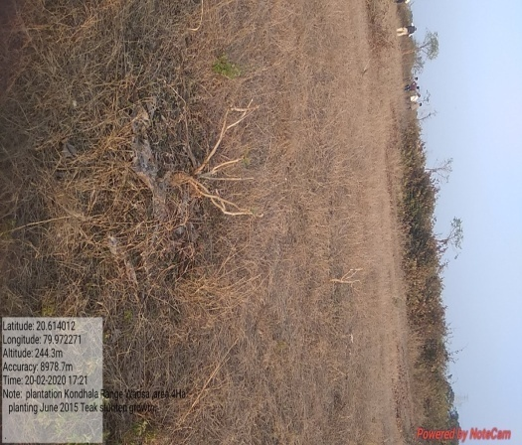
Stunted growth of Teak plants planted in 2015

SITE WISE EVALUATION ABSTRACT
Site Number: 39

A. Description of site
Name of Site- Manwad
Place- 234
Beat- Manwad Round- Manwad
Range- Panhala Forest Division- Kolhapur
Forest Circle- Kolhapur
Area of Treatment- Plantation: 14.660 Ha. GPS: Polygon: 16.660 Ha.
Difference- No change
Status of Land- Reserved Forest- No Protected Forest- No
Unclassed Forest- No Received as compensatory land- Yes
Zudpi Jungle- No
Site quality- IV b Density- Less than 0.4 Slope- Moderate
Available vegetation (Local Names)- Trees Hirda, Jabhul, Hela, Arjani, Kinjal, Shrubs,Dhayanti, Karwandi, Ain, Kumbha / Grass Mirvel, Kusal, Kazdel, Tambit, Suzal
B. Plantation Details
Model - 625 plants/ha.
Spacement- 4 × 4
Treatment Map- Yes
Soil Zone- Zone-III
Species selected for planting- Jamun, Awala, Hed, Bamboo, Kanchn

C. Survival & Status
Site suitability- Suitable
Suitability of species planted- Exept Kanchan, all species are suitable
Plant survival percentage- 92%
Average Height of plants- 55 cm
Average girth of plants-
General Health of Plants- Healthy
Sustainability- Sustainable

D. Protection-
Fencing Status- TCM - 1495 Rmt.
Fire- Amount Sanctioned in the estimate- Rs. 8184.00/-
Execution of the work- Work Done
Expenditure/Payment of the work- Rs. 8184.00/-
Grazing- Yes

E. Monitoring
Inspection of Plantations- APCCF - 0, CCF - 0, DCF - 0, ACF - 1, RFO - 1
Plantation register- Up-to-date
Measurement Book- Up-to-date
Cash Book- Up-to-date
Financial audit- Not Done
Fund pattern- Reguler Except curent year
F. Overall Rating A Grade
(Excellent – A+, Very Good – A, Good – B+, Average – B, C-Poor)
Reasons for success/ Failure- Regular fund

G. Date of Evaluation 20 Feb 2020
Name of Evaluators Mr. S. S. Dole, Mr. V. B. Patil
H. Photographs-
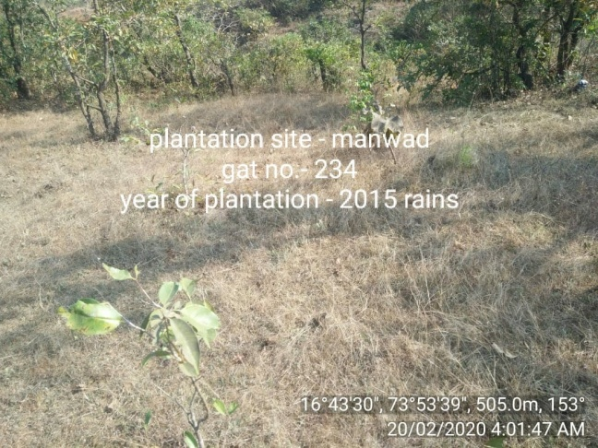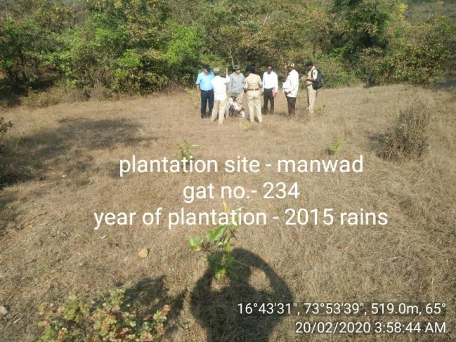
SITE WISE EVALUATION ABSTRACT
Site Number: 40

A. Description of site
Name of Site- Manbet
Place- 122, 123, 124
Beat- Kandalgaon Round- Sarvande
Range- Radhanagari Forest Division- Kolhapur
Forest Circle- Kolhapur
Area of Treatment- Plantation: 25.880 Ha. GPS: Polygon: 35.650 Ha.
Difference- Excess 10.770 Ha.
Status of Land- Reserved Forest- No Protected Forest- No
Unclassed Forest- No Received as compensatory land- Yes
Zudpi Jungle- No
Site quality- Poor Density- Less than 0.3 Slope- All typea of slope
Available vegetation (Local Names)- Trees: Kanjal, Dhawada, Ain, Amba, Jambul. Shrubs: Karwand, Aliv, Herb: Fern Grass: Kurad, Kusal,Tambit, Surad
B. Plantation Details
Model - 625 plants/ha.
Spacement- 4 × 4
Treatment Map- Yes
Soil Zone- Zone-III
Species selected for planting- Sawar, Khair, Awala, Jambul, Hed, Narka, Pangara, Umber, Varas, Kurashi, Kumbhi, Phanas, Toriphal, Kokam

C. Survival & Status
Site suitability- Suitable
Suitability of species planted- Yes
Plant survival percentage- 53%
Average Height of plants- 65 cm
Average girth of plants-
General Health of Plants- Semi-healthy
Sustainability- Sustainable if proper protection is done

D. Protection-
Fencing Status- TCM - 500 Rmt.
Fire- Amount Sanctioned in the estimate- Rs. 14448.00/-
Execution of the work- Work Done
Expenditure/Payment of the work- Rs. 14448.00/-
Grazing- No grazing

E. Monitoring
Inspection of Plantations- APCCF - 0, CCF - 0, DCF - 0, ACF - 0, RFO - 0
Plantation register- Up-to-date
Measurement Book- Up-to-date
Cash Book- Up-to-date
Financial audit- Not Done
Fund pattern- Funding received timely.
F. Overall Rating B+ Grade
(Excellent – A+, Very Good – A, Good – B+, Average – B, C-Poor)
Reasons for success/ Failure- Area at the plantation tallies with GPS.

G. Date of Evaluation 22 Feb 2020
Name of Evaluators Mr. S. S. Dole, Mr. V. B. Patil
H. Photographs-
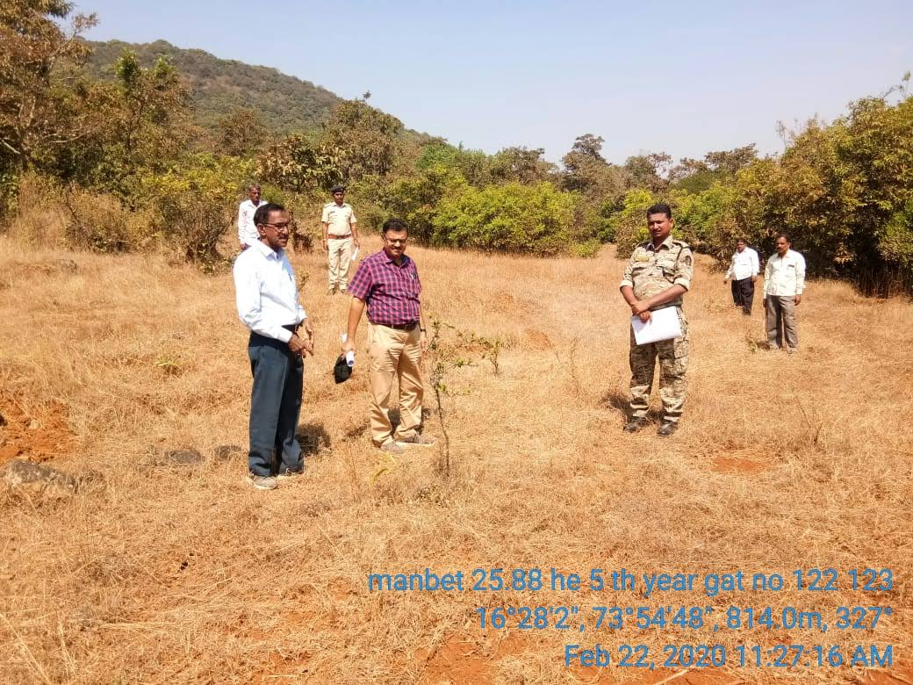

SITE WISE EVALUATION ABSTRACT
Site Number: 41

A. Description of site
Name of Site- Borgaon
Place- 1627/1
Beat- Wadegaon Round- Mulla
Range- N.Deori Forest Division- Gondia
Forest Circle- Nagpur
Area of Treatment- Plantation: 8.000 Ha. GPS: Polygon: 9.110 Ha.
Difference- Excess 1.110 Ha.
Status of Land- Reserved Forest- No Protected Forest- Yes
Unclassed Forest- No Received as compensatory land- No
Zudpi Jungle- No
Site quality- IV A Density- 0.3 Slope- Gentle
Available vegetation (Local Names)- Movai, Salai, Moha, Sindi, Dhoban, Bija, Garadi, Kuda, Kausal, Zadu Gawat
B. Plantation Details
Model - 625 plants/ha.
Spacement- 4 × 4
Treatment Map- No
Soil Zone- No zonation map prepared
Species selected for planting- Teak, Aawala, Arjun

C. Survival & Status
Site suitability- Suitable
Suitability of species planted- Yes
Plant survival percentage- 86%
Average Height of plants- 155 cm
Average girth of plants- 14 cm
General Health of Plants- Healthy
Sustainability- It will sustain, needs protection from grazing

D. Protection-
Fencing Status- TCM - 816 Rmt., Barbed Wire / Chain Link - 1400 Rmt.
Fire- Amount Sanctioned in the estimate- Rs. 4587.68/-
Execution of the work- Work Done
Expenditure/Payment of the work- Rs. 4774.00/-
Grazing- Yes

E. Monitoring
Inspection of Plantations- APCCF - 0, CCF - 0, DCF - 0, ACF - 0, RFO - 4
Plantation register- Maintained but not properly filled
Measurement Book- Not duly signed by RFO
Cash Book- Up-to date
Financial audit- Done. 2018-19
Fund pattern- It shows that funds flow is regular till Sep-19. Not received since October 2019
F. Overall Rating A+ Grade
(Excellent – A+, Very Good – A, Good – B+, Average – B, C-Poor)
Reasons for success/ Failure- The boundary of the plantation should be completely fenced for better protection.The planting stock should not be less than 18 months old.The treatment & zonation map should be proper with details.

G. Date of Evaluation 19 Feb 2020
Name of Evaluators Mr. A. S. Khune, Mr. D. S. Gadpande
H. Photographs-
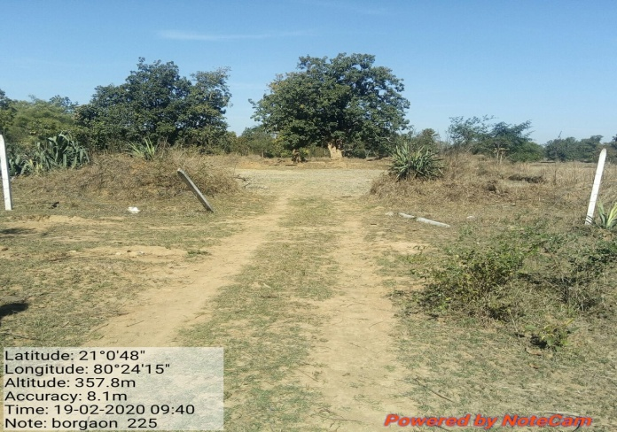
Broken fencing

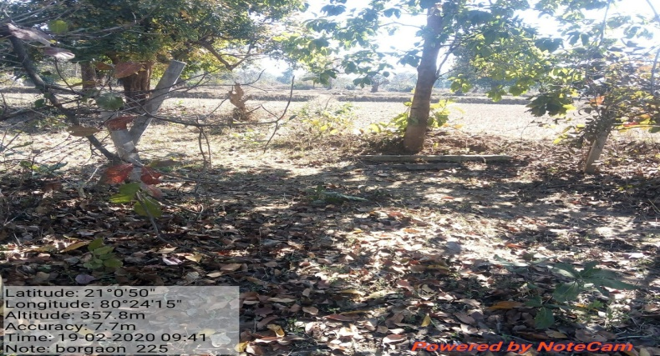
SITE WISE EVALUATION ABSTRACT
Site Number: 42

A. Description of site
Name of Site- Malegaon Mordara (Mulher)
Place- Sr.No.39 Comp. No.176
Beat- Mulher Round- Mulher
Range- Taharabad Forest Division- Malegaon
Forest Circle- Nashik
Area of Treatment- Plantation: 3.000 Ha. GPS: Polygon: 6.540 Ha.
Difference- Excess 3.540 Ha.
Status of Land- Reserved Forest- Yes Protected Forest- No
Unclassed Forest- No Received as compensatory land- No
Zudpi Jungle- No
Site quality- Normal Density- 0.3 to 0.4 Slope- Moderate
Available vegetation (Local Names)- Mixed
B. Plantation Details
Model - 1111 plants/ha.
Spacement- 3 × 3
Treatment Map- Yes
Soil Zone- Zone-I, Zone-II
Species selected for planting- Neem, Awala, Bamboo

C. Survival & Status
Site suitability- Suitable
Suitability of species planted- Yes
Plant survival percentage- 45%
Average Height of plants- 500 cm
Average girth of plants-
General Health of Plants- Healthy
Sustainability- Good

D. Protection-
Fencing Status- TCM - 439.56 Qbm.
Fire- Amount Sanctioned in the estimate- Rs. 947.00/-
Execution of the work- Work Not Done
Expenditure/Payment of the work- Rs. 0.00/-
Grazing- Damage to the plants by wild life

E. Monitoring
Inspection of Plantations- APCCF - 0, CCF - 0, DCF - 0, ACF - 0, RFO - 1
Plantation register- Up-to date
Measurement Book- Up-to date
Cash Book- Up-to date
Financial audit- Done. Year 2018-19
Fund pattern- Flow of funds is irregular
F. Overall Rating B+ Grade
(Excellent – A+, Very Good – A, Good – B+, Average – B, C-Poor)
Reasons for success/ Failure- Strict protection measures are recommended and People's participation is essential.

G. Date of Evaluation 17 Feb 2020
Name of Evaluators Mr. D. S. Pawar, Mr. P. H. Wagh
H. Photographs-
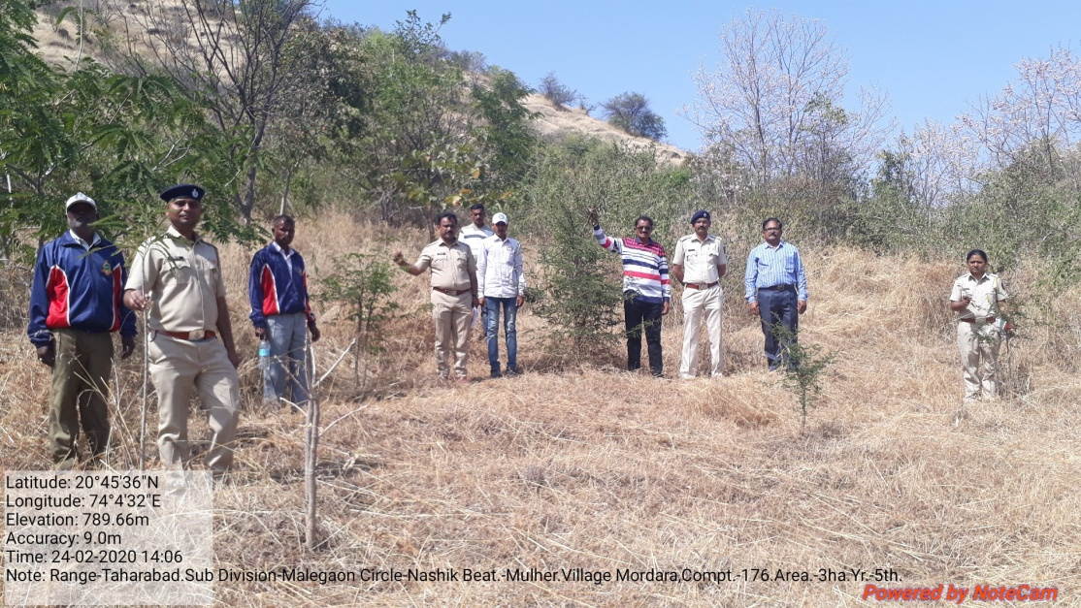
SITE WISE EVALUATION ABSTRACT
Site Number: 43

A. Description of site
Name of Site- Kardal
Place- 33
Beat- Kardal Round- Safale
Range- Safale Forest Division- Dahanu
Forest Circle- Thane
Area of Treatment- Plantation: 10.000 Ha. GPS: Polygon 11.120 Ha.
Difference- Excess 1.120 Ha.
Status of Land- Reserved Forest- No Protected Forest- No
Unclassed Forest- No Received as compensatory land- Yes
Zudpi Jungle- No
Site quality- Non forest area Density- Non forest area Slope- Gentle
Available vegetation (Local Names)- Few trees of Cashew, Palas, Sawan & Jambul are exsiting with shrubs of Karwand & climbers like Palaswel (Birtea supurba) & Ukshi
B. Plantation Details
Model - 1111 plants/ha.
Spacement- 3 × 3
Treatment Map- Yes
Soil Zone- Zone-III
Species selected for planting- Cashew, Bahava, Kanchan, Aaola, Saptpurni, Kadamb, Jambhul, Neem, Mango, Shisoo, Khaya, Bamboo, Karanj etc.

C. Survival & Status
Site suitability- Suitable
Suitability of species planted- Yes
Plant survival percentage- 83%
Average Height of plants- 450 cm
Average girth of plants- 33 cm
General Health of Plants- Healthy
Sustainability- Good.

D. Protection-
Fencing Status- TCM - 1048 Rmt., Barbed Wire / Chain Link - 1520 Rmt.
Fire- Amount Sanctioned in the estimate- Rs. 5583.00/-
Execution of the work- Work Done
Expenditure/Payment of the work- Rs. 5583.00/-
Grazing- Grazzing by strey cattle is noticed in Part II area only.

E. Monitoring
Inspection of Plantations- APCCF - 1, CCF - 1, DCF - 1, ACF - 1, RFO – 0, Others - 3
Plantation register- Up-to date
Measurement Book- Up-to date
Cash Book- Up-to date
Financial audit- Done. Year 2019-20
Fund pattern- Satisfactory.
F. Overall Rating A+ Grade
(Excellent – A+, Very Good – A, Good – B+, Average – B, C-Poor)
Reasons for success/ Failure- Cleaning and singling operations would be beneficial.

G. Date of Evaluation 28 Feb 2020
Name of Evaluators Mr. N. A. Patil
H. Photographs-
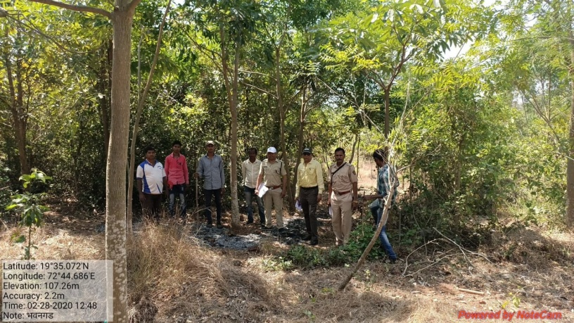
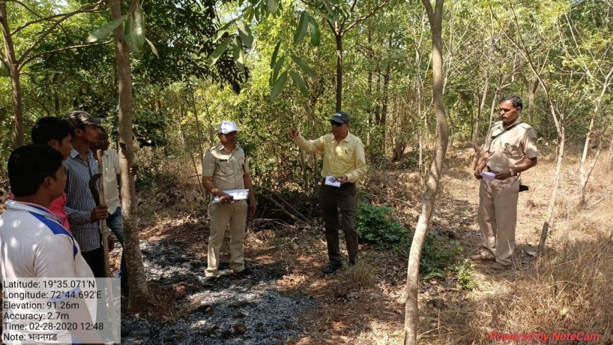
SITE WISE EVALUATION ABSTRACT
Site Number: 44

A. Description of site
Name of Site- Shil Ghatghar
Place- 64, 72 part
Beat- Shil Round- Kalyan
Range- Thane Forest Division- Thane
Forest Circle- Thane
Area of Treatment- Plantation: 6.460 Ha. GPS: Polygon: 10.500 Ha.
Difference- Excess 4.040 Ha.
Status of Land- Reserved Forest- Yes Protected Forest- No
Unclassed Forest- No Received as compensatory land- No
Zudpi Jungle- No
Site quality- 5A Density- 0.2 Slope- Gentle
Available vegetation (Local Names)- Shrubs and Grass
B. Plantation Details
Model - 2500 plants/ha.
Spacement- 2 × 2
Treatment Map- Yes
Soil Zone- Zone-II, Zone-III
Species selected for planting- Bamboo, Khair, Karanj, Jambhul, Kanchan, Shivan, Hirda, Apta, Awala, Chinch

C. Survival & Status
Site suitability- Suitable
Suitability of species planted- Yes
Plant survival percentage- 44%
Average Height of plants- 126 cm
Average girth of plants-
General Health of Plants- Semi-healthy
Sustainability- Poor.

D. Protection-
Fencing Status- Barbed Wire fencing for part of plantation area, which is totally destroyed now.
Fire- Amount Sanctioned in the estimate- Rs. 3607.00/-
Execution of the work- Work Done
Expenditure/Payment of the work- Rs. 3607.00/-
Grazing- No, inspite of plot borders

E. Monitoring
Inspection of Plantations- APCCF - 1, CCF - 0, DCF - 0, ACF - 0, RFO - 0
Plantation register- Incomplete
Measurement Book- Incomplete
Cash Book- Not available at site
Financial audit- Not done
Fund pattern- Regularly irregular.
F. Overall Rating B Grade
(Excellent – A+, Very Good – A, Good – B+, Average – B, C-Poor)
Reasons for success/ Failure- 1) The treatment map must be authenticated by RFO and ACF. 2) The work should be monitored at the appropriate time, so as to improve the quality of the field work. 3) Reglar fund flow is essential.

G. Date of Evaluation 18 Feb 2020
Name of Evaluators Mr. A. R. Thakre
H. Photographs-
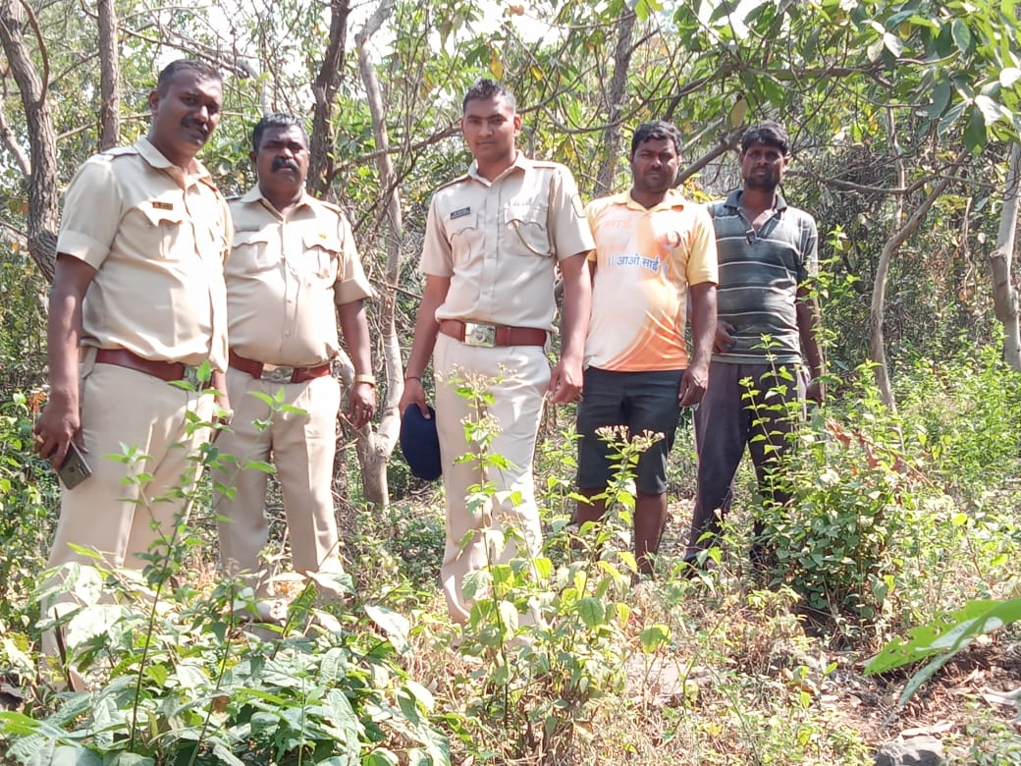
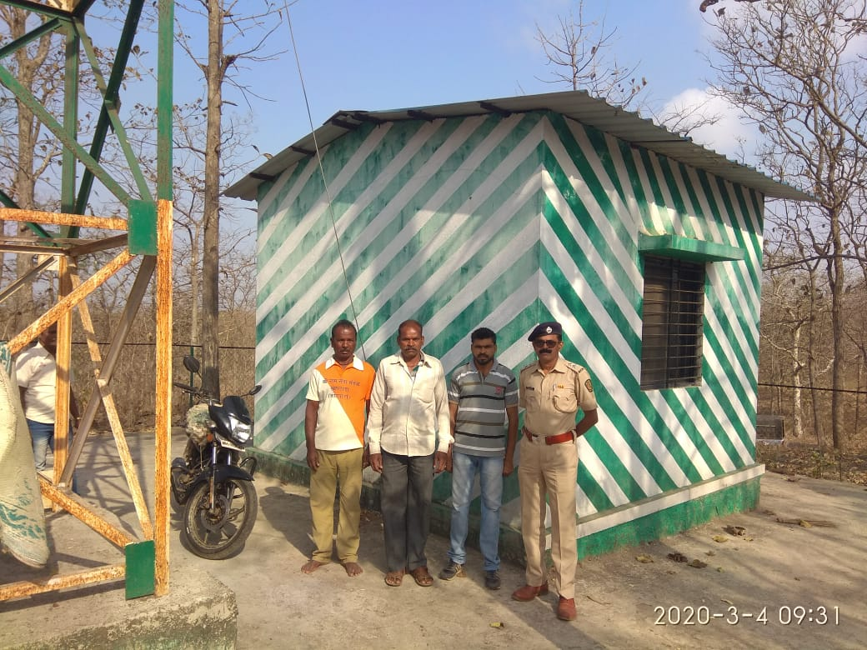

SITE WISE EVALUATION ABSTRACT
8th Year Works: Site No. 45-78
Site Number: 45

A. Description of site
Name of Site- Sawarkhed
Place- Survey No.E 02(E.Class)
Beat- Sawarkhed Round- Chondhi
Range- Patur Forest Division- Akola
Forest Circle- Amravati
Area of Treatment- plantation: 8.730 Ha. GPS: Polygon: 11.400 Ha.
Difference- Excess 2.670 Ha.
Status of Land- Reserved Forest- No Protected Forest- No
Unclassed Forest- No Received as compensatory land- Yes
Zudpi Jungle- No
Site quality- NR Density- NR Slope- Moderate
Available vegetation (Local Names)- Teak, Moha , Kalam, Anjan, Lendi, Dudhi, Palas , Bel, Ain, Thembrun, Aapta, Moin, Grass. Kusali, Marvel
B. Plantation Details
Model - 1111 plants/ha.
Spacement- 3 × 3
Treatment Map- Yes
Soil Zone- Zone-II, Zone-III
Species selected for planting- 1st Year Bamboo , 5th Year Mix species

C. Survival & Status
Site suitability- NR
Suitability of species planted- Yes
Plant survival percentage- 1st Year-29 %,5th Year-80.96
Average Height of plants- Bamboo: 422 cm, Other Plants: 278 cm
Average girth of plants- 16 cm
General Health of Plants- Healthy
Sustainability- If regularly protected from fire it will be a good Plantation

D. Protection-
Fencing Status- TCM - 1406 Rmt
Fire- Amount Sanctioned in the estimate- Rs. 1921.56/-
Execution of the work- Work Done
Expenditure/Payment of the work- Rs. 5223.00/-
Grazing- Not Obseved

E. Monitoring
Inspection of Plantations- APCCF - 0, CCF - 0, DCF - 0, ACF - 0, RFO - 1
Plantation register- up-to-date
Measurement Book- Up-to date
Cash Book- Not Available
Financial audit- Not Done
Fund pattern- Funds received are utilized timely.
F. Overall Rating A Grade
(Excellent – A+, Very Good – A, Good – B+, Average – B, C-Poor)
Reasons for success/ Failure- Good physical works & protection.There is scope for SMC works.

G. Date of Evaluation 21 Feb 2020
Name of Evaluators Mr. S. N. Bhagat, Mr. V. B. Nimbhorkar
H. Photographs-
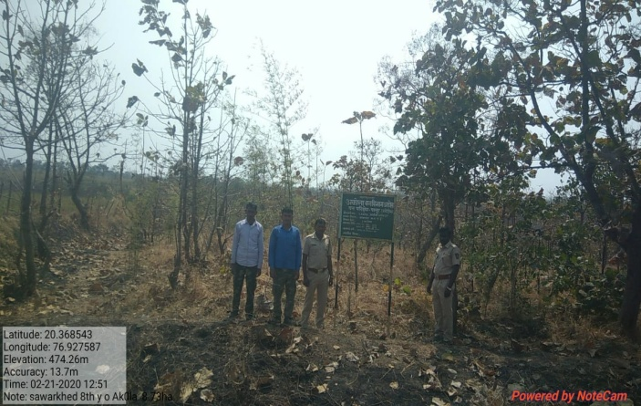

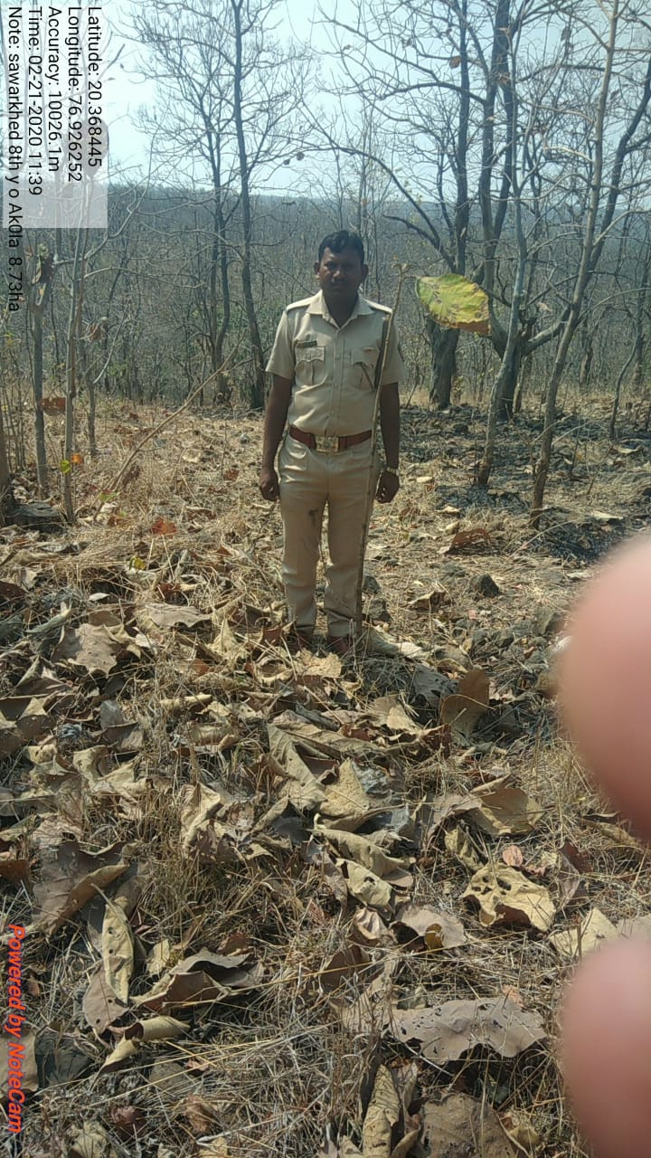
SITE WISE EVALUATION ABSTRACT
Site Number: 46

A. Description of site
Name of Site- Pardi
Place- Survey No.63, 86, 86/1, 101,102
Beat- Pardi Round- Morshi
Range- Morshi Forest Division- Amravati
Forest Circle- Amravati
Area of Treatment- Plantation: 12.300 Ha. GPS: Polygon: 12.641 Ha.
Difference- Excess 0.341 Ha.
Status of Land- Reserved Forest- No Protected Forest- No
Unclassed Forest- No Received as compensatory land- Yes
Zudpi Jungle- No
Site quality- NR Density- NR Slope- Gentle
Available vegetation (Local Names)- Babhul, Hiwar, Neem, Bor
B. Plantation Details
Model - 400 + 1100 plants/ha.
Spacement- 5 × 5, 3 × 3
Treatment Map- Yes
Soil Zone- Zone-III
Species selected for planting- Teak, Neem, Awala, Chinch, Shivan, Bamboo, Bor

C. Survival & Status
Site suitability- Sui
Suitability of species planted- Yes
Plant survival percentage- 32.50 %
Average Height of plants- 25 cm.
Average girth of plants- < 3 cm.
General Health of Plants- Unhealthy
Sustainability- Casualty replacement and barbed wire fencing may help in Sustainance of plantation.

D. Protection-
Fencing Status- TCM - 2191 Rmt.
Fire- Amount Sanctioned in the estimate- Rs. 2460.24/-
Execution of the work- Work Done
Expenditure/Payment of the work- Rs. 2784.00/-
Grazing- Illegal grazing

E. Monitoring
Inspection of Plantations- APCCF - 0, CCF - 0, DCF - 0, ACF - 0, RFO - 7
Plantation register- Up-to date
Measurement Book- Up-to date
Cash Book- Not Available in range office
Financial audit- Done. Year - 2017-18
Fund pattern- Funds received are utilized timely.
F. Overall Rating C Grade
(Excellent – A+, Very Good – A, Good – B+, Average – B, C-Poor)
Reasons for success/ Failure- As the land received as compensatory, it is nearer to village hence required barbed wire fencing or chainlink fencing Tall and stardy plants should be planted.

G. Date of Evaluation 22 Feb 2020
Name of Evaluators Mr. S. N. Bhagat, Mr. V. B. Nimbhorkar
H. Photographs-

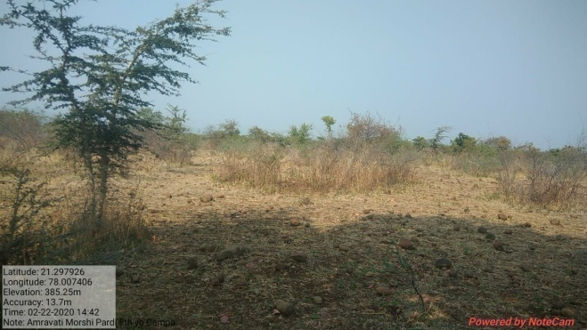

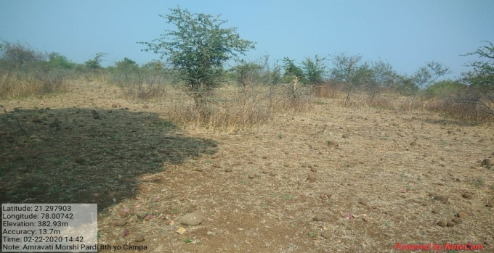
Degraded boulder area
SITE WISE EVALUATION ABSTRACT
Site Number: 47

A. Description of site
Name of Site- Kargata
Place- 257
Beat- Kargata Round- Sindevahi
Range- Sindevahi Forest Division- Bramhapuri
Forest Circle- Chandrapur
Area of Treatment- Plantation: 25.000 Ha. GPS: Polygon: 27.830 Ha.
Difference- Excess 2.830 Ha.
Status of Land- Reserved Forest- Yes Protected Forest- No
Unclassed Forest- No Received as compensatory land- No
Zudpi Jungle- No
Site quality- III Density- More than 0.4 Slope- Gente
Available vegetation (Local Names)- Teak, Bondara, Garadi, Moha, Medshing, Bel, Sajad, Kuda, Hiwar
B. Plantation Details
Model - 400 + 1100 plants/ha.
Spacement- 5 × 5, 3 × 3
Treatment Map- No
Soil Zone- Zone-III
Species selected for planting- Bamboo (2012), Khair, Ain, Medsing, Kawath, Bel, Teak (2017)

C. Survival & Status
Site suitability- Under-planting is done in dense forest. Selection of species is incorrect
Suitability of species planted- No , Planting in forest having density more than 0.4. Under planting of Teak spp.
Plant survival percentage- 2012-0.03 %, 2016-50.26 %
Average Height of plants- 2012-Bamboo-450 cm, 2016-Mix-53 cm
Average girth of plants- 2016-Mix-6.00 cm
General Health of Plants- Semi-healthy
Sustainability- Will not sustain except few established Bamboo clumps

D. Protection-
Fencing Status- TCM - 2400 Rmt.
Fire- Amount Sanctioned in the estimate- Rs. Nil/-
Execution of the work- Work Not Done
Expenditure/Payment of the work- Rs. 0.00/-
Grazing- No

E. Monitoring
Inspection of Plantations- APCCF - 0, CCF - 1, DCF - 1, ACF - 1, RFO - 7
Plantation register- Incomplete
Measurement Book- Incomplete
Cash Book- Up-to-date
Financial audit- Not Done
Fund pattern- No financial monitoring and checking of expenditure on plantation is observed.
F. Overall Rating B Grade
(Excellent – A+, Very Good – A, Good – B+, Average – B, C-Poor)
Reasons for success/ Failure- Underplanting of teak & misc.species in forest having crown density more than 0.6 will not survive.

G. Date of Evaluation 21 Feb 2020
Name of Evaluators Mr. S. M. Jagtap, Mr. B. T. Fartode
H. Photographs-
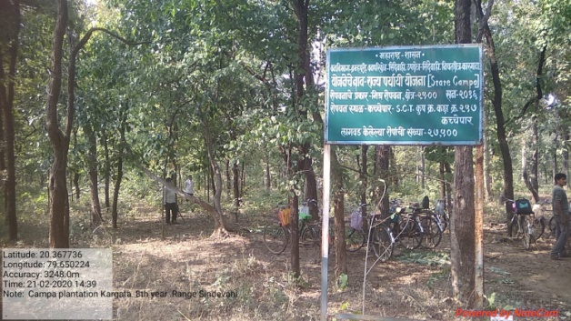
Density of forest > 0.4
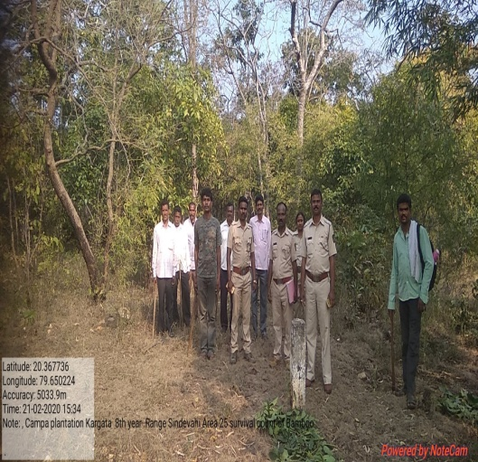
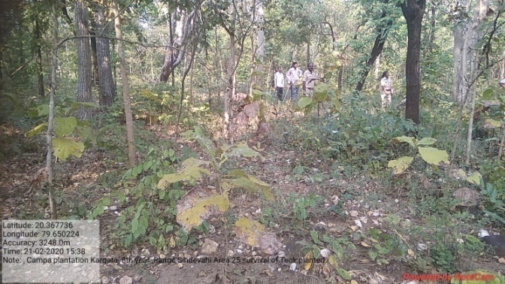
Only 3 Bamboo clumps,planted in 1st Year
Teak under planting 5th Year

SITE WISE EVALUATION ABSTRACT
Site Number: 48

A. Description of site
Name of Site- Chincholi
Place- 140
Beat- Chincholi Round- Wirur
Range- Wirur Forest Division- Central Chanda
Forest Circle- Chandrapur
Area of Treatment- Plantation: 5.000 Ha. GPS: Polygon: 7.190 Ha.
Difference- Excess 2.190 Ha.
Status of Land- Reserved Forest- Yes Protected Forest- No
Unclassed Forest- No Received as compensatory land- No
Zudpi Jungle- No
Site quality- IV Density- Less than 0.4 Slope- Gente
Available vegetation (Local Names)- Teak, Tendu, Moha, Dikamali, Kawith, Hiwar, Neem, Takla, Broom-grass & Kusal grass
B. Plantation Details
Model - 400 + 1100 plants/ha.
Spacement- 5 × 5, 3 × 3
Treatment Map- No
Soil Zone- Zone-III
Species selected for planting- Bamboo (2012), Khair, Sisoo, Aola, Karanj, Vilayati Chinch, Chinch & Shiras (2016)

C. Survival & Status
Site suitability- Suitabillity
Suitability of species planted- Yes, NR
Plant survival percentage- 30%(2012), 0 %(2017)
Average Height of plants- 63 cm
Average girth of plants- 6 cm
General Health of Plants- Unhealthy
Sustainability- Will not sustain except few established Karanj plants..

D. Protection-
Fencing Status- TCM - 425 Rmt.
Fire- Amount Sanctioned in the estimate- Rs. Nil/-
Execution of the work- Work Not Done
Expenditure/Payment of the work- Rs. 0.00/-
Grazing- Yes

E. Monitoring
Inspection of Plantations- APCCF - 0, CCF - 0, DCF - 0, ACF - 2, RFO - 0
Plantation register- Incomplete
Measurement Book- Incomplete
Cash Book- Up-to-date
Financial audit- Not Done
Fund pattern- No financial monitoring and checking of expenditure on plantation is observed.
F. Overall Rating B Grade
(Excellent – A+, Very Good – A, Good – B+, Average – B, C-Poor)
Reasons for success/ Failure- Worst quality physical works. No records,fire damages,grazing,broken TCM with road inside plantation.
G. Date of Evaluation 21 Feb 2020
Name of Evaluators Mr. S. M. Jagtap, Mr. B. T. Fartode
H. Photographs-
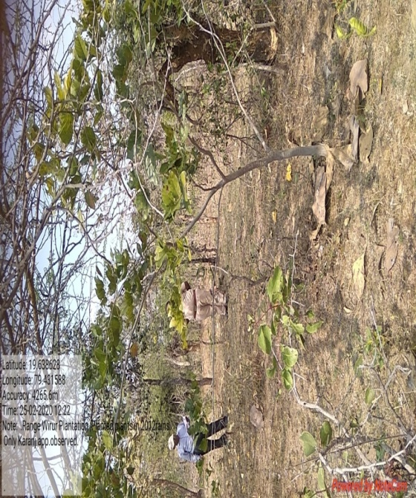
Only Karanj plants survived (2012) rains

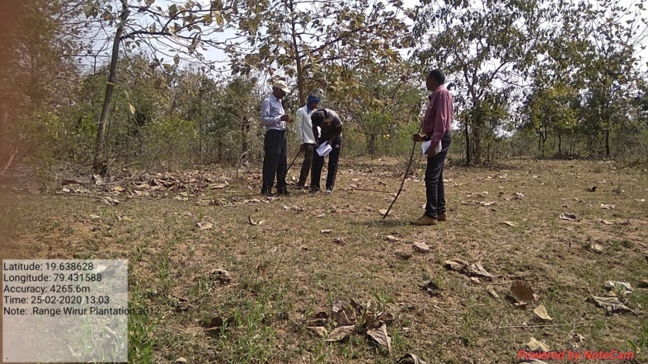
Not a single plant survived
(1100) planted in 2016

SITE WISE EVALUATION ABSTRACT
Site Number: 49

A. Description of site
Name of Site- Shemalya
Place- Compartment No:786
Beat- Panakhed Round- Wakwad
Range- Sangavi Forest Division- Dhule
Forest Circle- Dhule
Area of Treatment- Plantation: 40.000 Ha. GPS: Polygon: 61.000 Ha.
Difference- Excess 21.000 Ha.
Status of Land- Reserved Forest- Yes Protected Forest- No
Unclassed Forest- No Received as compensatory land- No
Zudpi Jungle- No
Site quality- III/IV Density- 0.4 Slope- Moderate (10 to 25 degrees)
Available vegetation (Local Names)- Teak, Palas, Maharukh, Neem, Babhul, proscpis, Ghaneri, Apta, Pawda, Rantulas, Takla, Zinrara, Bamboo, Tendu, Bhengurna
B. Plantation Details
Model - 400 + 1100 plants/ha.
Spacement- 5 × 5, 3 × 3
Treatment Map- Yes
Soil Zone- Zone-I, Zone-II, Zone-III
Species selected for planting- Teak, Khair, Neem, Aola, Chinch, Bor

C. Survival & Status
Site suitability- Suitable
Suitability of species planted- Yes
Plant survival percentage- 69%
Average Height of plants- 145 cm
Average girth of plants-
General Health of Plants- Healthy
Sustainability- very much suitable for planting

D. Protection-
Fencing Status- TCM - 2500 Rmt.
Fire- Amount Sanctioned in the estimate- Rs. 10470.80/-
Execution of the work- Work Done
Expenditure/Payment of the work- Rs. 10471.00/-
Grazing- No

E. Monitoring
Inspection of Plantations- APCCF - 0, CCF - 0, DCF - 2, ACF - 7, RFO - 8
Plantation register- UP-to-date
Measurement Book-
Cash Book- N.A Sent for audit
Financial audit- Not Done
Fund pattern- Record regarding finacial monitoring not available
F. Overall Rating B+ Grade
(Excellent – A+, Very Good – A, Good – B+, Average – B, C-Poor)
Reasons for success/ Failure- Proper maintenance is recommended.

G. Date of Evaluation 20 Feb 2020
Name of Evaluators Mr. S. K. Gawali, Mr. B. R. Challare
H. Photographs-
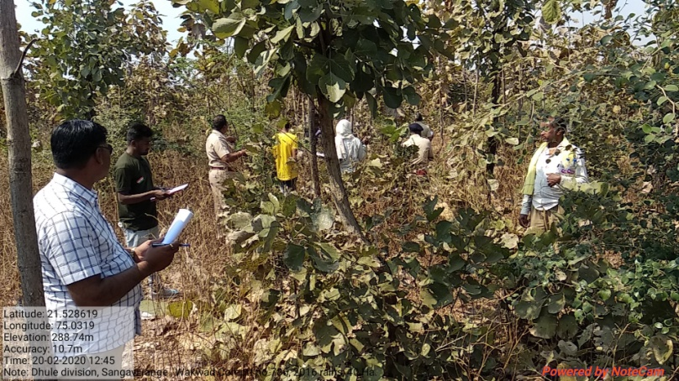

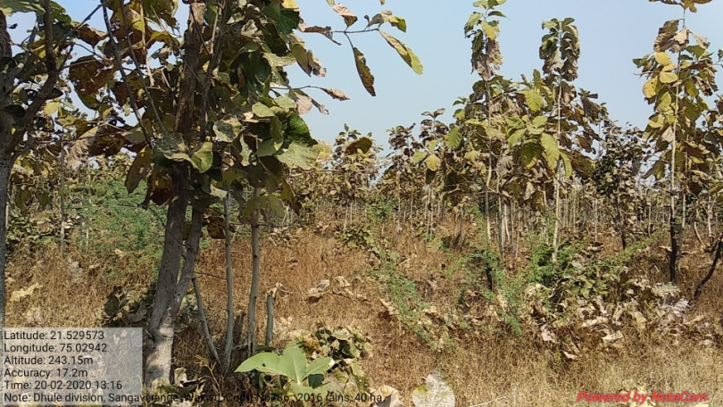
SITE WISE EVALUATION ABSTRACT
Site Number: 50

A. Description of site
Name of Site- Hadakhed
Place- Survey No:92/2
Beat- Sule Round- Sule
Range- Shirpur Forest Division- Dhule
Forest Circle- Dhule
Area of Treatment- Plantation: 4.990 Ha. GPS: Polygon: 4.990 Ha.
Difference- Excess 0.580 Ha.
Status of Land- Reserved Forest- No Protected Forest- No
Unclassed Forest- No Received as compensatory land- Yes
Zudpi Jungle- No
Site quality- N.R. Density- N.R. Slope- Gentle(0 to 10 degrees)
Available vegetation (Local Names)- Babhul, Teak, Apata, Palas, Ghayti, Yeltur, Takla, Tarmad, Landge, Rui, Chigat, Gokharu, Grass, Kusal, Bhuri, Kunda
B. Plantation Details
Model - 400 plants/ha.
Spacement- 5 × 5
Treatment Map- Yes
Soil Zone- Zone-II
Species selected for planting- Sissoo, Neem, Khair, Karanj, Awala, Ain, Semal, Anjan

C. Survival & Status
Site suitability- Suitable
Suitability of species planted- Yes
Plant survival percentage- 77%
Average Height of plants- 220 cm
Average girth of plants- 10 cm
General Health of Plants- Semi-healthy
Sustainability- Sustainable provided chainlink fencing is provided

D. Protection-
Fencing Status- TCM - 710 Rmt.
Fire- Amount Sanctioned in the estimate- Rs. 1306.23/-
Execution of the work- Work Done
Expenditure/Payment of the work- Rs. 1047.00/-
Grazing- Grazing ,Yes along agricultural boundry tramping is also noted

E. Monitoring
Inspection of Plantations- APCCF - 0, CCF - 0, DCF - 2, ACF - 4, RFO - 1
Plantation register- Up-to-date
Measurement Book- Up-to-date
Cash Book- Not made available
Financial audit- Not Done
Fund pattern- Record like a cashbook not made available
F. Overall Rating B Grade
(Excellent – A+, Very Good – A, Good – B+, Average – B, C-Poor)
Reasons for success/ Failure- Chainlink fencing is recommended.

G. Date of Evaluation 20 Feb 2020
Name of Evaluators Mr. S. K. Gawali, Mr. B. R. Challare
H. Photographs-
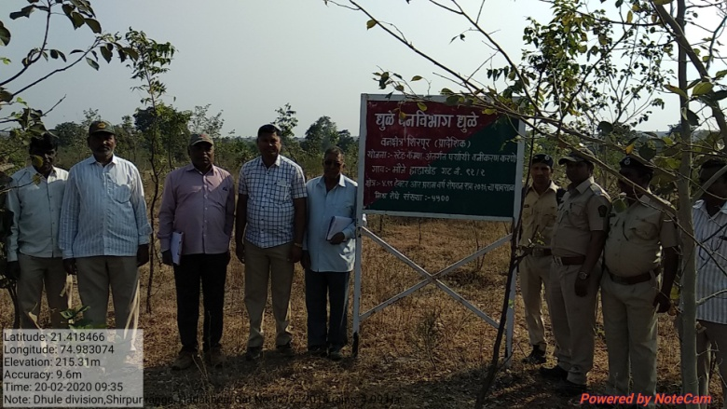
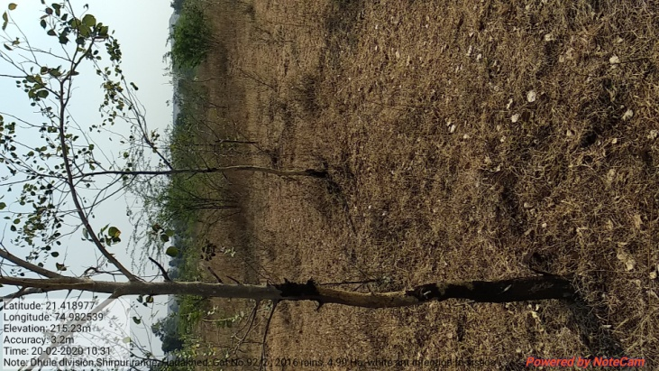
SITE WISE EVALUATION ABSTRACT
Site Number: 51

A. Description of site
Name of Site- Asali
Place- 1016/1017
Beat- Bhorkheda Round- Hisala
Range- Shirpur Forest Division- Dhule
Forest Circle- Dhule
Area of Treatment- Plantation: 40.000 Ha. GPS: Polygon: 70.000 Ha.
Difference- Excess 30.000 Ha.
Status of Land- Reserved Forest- Yes Protected Forest- No
Unclassed Forest- No Received as compensatory land- No
Zudpi Jungle- No
Site quality- IV Density- 0.4 Slope- Moderate
Available vegetation (Local Names)- Palas, Babhul, Kahsar, Prosopis, Ingranya, Henkal, Rantulas, Tarota, Rui, Lohtana, Awali, Vasandvel
B. Plantation Details
Model - 400 + 1100 plants/ha.
Spacement- 3 × 3, 5 × 5
Treatment Map- Yes
Soil Zone- Zone-II, Zone-III
Species selected for planting- Sisoo, Khair, Neem, Jambhul, Arjun, Sadada, Sawar, Bamboo, Anwala, Arjan, Karanj

C. Survival & Status
Site suitability- Suitable
Suitability of species planted- Yes
Plant survival percentage- 63%
Average Height of plants- 200 cm
Average girth of plants-
General Health of Plants- Healthy
Sustainability- Sustainable

D. Protection-
Fencing Status- TCM- 2000 Rmt.
Fire- Amount Sanctioned in the estimate- Rs. 10470.80/-
Execution of the work- Work Done
Expenditure/Payment of the work- Rs. 10471.00/-
Grazing- Light grazing damage-Grazing and browsing sighting

E. Monitoring
Inspection of Plantations- APCCF - 0, CCF - 0, DCF - 0, ACF - 0, RFO - 0
Plantation register- Up-to date but in poor condition
Measurement Book- Up-to date
Cash Book- Not made available
Financial audit- Not done
Fund pattern- Record not made available
F. Overall Rating B Grade
(Excellent – A+, Very Good – A, Good – B+, Average – B, C-Poor)
Reasons for success/ Failure- Strict protection measures are recommended.

G. Date of Evaluation 20 Feb 2020
Name of Evaluators Mr. B. R. Challare, Mr. P. H. Wagh
H. Photographs-

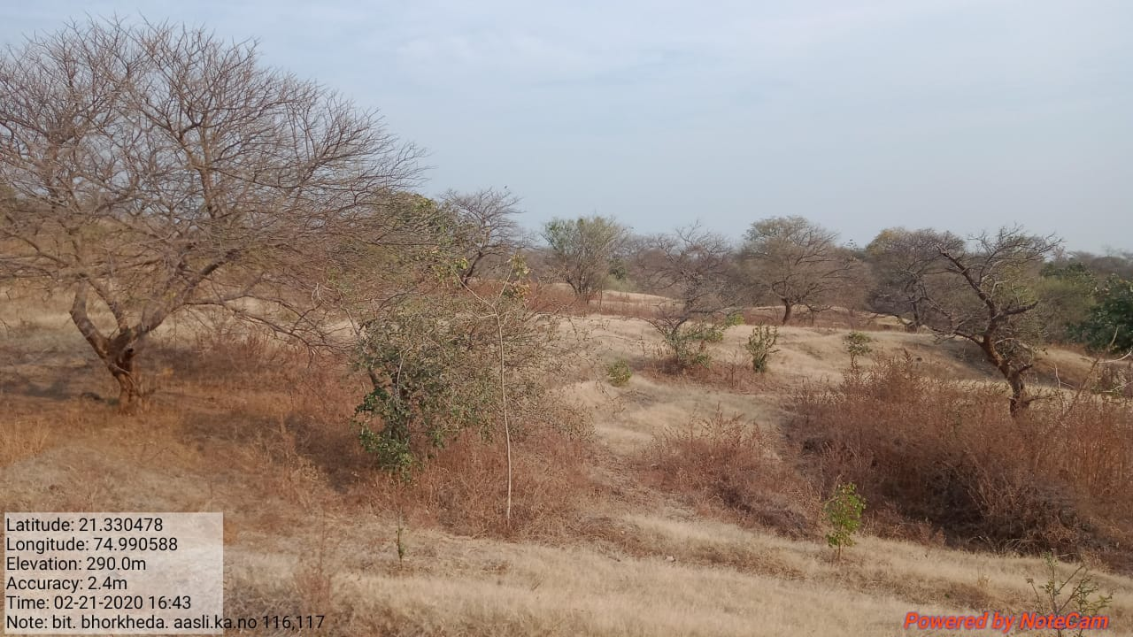
SITE WISE EVALUATION ABSTRACT
Site Number: 52

A. Description of site
Name of Site- Bamni
Place- 24
Beat- Bamni Round- Surgas
Range- Kathi Forest Division- Mewasi Taloda
Forest Circle- Dhule
Area of Treatment- Plantation: 28.000 Ha. GPS: Polygon: 40.000 Ha.
Difference- Excess 12.000 Ha.
Status of Land- Reserved Forest- Yes Protected Forest- No
Unclassed Forest- No Received as compensatory land- No
Zudpi Jungle- No
Site quality- Normal Density- 0.4 - 0.5 RF Slope- Heavy
Available vegetation (Local Names)- Tree, Shrubs
B. Plantation Details
Model - 2500 plants/ha.
Spacement- 2 × 2
Treatment Map- Yes
Soil Zone- Zone-I, Zone-II, Zone-III
Species selected for planting- Behada, Bamboo, Awala, Hirda, Bor, Khair, Bahava, Bel, Kavat

C. Survival & Status
Site suitability- Suitable
Suitability of species planted- Yes
Plant survival percentage- 43%
Average Height of plants- 145 cm
Average girth of plants-
General Health of Plants- Healthy
Sustainability- Good

D. Protection-
Fencing Status- TCM - 1512 Rmt.
Fire- Amount Sanctioned in the estimate- Rs. 3743.71/-
Execution of the work- Work Done
Expenditure/Payment of the work- Rs. 4073.00/-
Grazing- No

E. Monitoring
Inspection of Plantations- APCCF - 0, CCF - 0, DCF - 0, ACF - 0, RFO - 0
Plantation register- Up-to-date
Measurement Book- Up-to-date
Cash Book- Up-to-date
Financial audit- Done.
Fund pattern- Flow of funds is irregular
F. Overall Rating B Grade
(Excellent – A+, Very Good – A, Good – B+, Average – B, C-Poor)
Reasons for success/ Failure- As far as possible steep and slopy area should be avoided for plantation.

G. Date of Evaluation 18 Feb 2020
Name of Evaluators Mr. D. S. Pawar, Mr. P. H. Wagh
H. Photographs-
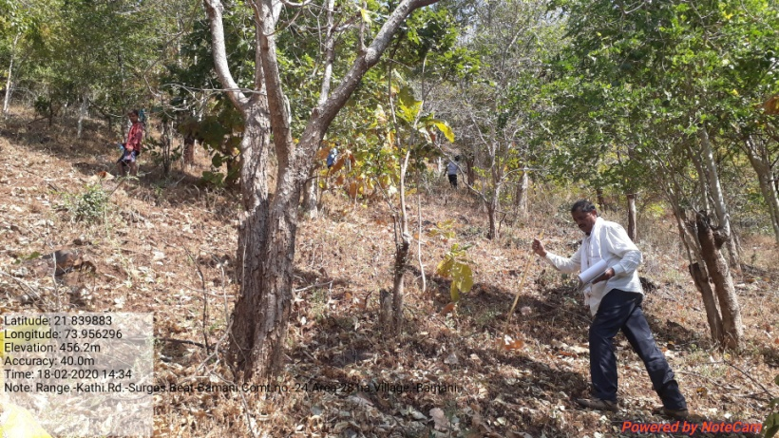
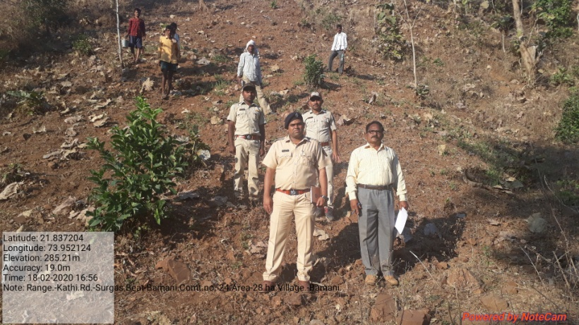
SITE WISE EVALUATION ABSTRACT
Site Number: 53

A. Description of site
Name of Site- Khochyapada
Place- Comp. No.91
Beat- Karanji Round- Kamod
Range- Chinchpada Forest Division- Nandurbar
Forest Circle- Dhule
Area of Treatment- Plantation: 25.000 Ha. GPS: Polygon: 26.340 Ha.
Difference- Excess 1.340 Ha.
Status of Land- Reserved Forest- Yes Protected Forest- No
Unclassed Forest- No Received as compensatory land- No
Zudpi Jungle- No
Site quality- Normal Density- 0.4 to 0.6 Slope- Moderate
Available vegetation (Local Names)- Mixed. Tree/Shrubs and herbs.
B. Plantation Details
Model - 1111 plants/ha.
Spacement- 3 × 3
Treatment Map- Yes
Soil Zone- Zone-I, Zone-II, Zone-III
Species selected for planting- Neem, Moha, Karanj, Sisoo, Awala, Bamboo

C. Survival & Status
Site suitability- Suitable
Suitability of species planted- Yes
Plant survival percentage- 29%
Average Height of plants- 200 cm
Average girth of plants-
General Health of Plants- Healthy
Sustainability- Good

D. Protection-
Fencing Status- TCM - 426 Rmt.
Fire- Amount Sanctioned in the estimate- Rs. 6544.25/-
Execution of the work- Work Not Done
Expenditure/Payment of the work- Rs. 0.00/-
Grazing- Partly seedling are browsed

E. Monitoring
Inspection of Plantations- APCCF - 0, CCF - 0, DCF - 0, ACF - 0, RFO - 0
Plantation register- Incomplete
Measurement Book- Incomplete
Cash Book- Not made available
Financial audit- Done.
Fund pattern- Timely flow of funds
F. Overall Rating C Grade
(Excellent – A+, Very Good – A, Good – B+, Average – B, C-Poor)
Reasons for success/ Failure- Good grazing protection work.

G. Date of Evaluation 17 Feb 2020
Name of Evaluators Mr. D. S. Pawar, Mr. P. H. Wagh
H. Photographs-
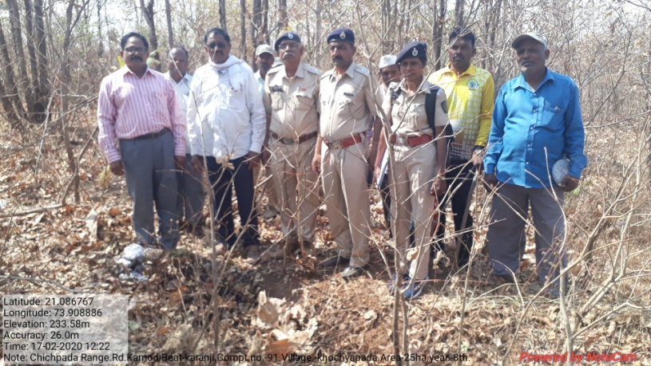
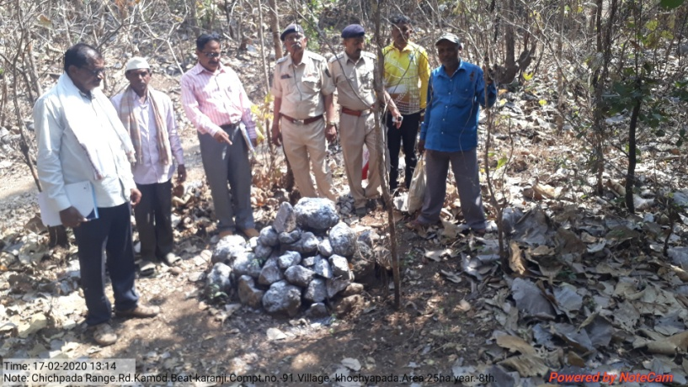

SITE WISE EVALUATION ABSTRACT
Site Number: 54

A. Description of site
Name of Site- Mohomandli
Place- 67/1
Beat- Mohamandli Round- Mohamandli
Range- Yawal East Forest Division- Yawal
Forest Circle- Dhule
Area of Treatment- Plantation: 25.000 Ha. GPS: Polygon: 32.000 Ha.
Difference- Excess 7.000 Ha.
Status of Land- Reserved Forest- Yes Protected Forest- No
Unclassed Forest- No Received as compensatory land- No
Zudpi Jungle- No
Site quality- Normal Density- 0.3 to 0.4 Slope- Moderate
Available vegetation (Local Names)- Mixed forest
B. Plantation Details
Model - 625 plants/ha.
Spacement- 4 × 4
Treatment Map- No
Soil Zone- Zone-I, Zone-II
Species selected for planting- Moha, Neem, Sisoo, ashid, Karanj, Chinch, Awala, Arjun, Jambhul, Shivam, Bamboo

C. Survival & Status
Site suitability- Suitable
Suitability of species planted- Yes
Plant survival percentage- 9%
Average Height of plants- 125 cm
Average girth of plants-
General Health of Plants- Unhealthy
Sustainability- Less sustain

D. Protection-
Fencing Status- Nil (Old TCM Exists)
Fire- Amount Sanctioned in the estimate- Rs. 3534.00/-
Execution of the work- Work Done
Expenditure/Payment of the work- Rs. 3403.00/-
Grazing- Grazing

E. Monitoring
Inspection of Plantations- APCCF - 1, CCF - 0, DCF - 0, ACF - 0, RFO - 0
Plantation register- Incomplete
Measurement Book- Incomplete
Cash Book- Not made available
Financial audit- Record Not Available
Fund pattern- Flow of funds is irregular
F. Overall Rating C Grade
(Excellent – A+, Very Good – A, Good – B+, Average – B, C-Poor)
Reasons for success/ Failure- 1) People's participation is essential. 2) Supervision and inspection should be frequent.

G. Date of Evaluation 21 Feb 2020
Name of Evaluators Mr. D. S. Pawar, Mr. P. H. Wagh
H. Photographs-
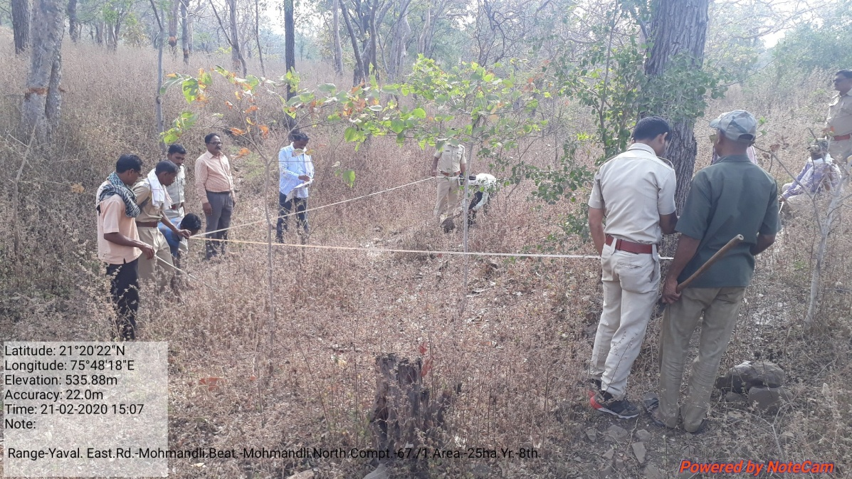

SITE WISE EVALUATION ABSTRACT
Site Number: 55

A. Description of site
Name of Site- Shembawane
Place- 62, 63, 64, 112
Beat- Shembavane Round- Yelwan- jugai
Range- Pendkhale Forest Division- Kolhapur
Forest Circle- Kolhapur
Area of Treatment- Plantation: 28.500 Ha. GPS: Polygon: 30.120 Ha.
Difference- Excess 1.620 Ha.
Status of Land- Reserved Forest- No Protected Forest- No
Unclassed Forest- No Received as compensatory land- Yes
Zudpi Jungle- No
Site quality- Poor Density- Less than 0.1 Slope- All typea of slope
Available vegetation (Local Names)- Tree: Anjani, Kumbha, Narkya, Ain, Kinjal, Jambul. Shrub: Karwand, Dhaman. Grass: Dongari, Marvel Kara, Kusali, Tambit
B. Plantation Details
Model - 400 plants/ha.
Spacement- 5 × 5
Treatment Map- Yes
Soil Zone- Zone-I, Zone-II, Zone-III
Species selected for planting- Jamun, Bamboo, Khair, Awala, Sawar, karanj, Kanchan

C. Survival & Status
Site suitability- Suitable however the protection by chainlink fencing neede
Suitability of species planted- Yes Except Karphan
Plant survival percentage- 57%
Average Height of plants- 45 cm
Average girth of plants-
General Health of Plants- Healthy
Sustainability- Unsustainable

D. Protection-
Fencing Status- TCM - 1200 Rmt., Live Hedge - 450 RMT
Fire- Amount Sanctioned in the estimate- Rs. 6508.00/-
Execution of the work- Work Done
Expenditure/Payment of the work- Rs. 6508.00/-
Grazing- No

E. Monitoring
Inspection of Plantations- APCCF - 0, CCF - 0, DCF - 0, ACF - 1, RFO - 0
Plantation register- Maintained but not up to date
Measurement Book- Maintained but not up to date
Cash Book- Maintained but not up to date
Financial audit- Not Done
Fund pattern- Timedy receipt
F. Overall Rating C Grade
(Excellent – A+, Very Good – A, Good – B+, Average – B, C-Poor)
Reasons for success/ Failure- The site is very steep and the site needs moreSMC works for plant survival.

G. Date of Evaluation 21 Feb 2020
Name of Evaluators Mr. S. S. Dole, Mr. V. B. Patil
H. Photographs-
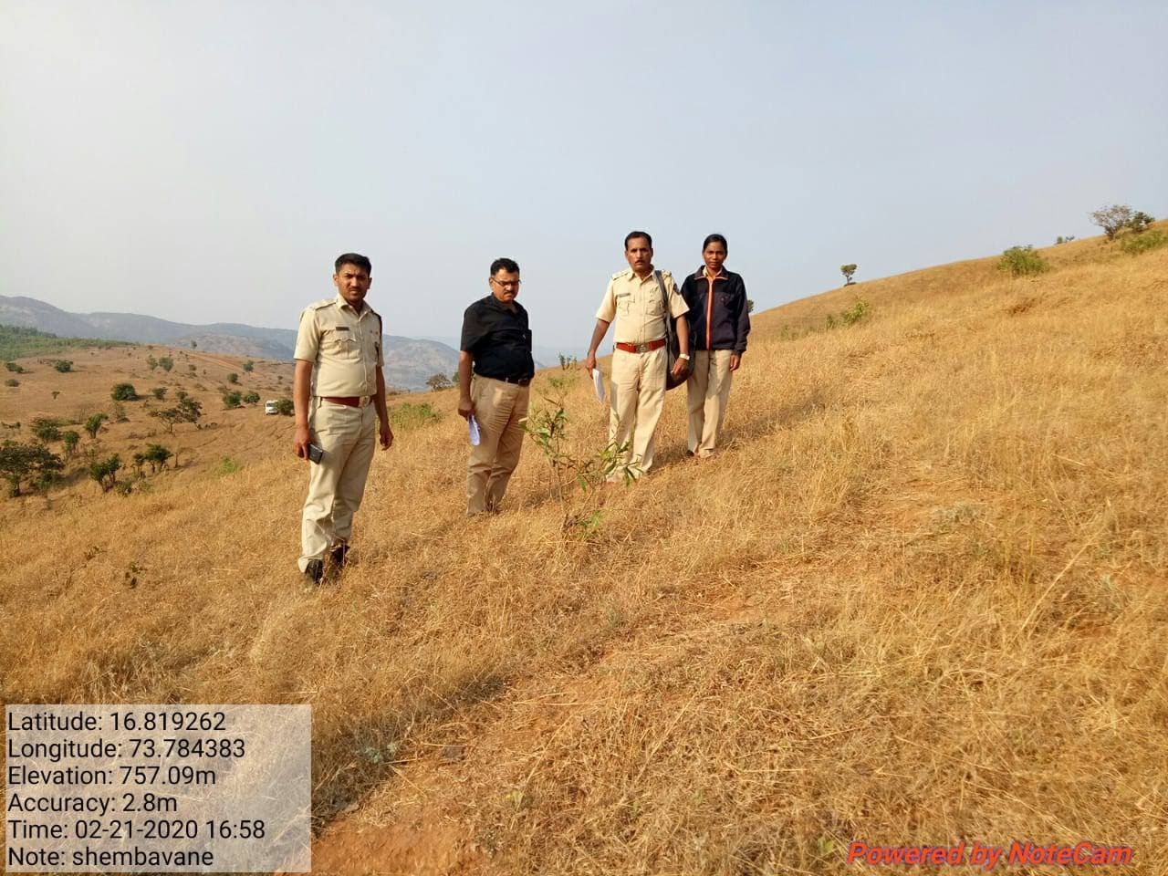
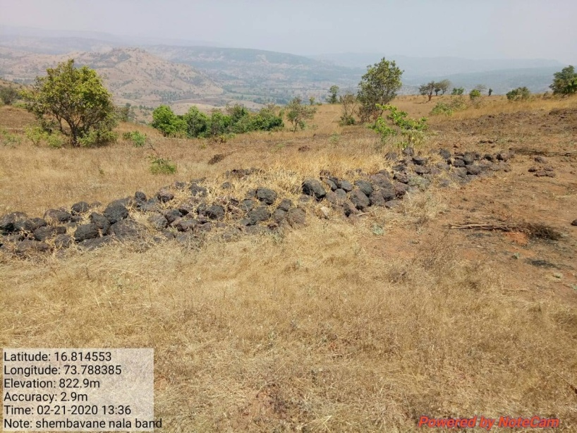
SITE WISE EVALUATION ABSTRACT
Site Number: 56

A. Description of site
Name of Site- Pendakhale
Place- Gut no. 407
Beat- Pendakhale Round- Pendakhale
Range- Pendakhale Forest Division- Kolhapur
Forest Circle- Kolhapur
Area of Treatment- Plantation: 17.300 Ha. GPS: Polygon: 17.300 Ha.
Difference- No Change
Status of Land- Reserved Forest- No Protected Forest- No
Unclassed Forest- No Received as compensatory land- Yes
Zudpi Jungle- No
Site quality- Normal Density- 4, 5 Slope- Moderate
Available vegetation (Local Names)- Aain, Kumbha, Jamun, Bamboo, Kapok, Palas, Hirda, Mango, Shrub: Rametha, Karwand
B. Plantation Details
Model - 400 plants/ha.
Spacement- 5 × 5
Treatment Map- No
Soil Zone- Zone-II
Species selected for planting- Shivan, Karanj, Awala, Silver Oak, Kashid, Australian Babhul, Teak, Mango, Khair, Jamun, Bamboo

C. Survival & Status
Site suitability- Suitable
Suitability of species planted- Except teak all Specise are suitable due to heavy rain (400cm) teak spicies can't suitable.
Plant survival percentage- 77%
Average Height of plants- 105 cm
Average girth of plants-
General Health of Plants- Healthy
Sustainability- Unsustainable

D. Protection-
Fencing Status- TCM - 1200 Rmt.
Fire- Amount Sanctioned in the estimate- Rs. 3808.00/-
Execution of the work- Work Done
Expenditure/Payment of the work- Rs. 3950.00/-
Grazing- Grazing by goat

E. Monitoring
Inspection of Plantations- APCCF - 0, CCF - 0, DCF - 0, ACF - 1, RFO - 1
Plantation register- Up-to-date
Measurement Book- Up-to-date
Cash Book- Up-to-date
Financial audit- Not Done
Fund pattern- Receipt of fund is timely.
F. Overall Rating B+ Grade
(Excellent – A+, Very Good – A, Good – B+, Average – B, C-Poor)
Reasons for success/ Failure- The plantation area needs protection. Chain link fecing and watering may be done for survival.

G. Date of Evaluation 21 Feb 2020
Name of Evaluators Mr. S. S. Dole, Mr. V. B. Patil
H. Photographs-
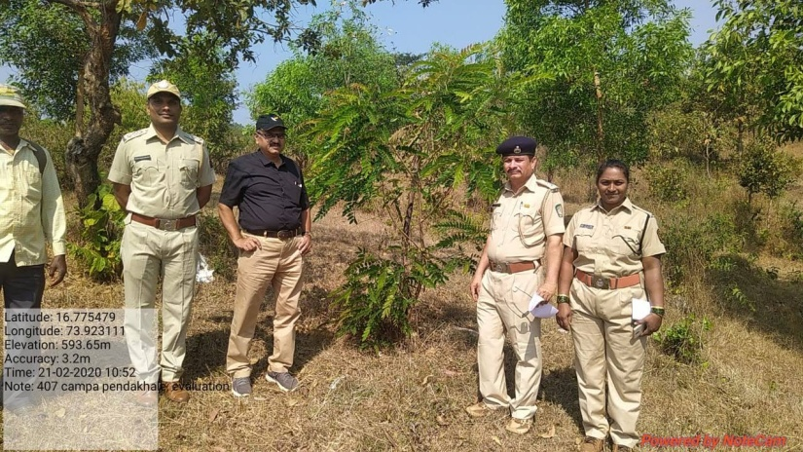
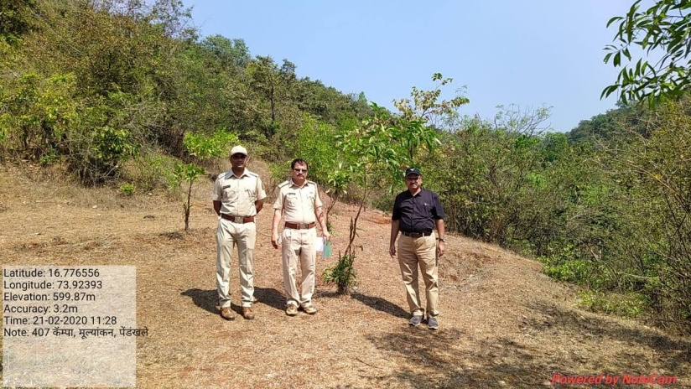
SITE WISE EVALUATION ABSTRACT
Site Number: 57

A. Description of site
Name of Site- Vaduj
Place- 359
Beat- Kaledhon Round- Mayani
Range- Vaduj Forest Division- Satara
Forest Circle- Kolhapur
Area of Treatment- Plantation: 4.970 Ha. GPS: Polygon: 4.970 Ha.
Difference- No Change
Status of Land- Reserved Forest- No Protected Forest- No
Unclassed Forest- No Received as compensatory land- Yes
Zudpi Jungle- No
Site quality- Density- Slope- Gentle
Available vegetation (Local Names)- Revenue land transferred for afforestation, hence no vegetation
B. Plantation Details
Model - 400 plants/ha.
Spacement- 5 × 5
Treatment Map- No
Soil Zone- Zone-III
Species selected for planting- Babhul

C. Survival & Status
Site suitability- Suitable
Suitability of species planted- Yes
Plant survival percentage- 44%
Average Height of plants- 15 cm
Average girth of plants-
General Health of Plants- Semi-healthy
Sustainability- Unsustainable, it is now only 0.15 cm at 8th year

D. Protection-
Fencing Status- TCM - 462.57 Rmt.
Fire- Amount Sanctioned in the estimate- Rs. 1094.00/-
Execution of the work- Work Done
Expenditure/Payment of the work- Rs. 1094.00/-
Grazing- Cattle

E. Monitoring
Inspection of Plantations- APCCF - 0, CCF - 0, DCF - 0, ACF - 0, RFO - 0
Plantation register- Not avialable
Measurement Book- Not available
Cash Book- Up-to-date
Financial audit- Not Done
Fund pattern- Funds are not avialable
F. Overall Rating C Grade
(Excellent – A+, Very Good – A, Good – B+, Average – B, C-Poor)
Reasons for success/ Failure- Site not suitable for afforestation.

G. Date of Evaluation 17 Feb 2020
Name of Evaluators Mr. S. S. Dole
H. Photographs-
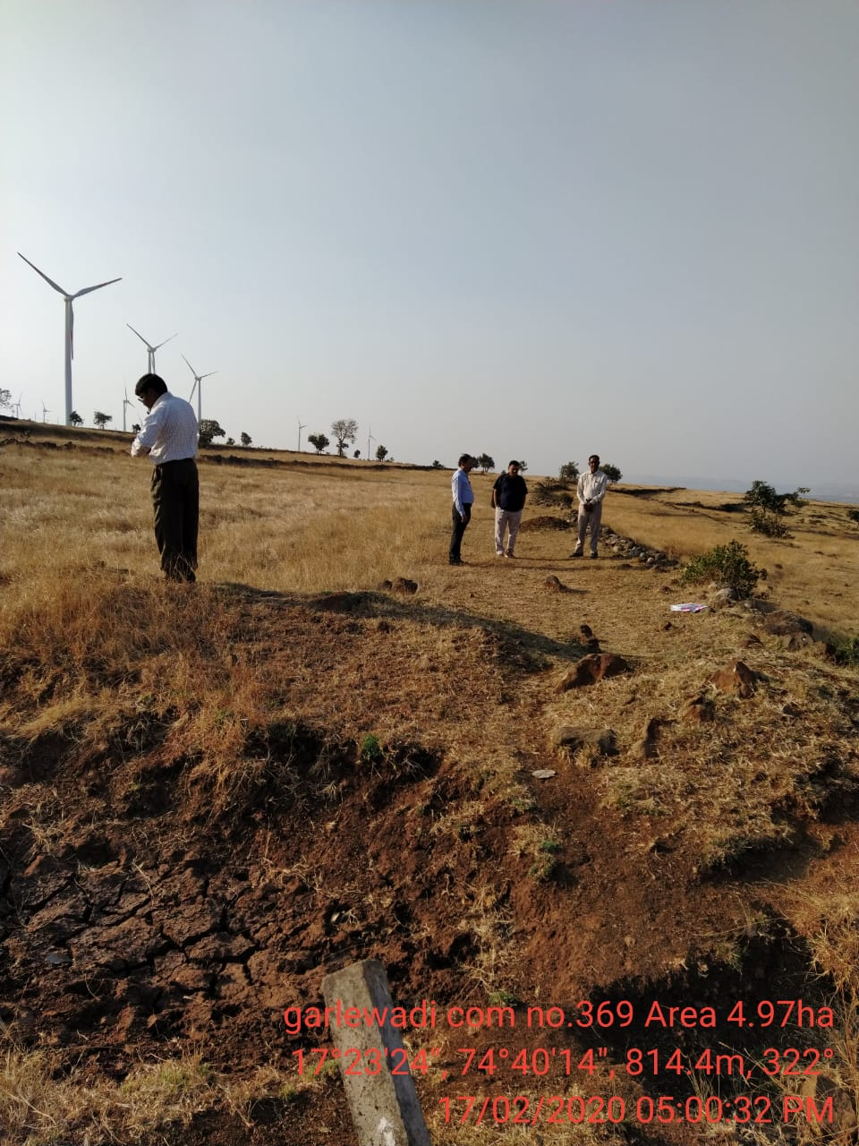
SITE WISE EVALUATION ABSTRACT
Site Number: 58

A. Description of site
Name of Site- Kini (Akodi)
Place- Comptt.No 965
Beat- Chandori Round- Umarazary
Range- Lakhani Forest Division- Bhandara
Forest Circle- Nagpur
Area of Treatment- Plantation: 20.000 Ha. GPS: Polgyon: 20.000 Ha.
Difference- No Change
Status of Land- Reserved Forest- No Protected Forest- No
Unclassed Forest- No Received as compensatory land- No
Zudpi Jungle- Yes
Site quality- Normal Density- Open Slope- Gentle
Available vegetation (Local Names)- Teak, Palas, Katsawar, Bharati, Tendu, Jamun, Charoli, Grass, Kusali.
B. Plantation Details
Model - 400 + 1100 plants/ha.
Spacement- 5 × 5, 3 × 3
Treatment Map- No
Soil Zone- Zone-III
Species selected for planting- Teak, Bamboo, Anjan, Jamun, Behada, Khair, Awala, Shivar, Chinch, Moha

C. Survival & Status
Site suitability- Suitable
Suitability of species planted- Yes.
Plant survival percentage- 80% (Cant distinguish plants planted in two phase )
Average Height of plants- 400 cm
Average girth of plants- 15 cm
General Health of Plants- Healthy
Sustainability- Good.

D. Protection-
Fencing Status- TCM - 993 Rmt.
Fire- Amount Sanctioned in the estimate- Rs. 4560.00/-
Execution of the work- Work Done
Expenditure/Payment of the work- Rs. 4560.00/-
Grazing- No

E. Monitoring
Inspection of Plantations- APCCF - 1, CCF - 0, DCF - 1, ACF - 2, RFO - 0
Plantation register- Up-to date
Measurement Book- Up-to date
Cash Book- Up-to date
Financial audit- Done.
Fund pattern- Yes.
F. Overall Rating A Grade
(Excellent – A+, Very Good – A, Good – B+, Average – B, C-Poor)
Reasons for success/ Failure- Maintenance of TCM recommended.

G. Date of Evaluation 20 Feb 2020
Name of Evaluators Mr. P. K. Lakde, Mr. S. A. Gawande
H. Photographs-
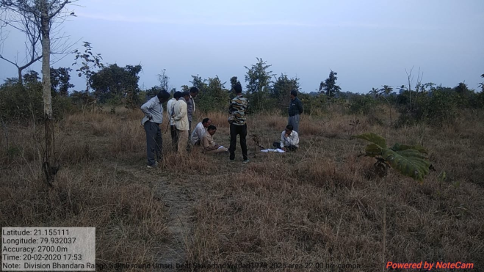

SITE WISE EVALUATION ABSTRACT
Site Number: 59

A. Description of site
Name of Site- Wadad
Place- Gat No.1978,2020
Beat- Chorbandh Round- Umri
Range- Sakoli Forest Division- Bhandara
Forest Circle- Nagpur
Area of Treatment- Plantation: 22.000 Ha. GPS: Polygon: 22.000 Ha.
Difference- No Cange
Status of Land- Reserved Forest- Yes Protected Forest- No
Unclassed Forest- No Received as compensatory land- No
Zudpi Jungle- No
Site quality- Normal Density- Open Slope- Plain
Available vegetation (Local Names)- Pawana, Kusal, Rantulas, Palas, Moha, Neem, Bor, Saag, Jambhul, Lendi, Kuda, Khair
B. Plantation Details
Model - 400 + 1100 plants/ha.
Spacement- 5 × 5, 3 × 3
Treatment Map- Yes
Soil Zone- Zone-II
Species selected for planting- Bamboo-8800, Teak, Aawala, Khair, Behala, Shiwar, Anjan, Karanj, Chinch

C. Survival & Status
Site suitability- Suitable
Suitability of species planted- Yes.
Plant survival percentage- 90%
Average Height of plants- Bamboo: 550 cm, Other: 270 cm
Average girth of plants-
General Health of Plants- Healthy
Sustainability- Sustainable

D. Protection-
Fencing Status- TCM - 1820 Rmt.
Fire- Amount Sanctioned in the estimate- Rs. 4591.00/-
Execution of the work- Work Not Done
Expenditure/Payment of the work- Rs. 0.00/-
Grazing- Yes

E. Monitoring
Inspection of Plantations- APCCF - 1, CCF - 0, DCF - 0, ACF - 1, RFO - 1
Plantation register- Up-to date
Measurement Book- Up-to date
Cash Book- Up-to date
Financial audit- Done. Year 2018-19
Fund pattern- Yes.
F. Overall Rating A+ Grade
(Excellent – A+, Very Good – A, Good – B+, Average – B, C-Poor)
Reasons for success/ Failure- Staff efforst are very good.

G. Date of Evaluation 20 Feb 2020
Name of Evaluators Mr. P. K. Lakde, Mr. S. A. Gawande
H. Photographs-
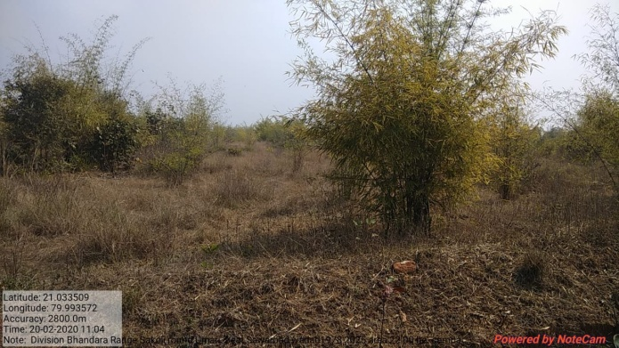

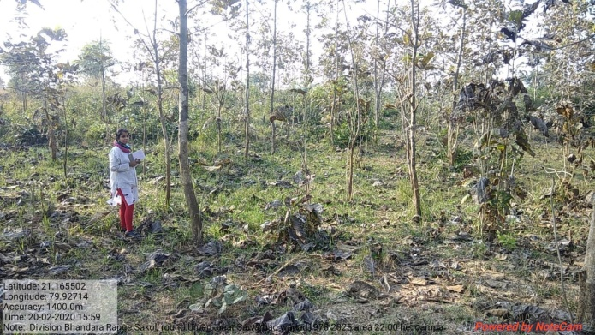
SITE WISE EVALUATION ABSTRACT
Site Number: 60

A. Description of site
Name of Site- Indora BK
Place- 479, 480, 481, 550, 552
Beat- Bondrani Round- Tiroda
Range- Tiroda Forest Division- Gondia
Forest Circle- Nagpur
Area of Treatment- Plantation: 24.000 Ha. GPS: Polygon: 22.700 Ha.
Difference- Less 1.300 Ha.
Status of Land- Reserved Forest- Yes Protected Forest- No
Unclassed Forest- No Received as compensatory land- No
Zudpi Jungle- No
Site quality- IV A Density- 0.2 Slope- Gentle
Available vegetation (Local Names)- Palas, Hiwar, Jambhul, Yeruni, Bharati, Kusal, Kasai, Padar, Bhurbhusi
B. Plantation Details
Model - 400 + 1100 plants/ha.
Spacement- 5 × 5, 2.5 × 2.5
Treatment Map- No
Soil Zone- No zonation map prepared
Species selected for planting- Bamboo, Teak, Aawala, Shivan, Arjun, Thirda

C. Survival & Status
Site suitability- Suitable
Suitability of species planted- Yes
Plant survival percentage- 96%
Average Height of plants- 61 cm
Average girth of plants-
General Health of Plants- Healthy
Sustainability- Only 1 visit by ACF has been done in the 1st year and plantation by ACF

D. Protection-
Fencing Status- No
Fire- Amount Sanctioned in the estimate- Rs. 5008.56/-
Execution of the work- Work Done
Expenditure/Payment of the work- Rs. 5481.00/-
Grazing- NR

E. Monitoring
Inspection of Plantations- APCCF - 0, CCF - 0, DCF - 0, ACF - 1, RFO - 0
Plantation register- Incomplete
Measurement Book- Up-to date
Cash Book- Up-to date
Financial audit- Done
Fund pattern- Funds flow is regular. Timely received. Funds are utilised timely.
F. Overall Rating B+ Grade
(Excellent – A+, Very Good – A, Good – B+, Average – B, C-Poor)
Reasons for success/ Failure- 1) Treatment was should be proper and detailed as per the instruction given by the superior officer. Zonation map should be proper. 2) TCM or other type of fencing should cover entire area of the boundry, if not plantation will not sustain.

G. Date of Evaluation 23 Feb 2020
Name of Evaluators Mr. A. S. Khune, Mr. D. S. Gadpande
H. Photographs-

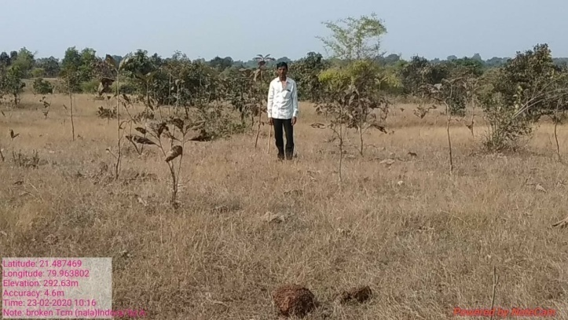

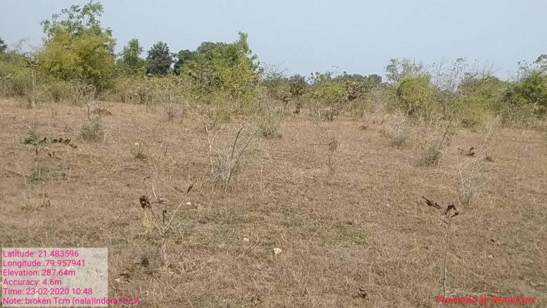
SITE WISE EVALUATION ABSTRACT
Site Number: 61

A. Description of site
Name of Site- Salegaon
Place- Survey No.62/2
Beat- Wadegaon Round- Mulla
Range- N.Deori Forest Division- Gondia
Forest Circle- Nagpur
Area of Treatment- Plantation: 4.980 Ha. GPS: Polygon: 6.260 Ha.
Difference- Excess 1.280 ha.
Status of Land- Reserved Forest- No Protected Forest- No
Unclassed Forest- Yes Received as compensatory land- No
Zudpi Jungle- No
Site quality- IV A Density- 0.2 Slope- Gentle
Available vegetation (Local Names)- Ain, Shinana, Dhawada, Tendul, Polar, Zadugavat, Kusar, Kuda
B. Plantation Details
Model - 400 + 1100 plants/ha.
Spacement- 5 × 5, 3 × 3
Treatment Map- No
Soil Zone- No zonation map prepared
Species selected for planting- Aawala, Sisso, Arjun, Teak, Bamboo. Actual planting done at the spacement of 2.5 × 5m

C. Survival & Status
Site suitability- Suitable
Suitability of species planted- Yes
Plant survival percentage- 55%
Average Height of plants- 80 cm
Average girth of plants- 11 cm
General Health of Plants- Unhealthy
Sustainability- Difficult to sustain

D. Protection-
Fencing Status- No
Fire- Amount Sanctioned in the estimate- Rs. 1092.31/-
Execution of the work- Work Not Done
Expenditure/Payment of the work- Rs. 0.00/-
Grazing- Yes

E. Monitoring
Inspection of Plantations- APCCF - 0, CCF - 0, DCF - 0, ACF - 1, RFO - 0
Plantation register- Up-to date
Measurement Book- No paid/cancelled
Cash Book- Incomplete
Financial audit- Done. 2018-19
Fund pattern- Fund flow is regular as per in the MB & cash book. In running year funds are awaited since 4.5 months.
F. Overall Rating B+ Grade
(Excellent – A+, Very Good – A, Good – B+, Average – B, C-Poor)
Reasons for success/ Failure- Total area is not closed by TCM,thusdifficult to survive.

G. Date of Evaluation 19 Feb 2020
Name of Evaluators Mr. A. S. Khune, Mr. D. S. Gadpande
H. Photographs-
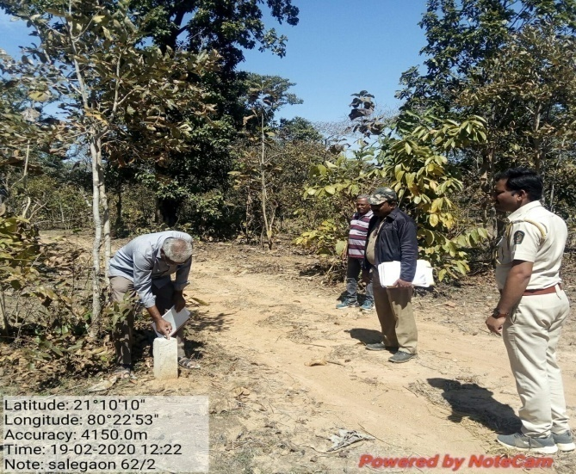
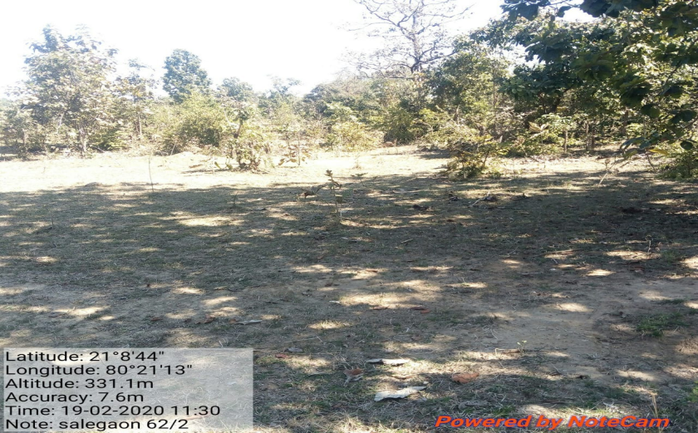

SITE WISE EVALUATION ABSTRACT
Site Number: 62

A. Description of site
Name of Site- Sukdi
Place- Zudpi Jungle S. No. 248, 397, 68, 73
Beat- Sukdi Round- Indora
Range- Tiroda Forest Division- Gondia
Forest Circle- Nagpur
Area of Treatment- Plantation: 10.400 Ha. GPS: Polygon:10.400 Ha.
Difference- No Change
Status of Land- Reserved Forest- No Protected Forest- No
Unclassed Forest- No Received as compensatory land- No
Zudpi Jungle- Yes
Site quality- IV A Density- 0.1 Slope- Gentle / Moderate (1 Ha patch)
Available vegetation (Local Names)- Bawen, Area, Kukudramzi, Zadugavat, Kusal
B. Plantation Details
Model - 400 + 1100 plants/ha.
Spacement- 5 × 5, 2.5 × 2.5
Treatment Map- No
Soil Zone- No zonation map prepared
Species selected for planting- Teak, Khair, Aawala, Arjun

C. Survival & Status
Site suitability- Suitable
Suitability of species planted- Yes
Plant survival percentage- 59%
Average Height of plants- 120 cm
Average girth of plants- 14 cm
General Health of Plants- Healthy
Sustainability- If protected from grazing

D. Protection-
Fencing Status- TCM - 718 Rmt.
Fire- Amount Sanctioned in the estimate- Rs. 2379.67/-
Execution of the work- Work Done
Expenditure/Payment of the work- Rs. 2512.00/-
Grazing- Yes

E. Monitoring
Inspection of Plantations- APCCF - 0, CCF - 0, DCF - 1, ACF - 1, RFO - 2
Plantation register- Incomplete
Measurement Book- Yes
Cash Book- Up-to date
Financial audit- Done. 2018-19
Fund pattern- It is seen from the record that funds flow is regular and timely given. The utilisation is also timely.
F. Overall Rating B+ Grade
(Excellent – A+, Very Good – A, Good – B+, Average – B, C-Poor)
Reasons for success/ Failure- No proper treatment map. Tall seedlings should be plantd.

G. Date of Evaluation 23 Feb 2020
Name of Evaluators Mr. A. S. Khune, Mr. D. S. Gadpande
H. Photographs-
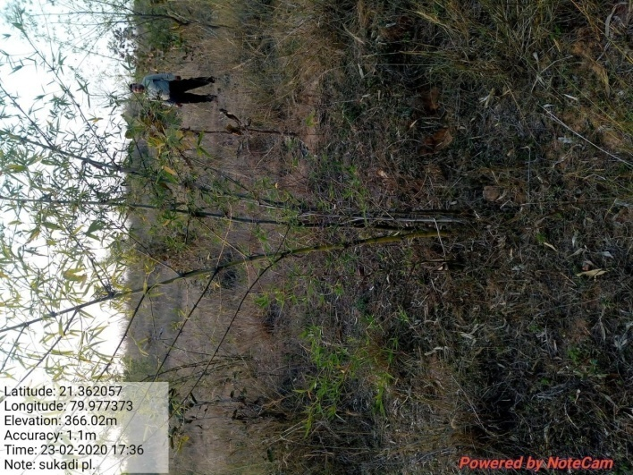

SITE WISE EVALUATION ABSTRACT
Site Number: 63

A. Description of site
Name of Site- Jamuniya
Place- Survey No.38, 59, 396, 406, 612, 618, 644
Beat- Tiroda Round- Tiroda
Range- Tiroda Forest Division- Gondia
Forest Circle- Nagpur
Area of Treatment- Plantation: 25.000 Ha. GPS: Polygon 23.190 Ha.
Difference- Less 1.810 Ha.
Status of Land- Reserved Forest- Yes Protected Forest- No
Unclassed Forest- No Received as compensatory land- No
Zudpi Jungle- No
Site quality- IV A Density- 0.3 Slope- Gentle
Available vegetation (Local Names)- Char, Moha, Rohan, Teak, Hiwar, Bondara, Ain, Eroni, Kusal, Zadugavat
B. Plantation Details
Model - 400 + 1100 plants/ha.
Spacement- 5 × 5, 2.5 × 2.5
Treatment Map- No
Soil Zone- No zonation map prepared
Species selected for planting- Teak, Shivan, Bamboo, Aawala, Khair, Arjun, Kawal, Behoda, Teak plant serving 80%

C. Survival & Status
Site suitability- Not suitable, most of this area is 0.4 dusty. Planting done in old Teak establish PL.
Suitability of species planted- Yes
Plant survival percentage- 51%
Average Height of plants- 60 cm
Average girth of plants-
General Health of Plants- Unhealthy
Sustainability- Difficult to sustain

D. Protection-
Fencing Status- No
Fire- Amount Sanctioned in the estimate- Rs. 5217.25/-
Execution of the work- Work Done
Expenditure/Payment of the work- Rs. 5937.00/-
Grazing- Yes

E. Monitoring
Inspection of Plantations- APCCF - 0, CCF - 0, DCF - 0, ACF - 0, RFO - 0
Plantation register- Incomplete
Measurement Book- No paid/cancelled
Cash Book- Up-to date
Financial audit- Done
Fund pattern- Fund flow is regular as per in the MB & cash book. In running year funds are awaited since 4.5 months.
F. Overall Rating B Grade
(Excellent – A+, Very Good – A, Good – B+, Average – B, C-Poor)
Reasons for success/ Failure- No proper treatment map. Zero inspections by forest officers. Small seedling, planting observed. Plantation is short by 1.905 Ha.

G. Date of Evaluation 22 Feb 2020
Name of Evaluators Mr. A. S. Khune, Mr. D. S. Gadpande
H. Photographs-
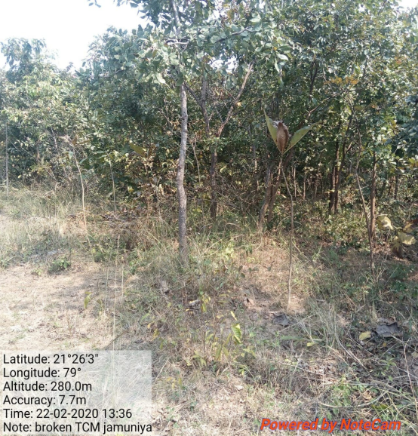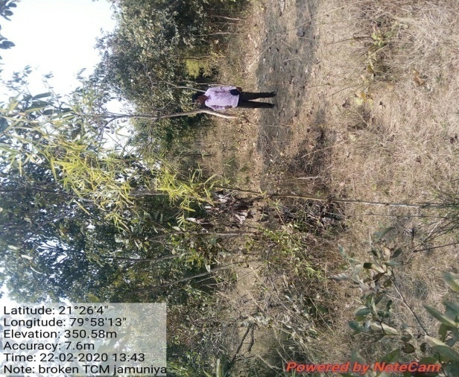

SITE WISE EVALUATION ABSTRACT
Site Number: 64

A. Description of site
Name of Site- Gangazari (Kharra)
Place- Gat No.146,179,167,16
Beat- Gangazari Round- Mundipar
Range- Gondia Forest Division- Gondia
Forest Circle- Nagpur
Area of Treatment- Plantation: 22.260 Ha. GPS: Polygon: 22.260 Ha.
Difference- No Change
Status of Land- Reserved Forest- No Protected Forest- No
Unclassed Forest- No Received as compensatory land- No
Zudpi Jungle- Yes
Site quality- High Forest Density- 0.45 Slope- Gentle
Available vegetation (Local Names)- Sajad, Dhawada, Charoli, Moha, Lendi, Zurmuri, Dikamali, Jamun, Tendu, Neem, Bihada, Kuda, Umbar, Rohan, Garadi
B. Plantation Details
Model - 400 + 1100 plants/ha.
Spacement- 5 × 5, 3 × 3
Treatment Map- No
Soil Zone- Zone-III
Species selected for planting- Teak, Karanj, Chinch, Khair, Sitafl,Aola, Shivan, Bel, Behada

C. Survival & Status
Site suitability- Suitable
Suitability of species planted-
Plant survival percentage- 43%
Average Height of plants- 160 cm
Average girth of plants- 14 cm
General Health of Plants- Healthy
Sustainability- Good. Yes.

D. Protection-
Fencing Status- TCM - 3339 Rmt.
Fire- Amount Sanctioned in the estimate- Rs. 4645.00/-
Execution of the work- Work Not Done
Expenditure/Payment of the work- Rs. 0.00/-
Grazing- No

E. Monitoring
Inspection of Plantations- APCCF - 0, CCF - 0, DCF - 0, ACF - 2, RFO - 1
Plantation register- Incomplete
Measurement Book- Up-to date
Cash Book- Up-to date
Financial audit- Not Done
Fund pattern- Yes.
F. Overall Rating B+ Grade
(Excellent – A+, Very Good – A, Good – B+, Average – B, C-Poor)
Reasons for success/ Failure- Chainlink fencing is recommended.

G. Date of Evaluation 18 Feb 2020
Name of Evaluators Mr. P. K. Lakde, Mr. S. A. Gawande
H. Photographs-

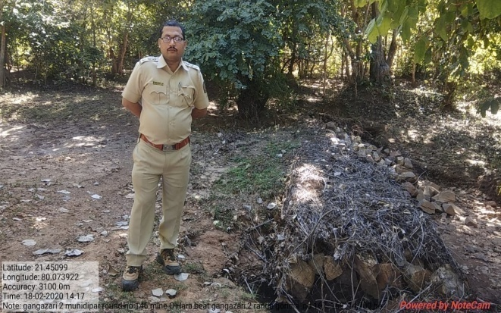
L.B.S.
SITE WISE EVALUATION ABSTRACT
Site Number: 65

A. Description of site
Name of Site- Dawaniwada
Place- 192
Beat- Dawaniwada Round- Dasgaon
Range- Gondia Forest Division- Gondia
Forest Circle- Nagpur
Area of Treatment- Plantation: 9.570 Ha. GPS: Polygon: 8.070 Ha.
Difference- Less 1.5 Ha.
Status of Land- Reserved Forest- No Protected Forest- No
Unclassed Forest- No Received as compensatory land- No
Zudpi Jungle- Yes
Site quality- High Forest Density- 0.5 Slope- Gentle
Available vegetation (Local Names)- Sajad, Dhawada, Lendi, Dekamal, Rohan, Kudwa, Umber, Tendu, Jamun, Garad, Moha, Charoli other
B. Plantation Details
Model - 400 + 1100 plants/ha.
Spacement- 5 × 5, 3 × 3
Treatment Map- No
Soil Zone- Zone-III
Species selected for planting- Teak, Bamboo, Sisoo, Shivar, Sitaphal, Awala, Karanj

C. Survival & Status
Site suitability- This land have density more than 0.4 No need to take such site.
Suitability of species planted- Yes.
Plant survival percentage- 28%
Average Height of plants- 237 cm
Average girth of plants- 14 cm
General Health of Plants- Healthy
Sustainability- Sustainable

D. Protection-
Fencing Status- TCM - 620 Rmt.
Fire- Amount Sanctioned in the estimate- Rs. 1997.00/-
Execution of the work- Work Not Done
Expenditure/Payment of the work- Rs. 0.00/-
Grazing- No

E. Monitoring
Inspection of Plantations- APCCF - 0, CCF - 0, DCF - 0, ACF - 1, RFO - 1
Plantation register- Incomplete
Measurement Book- Up-to date
Cash Book- Up-to date
Financial audit- Not Done
Fund pattern- Timely utilization of fund.
F. Overall Rating B Grade
(Excellent – A+, Very Good – A, Good – B+, Average – B, C-Poor)
Reasons for success/ Failure- Dense site-underplanting, Growth hamperred.

G. Date of Evaluation 18 Feb 2020
Name of Evaluators Mr. P. K. Lakde, Mr. S. A. Gawande
H. Photographs-
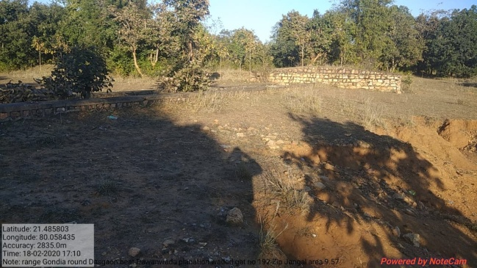

SITE WISE EVALUATION ABSTRACT
Site Number: 66

A. Description of site
Name of Site- Fukeshwor
Place- G.No.8/4
Beat- Fukeshwar Round- Matkagari
Range- North Umred Forest Division- Nagpur
Forest Circle- Nagpur
Area of Treatment- Plantation: 3.820 Ha. GPS: Polygon: 3.434 Ha.
Difference- Less 0.386 Ha.
Status of Land- Reserved Forest- No Protected Forest- No
Unclassed Forest- No Received as compensatory land- No
Zudpi Jungle- Yes
Site quality- Normal Density- Below 0.4 Slope- Gentle
Available vegetation (Local Names)- Degraded Sites
B. Plantation Details
Model - 400 + 1100 plants/ha.
Spacement- 5 × 5, 3 × 3
Treatment Map- No
Soil Zone- Zone-II
Species selected for planting- Teak

C. Survival & Status
Site suitability- Suitable
Suitability of species planted- Yes
Plant survival percentage- 45 % (2012), 60 % (2016)
Average Height of plants- Bamboo-250 cm, Mix-50 cm
Average girth of plants- -
General Health of Plants- Healthy
Sustainability- Sustainable

D. Protection-
Fencing Status- TCM - 4 × 40.978 Rmt.
Fire- Amount Sanctioned in the estimate- Rs. Nil/-
Execution of the work- Work Not Done
Expenditure/Payment of the work- Rs. 0.00/-
Grazing- Not noticed

E. Monitoring
Inspection of Plantations- APCCF - 0, CCF - 0, DCF - 0, ACF - 0, RFO - 0
Plantation register- Incomplete
Measurement Book- Incomplete
Cash Book- Up-to date
Financial audit- Not Done
Fund pattern- Record not available.
F. Overall Rating B+ Grade
(Excellent – A+, Very Good – A, Good – B+, Average – B, C-Poor)
Reasons for success/ Failure- If protected from grazing may sustain.

G. Date of Evaluation 24 Feb 2020
Name of Evaluators Mr. V. S. Bhonsle, Mr. S. B. Dabhade
H. Photographs-

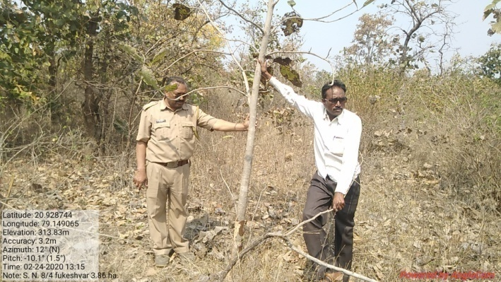
SITE WISE EVALUATION ABSTRACT
Site Number: 67

A. Description of site
Name of Site- Fukeshwar
Place- G.No.8/4
Beat- Fukeshwar Round- Matkagari
Range- North Umred Forest Division- Nagpur
Forest Circle- Nagpur
Area of Treatment- Plantation: 26.000 Ha. GPS: Polygon 35.635 Ha.
Difference- Excess 9.635 Ha.
Status of Land- Reserved Forest- No Protected Forest- No
Unclassed Forest- No Received as compensatory land- No
Zudpi Jungle- Yes
Site quality- Normal Density- 0.2 Slope- Gentle
Available vegetation (Local Names)- Neem, Palas, Teak, Bhavada, Bondara, Bor
B. Plantation Details
Model - 400 + 1100 plants/ha.
Spacement- 5 × 5, 3 × 3
Treatment Map- No
Soil Zone- Zonation not done
Species selected for planting- Teak, Karanj, Chinch, Khair, Sitafal, Aola

C. Survival & Status
Site suitability- Refractory, soil depth 0.20 mtr. Heavily grazed by kathewadi cattle. Suitable for teak only.
Suitability of species planted- No, Karanj planted in 2 × 2 not suitable
Plant survival percentage- 31%
Average Height of plants- 48 cm
Average girth of plants-
General Health of Plants- Semi-healthy
Sustainability- Unsustainable if not protected.

D. Protection-
Fencing Status- No
Fire- Amount Sanctioned in the estimate- Rs. Nil/-
Execution of the work- Work Not Done
Expenditure/Payment of the work- Rs. 0.00/-
Grazing- Kathewadi problem

E. Monitoring
Inspection of Plantations- APCCF - 0, CCF - 0, DCF - 0, ACF - 1, RFO - 0
Plantation register- Incomplete
Measurement Book- Incomplete
Cash Book- Up-to date
Financial audit- Not Done
Fund pattern-
F. Overall Rating C Grade
(Excellent – A+, Very Good – A, Good – B+, Average – B, C-Poor)
Reasons for success/ Failure- Overgrazing

G. Date of Evaluation 24 Feb 2020
Name of Evaluators Mr. V. S. Bhonsle, Mr. S. B. Dabhade
H. Photographs-

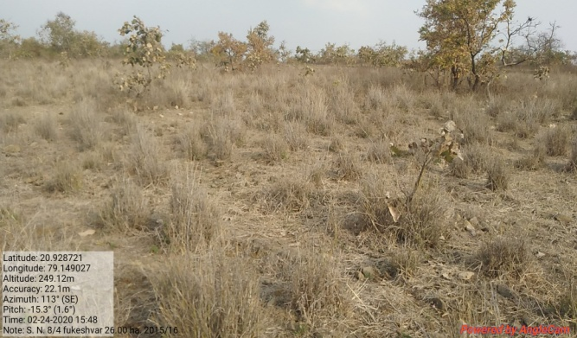

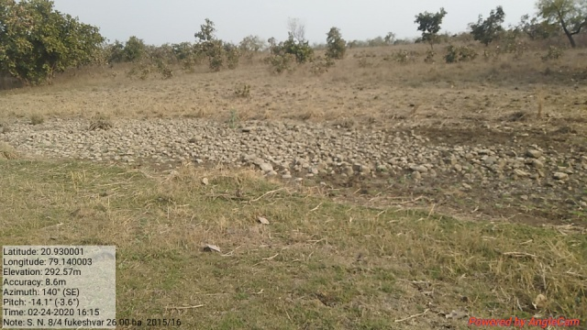
SITE WISE EVALUATION ABSTRACT
Site Number: 68

A. Description of site
Name of Site- Muradpur
Place- 56, 70
Beat- Samudrapur Round- Samudrapur
Range- Samudrapur Forest Division- Wardha
Forest Circle- Nagpur
Area of Treatment- Plantation: 12.240 Ha. GPS: Polygon: 10.880 Ha.
Difference- Less 1.390 Ha.
Status of Land- Reserved Forest- No Protected Forest- No
Unclassed Forest- No Received as compensatory land- No
Zudpi Jungle- Yes
Site quality- Normal Density- Open Slope- Gentle
Available vegetation (Local Names)- Hiwar, Chitali, Ali, Bor, Neem, Babhul, Bharati, Charoli, Palas, Noni, Bihada, Ain, Rohari, Pitundi, Lokhandi, Ghaneri, Lalghathi, Dhawada, Kusuli, Rantulas, Bhurbhushi, Takla, Khobarmuli, Marvel
B. Plantation Details
Model - 400 + 1100 plants/ha.
Spacement- 3 × 3, 5 × 5
Treatment Map- Yes
Soil Zone- Zone-III
Species selected for planting- 2 × 2-Awala, Sitafal, Khair, Casia, Kini, Chinch, Karanj=4800 plants 2016-Teak, Khair, Dhawada, Bor, Ain, Bamboo, Sisoo, Awala, Amaltash, Neem, Karanj, Sitafal, Semal, Anjan

C. Survival & Status
Site suitability- Suitable
Suitability of species planted- Yes.
Plant survival percentage- 39%
Average Height of plants- 112 cm
Average girth of plants- -
General Health of Plants- Unhealthy
Sustainability- Unsustainable

D. Protection-
Fencing Status- TCM - 2150 Rmt.
Fire- Amount Sanctioned in the estimate- Rs. 2694.14/-
Execution of the work- Work Done
Expenditure/Payment of the work- Rs. 4110.00/-
Grazing- By domestic animals

E. Monitoring
Inspection of Plantations- APCCF - 0, CCF - 0, DCF - 0, ACF - 2, RFO - 1
Plantation register- Up-to date
Measurement Book- Up-to date
Cash Book- Up-to date
Financial audit- Not Done
Fund pattern-
F. Overall Rating B Grade
(Excellent – A+, Very Good – A, Good – B+, Average – B, C-Poor)
Reasons for success/ Failure- Proper maintenance is recommended.

G. Date of Evaluation 24 Feb 2020
Name of Evaluators Mr. P. K. Lakde, Mr. S. A. Gawande
H. Photographs-

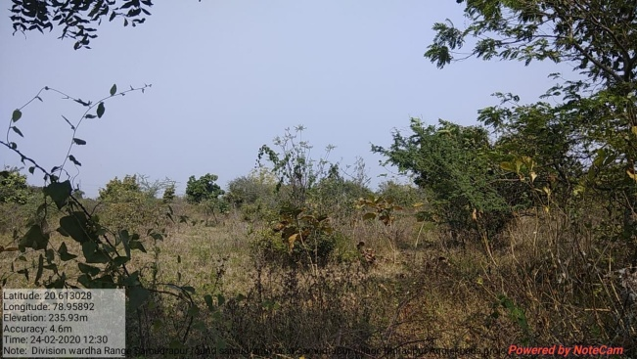

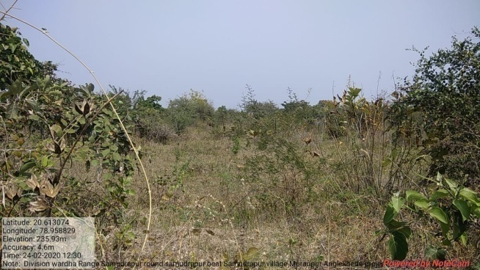
SITE WISE EVALUATION ABSTRACT
Site Number: 69

A. Description of site
Name of Site- Dhanora
Place- 14
Beat- Botora Round- Pardi
Range- Talegaon Forest Division- Wardha
Forest Circle- Nagpur
Area of Treatment- Plantation: 4.470 Ha. GPS: Polygon: 1.830 Ha.
Difference- Less 2.640 Ha.
Status of Land- Reserved Forest- No Protected Forest- No
Unclassed Forest- No Received as compensatory land- Yes
Zudpi Jungle- No
Site quality- NR Density- NR Slope- Gentle
Available vegetation (Local Names)- Palas, Giriendra, Neem, Kusal, Marvel
B. Plantation Details
Model - 400 + 1100 plants/ha.
Spacement- 5 × 5, 2.5 × 2.5
Treatment Map- No
Soil Zone- Zone-I
Species selected for planting- Teak, Bor, Papoda, Neem, Giriendia

C. Survival & Status
Site suitability- Suitable
Suitability of species planted- Yes.
Plant survival percentage- 76%
Average Height of plants- 200 cm
Average girth of plants- -
General Health of Plants- Healthy
Sustainability- Unsustainable

D. Protection-
Fencing Status- TCM - 620 Rmt.
Fire- Amount Sanctioned in the estimate- Rs. 983.00/-
Execution of the work- Work Not Done
Expenditure/Payment of the work- Rs. 0.00/-
Grazing- Yes

E. Monitoring
Inspection of Plantations- APCCF - 0, CCF - 0, DCF - 0, ACF - 1, RFO - 3
Plantation register- Up-to date
Measurement Book- Up-to date
Cash Book- Up-to date
Financial audit- Not Done
Fund pattern- Timely utilization of fund.
F. Overall Rating B+ Grade
(Excellent – A+, Very Good – A, Good – B+, Average – B, C-Poor)
Reasons for success/ Failure- Proper survey and and demarcation is recommended.

G. Date of Evaluation 26 Feb 2020
Name of Evaluators Mr. P. K. Lakde, Mr. S. A. Gawande
H. Photographs-

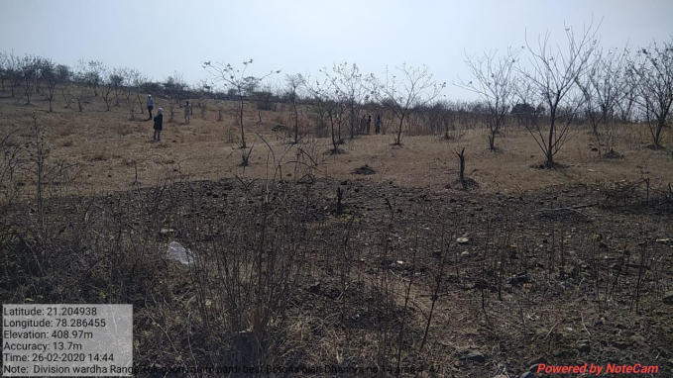

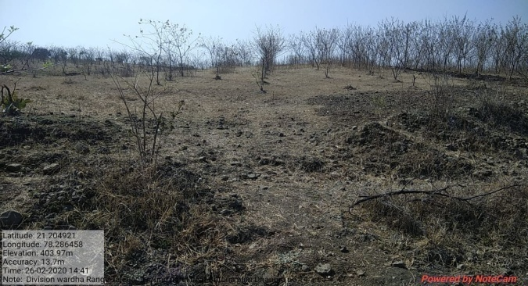
SITE WISE EVALUATION ABSTRACT
Site Number: 70

A. Description of site
Name of Site- Sawali BK
Place- Gat No.319
Beat- Pardi Round- Pardi
Range- Talegaon Forest Division- Wardha
Forest Circle- Nagpur
Area of Treatment- Plantation: 19.310 Ha. GPS: Polygon: 16.501 Ha.
Difference- Less 2.801 Ha.
Status of Land- Reserved Forest- No Protected Forest- No
Unclassed Forest- No Received as compensatory land- No
Zudpi Jungle- Yes
Site quality- Density- Open Slope- Gentle
Available vegetation (Local Names)- Shrubs
B. Plantation Details
Model - 400 + 1100 plants/ha.
Spacement- 5 × 5, 3 × 3
Treatment Map- Yes
Soil Zone- Zonation not done
Species selected for planting- 2 × 2-Teak, Papada, Khair, Neem, Behada & Bor, 2016- Teak, Khair, Neem, Papada, Bor

C. Survival & Status
Site suitability- Suitable
Suitability of species planted- Yes.
Plant survival percentage- 47%
Average Height of plants- 216 cm
Average girth of plants- -
General Health of Plants- Unhealthy
Sustainability- Good

D. Protection-
Fencing Status- TCM - 1240 Rmt.
Fire- Amount Sanctioned in the estimate- Rs. 4250.32/-
Execution of the work- Work Done
Expenditure/Payment of the work- Rs. 4250.00/-
Grazing- Yes

E. Monitoring
Inspection of Plantations- APCCF - 0, CCF - 1, DCF - 2, ACF - 2, RFO - 1
Plantation register- up-to-date
Measurement Book- Up-to date
Cash Book- Up-to date
Financial audit- Not Done
Fund pattern- Yes.
F. Overall Rating B+ Grade
(Excellent – A+, Very Good – A, Good – B+, Average – B, C-Poor)
Reasons for success/ Failure- Chainlink fencing is recommended.

G. Date of Evaluation 26 Feb 2020
Name of Evaluators Mr. P. K. Lakde, Mr. S. A. Gawande
H. Photographs-
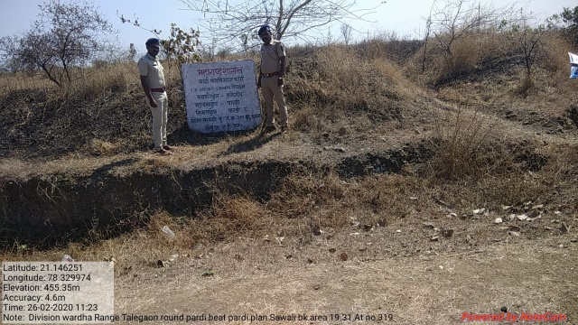

SITE WISE EVALUATION ABSTRACT
Site Number: 71

A. Description of site
Name of Site- Masala
Place- Gat No.2,3,17,18,55
Beat- Akoli Round- Zadsi
Range- Hingni Forest Division- Wardha
Forest Circle- Nagpur
Area of Treatment- Plantation: 20.860 Ha. GPS: Polygon: 18.700 Ha.
Difference- Less 2.160 Ha.
Status of Land- Reserved Forest- No Protected Forest- No
Unclassed Forest- No Received as compensatory land- No
Zudpi Jungle- Yes
Site quality- Normal Density- 0.1 Slope-
Available vegetation (Local Names)- Hiwar, Sisoo, Neem, Chilar, Bor, Palas
B. Plantation Details
Model - 400 + 1100 plants/ha.
Spacement- 5 × 5, 3 × 3
Treatment Map- Yes
Soil Zone- Zone-II
Species selected for planting- Teak, Behada, Karanj, Bor, Bamboo & 2016-Teak, Bihada, Bor, Neem, Awala, Karanj, Sisoo, Khair, Chinch

C. Survival & Status
Site suitability- Suitable
Suitability of species planted- Yes
Plant survival percentage- 55%
Average Height of plants- 210 cm
Average girth of plants-
General Health of Plants- Healthy
Sustainability- Good

D. Protection-
Fencing Status- TCM - 2090 Rmt.
Fire- Amount Sanctioned in the estimate- Rs. 4591.00/-
Execution of the work- Work Done
Expenditure/Payment of the work- Rs. 4795.00/-
Grazing- No

E. Monitoring
Inspection of Plantations- APCCF - 0, CCF - 0, DCF - 2, ACF - 2, RFO - 1
Plantation register- Up-to date
Measurement Book- Up-to date
Cash Book- Up-to date
Financial audit- Done
Fund pattern- Good
F. Overall Rating B+ Grade
(Excellent – A+, Very Good – A, Good – B+, Average – B, C-Poor)
Reasons for success/ Failure- Proper survey and and demarcation is recommended.

G. Date of Evaluation 25 Feb 2020
Name of Evaluators Mr. P. K. Lakde, Mr. S. A. Gawande
H. Photographs-
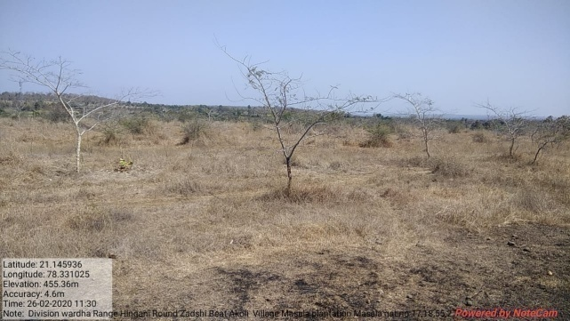

SITE WISE EVALUATION ABSTRACT
Site Number: 72

A. Description of site
Name of Site- Shastrinagar
Place- Gut No.111
Beat- Nandgaon Round- Nandgaon
Range- Nandgaon Forest Division- East Nashik
Forest Circle- Nashik
Area of Treatment- Plantation: 5.000 Ha. GPS: Polygon: 7.000 Ha.
Difference- Excess 2.000 Ha.
Status of Land- Reserved Forest- Yes Protected Forest- No
Unclassed Forest- No Received as compensatory land- No
Zudpi Jungle- No
Site quality- Normal Density- 0.1 to 0.2 Slope- Below 10 degrees
Available vegetation (Local Names)- Mixed
B. Plantation Details
Model - 400 + 1100 plants/ha.
Spacement- 5 × 5, 3 × 3
Treatment Map- Yes
Soil Zone- Zone-II
Species selected for planting- Neem, Palash, Babul, Shivan, Papdi, Bor

C. Survival & Status
Site suitability- Suitable
Suitability of species planted- Yes
Plant survival percentage- 41%
Average Height of plants- 250 cm
Average girth of plants-
General Health of Plants- Semi-healthy
Sustainability- Good

D. Protection-
Fencing Status- TCM - 955 Rmt.
Fire- Amount Sanctioned in the estimate- Rs. 1213.00/-
Execution of the work- Work Done
Expenditure/Payment of the work- Rs. 1213.00/-
Grazing- Grazing

E. Monitoring
Inspection of Plantations- APCCF - 0, CCF - 0, DCF - 1, ACF - 1, RFO - 0
Plantation register- Up-to date
Measurement Book- Up-to date
Cash Book- Up-to date
Financial audit- Done. Year 2019-20
Fund pattern- Flow of funds is irregular
F. Overall Rating B+ Grade
(Excellent – A+, Very Good – A, Good – B+, Average – B, C-Poor)
Reasons for success/ Failure- Strict grazing protection measures advised.

G. Date of Evaluation 26 Feb 2020
Name of Evaluators Mr. D. S. Pawar, Mr. P. H. Wagh
H. Photographs-
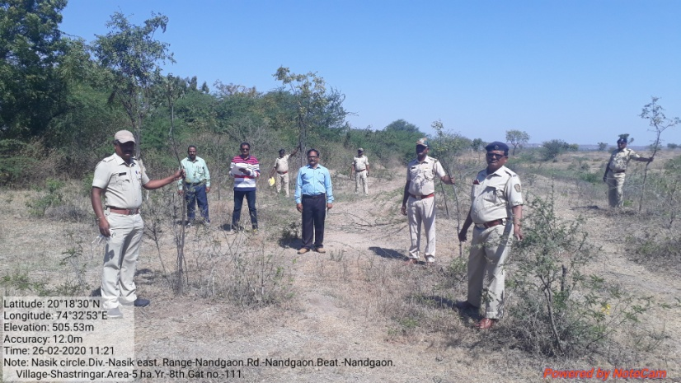
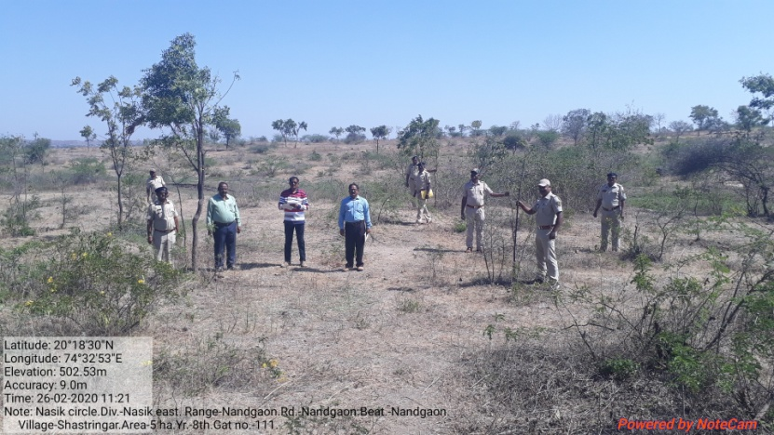

SITE WISE EVALUATION ABSTRACT
Site Number: 73

A. Description of site
Name of Site- Bhilwad
Place- Sr.No.122 Comp. No.149
Beat- Katarvel Round- Taharabad
Range- Taharabad Forest Division- Malegaon
Forest Circle- Nashik
Area of Treatment- Plantation: 25.000 Ha. GPS: Polygon: 36.000 Ha.
Difference- Excess 11.000 Ha.
Status of Land- Reserved Forest- Yes Protected Forest- No
Unclassed Forest- No Received as compensatory land- No
Zudpi Jungle- No
Site quality- Normal Density- 0.2 to 0.3 Slope- Moderate
Available vegetation (Local Names)- Mixed
B. Plantation Details
Model - 1111 plants/ha.
Spacement- 3 × 3
Treatment Map- Yes
Soil Zone- Zone-I, Zone-II, Zone-III
Species selected for planting- Neem, Awala, Bamboo

C. Survival & Status
Site suitability- Suitable
Suitability of species planted- Yes
Plant survival percentage- 37%
Average Height of plants- 215 cm
Average girth of plants-
General Health of Plants- Semi-healthy
Sustainability- Good

D. Protection-
Fencing Status- 1688.57 Qbm.
Fire- Amount Sanctioned in the estimate- Rs. 6544.00/-
Execution of the work- Work Done
Expenditure/Payment of the work- Rs. 6544.00/-
Grazing- Over Grazing

E. Monitoring
Inspection of Plantations- APCCF - 0, CCF - 1, DCF - 1, ACF - 0, RFO - 0
Plantation register- Up-to date
Measurement Book- Up-to date
Cash Book- Up-to date
Financial audit- Done. Year 2018-19
Fund pattern- Flow of funds is irregular
F. Overall Rating B Grade
(Excellent – A+, Very Good – A, Good – B+, Average – B, C-Poor)
Reasons for success/ Failure- People's participation and awareness is essential.

G. Date of Evaluation 25 Feb 2020
Name of Evaluators Mr. D. S. Pawar, Mr. P. H. Wagh
H. Photographs-
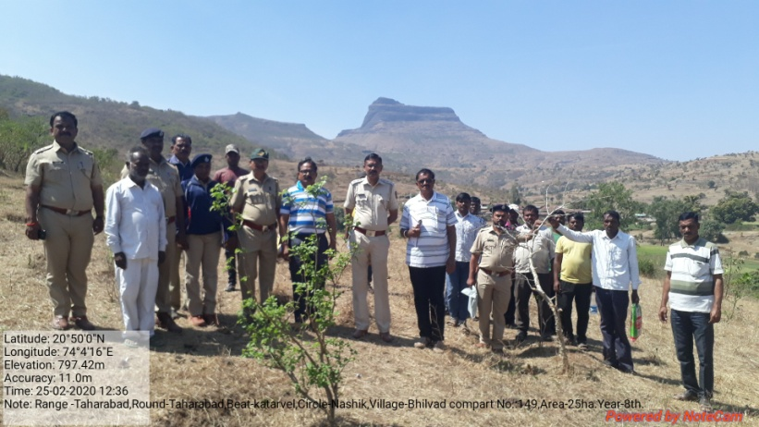
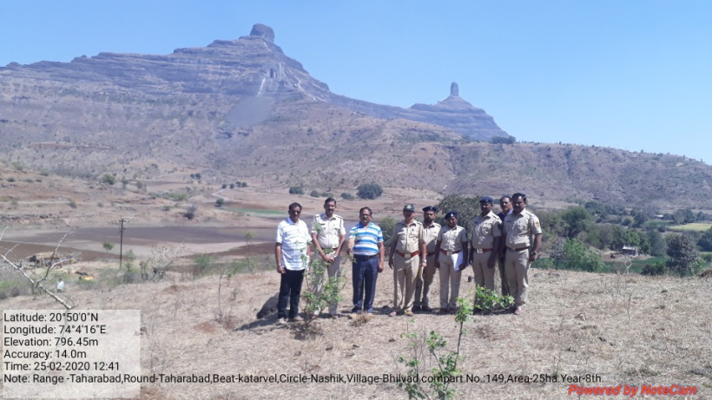

SITE WISE EVALUATION ABSTRACT
Site Number: 74

A. Description of site
Name of Site- Amdabad
Place- 299
Beat- Malthan Round- Shirur
Range- Shirur Forest Division- Junnar
Forest Circle- Pune
Area of Treatment- Plantation: 5.000 Ha. GPS: Polygon: 5.000 Ha.
Difference- No change
Status of Land- Reserved Forest- Yes Protected Forest- No
Unclassed Forest- No Received as compensatory land- No
Zudpi Jungle- No
Site quality- Poor Density- 0.4 Slope- Gentle
Available vegetation (Local Names)- Tree, Grass
B. Plantation Details
Model - 1111 plants/ha.
Spacement- 3 × 3
Treatment Map- Yes
Soil Zone- Zone-II
Species selected for planting- Neem, Wavla, Arjun, Sisoo, Chinch, Khair, Bor etc.

C. Survival & Status
Site suitability- Suitable
Suitability of species planted- Yes
Plant survival percentage- 51%
Average Height of plants- 64 cm
Average girth of plants-
General Health of Plants- Healthy
Sustainability- Good if protected well

D. Protection-
Fencing Status- No
Fire- Amount Sanctioned in the estimate- Rs. Nil/-
Execution of the work- Work Done
Expenditure/Payment of the work- Rs. 0.00/-
Grazing- No

E. Monitoring
Inspection of Plantations- APCCF - 0, CCF - 0, DCF - 0, ACF - 0, RFO - 0
Plantation register- Not available
Measurement Book- Not available
Cash Book- Not available
Financial audit- Not Done
Fund pattern- Wages pending for want of funds
F. Overall Rating C Grade
(Excellent – A+, Very Good – A, Good – B+, Average – B, C-Poor)
Reasons for success/ Failure- As there is no TCM, protection needs to be given top priority

G. Date of Evaluation 19 Feb 2020
Name of Evaluators Mr. G. P. Garad, Mr. R. K. Adkar
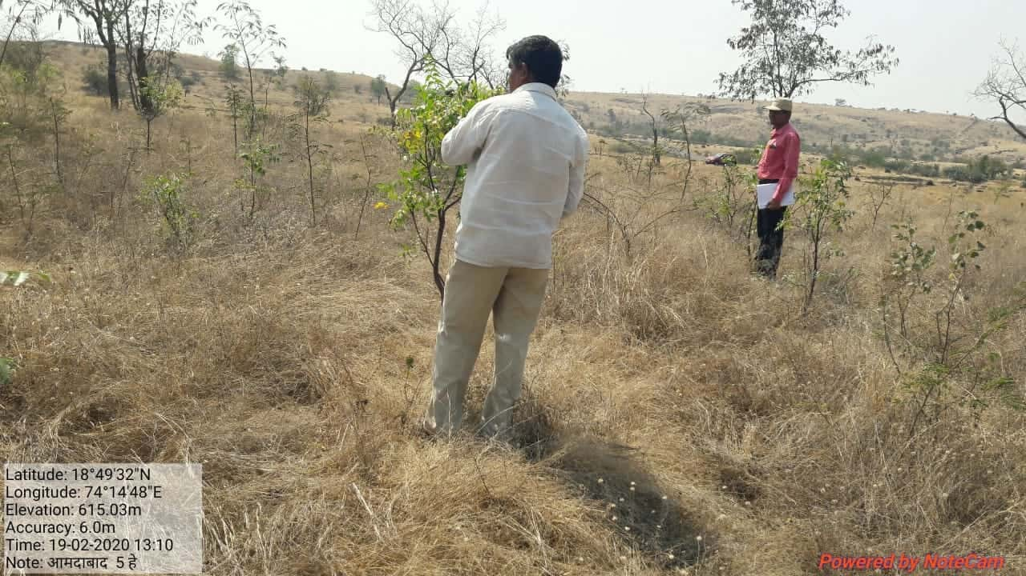
H. Photographs-

SITE WISE EVALUATION ABSTRACT
Site Number: 75

A. Description of site
Name of Site- Manjarwadi
Place- 109
Beat- Narayangaon Round- Narayangaon
Range- Junnar Forest Division- Junnar
Forest Circle- Pune
Area of Treatment- Plantation: 4.000 Ha. GPS: Polygon: 4.000 Ha.
Difference- No change
Status of Land- Reserved Forest- No Protected Forest- No
Unclassed Forest- No Received as compensatory land- No
Zudpi Jungle- No
Site quality- Degraded land Density- Open Slope- Gentle / Moderate
Available vegetation (Local Names)- Tree, Shrubs, Grass
B. Plantation Details
Model - 400 + 1100 plants/ha.
Spacement- 5 × 5, 3 × 3
Treatment Map- Yes
Soil Zone- Zone-II, Zone-III
Species selected for planting- Wavla, Raintree, Neem, Sisoo, Bor, Gliricidia, Kashid

C. Survival & Status
Site suitability-
Suitability of species planted- Yes
Plant survival percentage- 8%
Average Height of plants- 169 cm
Average girth of plants-
General Health of Plants- Healthy
Sustainability- Unsustainable

D. Protection-
Fencing Status- No
Fire- Amount Sanctioned in the estimate- Rs. 912.00/-
Execution of the work- Work Done
Expenditure/Payment of the work- Rs. 912.00/-
Grazing- Yes, except Glyricidia

E. Monitoring
Inspection of Plantations- APCCF - 0, CCF - 0, DCF - 0, ACF - 0, RFO - 0
Plantation register- Record not produced
Measurement Book- Record not produced
Cash Book- Not made available
Financial audit- Not Done
Fund pattern- No information
F. Overall Rating C Grade
(Excellent – A+, Very Good – A, Good – B+, Average – B, C-Poor)
Reasons for success/ Failure- Plantation is failed in spite of planting 2200 plants / Ha.

G. Date of Evaluation 03 Feb 2020
Name of Evaluators Mr. G. P. Garad, Mr. R. K. Adkar
H. Photographs-
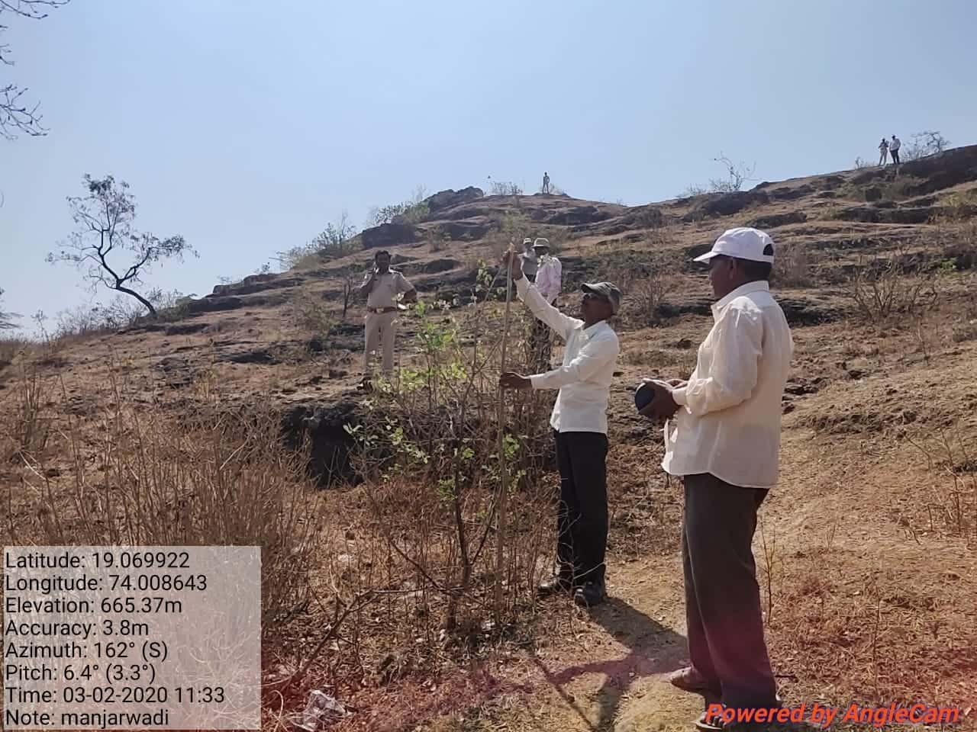

SITE WISE EVALUATION ABSTRACT
Site Number: 76

A. Description of site
Name of Site- Gunjalwadi
Place- 314
Beat- Belha Round- Belha
Range- Otur Forest Division- Junnar
Forest Circle- Pune
Area of Treatment- Plantation: 4.000 Ha. GPS: Polygon: 4.000 Ha.
Difference- No change
Status of Land- Reserved Forest- Yes Protected Forest- No
Unclassed Forest- No Received as compensatory land- No
Zudpi Jungle- No
Site quality- Degraded land Density- 0.4 Slope- Gentle
Available vegetation (Local Names)- Tree, Grass
B. Plantation Details
Model - 1111 plants/ha.
Spacement- 3 × 3
Treatment Map- Yes
Soil Zone- Zone-III
Species selected for planting- Neem, Amaltas, Wavla, Aala, Sisoo, Kashid, Siwan, Kanchan, Sitafal, Siras, Khair, Bor, Jamun etc.

C. Survival & Status
Site suitability- Suitable
Suitability of species planted- Yes
Plant survival percentage- 49%
Average Height of plants- 86 cm
Average girth of plants-
General Health of Plants- Healthy
Sustainability- Good if protected well

D. Protection-
Fencing Status- No
Fire- Amount Sanctioned in the estimate- Rs. 1185.92/-
Execution of the work- Work Done
Expenditure/Payment of the work- Rs. 1202.00/-
Grazing- No

E. Monitoring
Inspection of Plantations- APCCF - 0, CCF - 0, DCF - 0, ACF - 0, RFO - 0
Plantation register- Not available
Measurement Book- Record not produced
Cash Book- For await sent to pune
Financial audit- Not Done
Fund pattern- Wages pending for want of funds
F. Overall Rating B Grade
(Excellent – A+, Very Good – A, Good – B+, Average – B, C-Poor)
Reasons for success/ Failure- No any specific comment

G. Date of Evaluation 20 Feb 2020
Name of Evaluators Mr. G. P. Garad, Mr. R. K. Adkar
H. Photographs-
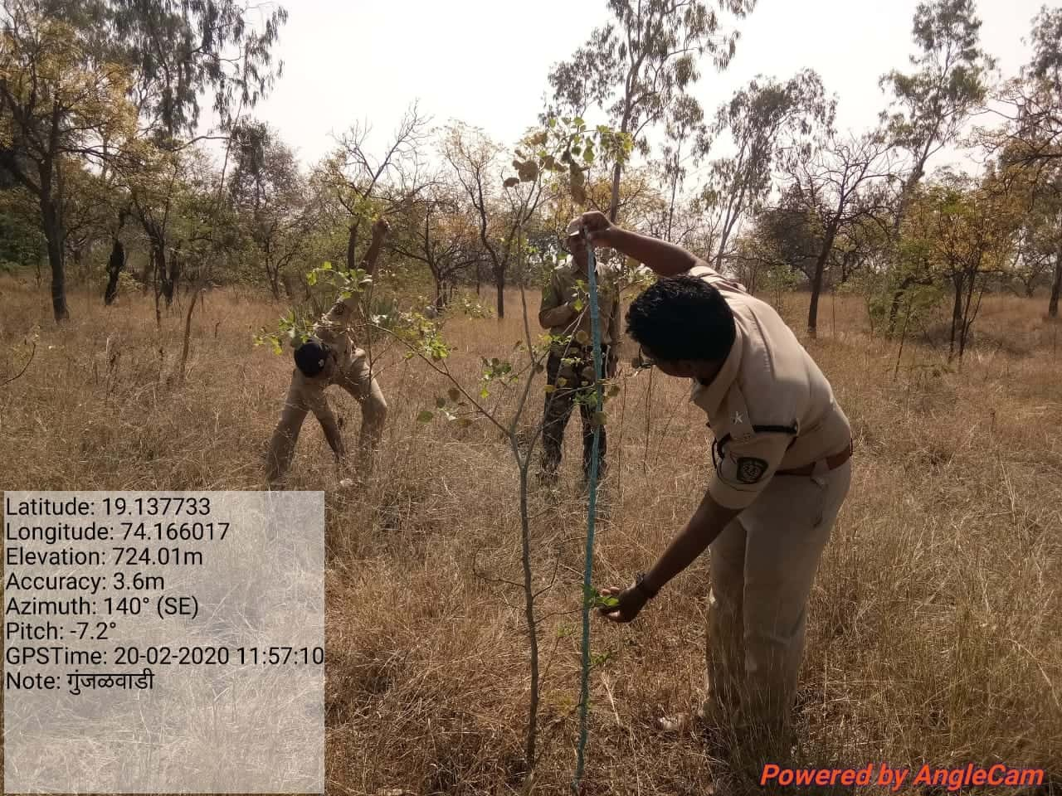
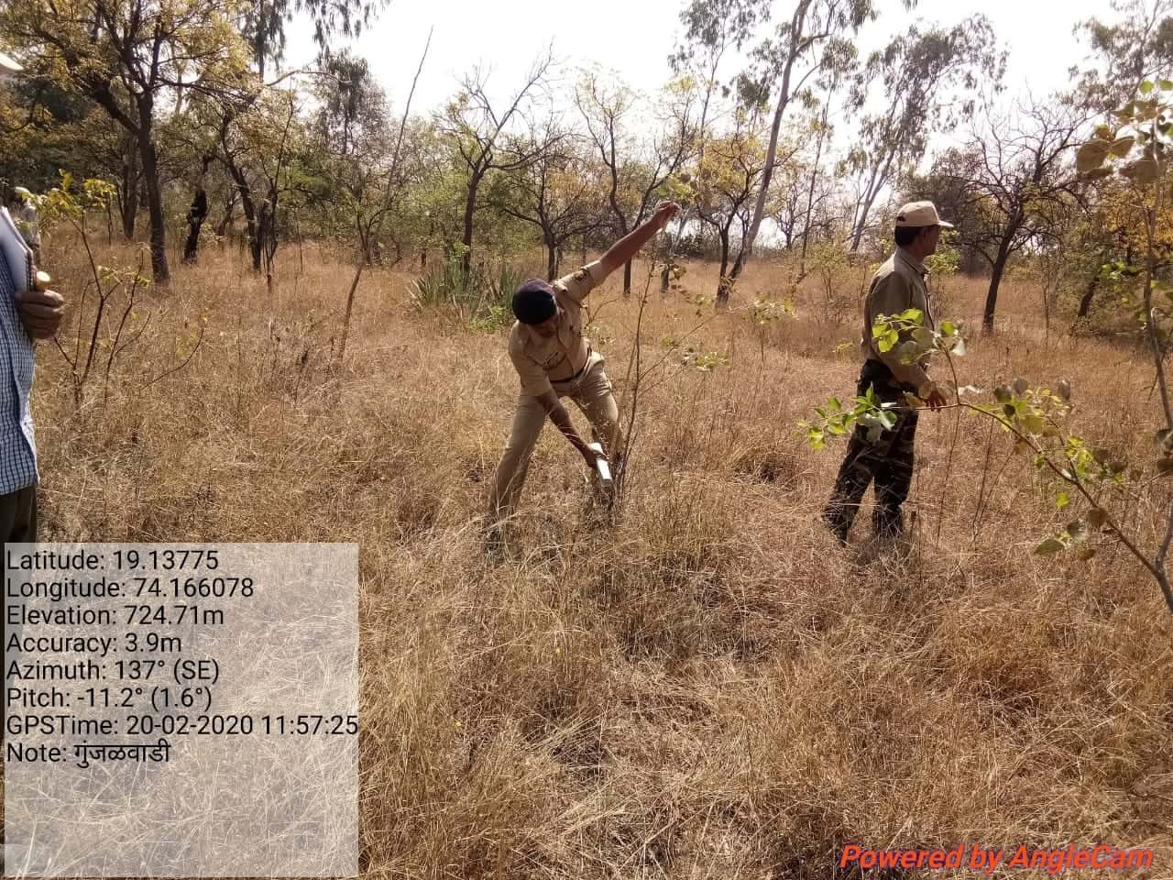

SITE WISE EVALUATION ABSTRACT
Site Number: 77

A. Description of site
Name of Site- Choul
Place- Compartment No.732
Beat- Choul Round- Nagaon
Range- Alibaug Forest Division- Alibaug
Forest Circle- Thane
Area of Treatment- Plantation: 26.000 Ha. GPS: Polygon: 26.000 Ha.
Difference- No change
Status of Land- Reserved Forest- Yes Protected Forest- No
Unclassed Forest- No Received as compensatory land- No
Zudpi Jungle- No
Site quality- IV B Density- 0.4 Slope- Gentle / Moderate
Available vegetation (Local Names)- Trees, Shrubs, Grass
B. Plantation Details
Model - 400 plants/ha.
Spacement- 5 × 5
Treatment Map- Yes
Soil Zone- Zone-III
Species selected for planting- Teak, Khair, Kaju, Bahwa, Karanj, Aola, Jamun, Siwan, Apta, Australian babool, Neem etc.

C. Survival & Status
Site suitability- Suitable
Suitability of species planted- Yes
Plant survival percentage- 74%
Average Height of plants- 162 cm
Average girth of plants-
General Health of Plants- Semi-healthy
Sustainability- TCM is old one, boundry is totally porous may create problem.

D. Protection-
Fencing Status- No
Fire- Amount Sanctioned in the estimate- Rs. 5938.00/-
Execution of the work- Work Done
Expenditure/Payment of the work- Rs. 5938.00/-
Grazing- No

E. Monitoring
Inspection of Plantations- APCCF - 0, CCF - 0, DCF - 0, ACF - 0, RFO - 0
Plantation register- Up-to date
Measurement Book- Up-to date
Cash Book- Up-to date
Financial audit- Not Done
Fund pattern- Wages are pending
F. Overall Rating B+ Grade
(Excellent – A+, Very Good – A, Good – B+, Average – B, C-Poor)
Reasons for success/ Failure- As TCM is totally filled, proper fencing is required

G. Date of Evaluation 25 Feb 2020
Name of Evaluators Mr. G. P. Garad
H. Photographs-
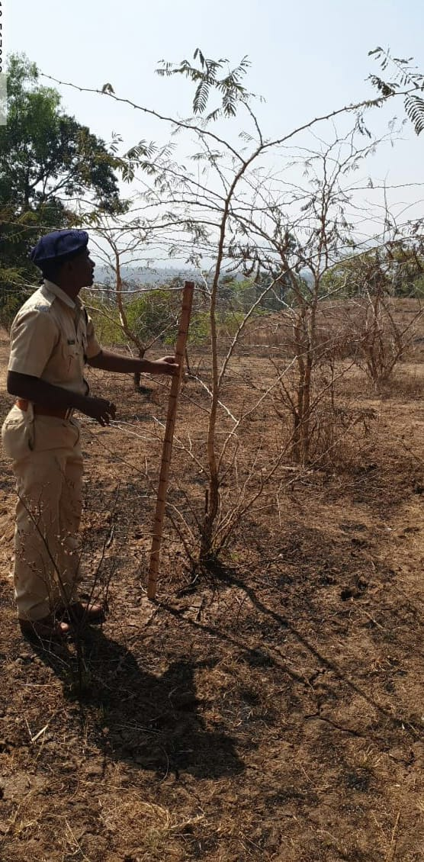
SITE WISE EVALUATION ABSTRACT
Site Number: 78

A. Description of site
Name of Site- Dattapur
Place- 537/347 (As per RFO record and in field)
Beat- Kalamb/Dattapur (As per RFO record and in field) Round- Kalamb / Jodmoha (As per RFO record and in field)
Range- Jodmoha Forest Division- Yawatmal
Forest Circle- Yawatmal
Area of Treatment- Plantation: 3.000 Ha. GPS: polygon: 3.000 Ha.
Difference- No change
Status of Land- Reserved Forest- Yes Protected Forest- No
Unclassed Forest- No Received as compensatory land- No
Zudpi Jungle- No
Site quality- IV b Density- Less than 0.3 Slope- Gentle
Available vegetation (Local Names)- Trees : Teak, Palas, Lendi etc /Shrubs Chilati, Bharati, Dhayati Ghaneri
B. Plantation Details
Model - 400 + 1100 plants/ha.
Spacement- 5 × 5, 3 × 3
Treatment Map- Yes
Soil Zone- Zone-III
Species selected for planting- Cassia, Karanj, Neem, , Chinch, Subabul, Char, Bamboo

C. Survival & Status
Site suitability- Suitable
Suitability of species planted- Yes
Plant survival percentage- 36%
Average Height of plants- 384 cm
Average girth of plants- 18 cm
General Health of Plants- Healthy
Sustainability- Plantation is healthy high chances of Sustainability

D. Protection-
Fencing Status- No Record found, but old TCM was found on peripheri of plantation.
Fire- Amount Sanctioned in the estimate- Rs. Nil/-
Execution of the work- Work Not Done
Expenditure/Payment of the work- Rs. 0.00/-
Grazing- No grazing

E. Monitoring
Inspection of Plantations- APCCF - 0, CCF - 0, DCF - 0, ACF - 0, RFO - 0
Plantation register- Incomplete
Measurement Book- Incomplete
Cash Book- Up-to date
Financial audit- Not Done
Fund pattern- From last year Funds not available timely.
F. Overall Rating B+ Grade
(Excellent – A+, Very Good – A, Good – B+, Average – B, C-Poor)
Reasons for success/ Failure- Inspection authorities should inspects the works as per norms and should record there inspection notes in plantation register and M B. Nobody inspected Plantation Register and M B

G. Date of Evaluation 17 Feb 2020
Name of Evaluators Mr. U. M. Dhopeshwarkar, Mr. R. T. More
H. Photographs-
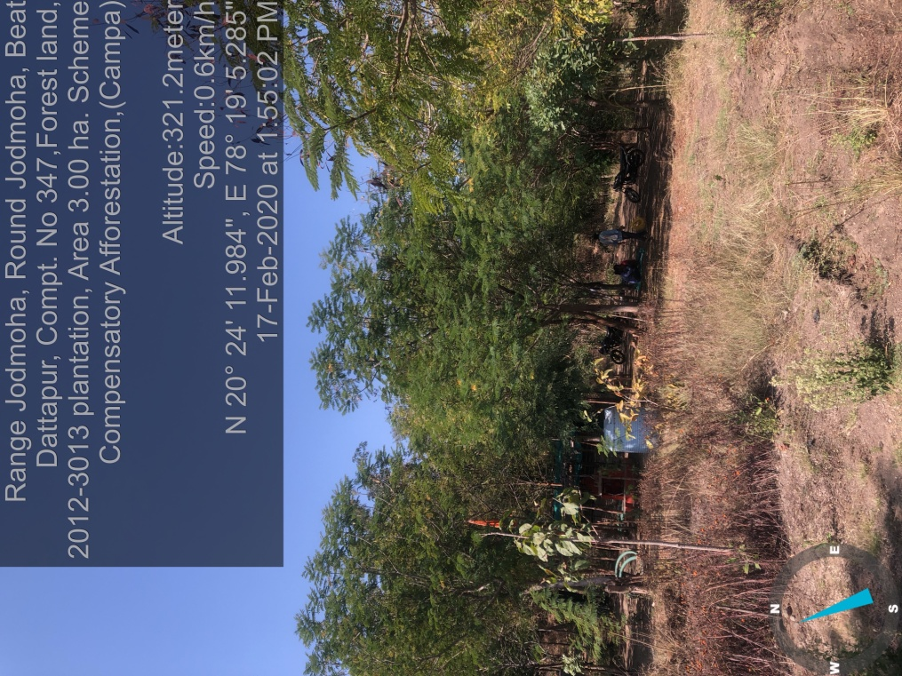

SITE WISE EVALUATION ABSTRACT
Conditional Works: Site No. 79-103
Site Number: 79

A. Description of site
Name of Site- Adul
Place- 135 / 316
Beat- Adul Round- Adul
Range- Aurangabad Forest Division- Aurangabad
Forest Circle- Aurangabad
Area of Treatment- Plantation: 2.200 Ha. GPS: Polygon: 2.425 Ha.
Difference- Excess 0.225 Ha.
Status of Land- Reserved Forest- Yes Protected Forest- No
Unclassed Forest- No Received as compensatory land- No
Zudpi Jungle- No
Site quality- Normal Density- 0.1 / RF Slope- Moderate
Available vegetation (Local Names)- Bahava, Neem, Bor, Henkal, Bor, Kusali, Pavanya, Tendu, Hiwar, Bhabhul
B. Plantation Details
Model - 625 plants/ha.
Spacement- 4 × 4
Treatment Map- Yes
Soil Zone- Zone-II
Species selected for planting- Neem, Bor, Sissoo, Karanj and Awala

C. Survival & Status
Site suitability- Suitable
Suitability of species planted- Yes
Plant survival percentage- 43%
Average Height of plants- 235 cm
Average girth of plants-
General Health of Plants- Healthy
Sustainability- Good

D. Protection-
Fencing Status- 230 Rmt.
Fire- Amount Sanctioned in the estimate- Rs. 1304.51/-
Execution of the work- Work Done
Expenditure/Payment of the work- Rs. 1186.00/-
Grazing- No

E. Monitoring
Inspection of Plantations- APCCF - 0, CCF - 0, DCF - 0, ACF - 1, RFO - 4
Plantation register- Up-to-date
Measurement Book- Up-to-date
Cash Book- Up-to-date
Financial audit- Done. Year 18-19
Fund pattern- Yes, But There is no funding flow timely in this year
F. Overall Rating B+ Grade
(Excellent – A+, Very Good – A, Good – B+, Average – B, C-Poor)
Reasons for success/ Failure- Good efforts by staff and people.

G. Date of Evaluation 29 Feb 2020
Name of Evaluators Mr. D. S. Pawar, Mr. P. H. Wagh
H. Photographs-

SITE WISE EVALUATION ABSTRACT
Site Number: 80

A. Description of site
Name of Site- Babupeth
Place- 402
Beat- Babupeth Round- Chandrapur
Range- Chandrapur Forest Division- Chandrapur
Forest Circle- Chandrapur
Area of Treatment- Plantation: 10.000 Ha. GPS: Polygon: 13.000 Ha.
Difference- Excess 3.000 Ha.
Status of Land- Reserved Forest- Yes Protected Forest- No
Unclassed Forest- No Received as compensatory land- No
Zudpi Jungle- No
Site quality- IV Density- Less than 0.1 Slope- Gente
Available vegetation (Local Names)- Tendu, Amaltash, Kuda, Bondara, Bhirra, Rantulas, Kukutranzi
B. Plantation Details
Model - 400 plants/ha.
Spacement- 5 × 5
Treatment Map- No
Soil Zone- Zone-I, Zone-II, Zone-III
Species selected for planting- Bamboo

C. Survival & Status
Site suitability- Suitabillity
Suitability of species planted- Yes
Plant survival percentage- 0%
Average Height of plants- 124 cm
Average girth of plants-
General Health of Plants- Healthy
Sustainability- Part of area is water logged. Sustenance is partly.

D. Protection-
Fencing Status- No
Fire- Amount Sanctioned in the estimate- Rs. 6314.00/-
Execution of the work- Work Done
Expenditure/Payment of the work- Rs. 6314.00/-
Grazing- Tender tips of Plants broken

E. Monitoring
Inspection of Plantations- APCCF - 0, CCF - 0, DCF - 0, ACF - 1, RFO - 0
Plantation register- Up-to-date
Measurement Book- Up-to-date
Cash Book- Up-to-date
Financial audit- Not Done
Fund pattern- Funds are allotted to RFO after requisition from them only
F. Overall Rating B Grade
(Excellent – A+, Very Good – A, Good – B+, Average – B, C-Poor)
Reasons for success/ Failure- Allotment of funds for site specific estimates as per direction from PCCF vide letter Dtd.1.4.2015 is essential.
Fire damaged the plantation. All sides are not covered with fencing.Grazing is observed. Though irrigation tank & water pipeline installed,is damaged & wastefull expenditure.

G. Date of Evaluation 19 Feb 2020
Name of Evaluators Mr. S. M. Jagtap, Mr. B. T. Fartode
H. Photographs-

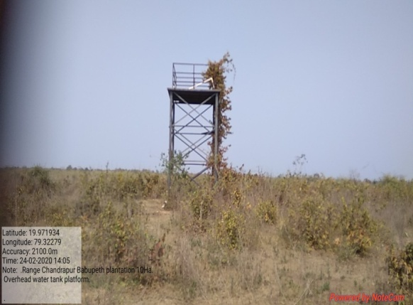
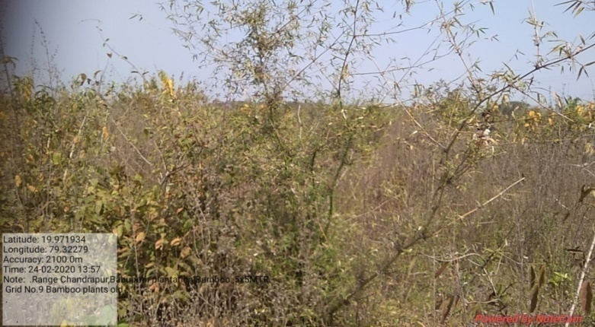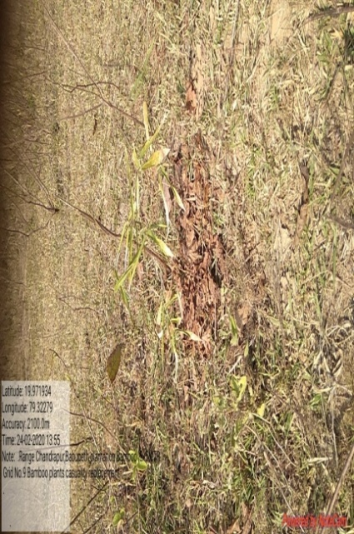
Damaged Pipe line
Bamboo plants planted in 2016
Casuality replacement in 2019

SITE WISE EVALUATION ABSTRACT
Site Number: 81

A. Description of site
Name of Site- Masale
Place- G. No. 155
Beat- Masale Round- Masale
Range- Sakri Forest Division- Dhule
Forest Circle- Dhule
Area of Treatment- Plantation: 2.110 Ha. GPS: Polygon: 2.110 Ha.
Difference- Excess 1.890 Ha.
Status of Land- Reserved Forest- No Protected Forest- No
Unclassed Forest- No Received as compensatory land- Yes
Zudpi Jungle- No
Site quality- N.R. Density- N.R. Slope-
Available vegetation (Local Names)- Sissoo, Kashid, Khair, Neem, Sitafal, Babhul, Bor, Subabhul
B. Plantation Details
Model - 625 plants/ha.
Spacement- 4 × 4
Treatment Map- Yes
Soil Zone- Zone-II
Species selected for planting- Khair, Chinch, Neem, Anwala, Karanj, Sissoo, Sitafal, Kawath, Maharukh, Dhavda, Kansar

C. Survival & Status
Site suitability- N.R.
Suitability of species planted- Yes
Plant survival percentage- 96%
Average Height of plants- 65 cm
Average girth of plants-
General Health of Plants- Unhealthy
Sustainability- Sustainable

D. Protection-
Fencing Status- TCM - 205 Rmt.
Fire- Amount Sanctioned in the estimate- Rs. Sanctioned estimate/-
Execution of the work- Work Not Done
Expenditure/Payment of the work- Rs. 0.00/-
Grazing- No

E. Monitoring
Inspection of Plantations- APCCF - 0, CCF - 0, DCF - 0, ACF - 0, RFO - 0
Plantation register- Incomplete
Measurement Book- Up-to-date
Cash Book- Not made available
Financial audit- Not Done
Fund pattern- Funds flow is not proper. For PPO-PYO funds were provided at the end of Financial year. For FYO operations ,no funds received for any item till today.
F. Overall Rating A Grade
(Excellent – A+, Very Good – A, Good – B+, Average – B, C-Poor)
Reasons for success/ Failure- 1) Chainlink fencing must be part of the scheme. 2) Planting of tall seeding of atleast 18 months is advocated.

G. Date of Evaluation 17 Feb 2020
Name of Evaluators Mr. S. K. Gawali, Mr. B. R. Challare
H. Photographs-
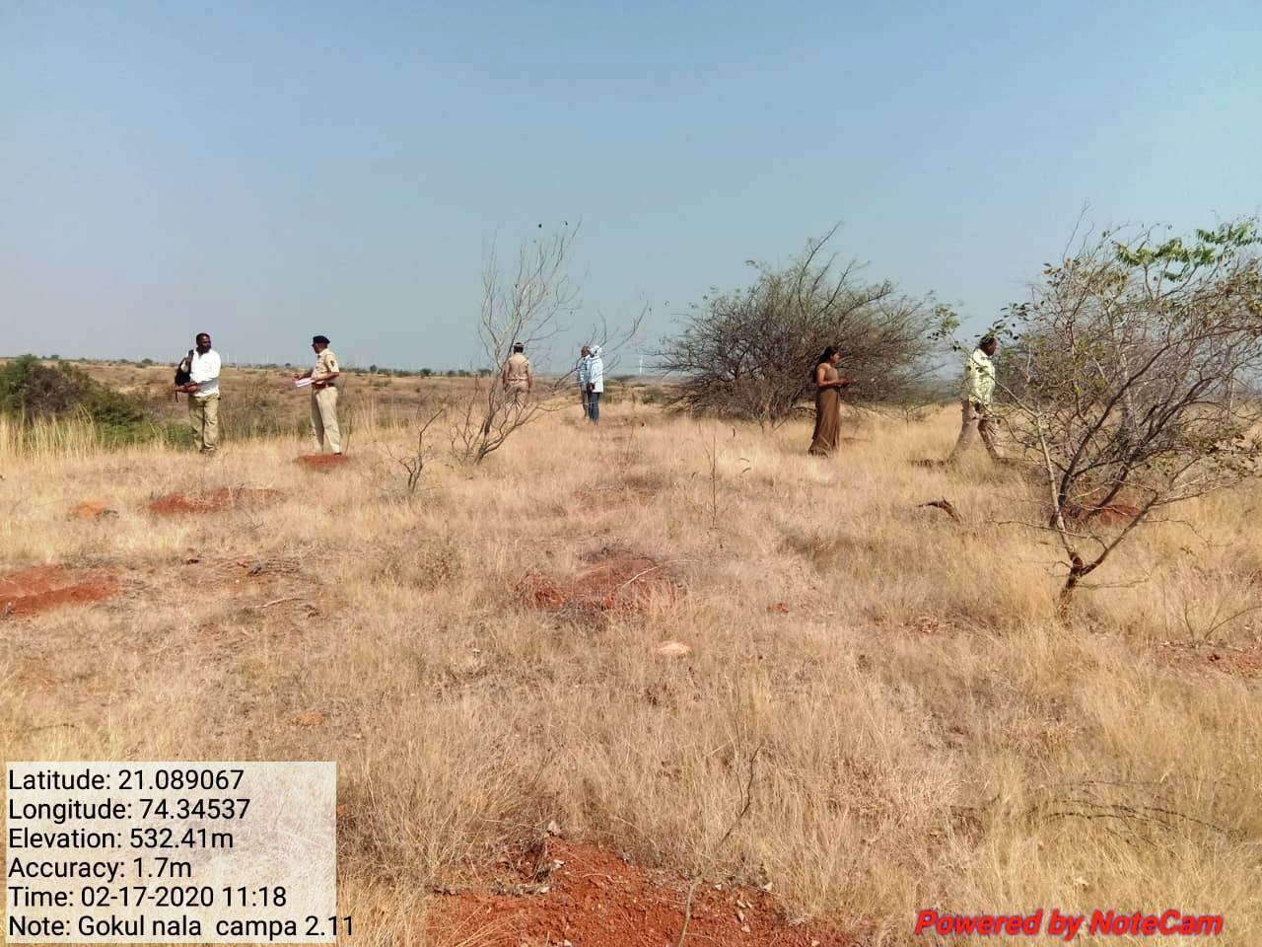
SITE WISE EVALUATION ABSTRACT
Site Number: 82

A. Description of site
Name of Site- Parle
Place- 46,47
Beat- Parle Round- Patne
Range- Patne Forest Division- Kolhapur
Forest Circle- Kolhapur
Area of Treatment- Plantation: 10.000 Ha. GPS: Polygon: 32.860 Ha.
Difference- Excess 22.860 Ha.
Status of Land- Reserved Forest- Yes Protected Forest- No
Unclassed Forest- No Received as compensatory land- No
Zudpi Jungle- No
Site quality- IV b Density- Less than 0.3 Slope- All typea of slope
Available vegetation (Local Names)- Tree: Ain, Arjani, Kumbha, Hirda, Behata, Jambhul. Shrubs: Karwand, Aliv. Marvel,
B. Plantation Details
Model - 400 plants/ha.
Spacement- 5 × 5
Treatment Map- Yes
Soil Zone- Zone-III
Species selected for planting- Jamun, Ain, Awala, Hela, Kumbha, Carpus

C. Survival & Status
Site suitability- The side is inside the forest and in patches. The grors area is more.
Suitability of species planted- Yes Except Silver ouk
Plant survival percentage- 94%
Average Height of plants- 45 cm
Average girth of plants-
General Health of Plants- Healthy
Sustainability- Sustainable

D. Protection-
Fencing Status- Live Hedge - 500 Rmt.
Fire- Amount Sanctioned in the estimate- Rs. 2284.00/-
Execution of the work- Work Done
Expenditure/Payment of the work- Rs. 2284.00/-
Grazing- Yes

E. Monitoring
Inspection of Plantations- APCCF - 0, CCF - 0, DCF - 0, ACF - 0, RFO - 7
Plantation register- Incomplete
Measurement Book- Up-to-date
Cash Book- Up-to-date
Financial audit- Done. Year 2018-19
Fund pattern- Fund avialablity is not proper feed back to me.
F. Overall Rating A Grade
(Excellent – A+, Very Good – A, Good – B+, Average – B, C-Poor)
Reasons for success/ Failure- Funds should be provited regularly.

G. Date of Evaluation 24 Feb 2020
Name of Evaluators Mr. S. S. Dole, Mr. V. B. Patil
H. Photographs-

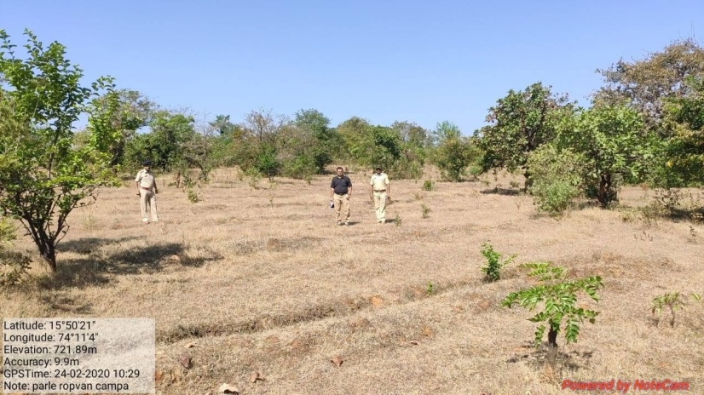
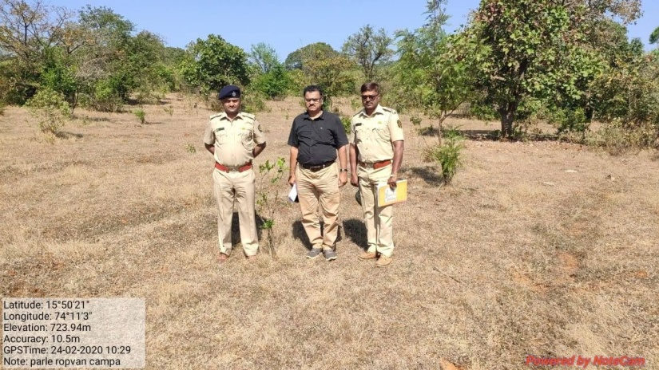
SITE WISE EVALUATION ABSTRACT
Site Number: 83

A. Description of site
Name of Site- Megholi
Place- 300, 301
Beat- Vengarul Round- Gargoti
Range- Gargoti Forest Division- Kolhapur
Forest Circle- Kolhapur
Area of Treatment- Plantation: 5.000 Ha. GPS: Polygon: 34.397 Ha. (Combined for 2 sites)
Difference- Excess 29.970 Ha.
Status of Land- Reserved Forest- Yes Protected Forest- No
Unclassed Forest- No Received as compensatory land- No
Zudpi Jungle- No
Site quality- IV Density- Less than 0.4 Slope- All typea of slope
Available vegetation (Local Names)- Shrub: Ranetha, Karwand, Ghaneri, Toran, Danmodi. Grass: Kusal, Gonodvel, Karad, Kusal
B. Plantation Details
Model - 1000 plants/ha.
Spacement- 5 × 2
Treatment Map- Yes
Soil Zone- Zone-III
Species selected for planting- Silver Oak, Jamun, Awala, Karanj, Dhavda, Vavala, Bamboo, Bahava

C. Survival & Status
Site suitability- Suitable however the Gross area more and Honey combing plantation
Suitability of species planted- Yes
Plant survival percentage- 74%
Average Height of plants- 100 cm
Average girth of plants-
General Health of Plants- Healthy
Sustainability- Sustainable

D. Protection-
Fencing Status- TCM - 270 Rmt.
Fire- Amount Sanctioned in the estimate- Rs. 753.65/-
Execution of the work- Work Not Done
Expenditure/Payment of the work- Rs. 0.00/-
Grazing- No

E. Monitoring
Inspection of Plantations- APCCF - 0, CCF - 0, DCF - 0, ACF - 0, RFO - 0
Plantation register- Up-to-date
Measurement Book- Up-to-date
Cash Book- Up-to-date
Financial audit- Done. Year 2019-20
Fund pattern- Funding received timely.
F. Overall Rating A Grade
(Excellent – A+, Very Good – A, Good – B+, Average – B, C-Poor)
Reasons for success/ Failure- The area is rich is in wild life. The site is good habitat for Baison, Elephants and Wild Boar. The site should be protected.

G. Date of Evaluation 22 Feb 2020
Name of Evaluators Mr. S. S. Dole
H. Photographs-
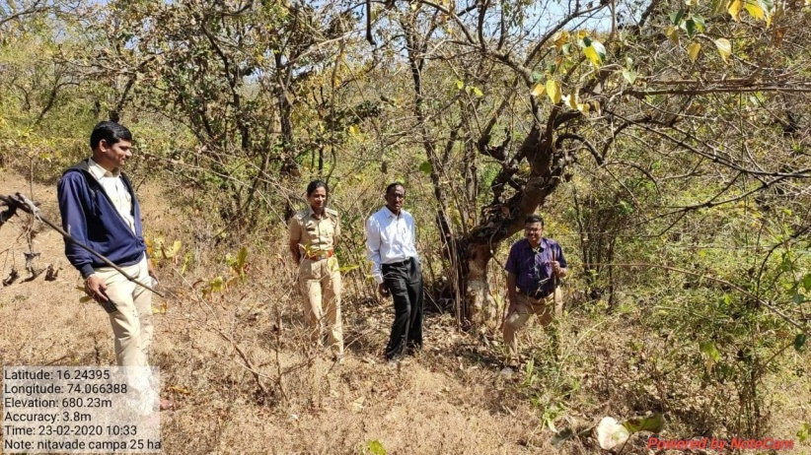
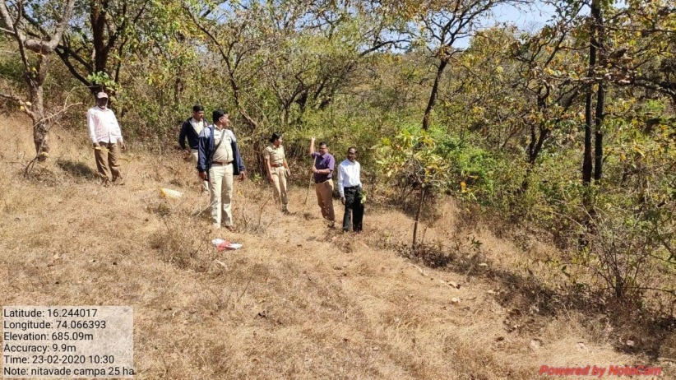

SITE WISE EVALUATION ABSTRACT
Site Number: 84

A. Description of site
Name of Site- Nitawade
Place- 329
Beat- Nitawade Round- Gargoti
Range- Gargoti Forest Division- Kolhapur
Forest Circle- Kolhapur
Area of Treatment- Plantation: 25.000 Ha. GPS: Polygon: 25.000 Ha.
Difference- No Chanage
Status of Land- Reserved Forest- Yes Protected Forest- Yes
Unclassed Forest- No Received as compensatory land- No
Zudpi Jungle- No
Site quality- IV Density- 0.4-0.5 Slope- All typea of slope
Available vegetation (Local Names)- Trees: Kinjal, Jamun, Awala, Sisam, Asana, Ain. shrub: Rameta, Toran, Karvand. Grass: Marvel, Kusal, Chiman Chara
B. Plantation Details
Model - 400 plants/ha.
Spacement- 5 × 5
Treatment Map- Yes
Soil Zone- Zone-II
Species selected for planting- Jamun, Awala, Karanj, Hed, Shikekai, Apta, Bamboo, Chinch, Vavala, Dhavada, Phanas, Mango, Sawar

C. Survival & Status
Site suitability- Suitable but density more than 0.4 Natural regenevstion is more to be protceted improved
Suitability of species planted- Yes
Plant survival percentage- 66%
Average Height of plants- 120 cm
Average girth of plants-
General Health of Plants- Healthy
Sustainability- Sustainable

D. Protection-
Fencing Status- TCM - 1500 Rmt., Barbed Wire / Chain Link - 1875 Rmt.
Fire- Amount Sanctioned in the estimate- Rs. Nil/-
Execution of the work- Work Not Done
Expenditure/Payment of the work- Rs. 0.00/-
Grazing- -

E. Monitoring
Inspection of Plantations- APCCF - 0, CCF - 0, DCF - 0, ACF - 1, RFO - 0
Plantation register- Up-to-date
Measurement Book- Maintained but not up to date
Cash Book- Maintained but not up to date
Financial audit- Not Done
Fund pattern- Funding is proper
F. Overall Rating A Grade
(Excellent – A+, Very Good – A, Good – B+, Average – B, C-Poor)
Reasons for success/ Failure- The area is honey combed and wild life is observed. Browsing noticed and growth of plants is unsatisfactory.

G. Date of Evaluation 23 Feb 2020
Name of Evaluators Mr. S. S. Dole, Mr. V. B. Patil
H. Photographs-
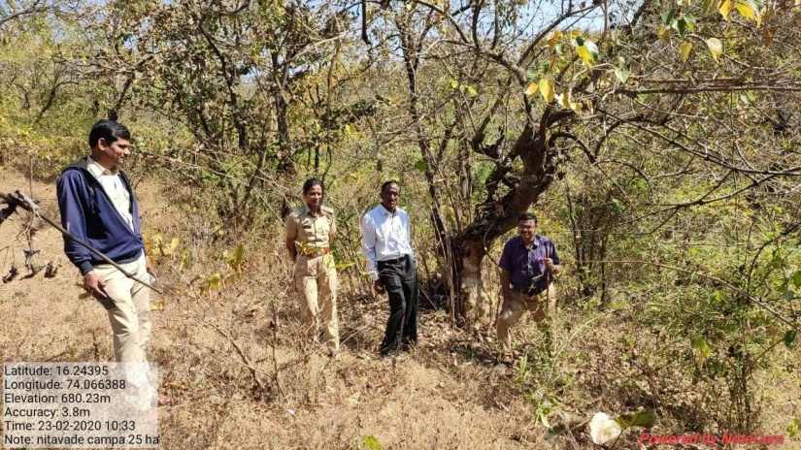
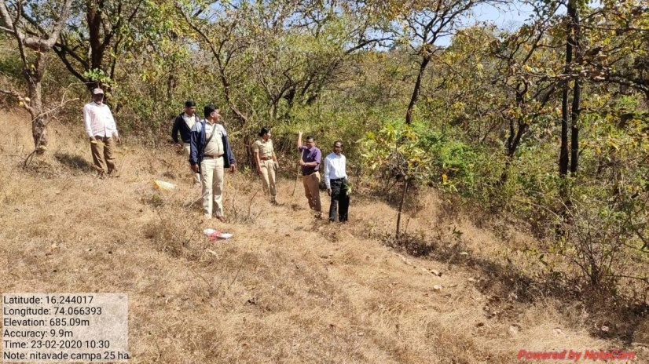
SITE WISE EVALUATION ABSTRACT
Site Number: 85

A. Description of site
Name of Site- Padkhambe
Place- 298, B.C.
Beat- Vengarul Round- Gargoti
Range- Gargoti Forest Division- Kolhapur
Forest Circle- Kolhapur
Area of Treatment- Plantation: 10.000 Ha. GPS: Polygon: 34.397 Ha. (Combined for 2 sites)
Difference- Excess 16.269
Status of Land- Reserved Forest- Yes Protected Forest- No
Unclassed Forest- No Received as compensatory land- No
Zudpi Jungle- No
Site quality- IV Density- 0.3 Slope- Moderate
Available vegetation (Local Names)- Jambul, Awala, Dhavada, Asan, Ain, Kingal, Behada, Aliv
B. Plantation Details
Model - 1000 plants/ha.
Spacement- 5 × 2
Treatment Map- Yes
Soil Zone- Zone-III
Species selected for planting- Jambul, Awala, Karanj, Dhavada, Palas, Hed, Khair, Bamboo, Bahava, Silver Oak

C. Survival & Status
Site suitability- The site is in interior forest un approchable very deep inside the forest. Plantation are in honey combirg dense honert size is Suitable
Suitability of species planted- Yes
Plant survival percentage- 71%
Average Height of plants- 40 cm
Average girth of plants-
General Health of Plants- Healthy
Sustainability- Sustainable

D. Protection-
Fencing Status- TCM - 540 Rmt.
Fire- Amount Sanctioned in the estimate- Rs. 1507.00/-
Execution of the work- Work Not Done
Expenditure/Payment of the work- Rs. 0.00/-
Grazing- No

E. Monitoring
Inspection of Plantations- APCCF - 0, CCF - 0, DCF - 0, ACF - 0, RFO - 0
Plantation register- Up-to-date
Measurement Book- Incomplete
Cash Book- Incomplete
Financial audit- Not Done
Fund pattern- Fundung is Proper
F. Overall Rating B+ Grade
(Excellent – A+, Very Good – A, Good – B+, Average – B, C-Poor)
Reasons for success/ Failure- Inspection paths are required.

G. Date of Evaluation 28 Feb 2020
Name of Evaluators Mr. S. S. Dole, Mr. V. B. Patil
H. Photographs-
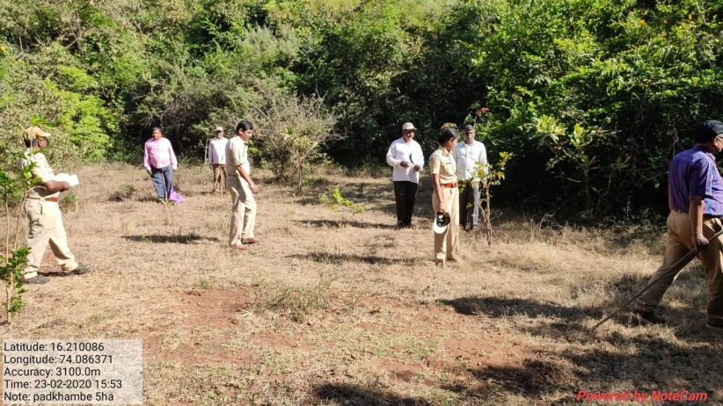
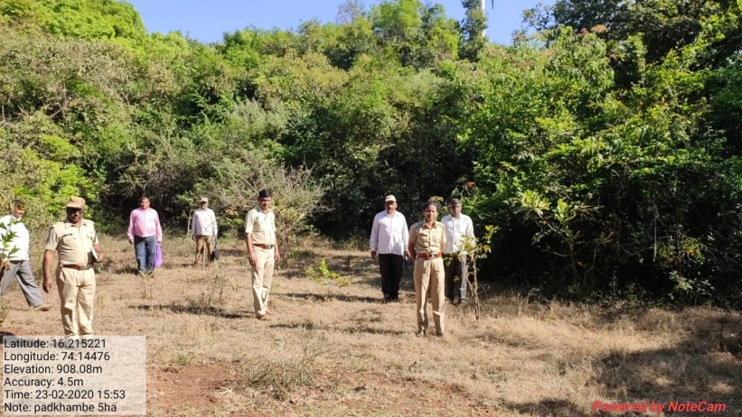
SITE WISE EVALUATION ABSTRACT
Site Number: 86

A. Description of site
Name of Site- Borgaon Bazar
Place- Survey No.225
Beat- Borgaon Bazar Round- Deori
Range- N.Deori Forest Division- Gondia
Forest Circle- Nagpur
Area of Treatment- Plantation: 5.000 Ha. GPS: Polygon: 6.480 Ha.
Difference- Excess 1.480 Ha.
Status of Land- Reserved Forest- Yes Protected Forest- No
Unclassed Forest- No Received as compensatory land- No
Zudpi Jungle- No
Site quality- IV A Density- 0.2 Slope- Gentle
Available vegetation (Local Names)- Dhavda, Seham, Charch, Ain, Moha, Kada, Zodagard, Kusal
B. Plantation Details
Model - 1111 plants/ha.
Spacement- 3 × 3
Treatment Map- No
Soil Zone- Zone-III
Species selected for planting- Aawala, Jambhul, Beheda, Hirda, Mahanke, Neem

C. Survival & Status
Site suitability- Suitable
Suitability of species planted- Yes
Plant survival percentage- 58%
Average Height of plants- 40 cm
Average girth of plants- 5 cm
General Health of Plants- Unhealthy
Sustainability- Will not be sustained

D. Protection-
Fencing Status- Barbed Wire / Chain Link - 1050 Rmt.
Fire- Amount Sanctioned in the estimate- Rs. 2983.60/-
Execution of the work- Work Done
Expenditure/Payment of the work- Rs. 2984.00/-
Grazing- Yes

E. Monitoring
Inspection of Plantations- APCCF - 0, CCF - 0, DCF - 0, ACF - 0, RFO - 1
Plantation register- Maintained but not properly filled
Measurement Book- Not duly signed by RFO
Cash Book- Up-to date
Financial audit- Done. 2018-19
Fund pattern- Funds pattern is regular but irregular in current year i.e.2019-20.
F. Overall Rating B+ Grade
(Excellent – A+, Very Good – A, Good – B+, Average – B, C-Poor)
Reasons for success/ Failure- The boundary of the plantation should be completely fenced.The planting stock should not be less than 18 months old.The treatment & zonation map should be proper with details.

G. Date of Evaluation 19 Feb 2020
Name of Evaluators Mr. A. S. Khune, Mr. D. S. Gadpande
H. Photographs-
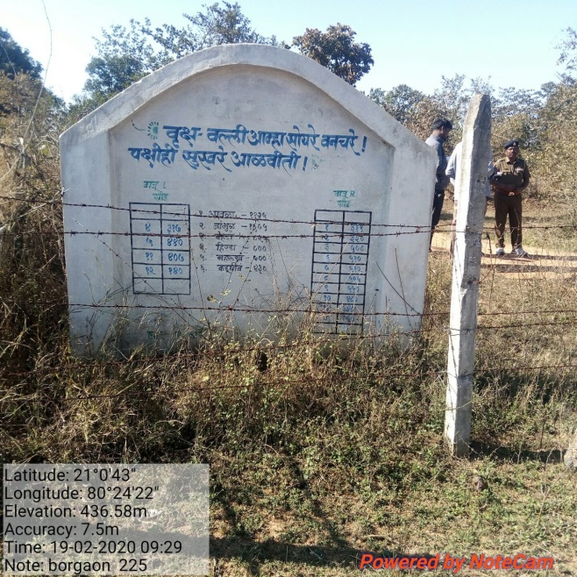

SITE WISE EVALUATION ABSTRACT
Site Number: 87

A. Description of site
Name of Site- Deori
Place- 1679 PF
Beat- Deori Round- Deori
Range- N.Deori Forest Division- Gondia
Forest Circle- Nagpur
Area of Treatment- Plantation: 15.000 Ha. GPS: Polygon 16.230 Ha.
Difference- Excess 1.230 Ha.
Status of Land- Reserved Forest- No Protected Forest- Yes
Unclassed Forest- No Received as compensatory land- No
Zudpi Jungle- No
Site quality- IV A Density- 0.4 Average Slope- Gentle
Available vegetation (Local Names)- Char, Bija, Kumbhi, Ain, Palas, Sehanar, Garadi, Ghatbor, Kuda, Chilati, Neem, Asara, Chikana Grass
B. Plantation Details
Model - 1111 plants/ha.
Spacement- 3 × 3
Treatment Map- No
Soil Zone- No zonation done on map. 40% area in zone II and rest in zone III
Species selected for planting- Aawala, Jambhul, Maharukh, Behada, Neem, Hirda, Shivan, Putranjiva

C. Survival & Status
Site suitability- Not suitable, average 0.4 density and part zone II area
Suitability of species planted- Yes
Plant survival percentage- 52%
Average Height of plants- 65 cm
Average girth of plants- 10 cm
General Health of Plants- Semi-healthy
Sustainability- Will not sustain if no fencing and grazing check.

D. Protection-
Fencing Status- Barbed Wire / Chain Link - 2350 Rmt.
Fire- Amount Sanctioned in the estimate- Rs. 8950.80/-
Execution of the work- Work Done
Expenditure/Payment of the work- Rs. 8951.00/-
Grazing- Yes, Due to improper fence

E. Monitoring
Inspection of Plantations- APCCF - 1, CCF - 0, DCF - 0, ACF - 1, RFO - 2
Plantation register- Maintained but not properly filled
Measurement Book- Payments not duly signed
Cash Book- Up-to date
Financial audit- Done. 2018-19
Fund pattern- Funds are received timely. Funds are utilized timely.
F. Overall Rating B+ Grade
(Excellent – A+, Very Good – A, Good – B+, Average – B, C-Poor)
Reasons for success/ Failure- The boundary of the plantation should be completely fenced.The planting stock should not be less than 18 months old.The treatment & zonation map should be proper with details.

G. Date of Evaluation 18 Feb 2020
Name of Evaluators Mr. A. S. Khune, Mr. D. S. Gadpande
H. Photographs-
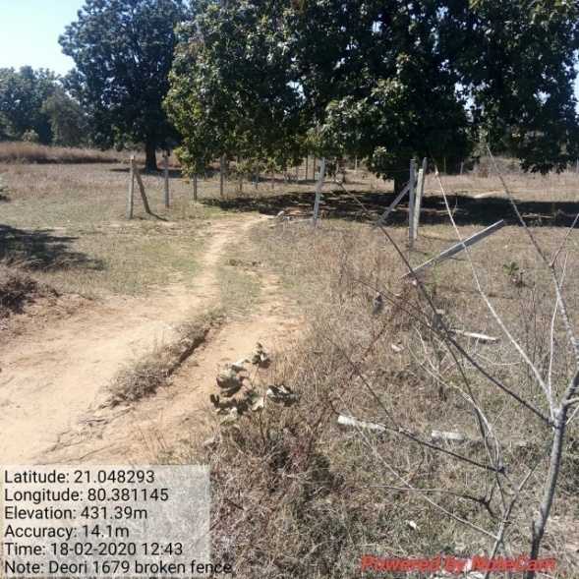
Broken fence
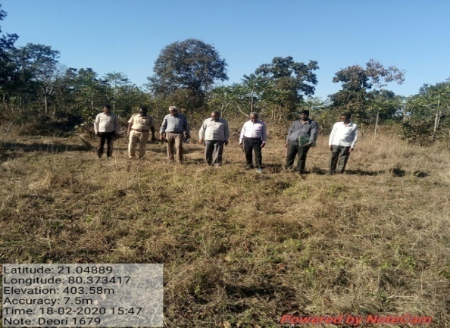
Only survival, no growth
SITE WISE EVALUATION ABSTRACT
Site Number: 88

A. Description of site
Name of Site- Nawezari
Place- Comptt.No.72
Beat- Lunava Round- Wadegaon
Range- Tiroda Forest Division- Gondia
Forest Circle- Nagpur
Area of Treatment- Plantation: 12.000 Ha. GPS: Polygon 13.250 Ha.
Difference- Excess 1.250 ha.
Status of Land- Reserved Forest- No Protected Forest- Yes
Unclassed Forest- No Received as compensatory land- No
Zudpi Jungle- No
Site quality- IV A Density- 0.1 Slope- Gentle
Available vegetation (Local Names)- Neem, Moha, Hiwar, Garadi, Bharati, Sehana, Ghaneri, Zilbuli, Kusal, Takla, Marwel, Rantulas, Kharsali
B. Plantation Details
Model - 2500 plants/ha.
Spacement- 2 × 2
Treatment Map- No
Soil Zone- No zonation map prepared
Species selected for planting- Aawala, Behada, Hirda, Bel, Kawal, Neem, Arjun

C. Survival & Status
Site suitability- Suitable
Suitability of species planted- Yes
Plant survival percentage- 54%
Average Height of plants- 330 cm
Average girth of plants- 20 cm
General Health of Plants- Healthy
Sustainability- Sustainable

D. Protection-
Fencing Status- No
Fire- Amount Sanctioned in the estimate- Rs. 6699.00/-
Execution of the work- Work Done
Expenditure/Payment of the work- Rs. 6699.00/-
Grazing- No

E. Monitoring
Inspection of Plantations- APCCF - 0, CCF - 0, DCF - 1, ACF - 0, RFO - 0, Others - 3 (Including Principal Secretary, (Forests))
Plantation register- Up-to date
Measurement Book- Up-to date
Cash Book- Up-to date
Financial audit- Done
Fund pattern- Fund flow is regular & timely. Fund are utilized timely.
F. Overall Rating A Grade
(Excellent – A+, Very Good – A, Good – B+, Average – B, C-Poor)
Reasons for success/ Failure- 1) The boundry of the plantation should be completely closed by effective from up to stop the grazing & biotic interference. 2) The planting stock should not be less than 18 months old 3) The treatment map, zonation map should be proper & detailed.

G. Date of Evaluation 24 Feb 2020
Name of Evaluators Mr. A. S. Khune, Mr. D. S. Gadpande
H. Photographs-
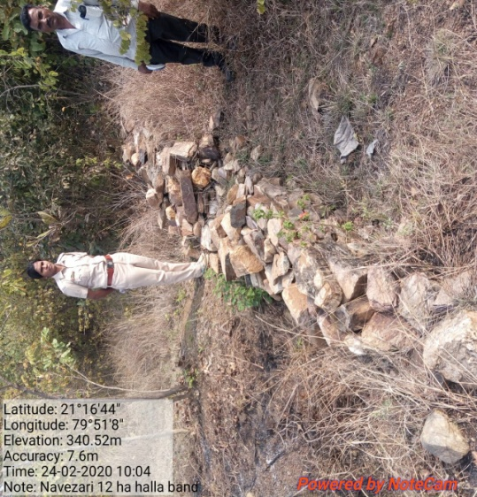
Improper LBS

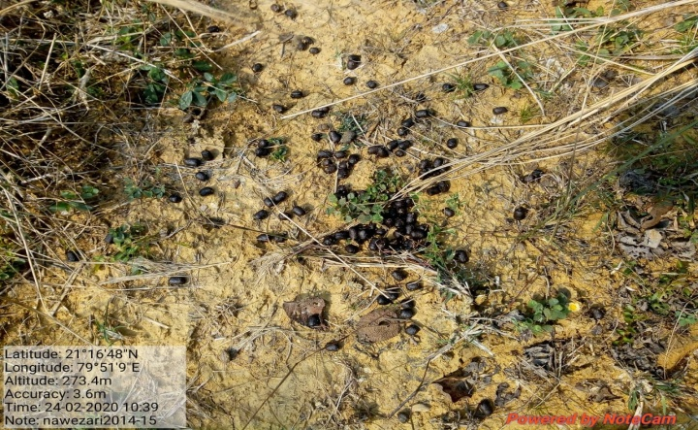
Wildlife grazing
SITE WISE EVALUATION ABSTRACT
Site Number: 89

A. Description of site
Name of Site- Khairibodi
Place- Sr.No. 821, 822
Beat- Tiroda Round- Tiroda
Range- Tiroda Forest Division- Gondia
Forest Circle- Nagpur
Area of Treatment- Plantation: 5.500 Ha. GPS: Polygon: 5.640 Ha.
Difference- Excess 0.140 Ha.
Status of Land- Reserved Forest- Yes Protected Forest- No
Unclassed Forest- No Received as compensatory land- No
Zudpi Jungle- No
Site quality- IV A Density- 0.1 Slope- Gentle
Available vegetation (Local Names)- Hiwar, Ain
B. Plantation Details
Model - Mixed Plantation
Spacement- 5 × 5, 2.5 × 2.5
Treatment Map- No
Soil Zone- No zonation map prepared
Species selected for planting- Teak, Aawala, Kawaj, Behada, Shivan, Neem, Jambhul, Ritha.

C. Survival & Status
Site suitability- Suitable
Suitability of species planted- Yes, Bower land, ans hirar species
Plant survival percentage- 86%
Average Height of plants- 60 cm
Average girth of plants- 7 cm
General Health of Plants- Healthy
Sustainability- If not well protected, plantation will not sustained.

D. Protection-
Fencing Status- No
Fire- Amount Sanctioned in the estimate- Rs. 1471.25/-
Execution of the work- Work Done
Expenditure/Payment of the work- Rs. 1421.00/-
Grazing- No

E. Monitoring
Inspection of Plantations- APCCF - 0, CCF - 0, DCF - 0, ACF - 0, RFO - 0
Plantation register- Incomplete
Measurement Book- No paid/cancelled
Cash Book- Up-to date
Financial audit- Done
Fund pattern- Funds are received monthly given by Divisional Office timely. Also, utilised timely. Since oct-19 funds not received.
F. Overall Rating A Grade
(Excellent – A+, Very Good – A, Good – B+, Average – B, C-Poor)
Reasons for success/ Failure- 1) The TCM must be effective. It is in santioned estimates. 2) If barbed wire & chain link fencing is in the estimate, it should be covered by entire length.

G. Date of Evaluation 22 Feb 2020
Name of Evaluators Mr. A. S. Khune, Mr. D. S. Gadpande
H. Photographs-

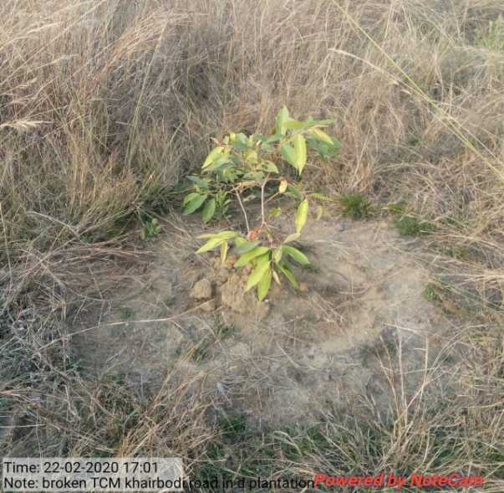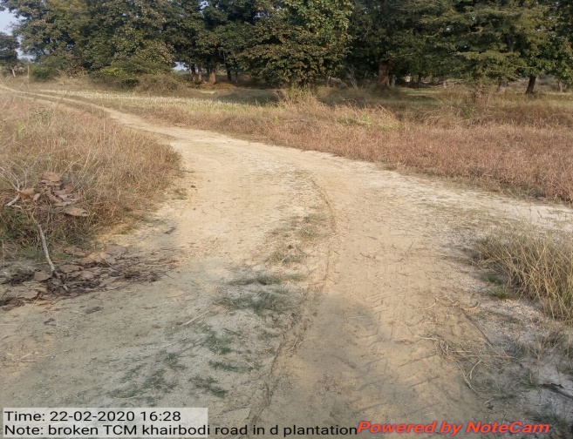
Road through plantation

SITE WISE EVALUATION ABSTRACT
Site Number: 90

A. Description of site
Name of Site- Ranipur Wardha
Place- 366 PF
Beat- Sirsi Round- Zarkuli
Range- South Umred Forest Division- Nagpur
Forest Circle- Nagpur
Area of Treatment- Plantation: 1.730 Ha. GPS: Polygon: 2.500 Ha.
Difference- Excess 0.860 Ha.
Status of Land- Reserved Forest- No Protected Forest- Yes
Unclassed Forest- No Received as compensatory land- No
Zudpi Jungle- No
Site quality- IV B Density- 0 Slope- Plain area
Available vegetation (Local Names)- Teak, Sajad, Moha, Bor,
B. Plantation Details
Model - 1111 plants/ha.
Spacement- 3 × 3
Treatment Map- Yes.
Soil Zone- Zone-III
Species selected for planting- Neem, Jamun, Behada, Amaltas, Tamarind, Sitaphal, Umber, Chinch

C. Survival & Status
Site suitability- Suitable. Site selected is from enchrochment vacated. Place is suitable for planting.
Suitability of species planted- Jamun is planted but not suitable
Plant survival percentage- 81%
Average Height of plants- 65 cm
Average girth of plants-
General Health of Plants- Semi-healthy
Sustainability- Not sustainable because of lack of fencing.

D. Protection-
Fencing Status- TCM - 600 Rmt.
Fire- Amount Sanctioned in the estimate- Rs. 1038.00/-
Execution of the work- Work Done
Expenditure/Payment of the work- Rs. 1065.00/-
Grazing- Not recorded

E. Monitoring
Inspection of Plantations- APCCF - 0, CCF - 0, DCF - 0, ACF - 1, RFO - 2
Plantation register- Incomplete
Measurement Book- MB not produced
Cash Book- Up-to date
Financial audit- Done
Fund pattern- Regular.
F. Overall Rating A Grade
(Excellent – A+, Very Good – A, Good – B+, Average – B, C-Poor)
Reasons for success/ Failure- If protected may survive.
G. Date of Evaluation 18 Feb 2020
Name of Evaluators Mr. V. S. Bhonsle, Mr. S. B. Dabhade
H. Photographs-

SITE WISE EVALUATION ABSTRACT
Site Number: 91

A. Description of site
Name of Site- Kawathe Mahakai
Place- FS No. 16 235
Beat- Kawathe Mahakai Round- Warwande
Range- Sangamner Forest Division- Sangamner
Forest Circle- Nashik
Area of Treatment- Plantation: 2.870 Ha. GPS: Polygon: 3.000 Ha.
Difference- Excess 0.130 Ha.
Status of Land- Reserved Forest- Yes Protected Forest- No
Unclassed Forest- No Received as compensatory land- No
Zudpi Jungle- No
Site quality- V Density- less than 0.1 Slope- Gentle(0 to 10 degrees)
Available vegetation (Local Names)- Trees-Babhul, Neem, Anjan, Kansar, Grass- Kusal, Kadi, Tarwad, Ghentuli, Amoni, Henkar, Karwand
B. Plantation Details
Model - 625 plants/ha.
Spacement- 4 × 4
Treatment Map- Yes
Soil Zone- Zone-I, Zone-II, Zone-III
Species selected for planting- Chinch, Awala, Sitafal, Palas, Bor, Bel, Mehandi

C. Survival & Status
Site suitability- Not suitable - The land selected on the basis of its location under high power transmission line is murumy with intermitant stony and rocky patches. It is dry zone
Suitability of species planted- No The locality is has poor quality soil and murum. Rainfall is very low species like bamboo,bhenda,hirda are not suitable (215 mm)
Plant survival percentage- 96%
Average Height of plants- 50 cm
Average girth of plants- 4 cm
General Health of Plants- Unhealthy
Sustainability- Unlikely to be sustainable for the reason of planting of tree spps. Of high rainfall zone.

D. Protection-
Fencing Status- TCM - 139 Rmt., Stone Wall - 21 Rmt.
Fire- Amount Sanctioned in the estimate- Rs. 17077.00/-
Execution of the work- Work Done
Expenditure/Payment of the work- Rs. 17077.00/-
Grazing- No
E. Monitoring
Inspection of Plantations- APCCF - 0, CCF - 0, DCF - 0, ACF - 0, RFO - 2
Plantation register- up-to-date
Measurement Book- Up-to-date
Cash Book- Sent to pune for audit
Financial audit- Done. Year 2019-20
Fund pattern- There was total stoppage of funds during this current financial year till date of visit of ET.
F. Overall Rating A Grade
(Excellent – A+, Very Good – A, Good – B+, Average – B, C-Poor)
Reasons for success/ Failure- Evaluater recommends plating of grasses instead of medicinal plants.

G. Date of Evaluation 23 Feb 2020
Name of Evaluators Mr. S. K. Gawali, Mr. B. R. Challare
H. Photographs-
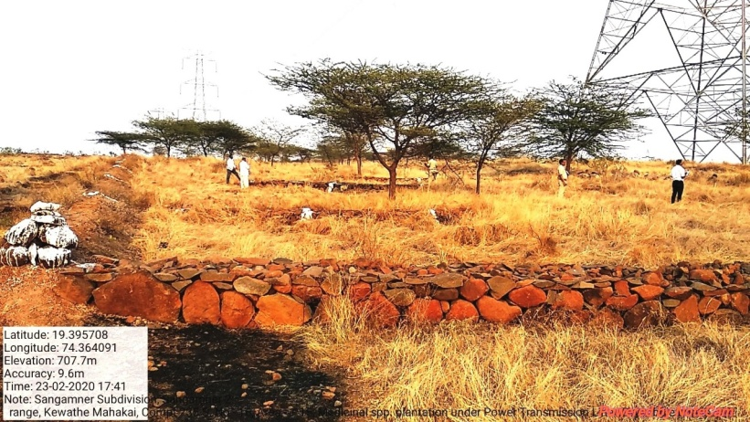
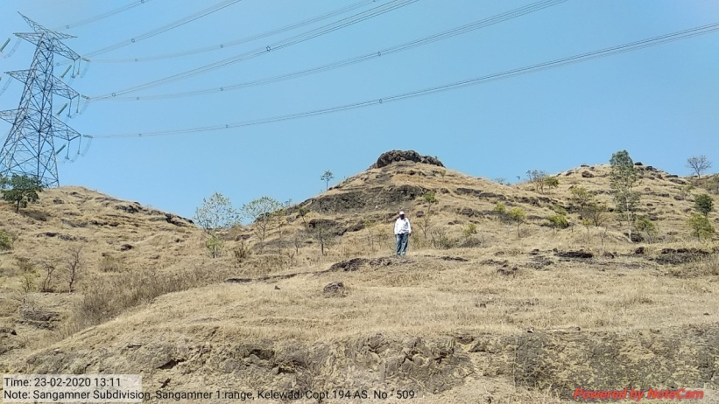

SITE WISE EVALUATION ABSTRACT
Site Number: 92

A. Description of site
Name of Site- Pimpre Khurd
Place- 519
Beat- Walhe Round- Jejuri
Range- Saswad Forest Division- Bhor
Forest Circle- Pune
Area of Treatment- Plantation: 10.000 Ha. GPS: Polygon: 10.000 Ha.
Difference- No change
Status of Land- Reserved Forest- Yes Protected Forest- No
Unclassed Forest- No Received as compensatory land- No
Zudpi Jungle- No
Site quality- Degraded land Density- Less than 0.4 Slope- Gentle
Available vegetation (Local Names)- Tree, Grass
B. Plantation Details
Model - 625 plants/ha.
Spacement- 4 × 4
Treatment Map- Yes
Soil Zone- Zone-III
Species selected for planting- Sisoo, Neem, Karanj, Sitaphal, Chinch, Wavla, Babul, Kanchan, Parkinsona etc.

C. Survival & Status
Site suitability- Suitable
Suitability of species planted- Yes
Plant survival percentage- 100%
Average Height of plants- 84 cm
Average girth of plants-
General Health of Plants- Healthy
Sustainability- Seems to have very good future

D. Protection-
Fencing Status- TCM - 1565 Rmt.
Fire- Amount Sanctioned in the estimate- Rs. 6408.00/-
Execution of the work- Work Done
Expenditure/Payment of the work- Rs. 6408.00/-
Grazing- No

E. Monitoring
Inspection of Plantations- APCCF - 0, CCF - 0, DCF/DFO - 2, ACF - 0, RFO - 1
Plantation register- Up-to date
Measurement Book- Up-to date
Cash Book- Up-to date
Financial audit- Not Done
Fund pattern- Funds for SYO yet to be received
F. Overall Rating A+ Grade
(Excellent – A+, Very Good – A, Good – B+, Average – B, C-Poor)
Reasons for success/ Failure- Gap in TCM needs to be plugged

G. Date of Evaluation 18 Feb 2020
Name of Evaluators Mr. G. P. Garad, Mr. R. K. Adkar
H. Photographs-
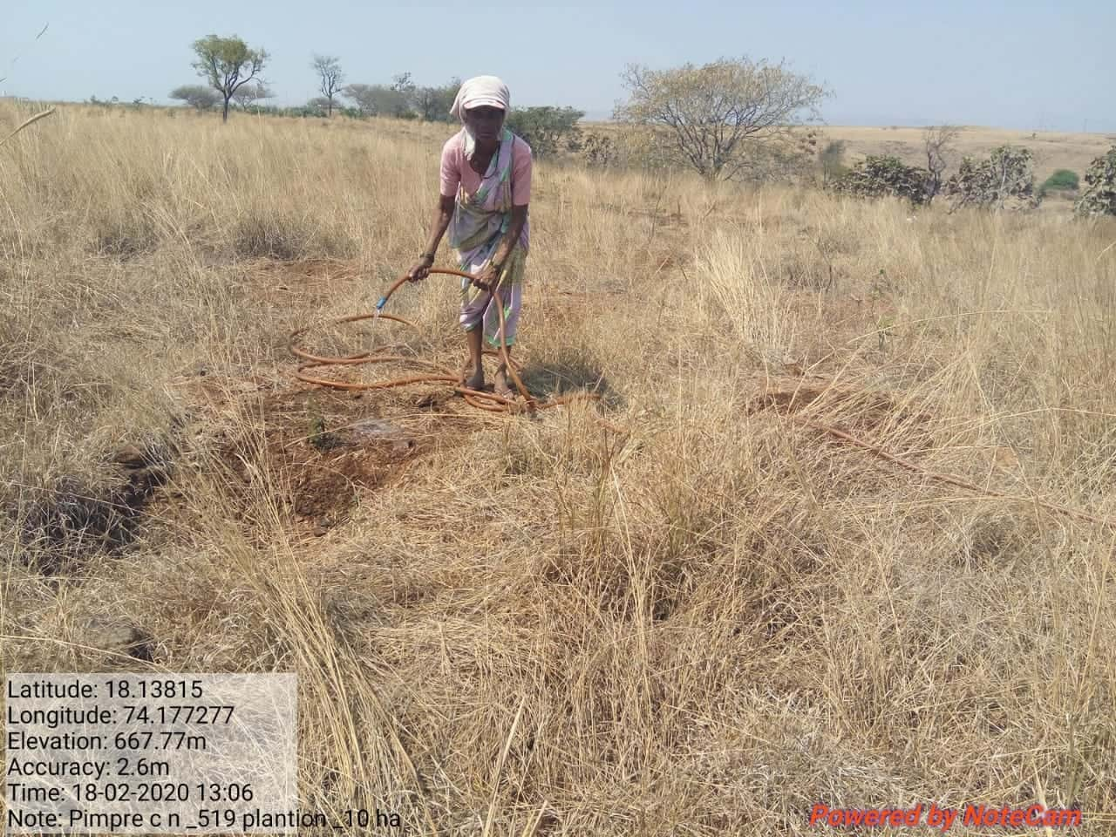
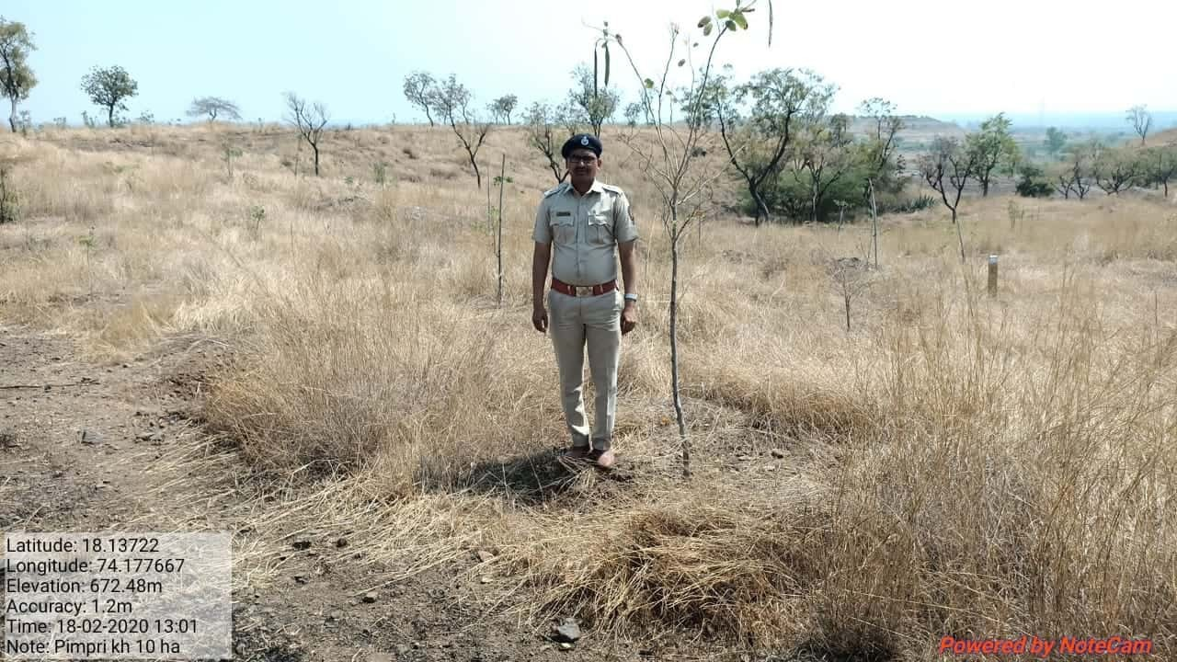
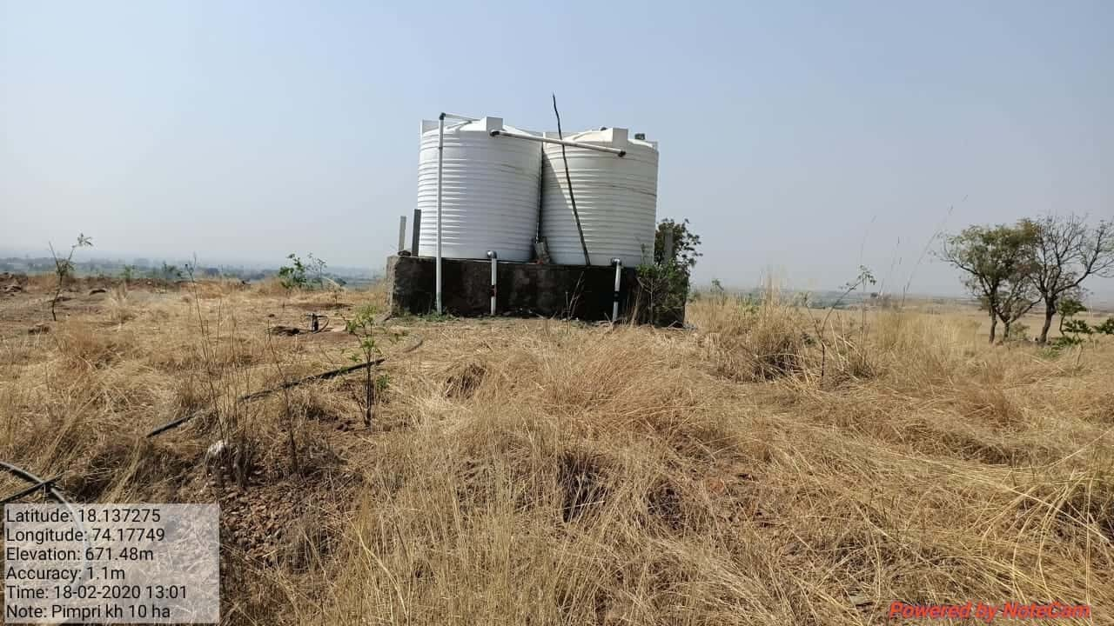
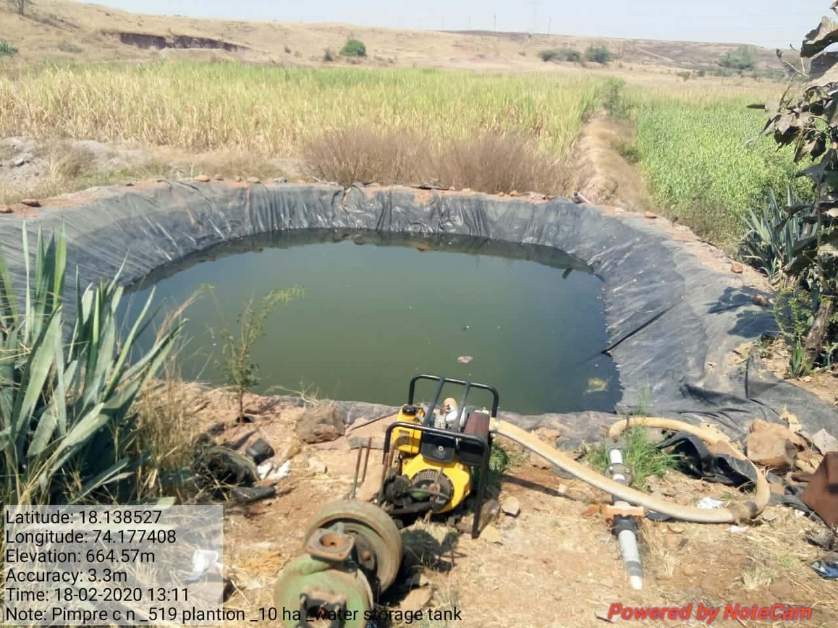

SITE WISE EVALUATION ABSTRACT
Site Number: 93

A. Description of site
Name of Site- Kamare
Place- 100 & 104
Beat- Kamare Round- Shelwal
Range- Palghar Forest Division- Dahanu
Forest Circle- Thane
Area of Treatment- Plantation: 10.000 Ha. GPS: Polygon: 16.000 Ha.
Difference- Excess 6.000 Ha.
Status of Land- Reserved Forest- Yes Protected Forest- No
Unclassed Forest- No Received as compensatory land- No
Zudpi Jungle- No
Site quality- III and IV A Density- 0.5 to 0.6 Slope- Moderate
Available vegetation (Local Names)- Tree, Shrubs and climbers
B. Plantation Details
Model - 278 plants/ha.
Spacement- 6 × 6
Treatment Map- Yes
Soil Zone- Zone-I, Zone-III
Species selected for planting- Bamboo

C. Survival & Status
Site suitability- Not Suitable. Bamboo plantation is raised in dense bushy growth of bushes, climbers and undergrowth of natural regeneration having density 0.5 to 0.6.
Suitability of species planted- No. Bamboo planted in dense bushy undergrowth and middle story trees having density more than 0.4
Plant survival percentage- 67%
Average Height of plants- 40 cm
Average girth of plants-
General Health of Plants- Unhealthy
Sustainability- Natural regeneration is good but growth of bamboo is not encouraging due to dense undergrowth.

D. Protection-
Fencing Status- TCM - 61 Rmt. (Part Fending)
Fire- Amount Sanctioned in the estimate- Rs. 6792.40/-
Execution of the work- Work Done
Expenditure/Payment of the work- Rs. 6793.00/-
Grazing- Not seen

E. Monitoring
Inspection of Plantations- APCCF - 0, CCF - 0, DCF - 0, ACF - 0, RFO - 1
Plantation register- Up-to date
Measurement Book- Up-to date
Cash Book- Sent for Audit
Financial audit- Not Done
Fund pattern- Late funding at range level. S.Y.O. funds yet not received.
F. Overall Rating B+ Grade
(Excellent – A+, Very Good – A, Good – B+, Average – B, C-Poor)
Reasons for success/ Failure- 1) Bamboo plantation should be suitable in the open area. 2) Site specific estimate of works should be adopted.

G. Date of Evaluation 18 Feb 2020
Name of Evaluators Mr. N. A. Patil
H. Photographs-

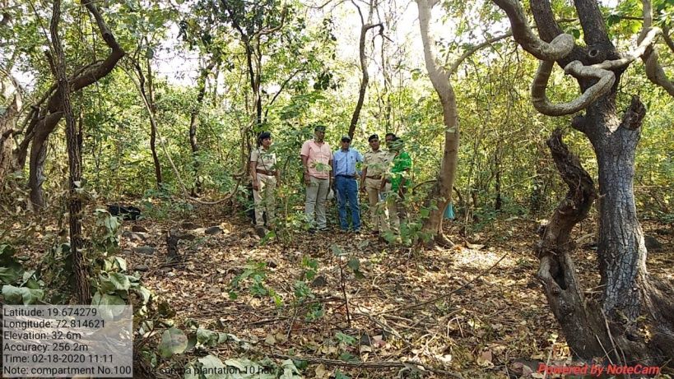
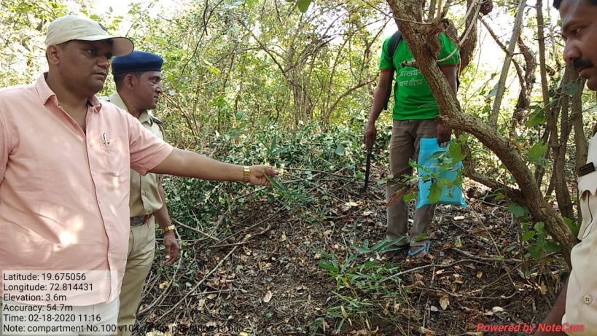
SITE WISE EVALUATION ABSTRACT
Site Number: 94

A. Description of site
Name of Site- Murbad
Place- 297, 279
Beat- Murbad Round- Murbad
Range- Kasa Forest Division- Dahanu
Forest Circle- Thane
Area of Treatment- Plantation: 11.960 Ha. GPS: Polygon: 8.800 Ha.
Difference- Less 3.160 Ha.
Status of Land- Reserved Forest- Yes (Deemed R.F. Acquired private forest) Protected Forest- No
Unclassed Forest- No Received as compensatory land- No
Zudpi Jungle- No
Site quality- IV A Density- 0.1 Slope- Gentle
Available vegetation (Local Names)- Only shrubs like Bor, Ain, Grasses are available
B. Plantation Details
Model - 625 plants/ha.
Spacement- 4 × 4
Treatment Map- No
Soil Zone- Zone-II, Zone-III
Species selected for planting- Aawala, Sitaphal, Kavath, Neem, Cashew, Jambhul, Karanj, Mango, Shatawari etc.

C. Survival & Status
Site suitability- Overall soil is suitable for medicinal plantation.
Suitability of species planted- Some of the species like Shatawari (not survival) Mango, cashew are fruit trees.
Plant survival percentage- 65%
Average Height of plants- 40 cm
Average girth of plants-
General Health of Plants- Unhealthy
Sustainability- Not sustainable as per the present condition of surviving seedlings.

D. Protection-
Fencing Status- TCM - 132 × 2 Rmt. (Part Fencing)
Fire- Amount Sanctioned in the estimate- Rs. 8123.00/-
Execution of the work- Work Done
Expenditure/Payment of the work- Rs. 7499.00/-
Grazing- Yes

E. Monitoring
Inspection of Plantations- APCCF - 0, CCF - 0, DCF - 0, ACF - 0, RFO - 0
Plantation register- Incomplete
Measurement Book- Not in book form
Cash Book- Up-to date
Financial audit- By C.A.
Fund pattern- PYO & FYO - funds received in time. However 2nd year funds yet not received.
F. Overall Rating B+ Grade
(Excellent – A+, Very Good – A, Good – B+, Average – B, C-Poor)
Reasons for success/ Failure- Uncontrolled grazing damaged the plantation.

G. Date of Evaluation 20 Feb 2020
Name of Evaluators Mr. N. A. Patil
H. Photographs-
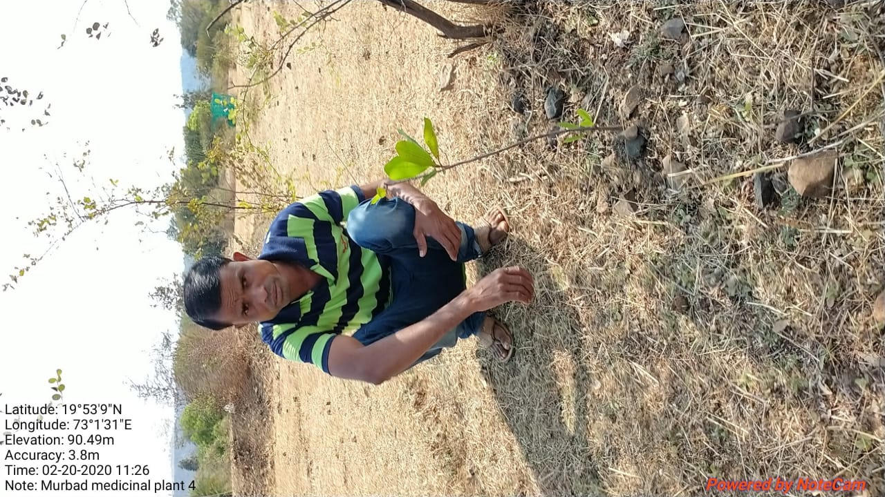

SITE WISE EVALUATION ABSTRACT
Site Number: 95

A. Description of site
Name of Site- Babare
Place- 691
Beat- Bahare Round- Kharada
Range- Dolkhamb Forest Division- Shahapur
Forest Circle- Thane
Area of Treatment- Plantation: 25.000 Ha GPS: Polygon: 53.200 Ha.
Difference- Excess 28.200 Ha.
Status of Land- Reserved Forest- Yes Protected Forest- No
Unclassed Forest- No Received as compensatory land- No
Zudpi Jungle- No
Site quality- III / IV Density- 0.6 Slope- Heavy
Available vegetation (Local Names)- Teak, Ain, Palas, Hed, Kalamb, Dhavda, Kahandol, Karwand, Murudsheng, Grasses-Marvel
B. Plantation Details
Model - 1111 plants/ha.
Spacement- 3 × 3
Treatment Map- Yes
Soil Zone- Zone-I, Zone-II, Zone-III
Species selected for planting- Teak, Shivan, Khair

C. Survival & Status
Site suitability- Suitable
Suitability of species planted- Yes
Plant survival percentage- 81%
Average Height of plants- 55 cm
Average girth of plants- 3.5 cm
General Health of Plants- Healthy
Sustainability- Sustainable provided fire protection is done

D. Protection-
Fencing Status- No
Fire- Amount Sanctioned in the estimate- Rs. 140938.15/-
Execution of the work- Work Done
Expenditure/Payment of the work- Rs. 0.00/-
Grazing- No

E. Monitoring
Inspection of Plantations- APCCF - 0, CCF - 0, DCF - 1, ACF - 2, RFO - 2
Plantation register- Up-to-date
Measurement Book- Up-to-date
Cash Book- Up-to-date
Financial audit- Not Done
Fund pattern- No funds were received for any FYO operations
F. Overall Rating B+ Grade
(Excellent – A+, Very Good – A, Good – B+, Average – B, C-Poor)
Reasons for success/ Failure- Nil

G. Date of Evaluation 26 Feb 2020
Name of Evaluators Mr. S. K. Gawali, Mr. B. R. Challare
H. Photographs-

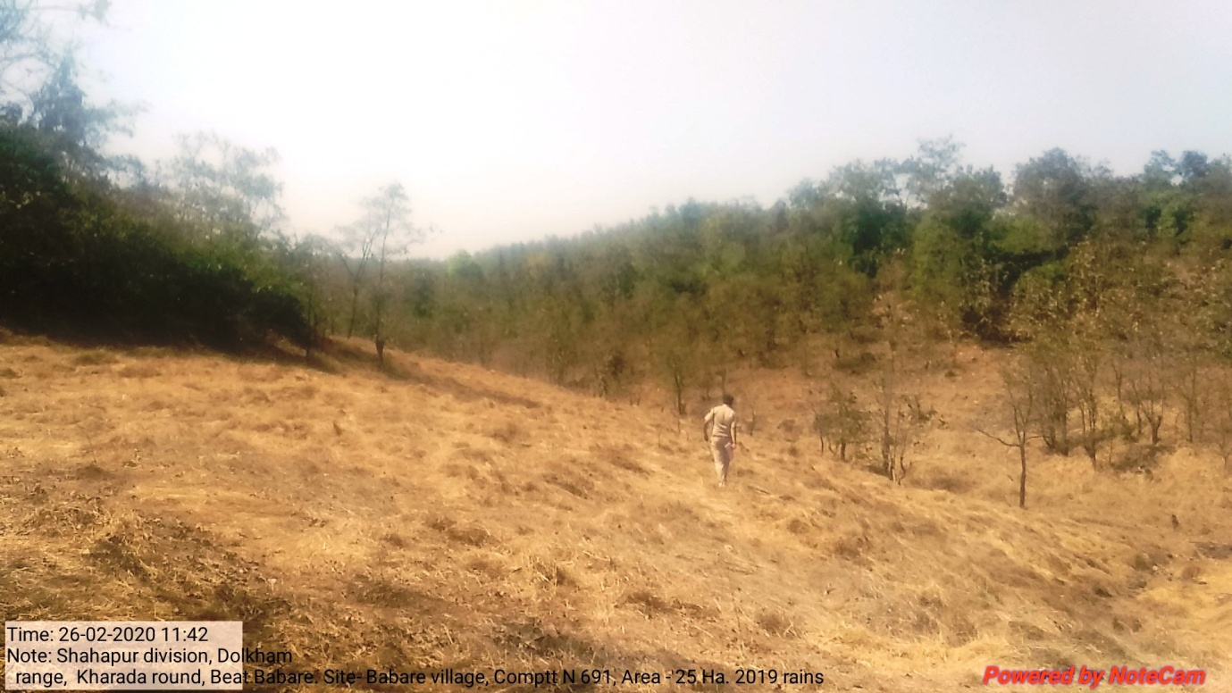
SITE WISE EVALUATION ABSTRACT
Site Number: 96

A. Description of site
Name of Site- Khaira
Place- 687
Beat- Musai Round- Shenva
Range- Dhasai Forest Division- Shahapur
Forest Circle- Thane
Area of Treatment- Plantation 25.000 Ha. GPS: Polygon 30.472 Ha.
Difference- Excess 5.472 Ha.
Status of Land- Reserved Forest- Yes Protected Forest- No
Unclassed Forest- No Received as compensatory land- No
Zudpi Jungle- No
Site quality- III Density- 0.5 Slope- Gentle(0 to 10 degrees)
Available vegetation (Local Names)- Teak, Ain, Palas, Hed, Kalam, Dhavda, Kahandol, Karwand, Murudsheng, Grasses-Marvel
B. Plantation Details
Model - 1111 plants/ha.
Spacement- 3 × 3
Treatment Map- Yes
Soil Zone- Zone-I, Zone-II, Zone-III
Species selected for planting- Teak, Shivam, Khair

C. Survival & Status
Site suitability- Suitable
Suitability of species planted- Yes
Plant survival percentage- 87%
Average Height of plants- 65 cm
Average girth of plants- 5 cm
General Health of Plants- Healthy
Sustainability- -

D. Protection-
Fencing Status- TCM - 1330 Rmt., Sonewall - 20 Rmt.
Fire- Amount Sanctioned in the estimate- Rs. 7290.00/-
Execution of the work- Work Not Done
Expenditure/Payment of the work- Rs. 0.00/-
Grazing- Yes , light grazing

E. Monitoring
Inspection of Plantations- APCCF - 0, CCF - 0, DCF - 0, ACF - 1, RFO - 2
Plantation register- Up-to-date
Measurement Book- Up-to-date
Cash Book- Up-to-date
Financial audit- Done
Fund pattern-
F. Overall Rating A Grade
(Excellent – A+, Very Good – A, Good – B+, Average – B, C-Poor)
Reasons for success/ Failure-

G. Date of Evaluation 27 Feb 2020
Name of Evaluators Mr. S. K. Gawali, Mr. B. R. Challare
H. Photographs-
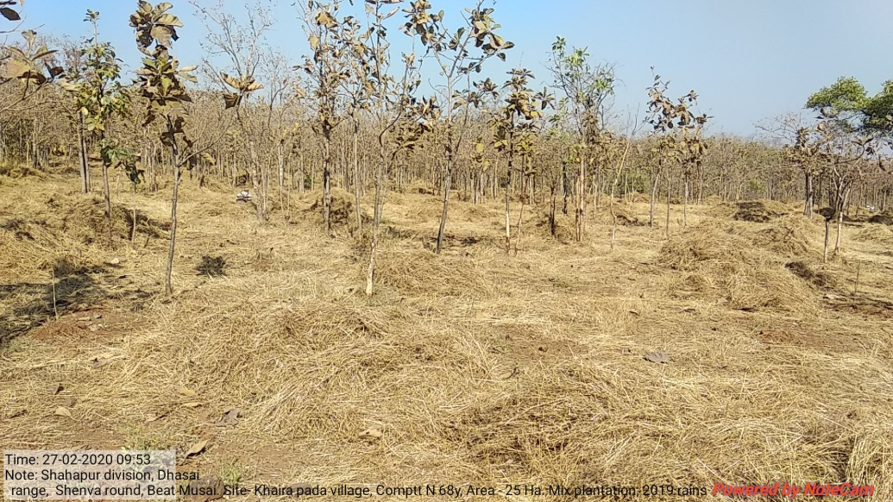

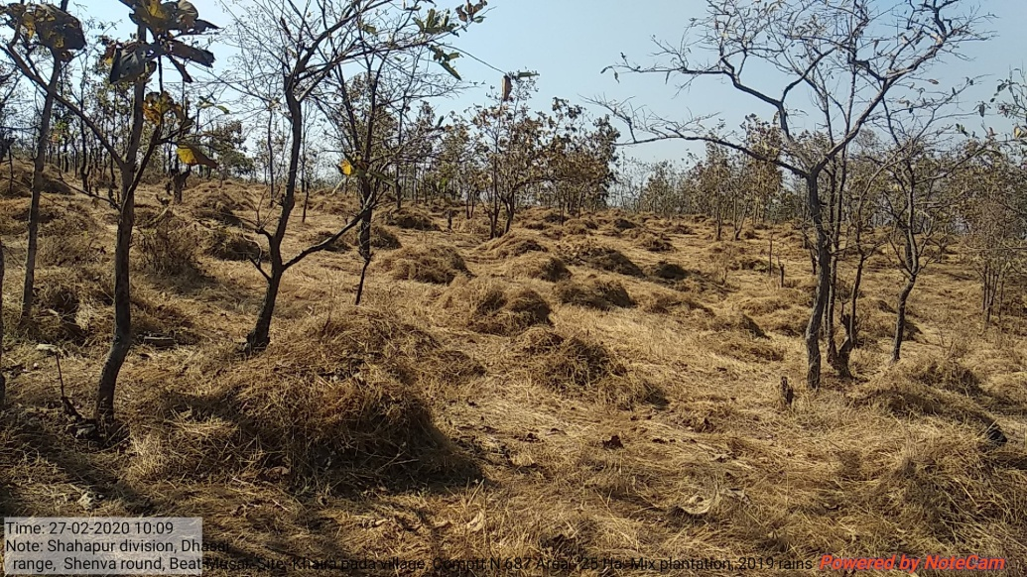
SITE WISE EVALUATION ABSTRACT
Site Number: 97

A. Description of site
Name of Site- Murabicha pada
Place- 674
Beat- Murabipada Round- Sarangpuri
Range- Dhasai Forest Division- Shahapur
Forest Circle- Thane
Area of Treatment- Plantation: 10.000 Ha. GPS: Polygon 16.400 Ha.
Difference- Excess 6.400 Ha.
Status of Land- Reserved Forest- Yes Protected Forest- No
Unclassed Forest- No Received as compensatory land- No
Zudpi Jungle- No
Site quality- II-Normal Density- 0.7 Slope- Moderate (10 to 25 degrees)
Available vegetation (Local Names)- Teak, Sadada, Khair, Bandara, Varas, Kahandol, Karawand, Toran, Ukshi, Burada, Kuda(Both) Grass-Telya, Pawanya, Bhatani
B. Plantation Details
Model - 400 plants/ha.
Spacement- 5 × 5
Treatment Map- Yes
Soil Zone- Zone-I, Zone-II, Zone-III
Species selected for planting- Bamboo (Dendrocalamus strictus)

C. Survival & Status
Site suitability- Sustainable. as the site has all associate species of Bamboo.
Suitability of species planted- Yes
Plant survival percentage- 83%
Average Height of plants- 60 cm
Average girth of plants- 3 cm
General Health of Plants- Healthy
Sustainability- -

D. Protection-
Fencing Status- TCM - 319.5 Rmt., Stonewall - 225.70 Rmt.
Fire- Amount Sanctioned in the estimate- Rs. 3396.00/-
Execution of the work- Work Done
Expenditure/Payment of the work- Rs. 0.00/-
Grazing- No

E. Monitoring
Inspection of Plantations- APCCF - 0, CCF - 0, DCF - 0, ACF - 1, RFO - 1
Plantation register- UP-to-date
Measurement Book- Up-to-date
Cash Book- Up-to-date
Financial audit- Not Done
Fund pattern-
F. Overall Rating A Grade
(Excellent – A+, Very Good – A, Good – B+, Average – B, C-Poor)
Reasons for success/ Failure- 1) Site specific estimates should be prepared. 2) Watchman should be provided for protection.

G. Date of Evaluation 26 Feb 2020
Name of Evaluators Mr. S. K. Gawali, Mr. B. R. Challare
H. Photographs-
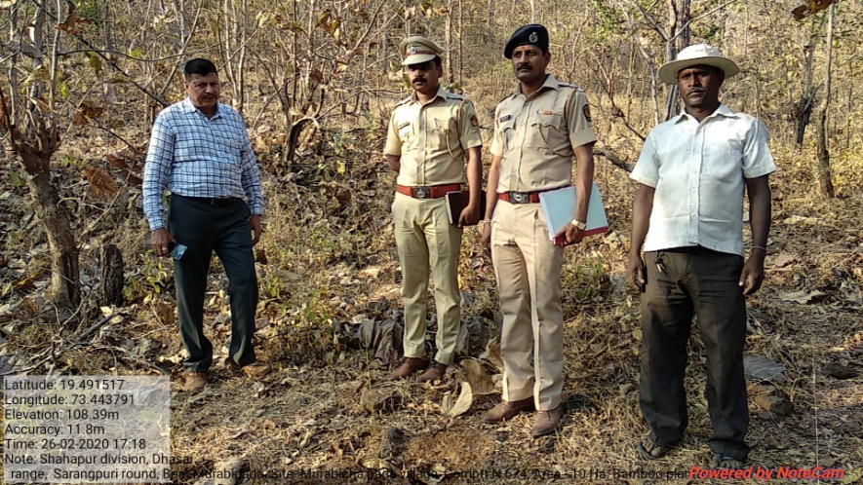
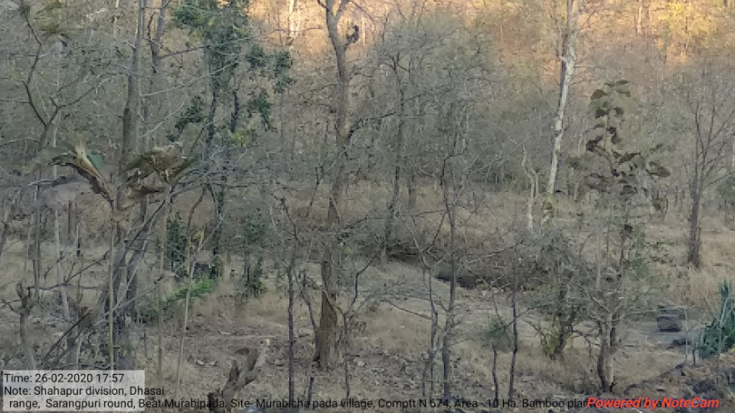
SITE WISE EVALUATION ABSTRACT
Site Number: 98

A. Description of site
Name of Site- Khaira
Place- 95,96
Beat- Musai Round- Shenva
Range- Dhasai Forest Division- Shahapur
Forest Circle- Thane
Area of Treatment- Plantation: 25.000 Ha. GPS: Polygon 35.360 Ha.
Difference- Excess 10.360 Ha.
Status of Land- Reserved Forest- No Protected Forest- Yes
Unclassed Forest- No Received as compensatory land- No
Zudpi Jungle- No
Site quality- III-Normal Density- 0.2 Slope- Heavy
Available vegetation (Local Names)- Teak, Ain, Dhavada, Bondona, Mona
B. Plantation Details
Model - 400 plants/ha.
Spacement- 5 × 5
Treatment Map- Yes
Soil Zone- Zone-I, Zone-II, Zone-III
Species selected for planting- Bamboo (Dendrocalamus strictus), Khair, Shivan

C. Survival & Status
Site suitability- Suitable
Suitability of species planted- Yes
Plant survival percentage- 88%
Average Height of plants- Bamboo-150 cm, Others-80 cm
Average girth of plants- 5 cm
General Health of Plants- Healthy
Sustainability- -

D. Protection-
Fencing Status- TCM - 381 Rmt, Live Hedge - 369 Rmt.
Fire- Amount Sanctioned in the estimate- Rs. 7390.00/-
Execution of the work- Work Not Done
Expenditure/Payment of the work- Rs. 0.00/-
Grazing- No

E. Monitoring
Inspection of Plantations- APCCF - 0, CCF - 0, DCF - 0, ACF - 0, RFO - 2
Plantation register- UP-to-date
Measurement Book- Up-to-date
Cash Book- Up-to-date
Financial audit- Not Done
Fund pattern-
F. Overall Rating A Grade
(Excellent – A+, Very Good – A, Good – B+, Average – B, C-Poor)
Reasons for success/ Failure- 1) Shivan is damaged by browsing hence instead of Shivan, Moha is recommended for planting. 2) Area infested with heavy grass hence its cutting and bailing is recommended.

G. Date of Evaluation 27 Feb 2020
Name of Evaluators Mr. S. K. Gawali, Mr. B. R. Challare
H. Photographs-
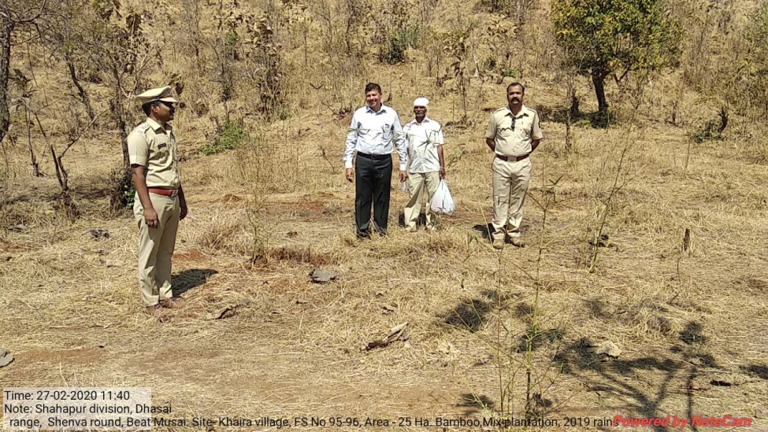

SITE WISE EVALUATION ABSTRACT
Site Number: 99

A. Description of site
Name of Site- Shera
Place- Survey No-4.No-489
Beat- Shera Round- Shera
Range- Shahapur Forest Division- Shahapur
Forest Circle- Thane
Area of Treatment- Plantation: 9.059 Ha. GPS: Polygon: 16.059 Ha.
Difference- Excess 7.000 Ha.
Status of Land- Reserved Forest- No Protected Forest- Yes
Unclassed Forest- No Received as compensatory land- No
Zudpi Jungle- No
Site quality- III Density- less than 0.1 Slope- Gentle(0 to 10 degrees)
Available vegetation (Local Names)- Ber, Bhatani, Teak, Ain, Palas, Dhawada Bamboo, Sawar, Shemat
B. Plantation Details
Model - 1111 plants/ha.
Spacement- 3 × 3
Treatment Map- Yes
Soil Zone- Zone-II, Zone-III
Species selected for planting- Awala, Behada, Hirda, Shivam, Chich, Teak, Bamboo, Neem, Kahandol, Bahara

C. Survival & Status
Site suitability- Suitable
Suitability of species planted- Yes
Plant survival percentage- 84%
Average Height of plants- 50 cm
Average girth of plants- 4 cm
General Health of Plants- Healthy
Sustainability- sustainable,provide protected from biotic interference

D. Protection-
Fencing Status- TCM - 924 Rmt.
Fire- Amount Sanctioned in the estimate- Rs. 6153.00/-
Execution of the work- Work Done
Expenditure/Payment of the work- Rs. 6153.00/-
Grazing- No

E. Monitoring
Inspection of Plantations- APCCF - 0, CCF - 0, DCF - 0, ACF - 0, RFO - 3
Plantation register- up-to-date
Measurement Book- Up-to-date
Cash Book- Not made available
Financial audit- Not Done
Fund pattern- No timely available of funds for plantation opertions
F. Overall Rating A Grade
(Excellent – A+, Very Good – A, Good – B+, Average – B, C-Poor)
Reasons for success/ Failure- 1) Chainlink fencing is recommended. 2) Capacity building of record maintenance of staff.

G. Date of Evaluation 28 Feb 2020
Name of Evaluators Mr. S. K. Gawali, Mr. B. R. Challare
H. Photographs-
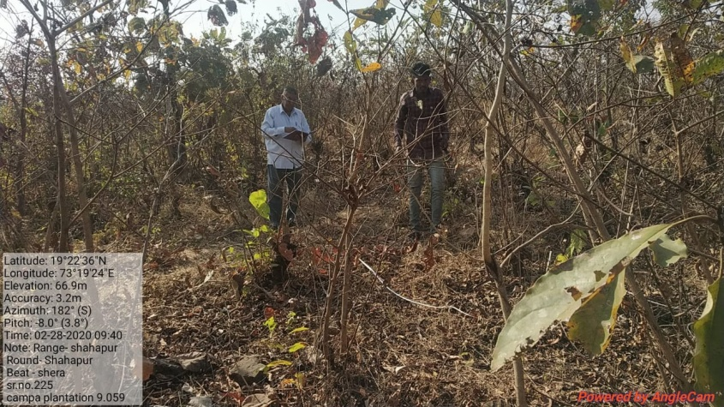

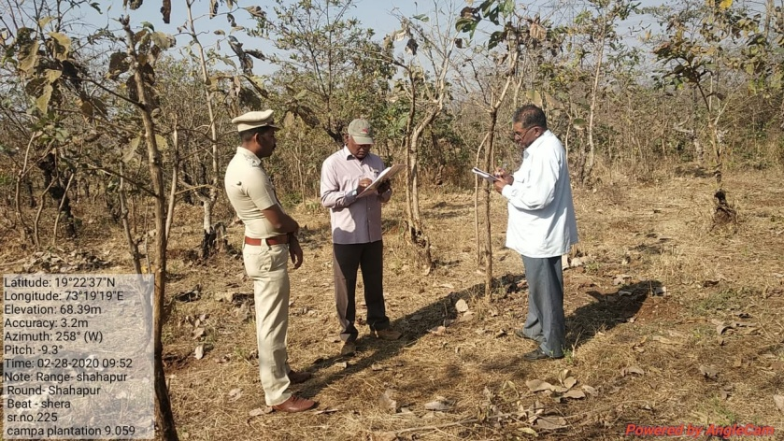
SITE WISE EVALUATION ABSTRACT
Site Number: 100

A. Description of site
Name of Site- Bhorande
Place- 726
Beat- Diwanpada Round- Moroshi
Range- Tokawade - South Forest Division- Thane
Forest Circle- Thane
Area of Treatment- Plantation: 10.000 Ha. GPS: Polygon: 12.500 Ha.
Difference- Excess 2.500 Ha.
Status of Land- Reserved Forest- Yes Protected Forest- No
Unclassed Forest- No Received as compensatory land- No
Zudpi Jungle- No
Site quality- Mix forest 4A Density- RF 0.4 Slope- Heavy
Available vegetation (Local Names)- Tree.
B. Plantation Details
Model - 1111 plants/ha.
Spacement- 3 × 3
Treatment Map- Yes, Not Authenticated
Soil Zone- Zone-I, Zone-II, Zone-III
Species selected for planting- Jambhul, Karanj, Awala, Kawat, Ritha, Vehala, Chinch, Shishu, Adulsa and Nirgudi

C. Survival & Status
Site suitability- Not suitable. The compartment No. is 726 and the slope of the hill is more than 250
Suitability of species planted- Yes
Plant survival percentage- 93%
Average Height of plants- 120 cm
Average girth of plants-
General Health of Plants- Healthy
Sustainability- Doubtful.

D. Protection-
Fencing Status- No
Fire- Amount Sanctioned in the estimate- Rs. 30253.00/-
Execution of the work- Work Done
Expenditure/Payment of the work- Rs. 6992.00/-
Grazing- No

E. Monitoring
Inspection of Plantations- APCCF - 0, CCF - 0, DCF - 0, ACF - 0, RFO - 1
Plantation register- Up-to date
Measurement Book- Up-to date
Cash Book- Notmade available by JFM
Financial audit- Not Done
Fund pattern- For PPO and FYO work the funds were received on time, however for SYO work no funds were received.
F. Overall Rating A Grade
(Excellent – A+, Very Good – A, Good – B+, Average – B, C-Poor)
Reasons for success/ Failure- The RFO, on his own validation has started drip irrigation by use of plastic bottles in the area of first two grids only.

G. Date of Evaluation 19 Feb 2020
Name of Evaluators Mr. A. R. Thakre
H. Photographs-
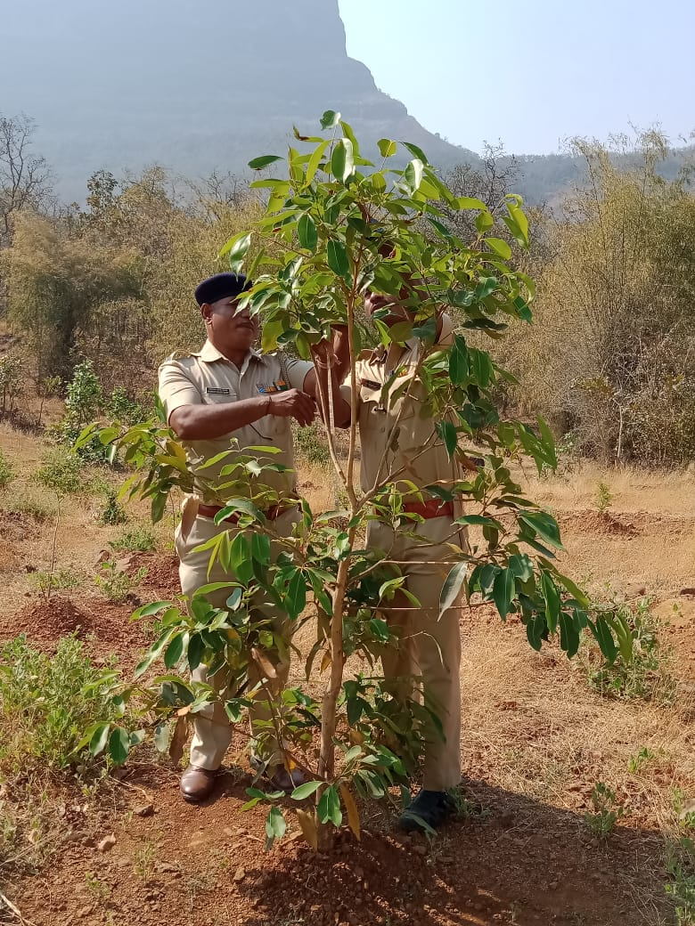

SITE WISE EVALUATION ABSTRACT
Site Number: 101

A. Description of site
Name of Site- Pendhare
Place- Comp. No. 737
Beat- Pendhare Round- Pendhare
Range- Tokawade - South Forest Division- Thane
Forest Circle- Thane
Area of Treatment- Plantation: 5.000 Ha. GPS: Polygon: 7.500 Ha.
Difference- Excess 2.500 Ha.
Status of Land- Reserved Forest- Yes Protected Forest- No
Unclassed Forest- No Received as compensatory land- No
Zudpi Jungle- No
Site quality- IV A, Normal Density- RF 0.4 Slope- Moderate
Available vegetation (Local Names)- Teak, Ain, Dharava, Bhend, Hund, Lokhandi, Kinhaia, Nana
B. Plantation Details
Model - 1111 plants/ha.
Spacement- 3 × 3
Treatment Map- Yes, Not Authenticated
Soil Zone- Zone-II
Species selected for planting- Sitaphal, Velha, Karanj, Jambhul, Kavat, Awala, Bahava, Chinch

C. Survival & Status
Site suitability- Not suitable. The compartment No.737 is allotted to Improvement Working Circle and it could have been worked accordingly. Here, the growth of Teak is very poor and stunted. This is a good area for NR model.
Suitability of species planted- Yes
Plant survival percentage- 78%
Average Height of plants- 100 cm
Average girth of plants-
General Health of Plants- Unhealthy
Sustainability- Will not sstain unless proper silvicultural activities are undertaken.

D. Protection-
Fencing Status- No
Fire- Amount Sanctioned in the estimate- Rs. 15126.50/-
Execution of the work- Work Done
Expenditure/Payment of the work- Rs. 3396.00/-
Grazing- No

E. Monitoring
Inspection of Plantations- APCCF - 0, CCF - 0, DCF - 0, ACF - 0, RFO - 0
Plantation register- Incomplete
Measurement Book- Up-to date
Cash Book- JFMC Cashbook not made available
Financial audit- Not done
Fund pattern- For PPO and FYO work the funds were received on time, however for SYO work no funds were received.
F. Overall Rating A Grade
(Excellent – A+, Very Good – A, Good – B+, Average – B, C-Poor)
Reasons for success/ Failure- Silvicultural operatoins, proper weeding and soil working needs to be attended.

G. Date of Evaluation 19 Feb 2000
Name of Evaluators Mr. A. R. Thakre
H. Photographs-
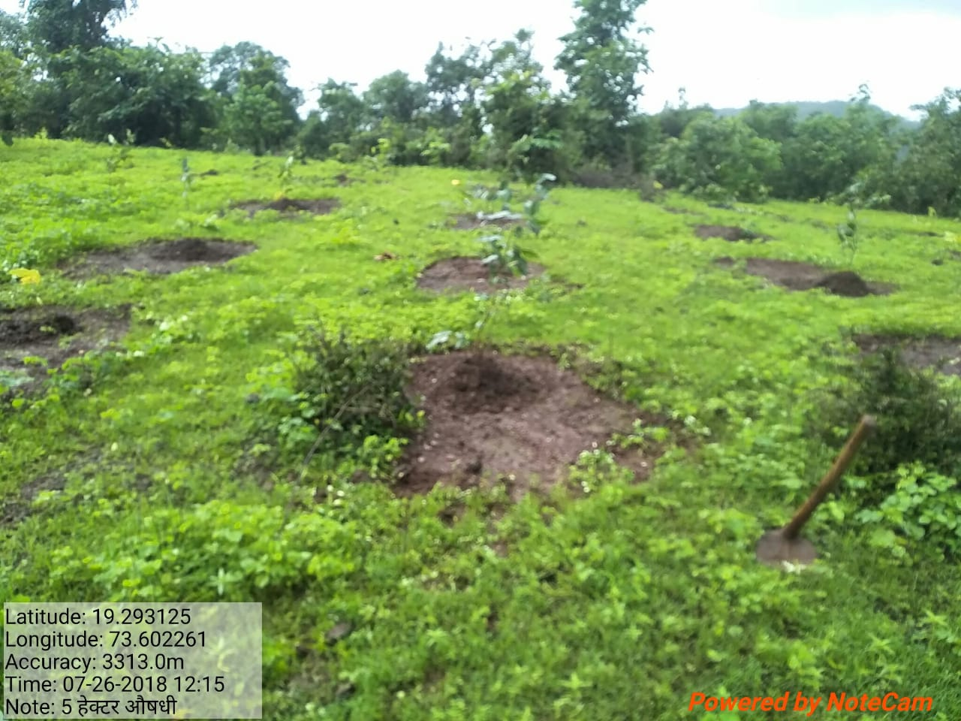
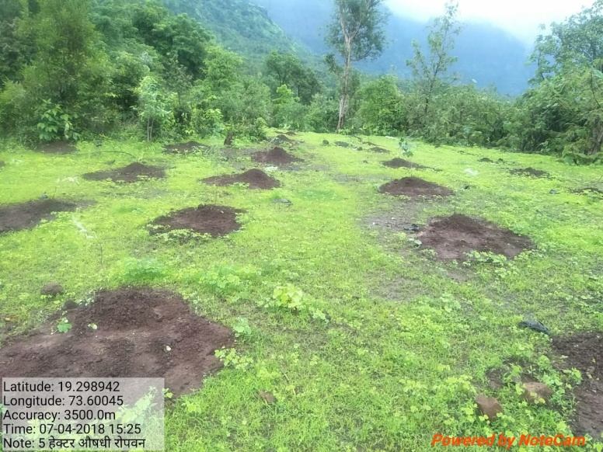

SITE WISE EVALUATION ABSTRACT
Site Number: 102

A. Description of site
Name of Site- Karchonde and Zadghar
Place- 145 Zadghar, 43 Kochare
Beat- Tokawade Round- Tokawade
Range- Tokawade North Forest Division- Thane
Forest Circle- Thane
Area of Treatment- Plantation: 10.000 Ha. GPS: Polygon: 14.120 Ha.
Difference- Excess 4.120 Ha.
Status of Land- Reserved Forest- No Protected Forest- Yes. Alloted to JFM Committee Donderwadi
Unclassed Forest- No Received as compensatory land- No
Zudpi Jungle- No
Site quality- Grass land Density- Less than 0.4 Slope- Gentle
Available vegetation (Local Names)- It's a open track, rather a grass land at Zadghar. It's a stunted growth of trees of Ain, Saag, Kirmira and others at Karchonde.
B. Plantation Details
Model - 1111 plants/ha.
Spacement- 3 × 3
Treatment Map- Yes
Soil Zone- Zone-I
Species selected for planting- Kaju, Awala, Ritha, Adulsa, Kanchan (Both sites)

C. Survival & Status
Site suitability- Not suitable. In survey No. 43 the entire area is covered with thick growth of Teak and Ain coppice shoots. In survey no. 145 Zadgar, the site is under transmission line and the area has sheet rocks which covers more than half of the plantation area. It is a barren grass land.
Suitability of species planted- Yes
Plant survival percentage- 25%
Average Height of plants- 90 cm
Average girth of plants-
General Health of Plants- Semi-healthy
Sustainability- Poor.

D. Protection-
Fencing Status- No
Fire- Amount Sanctioned in the estimate- Rs. 30253.00/-
Execution of the work- Work Done
Expenditure/Payment of the work- Rs. 6792.00/-
Grazing- No
E. Monitoring
Inspection of Plantations- APCCF - 0, CCF - 0, DCF - 0, ACF - 0, RFO - 1
Plantation register- Incomplete
Measurement Book- Up-to date
Cash Book- Not available (It was informed that JFMC CB has been sent to division office)
Financial audit- Not done
Fund pattern- Funding is in irregular pattern.
F. Overall Rating C Grade
(Excellent – A+, Very Good – A, Good – B+, Average – B, C-Poor)
Reasons for success/ Failure- Site selection and preparation of treatment map, needs to be properly monitored by higher authorities. Their guidance particularly in selection of site, is very important.

G. Date of Evaluation 20 Feb 2020
Name of Evaluators Mr. A. R. Thakre
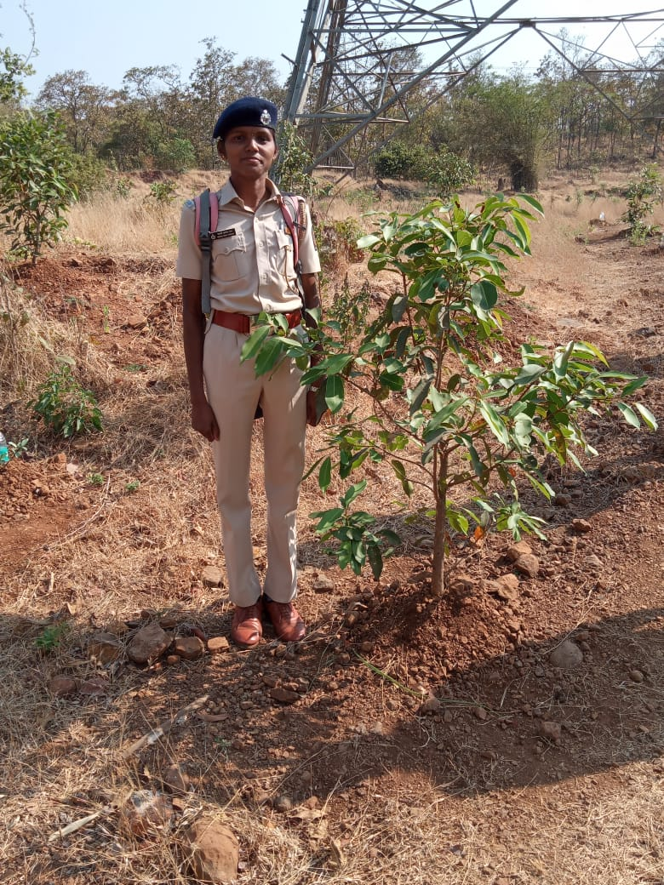
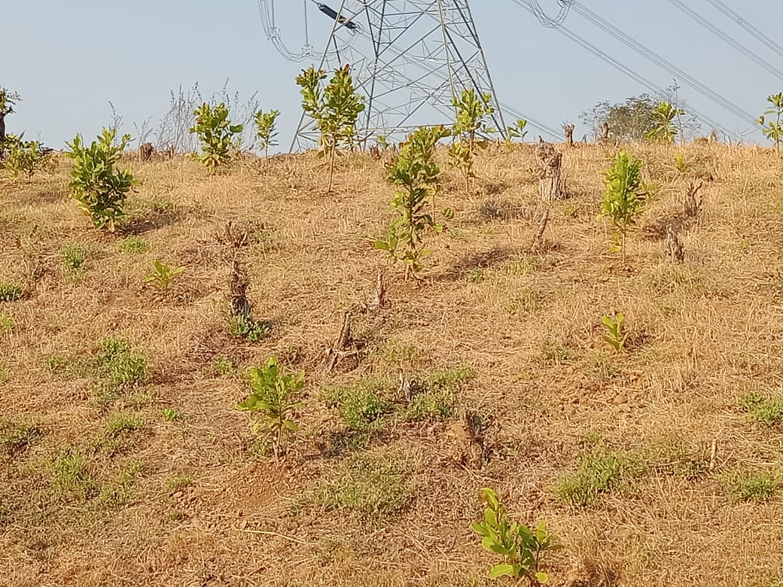
H. Photographs-

SITE WISE EVALUATION ABSTRACT
Site Number: 103

A. Description of site
Name of Site- Gavara
Place- Compt no 55
Beat- Junoni Round- Matharjun
Range- Jamni ForestDivision- Pandharkawada
Forest Circle- Yawatmal
Area of Treatment- Plantation: 5.000 Ha. GPS: Polygon: 5.000 Ha.
Difference- No change
Status of Land- Reserved Forest- Yes Protected Forest- No
Unclassed Forest- No Received as compensatory land- No
Zudpi Jungle- No
Site quality- IV b Density- Less than 0.2 Slope- Gentle
Available vegetation (Local Names)- Trees Teak, Tendu, Dhawada, Yen, Bahawa, Palas, Pimple, Neem, / Shrubs Chilati, Bharati, Herbs, Rajmonia / Grasses Rantulas, Kusal, Kambarmodi, Marvel
B. Plantation Details
Model - 625 plants/ha.
Spacement- 4 × 4
Treatment Map- Yes
Soil Zone- Zone-II
Species selected for planting- Behada, Bel, Karanj, Neem,Jambhul, Awala, Shatawari, Adulsa, Chandan, Kadamba, and Patharchur.

C. Survival & Status
Site suitability- Suitable
Suitability of species planted- Yes,
Plant survival percentage- 89%
Average Height of plants- 98 cm
Average girth of plants-
General Health of Plants- Healthy
Sustainability- In first year itself all plants are well established so plantation will sustain

D. Protection-
Fencing Status- TCM - 1020 Rmt.
Fire- Amount Sanctioned in the estimate- Rs. 3607.70/-
Execution of the work- Work Done
Expenditure/Payment of the work- Rs. 3606.00/-
Grazing- No

E. Monitoring
Inspection of Plantations- APCCF - 0, CCF - 0, DCF - 0, ACF - 1, RFO - 2
Plantation register- Up-to date
Measurement Book- Up-to date
Cash Book- Up-to date
Financial audit- Not Done
Fund pattern- year Funds not available timely
F. Overall Rating A Grade
(Excellent – A+, Very Good – A, Good – B+, Average – B, C-Poor)
Reasons for success/ Failure- Very good efforts taken by field staff for raising the plantation. Planting stock is also good. Chandan Plants were introduced in Mix Medicinal plantation.

G. Date of Evaluation 19 Feb 2020
Name of Evaluators Mr. U. M. Dhopeshwarkar, Mr. R. T. More
H. Photographs-
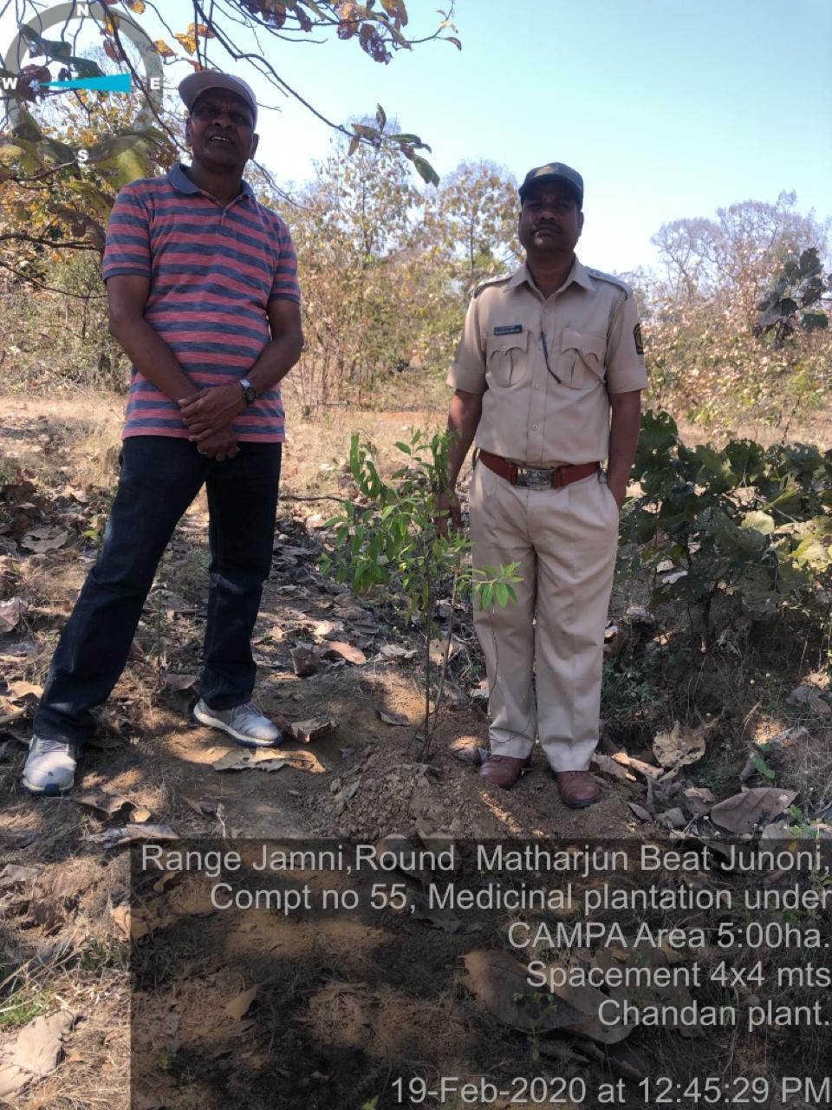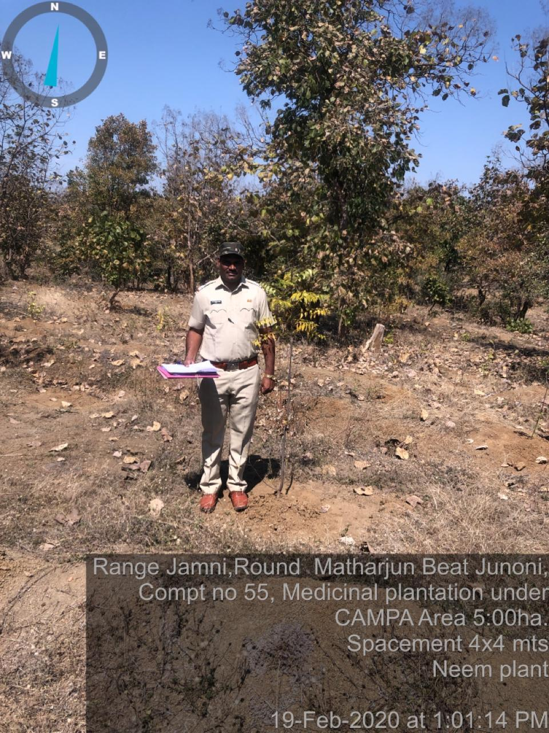




MAHARASHTRA COMPENSATORY AFFORESTATION FUND MANAGEMENT AND PLANNING AUTHORITY (Maha CAMPA)
Vanbhavan, Ramgiri Road, Civil Line, Nagpur-440001

Evaluation Report
of
CAMPA Plantation Works
In Maharashtra State
Period : 2011-12 to 2019-20

****
Chief Executive Officer
Maha CAMPA, Nagpur

